Software Requirements and Design Document- Group #8- Version 3.0

Team Members:

Team Members
Name | FSU ID | GITHUB ID
Emma Berry | Emb23e | EmmaVeryBerry
Hailie Tucker | Hlt22c | HailieT
Caitlin O’Donnell | Cmo21e | caitlinod
Joseph Daniele | Jnd23a | josephdaniele

Overview
Trajectory is a mobile application designed to improve academic productivity through structured study tracking and social accountability. The system allows users to set academic goals, log study sessions, and track progress over time while incorporating gamification elements such as achievements, streaks, and leaderboards.
Unlike traditional productivity tools that focus only on individual tracking, Trajectory integrates social features including friend connections, activity feeds, and competitive leaderboards. The system combines a clean, dark-themed user interface with a full backend architecture that supports persistent data storage and real-time interaction through API endpoints.
This version reflects the completed frontend implementation and the integrated backend system, including study tracking, goals, achievements, and social features.

Functional Requirements
- User Registration (High Priority)
The system shall allow users to create an account using a username, email, password, university, and major.
- User Login (High Priority)
The system shall allow users to log in using valid credentials and display appropriate error messages for invalid inputs.
- Goal Setting (High Priority)
The system shall allow users to create and manage academic goals including study targets and deadlines.
- Study Session Logging (High Priority)
The system shall allow users to log study sessions with date, duration, and optional notes.
- Study Progress Tracking (High Priority)
The system shall calculate and display weekly study progress based on logged sessions and user goals.
- Streak Tracking (High Priority)
The system shall track consecutive study days and maintain both current and longest streak values.
- Achievement System (Medium Priority)
The system shall award achievements based on milestones such as streak length and study hours.
- Social / Friends System (Medium Priority)
The system shall allow users to send friend requests, accept or decline them, and maintain a list of friends.
- Activity Feed (Medium Priority)
The system shall display recent activity including study sessions, achievements, and milestones.
- Leaderboards (Low Priority)
The system shall rank users globally and among friends based on streaks or study performance.
- Community Features (Medium Priority)
The system shall support community-based groupings such as university, major, or custom groups.

Non-functional Requirements
- Usability: The system must be easy to use and allow users to access all major features within minimal navigation steps.
- Portability: The application must run on both iOS and Android devices using React Native.
- Reliability: The backend must consistently handle API requests without crashing, and data must persist correctly.
- Performance: API responses must be returned quickly, and the app should load within reasonable time limits.
- Security: Sensitive data such as passwords must not be stored in plaintext.
- Consistency: The system must maintain consistent UI design and data integrity across all components.
- Scalability: The backend must support increasing numbers of users and data without significant performance degradation
Visual Consistency:
The application must maintain a consistent dark theme and design system.
Use Case Diagram:
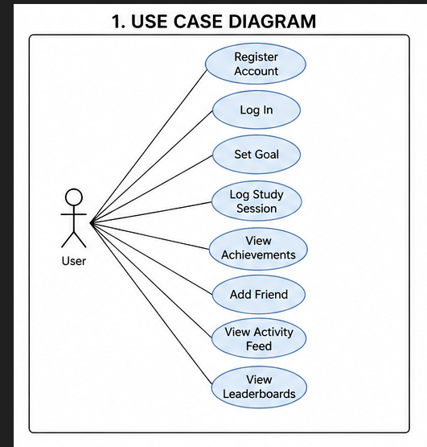

The system includes the following use cases:
- Register Account
- Log In
- Set Goal
- Log Study Session
- Run Pomodoro Timer
- View Achievements
- Add Friend
- View Activity Feed
- View Leaderboards
All use cases depend on user authentication except registration.
Textual Use Case Descriptions:
UC-01: Register Account
User enters required information. The system validates inputs and creates a new account if valid.
UC-02: Log In
User enters login credentials. The system verifies credentials and grants access.
UC-03: Set Goal
User creates a study goal with weekly targets. The system stores and tracks the goal.
UC-04: Log Study Session
User submits a study session. The system validates inputs, stores the session, updates progress, and triggers streak/achievement logic.
UC-05: View Achievements
User views earned and locked achievements. The system displays progress toward achievements.
UC-06: Add Friend
User sends a friend request. The system updates relationship status based on acceptance.
UC-07: View Activity Feed
User views recent activity including study sessions and achievements.

Class Diagram and/or Sequence Diagrams
Class Diagram:
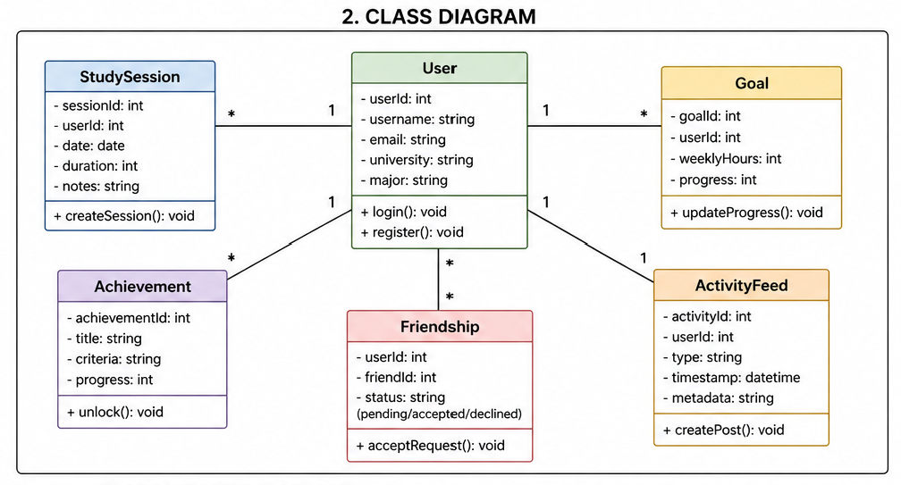

The system follows an object-oriented structure with the following main entities:
- User (userId, username, email, password, university, major)
- StudySession (sessionId, userId, date, duration, notes)
- Goal (goalId, userId, weeklyHours, progress)
- Achievement (achievementId, title, criteria, progress)
- Friendship (userId, friendId, status)
- ActivityFeed (activityId, userId, type, metadata, timestamp)
- Community (communityId, type, members)

Sequence diagrams:
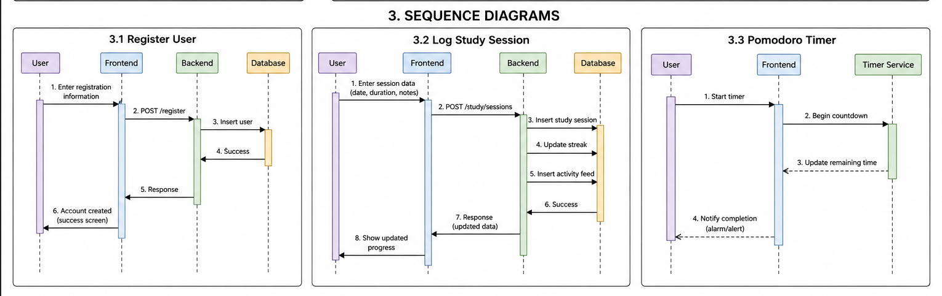
- User Registration
- Log Study Session
- Run Pomodoro Timer

Operating Environment

- Platforms: iOS 14+ and Android 10+
- Development Environment: React Native with Expo, Node.js backend server
- Database: MySQL
- Version Control: GitHub
- Runtime Environment: Local development using web/mobile browser and Expo

Assumptions and Dependencies

Assumptions include:
- Users will have access to a mobile device with internet connectivity
- Backend and frontend components will remain synchronized during development
- MySQL database is properly configured and accessible
- External tools such as GitHub, Expo, and Node.js are available and functional
Dependencies include:
- React Native / Expo for frontend
- Node.js and Express.js for backend
- MySQL for data storage
- React Navigation for UI routing

