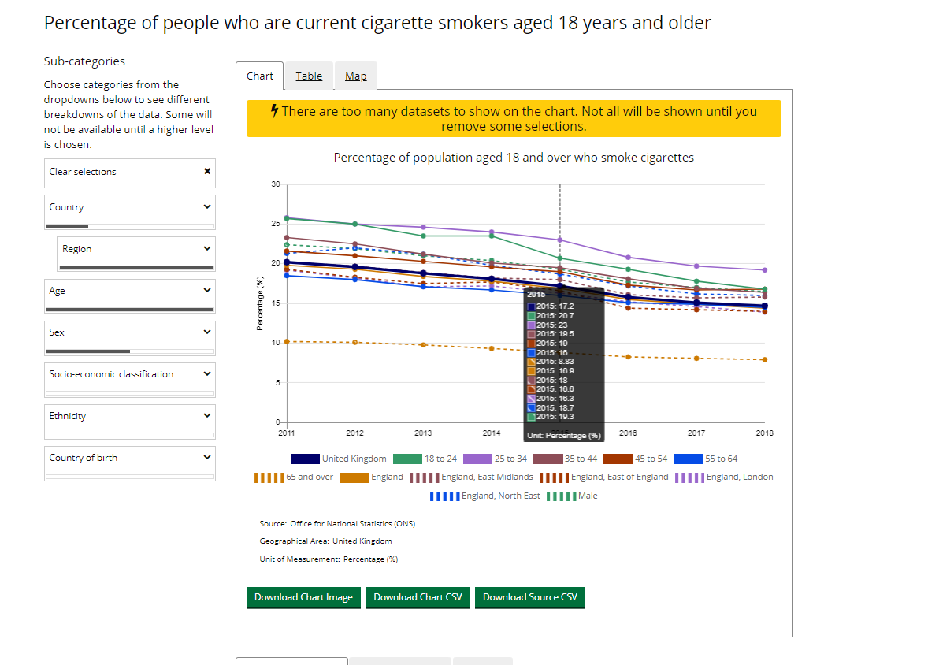

3.a.1 on platform: England > All Regions> All Ages > Men and headline

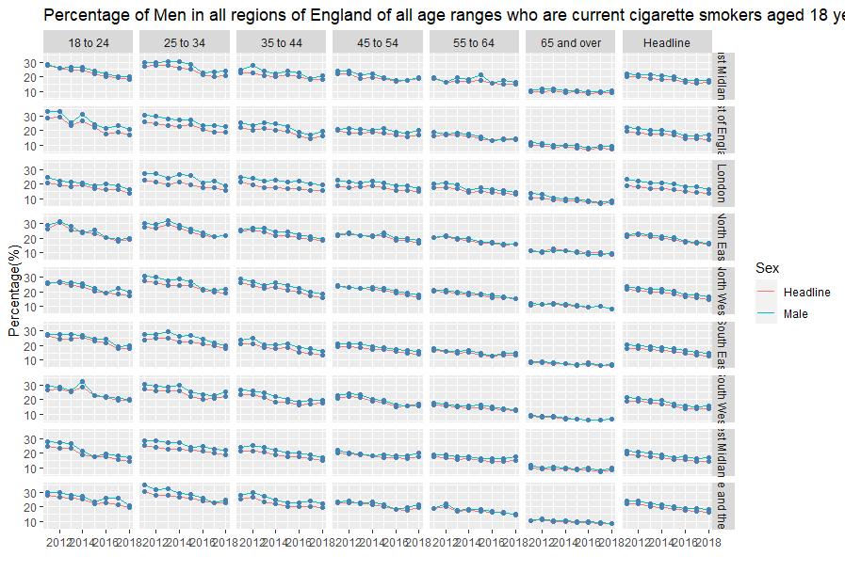
Shiny web app Output for same selections:

