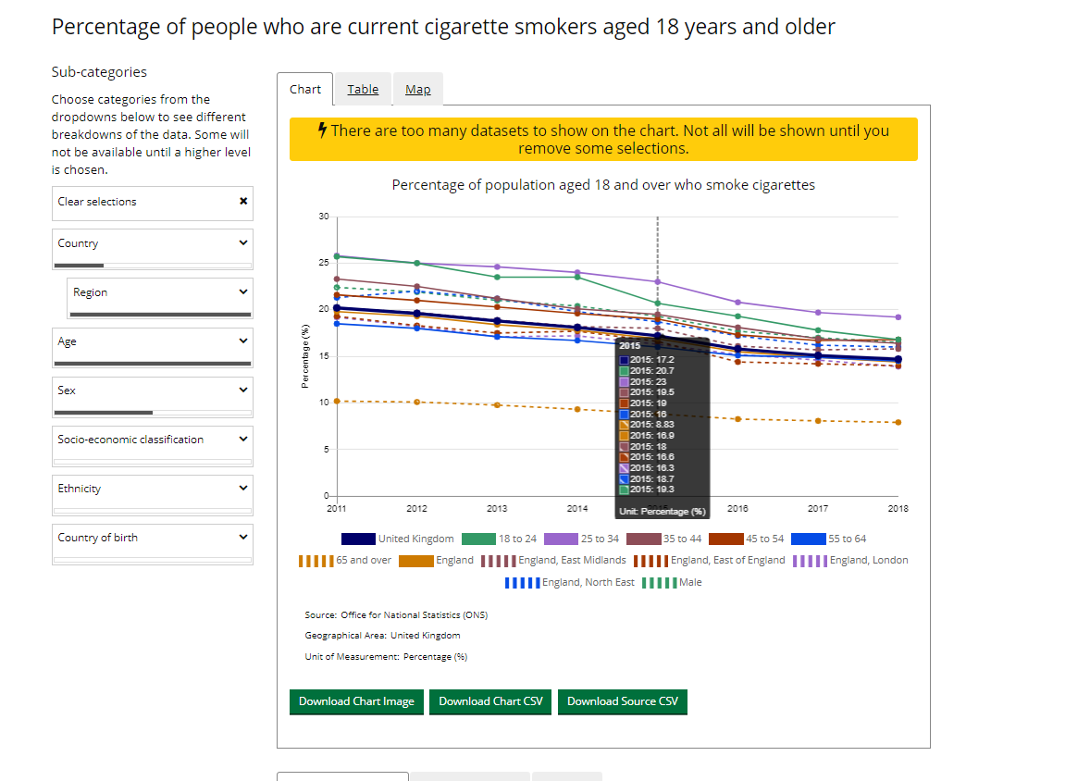

3.a.1 on platform: England > All Regions> All Ages > Men and headline

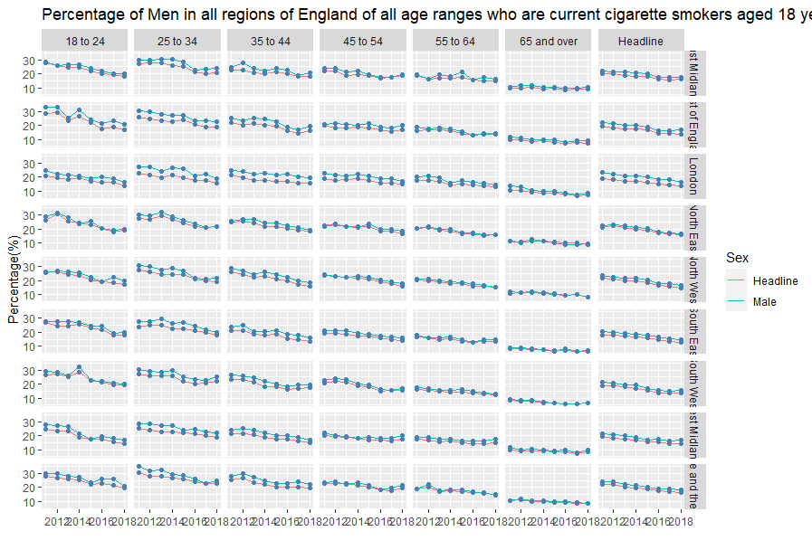Shiny web app Output for same selections: