🐕  Dog | 🐱  Cat | 🐭  Mouse | 🦁  Lion
🐆  Leopard | 🍎  Apple | 🧀  Cheese | 🍞  Bread
🍭  Lollipop | 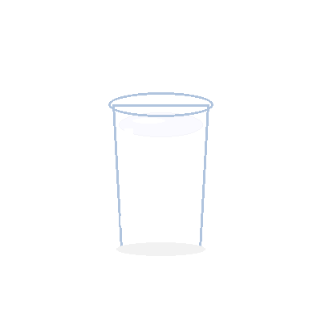  Milk | 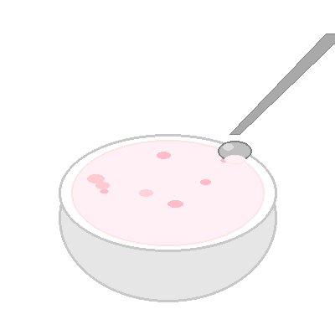  Yogurt | 🐘  Elephant
🍩  Donut | 🐦  Bird | 🐟  Fish | 🍌  Banana
🎂  Cake | 👩  Mom | 👨  Dad | 🍉  Watermelon
💧  Water | 🍚  Rice | 🐒  Monkey | 🔴  Red
🟢  Green | 🔵  Blue | ⚪  White | ⚫  Black
🟤  Brown | 🟡  Yellow | 🟣  Purple | 🐘  Big
🐭  Small | 🦒  Tall | 🧸  Short | 👴  Grandpa
👵  Grandma | 👶  Baby

