🌟 英语单词学习卡片 🌟
适合5岁儿童 | 共38个单词 | 打印后剪裁使用
🐕  Dog | 🐱  Cat
🐭  Mouse | 🦁  Lion
🐆  Leopard | 🍎  Apple
🧀  Cheese | 🍞  Bread
🍭  Lollipop |   Milk
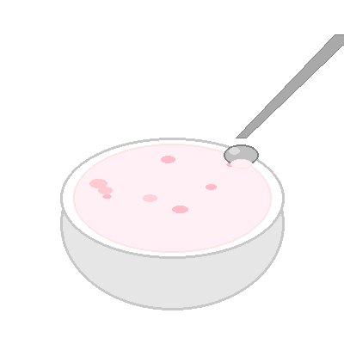  Yogurt | 🐘  Elephant
🍩  Donut | 🐦  Bird
🐟  Fish | 🍌  Banana
🎂  Cake | 👩  Mom
👨  Dad | 🍉  Watermelon
💧  Water | 🍚  Rice
🐒  Monkey | 🔴  Red
🟢  Green | 🔵  Blue
⚪  White | ⚫  Black
🟤  Brown | 🟡  Yellow
🟣  Purple | 🐘  Big
🐭  Small | 🦒  Tall
🧸  Short | 👴  Grandpa
👵  Grandma | 👶  Baby

