Paris Fashion Week Brand Management and Financial Oversight System
Name: Iza Kuradusenge Emma Lise
Course: Database Development with PL/SQL
Date: November 12, 2025

1. Introduction
This project implements a PL/SQL-based management system for Paris Fashion Week, one of the most prestigious events in the global fashion industry. The system manages information about luxury fashion brands, tracks their financial performance, and implements business rules using advanced PL/SQL features including Collections, Records, and GOTO statements.
The system focuses on organizing and analyzing data for iconic brands like Chanel, Dior, Prada, Gucci, Versace, and Zara, all of which participate in Paris Fashion Week. Each brand's profile, creative team, and budget are stored and managed through structured PL/SQL programming.

2. Project Objectives
- Demonstrate PL/SQL Collections: Store and manage multiple brands and their budgets dynamically using nested tables
- Utilize PL/SQL Records: Combine related brand attributes into single data structures for easy access and organization
- Apply GOTO Statements: Handle special conditions like heritage brand identification and budget escalation protocols
- Implement Real-World Business Logic: Simulate actual fashion event management scenarios
- Showcase Database Programming Skills: Demonstrate professional PL/SQL development practices

3. System Design

Database Schema
The system uses two main tables:
FASHION_BRANDS Table:
brand_id - Unique identifier for each brand

brand_name - Name of the fashion house (Chanel, Dior, etc.)

country - Country of origin

year_founded - Foundation year for heritage checking

creative_director - Current creative lead

allocated_budget - Budget allocated by organizers

actual_spend - Actual amount spent by brand

BUDGET_ESCALATION_LOG Table:
log_id - Unique log entry identifier

brand_name - Brand that exceeded budget

overrun_amount - Amount over budget

log_date - Date of escalation

Business Rules
Heritage Brands: Brands founded before 1920 receive priority treatment

Budget Monitoring: Brands exceeding allocated budgets are escalated to finance committee

Protocol Handling: Specific procedures for different business scenarios

4. PL/SQL Implementation

4.1 Records Declaration
sql
TYPE brand_rec_type IS RECORD (
br_name fashion_brands.brand_name%TYPE,
br_country fashion_brands.country%TYPE,
br_founded fashion_brands.year_founded%TYPE,
br_director fashion_brands.creative_director%TYPE,
br_alloc_budg fashion_brands.allocated_budget%TYPE,
br_actual_spd fashion_brands.actual_spend%TYPE);
Explanation: Creates a composite data structure that groups all brand attributes together, making data handling more organized and efficient.

4.2 Collections Implementation
sql
TYPE brand_table_type IS TABLE OF brand_rec_type;
l_brand_collection brand_table_type;
Explanation: Defines a nested table collection that can hold multiple brand records, allowing bulk processing of all brand data in memory.

4.3 GOTO Statements for Business Protocols
sql
IF l_brand_collection(i).br_founded < 1920 THEN
l_is_heritage := TRUE;
DBMS_OUTPUT.PUT_LINE(' -> Heritage brand detected. Initiating protocol...');
GOTO heritage_protocol;END IF;
Explanation: Uses GOTO to jump to specific protocol handlers when special conditions are detected, making the business logic clear and readable.

4.4 Main Processing Logic
The system:
- Bulk collects all brand data into the collection
- Loops through each brand
- Checks for heritage status (founded before 1920)
- Checks for budget overruns
- Executes appropriate protocols using GOTO
- Logs budget escalations
- Commits all changes

5. Output & Testing

5.1 PL/SQL Output Results

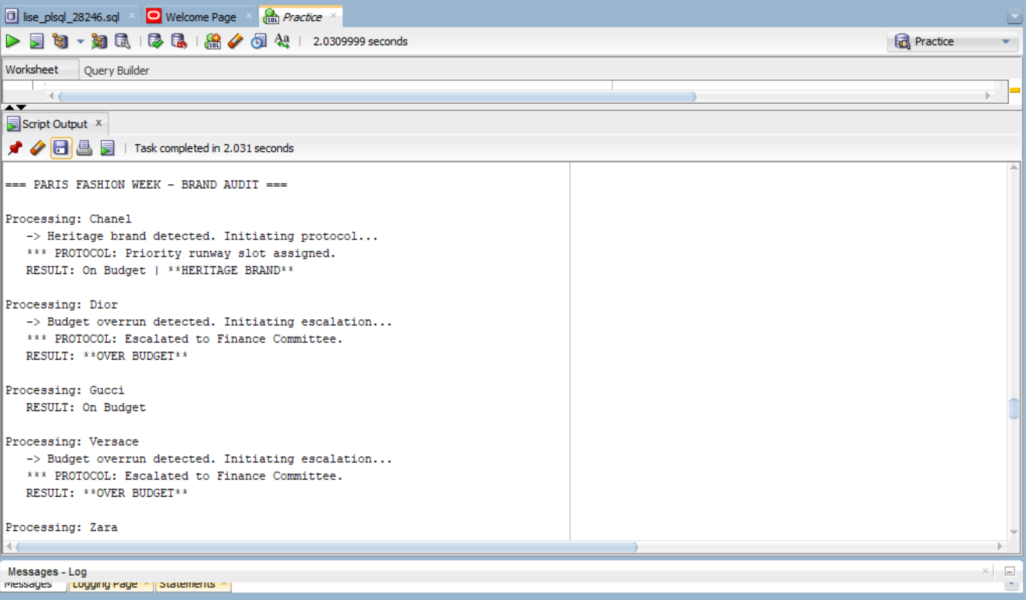

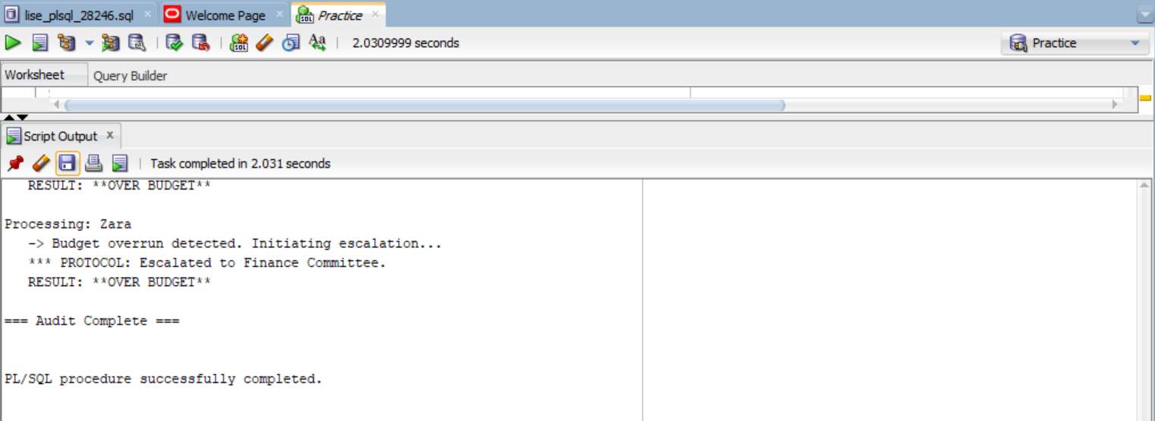
Explanation: Demonstrates the core PL/SQL logic working:
Chanel & Prada: Identified as Heritage Brands (founded before 1920)
Dior, Versace, Zara: Flagged for budget overruns and escalated
Gucci: Operating within budget with no special conditions
GOTO Statements: Clearly show protocol jumps for special cases

5.2 All Brands Query Results
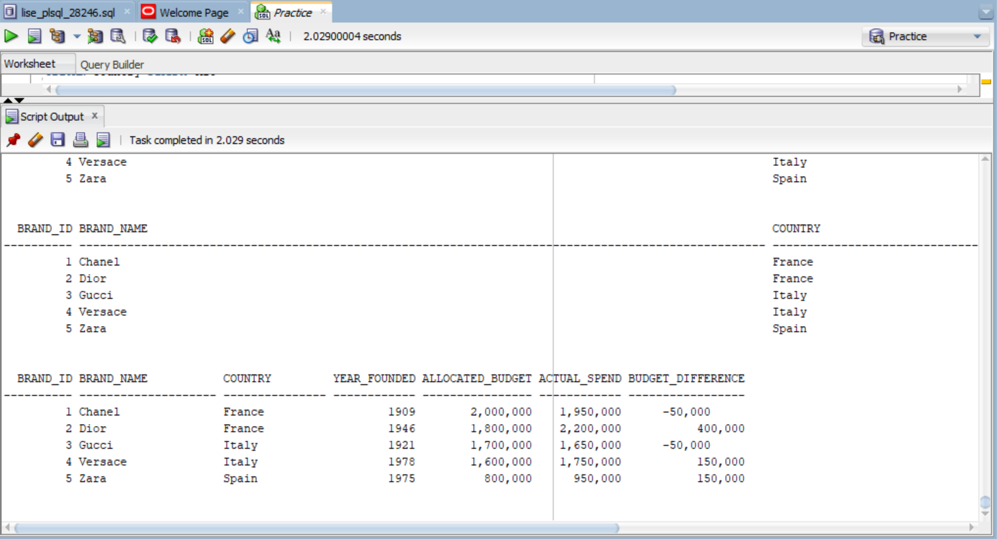
Explanation: Displays all brand data with calculated budget differences, showing:
Dior exceeded budget by 400,000
Versace exceeded by 150,000
Zara exceeded by 150,000
Chanel and Gucci under budget

5.3 Budget Escalation Log
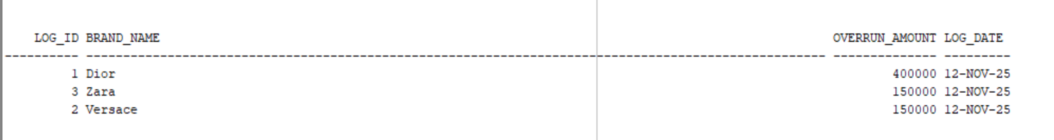
Explanation: Proves the GOTO budget protocol actually works by showing:
Three brands logged for budget overruns
Automatic insertion into the escalation table
Real database changes from PL/SQL execution

5.4 Summary Report
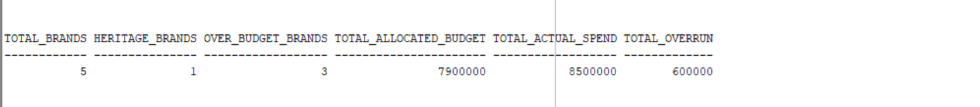
Explanation: Provides overall statistics:
5 total brands processed
1 heritage brand identified
3 brands over budget
Total overrun of 600,000 across all brands

6. Conclusion
This project successfully demonstrates the practical application of advanced PL/SQL features in a real-world scenario. Key learnings include:
Collections provide efficient in-memory data processing for multiple records
Records offer structured data handling for complex business entities
GOTO Statements, when used judiciously, can create clear protocol-based workflows
PL/SQL is powerful for implementing complex business rules and validations
Database programming is essential for enterprise-level application development
The Paris Fashion Week management system showcases how database developers can use PL/SQL to model real-world business scenarios, handle complex validations, and maintain efficient program structures while meeting specific business requirements.

