**POULTRY HUB**

**P.O.BOX 1201**

**GULU (UG)**

**Phone contact: 256 770 680 938**

**Email:** [**eolara68@gmail.com**](mailto:eolara68@gmail.com)

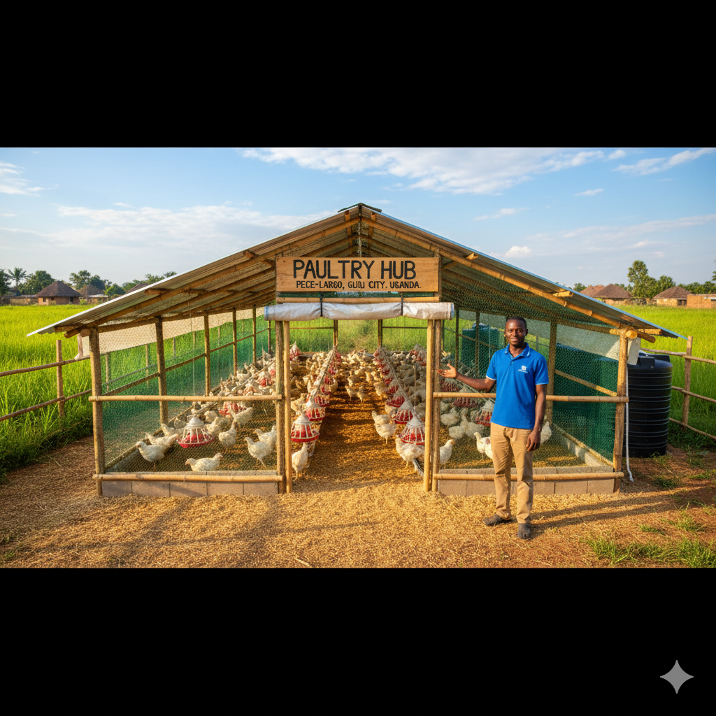

**EXECUTIVE SUMMARY**

### Overview

**Poultry Hub** is a new, small-scale poultry enterprise operating in **Pece-Laroo, Gulu City, Uganda**. Founded and led by **Olara Emmanuel** (Gulu University, Bachelor of Computer Science), the venture is strategically focused on addressing the local market's need for a **consistent, high-quality, and hygienically-raised poultry meat supply**. The business is fully capitalized by the founder's investment of **UGX 10,000,000**.

This limited starting capital dictates a highly efficient **"lean production and rapid-reinvestment model."** The initial operation centers on **small broiler chickens** due to their short 6-8 week production cycle, which ensures **quick cash flow generation** necessary for continuous scaling. Poultry Hub distinguishes itself by combining practical, cage-free farming with **data-driven management** to optimize Feed Conversion Ratio (FCR) and minimize losses—a competitive edge derived from the founder's technical background.

### Current State of Operations

Poultry Hub is in the **pre-launch phase**, with the UGX 10,000,000 capital allocated to essential setup:

1. **Site & Infrastructure:** Securing a long-term lease in **Pece Pawel** and constructing a foundational, expandable, and bio secure **cage-free poultry house** (UGX 3,000,000).
2. **Working Capital:** The majority of the capital (UGX 4,500,000) is dedicated to securing the first two cycles of **day-old chicks and bulk feed** to immediately initiate production and cash flow.
3. **Supply Chain:** Initial contracts are being finalized with regional suppliers to secure a reliable, consistent input stream—a critical factor for the high-turnover model.

### Strategic Focus and Competitive Advantage

Poultry Hub targets the **Gulu City Food Service Sector** (restaurants, hotels, and established butcheries) that prioritize reliability and freshness over cost.

|  |  |
| --- | --- |
| Competitive Advantage | Strategic Application |
| **Technology & Efficiency** | Founder's Computer Science skills used to implement simple, low-cost monitoring systems for **FCR tracking** and inventory management, ensuring high profitability and reduced waste. |
| **Location & Freshness** | Operations in **Pece-Laroo** allow for **same-day delivery** to Gulu customers, guaranteeing the freshest product, unlike competitors relying on longer transit or frozen stock. |

### Financial Summary

The financial projections are based on maximizing efficiency and doubling capacity each year through the aggressive reinvestment of profits.

|  |  |  |  |  |
| --- | --- | --- | --- | --- |
| Financial Summary (UGX) | Financial Year 1 | Financial Year 2 | Financial Year 5 | **Key Metric** |
| **Total Revenue** | UGX 22,000,000 | UGX 48,000,000 | UGX 216,000,000 | **Growth Driver** |
| **Total Expenses** | UGX 18,700,000 | UGX 32,100,000 | UGX 115,300,000 | **Cost of Goods Sold (Feed)** |
| **Net Income** | UGX 1,518,000 | UGX 10,960,000 | UGX 71,900,000 | **Reinvestment Capital** |
| **Net Profit Margin** | 6.9% | 22.8% | 33.3% | **Profitability Target** |

The initial low margin in financial year 1 is expected, but the sharp increase to over 22% in financial year 2 demonstrates the high scalability and financial viability of the lean operational model.

### Future Vision

Poultry Hub's vision is to achieve regional leadership in quality poultry supply by:

* **Year 3:** Diversifying into **layer production (eggs)** to stabilize cash flow and mitigate market risks.
* **Year 5:** Reaching over UGX 200 million in annual revenue, establishing a benchmark for technologically-driven, ethical farming in **Northern Uganda**.

### Funding Requirements

**UGX 10,000,000** in initial funds, fully contributed by Olara Emmanuel. No external financing is sought in Phase 1. This capital ensures a debt-free, sustainable start.

**COMPANY DESCRIPTION**

**Company Description**

**Poultry Hub** is a poultry farm dedicated to the commercial production of poultry meat and, later, eggs. We operate a lean, cage-free facility designed for maximum throughput and minimum waste. Our unique blend of agricultural experience and Computer Science-backed management is our core differentiator in the local Gulu market.

**Legal Structure**

Sole Proprietorship (initially), transitioning to a registered Limited Company as growth milestones are achieved in Year 3.

**Mission & Vision Statement**

* **Mission:** To supply the **Gulu City** market with the freshest, most consistent, and ethically-raised poultry products.
* **Vision:** To be the leading technologically-driven poultry farm in Northern Uganda.

**Objectives**

1. Achieve positive net income in Year 1.
2. Expand capacity by 100% by the end of Year 2.
3. Establish contract relationships with at least three major restaurants/hotels in Gulu by Year 3.

**Critical Success Factors**

* Maintaining a high Feed Conversion Ratio (FCR) through data tracking.
* Ensuring an uninterrupted, reliable supply of day-old chicks and feed.
* Minimizing bird mortality through strict hygiene and monitoring.
* Consistency in product size and delivery schedules.

**SWOT Analysis**

|  |  |
| --- | --- |
| Strengths | Weaknesses |
| Low startup cost (UGX 10,000,000) and zero initial debt. | Limited starting scale and working capital. |
| Management's blend of poultry experience and Computer Science skills (efficiency). | High reliance on Olara Emmanuel for all core functions initially. |
| **Pece-Laroo** location provides proximity to **Gulu City** markets. | Vulnerability to local feed supply chain issues. |
| **Opportunities** | **Threats** |
| Growing middle class demand for quality protein in Gulu. | Disease outbreaks (e.g., Avian Flu) leading to mortality. |
| Potential for technology integration (low-cost monitoring systems). | Volatility and continuous increase in feed prices. |

**Customers**

**Target Market**

* **Primary:** Small-to-medium-sized **Restaurants, Hotels, and Fast-Food Eateries** in Gulu City that require consistent weekly or bi-weekly deliveries.
* **Secondary:** Local **Butcheries and Retail Vendors** in the Pece and Gulu main markets.

**Why Customers Choose “Poultry Hub”**

1. **Consistency:** Reliable delivery schedules and consistent bird weights/quality, which local farmers often fail to provide.
2. **Freshness:** Proximity in **Pece-Laroo** allows for same-day delivery, unlike regional competitors.
3. **Ethical/Quality:** Commitment to **cage-free** rearing and high hygiene standards.

**Competitors**

**Competitive Landscape**

Competition in the Gulu area is mainly fragmented small-scale farmers and a few large, distant processors. Poultry Hub targets the quality and consistency middle ground.

**Competitor**

|  |  |  |  |
| --- | --- | --- | --- |
| Competitor Type | Focus | Price Point | Poultry Hub's Advantage |
| **Local Small-Holders** | Low volume, varied quality | Low | **Consistency, hygiene, and supply volume.** |
| **Regional Processors** | High volume, frozen/chilled | Moderate | **Freshness and local economic support.** |

**BUSINESS STRATEGY**

**Business Model**

**Lean Production & Reinvestment Model:** Start small, maximize production cycles (broilers mature in 6-8 weeks), reinvest 100% of Net Income back into increasing capacity (more chicks, larger shelter) until minimum efficient scale is reached.

**Operational Plan**

1. **Sourcing:** Establish a reliable contract with a single, reputable day-old chick hatchery and feed supplier.
2. **Husbandry:** Strict adherence to vaccination schedules and hygiene protocols to prevent disease.
3. **Sales:** Sales are executed before harvest to minimize holding time and cost.

**Production Plan**

The plan is based on increasing flock size by reinvesting profit:

* **Year 1:** Focus on a small, high-density flock with rapid turnover cycles (approx. 5 cycles).
* **Year 2-5:** Gradual expansion of the main structure in Pece Pawel to accommodate larger flocks.

**Business Development Phases**

|  |  |  |
| --- | --- | --- |
| Phase | Focus | Funding |
| **Phase 1 (Year 1)** | Broiler production, maximizing FCR, establishing 5 key customer contracts. | UGX 10,000,000 (Initial Capital) |
| **Phase 2 (Year 2-3)** | Expand facility size, purchase layers for egg production, and hire 1 full-time sales agent. | Reinvested Net Income (UGX 10.9M in the second year) |
| **Phase 3 (Year 4-5)** | Diversify into duck production, explore processing/packaging options. | Reinvested Net Income |

**Suppliers**

* Day-Old Chicks (DOCs) Hatchery (Ugandan/Kenyan source).
* Poultry Feed Mill (Local/Regional bulk supplier).
* Veterinary Services (Local Gulu vet).

**Key Resources**

* Leased Land in Pece Pawel, Gulu City.
* **Olara Emmanuel's** technical expertise.
* The high-turnover broiler breed.

**Key Activities**

* Feed Procurement and Management (FCR Tracking).
* Flock Health Monitoring (Disease prevention).
* Direct Customer Relationship Management (Sales).

**Key Metrics**

* **Feed Conversion Ratio (FCR):** Amount of feed required to gain one unit of weight (Target: <2.0).
* **Mortality Rate:** Percentage of chicks lost (Target: <3%).
* **Customer Retention Rate:** (Target: 80%).

**Future Growth**

Future growth will involve vertical integration (e.g., small-scale processing/packaging) and diversification into higher-margin products like organic poultry or specialized feeds.

**PRODUCTION PLAN**

The production plan for Poultry Hub is centered on a **high-efficiency, rapid-cycle model** designed to maximize the turnover of the UGX 10,000,000 startup capital. Production will proceed in three distinct phases, with success metrics governed by data derived from the founder's Computer Science background.

### Product / Service Description

Poultry Hub's initial and primary product is the **Small Broiler Chicken**, specifically raised to meet the demanding requirements of the Gulu food service sector.

* **Initial Focus (Phase 1: Year 1-2):** **Small Broilers (Meat Production).** Broilers are chosen for their **short, 6-8 week production cycle**, which allows Poultry Hub to execute 5-6 cycles per year. This ensures continuous, rapid cash flow and capital reinvestment. The small, portion-controlled size is preferred by local restaurants and fast-food kiosks in Gulu for inventory management and consistent serving.
* **Expansion Products (Phase 2 & 3: Year 3+):**
  + **Layers Chicken:** Introduced to diversify revenue and provide a more stable, long-term cash flow stream from egg sales.
  + **Ducks (Meat/Eggs):** A specialty product targeted at high-end hotels and niche markets, providing a higher margin once scalability is proven.
* **Rearing Method:** All production employs a **cage-free**, deep-litter system on the Pece-Laroo site. This method reduces stress, improves meat quality, and minimizes initial infrastructure costs compared to caged systems.

### Production Cycle & Scale Management

The model is based on disciplined batch management and continuous reinvestment.

|  |  |  |  |
| --- | --- | --- | --- |
| Metric | Phase 1 (Startup Y1) | Phase 2 (Expansion Y2) | Phase 3 (Scaling Y3+) |
| **Flock Size per Batch (Estimated)** | 300−400 Birds | 600−800 Birds | 1,200+ Birds |
| **Production Cycles per Year** | 5 | 5 | 5 |
| **Key Operational Focus** | **Biosecurity & FCR Tracking** | **Infrastructure Expansion & Labor Specialization** | **Diversification (Layers/Ducks) & Processing** |
| **Capital Source for Next Cycle** | Initial UGX 4.5M + Reinvested Y1 Profit | Reinvested Y2 Net Income (UGX 10.96M) | Reinvested Y3 Net Income (UGX 29.48M) |

#### Biosecurity and Husbandry

Given the financial risk of disease with limited capital, a **strict biosecurity protocol** is implemented:

1. **All-In, All-Out System:** Each batch is raised, sold, and the house thoroughly cleaned and disinfected before the next batch arrives.
2. **Vaccination Schedule:** Strict adherence to the standard Ugandan vaccination schedule for day-old chicks.
3. **Digital Monitoring:** The founder uses digital tools (spreadsheets/mobile apps) to log daily mortality, feed consumption, and water intake. This early detection system is critical for preventing widespread loss.

### Price

Pricing is strategically positioned at a **moderate-to-premium level** in the Gulu market.

* **Value Proposition:** The slightly higher price point (approximately 5−10% above inconsistent local suppliers) is justified by **guaranteed consistency, freshness, and the cage-free ethical standard.**
* **Pricing Goal:** The primary objective is to **maximize the margin per bird** through optimized cost management (low FCR), not through undercutting competition, while remaining competitive against larger, often frozen, imported alternatives.
* **Negotiation:** Price negotiation is limited to bulk-order contracts with major institutions, providing Poultry Hub with predictable revenue streams.

### Distribution

A highly responsive **Direct Sales and Distribution Model** is essential for meeting the Gulu food service sector's demand for freshness.

* **Logistics Management:** **Olara Emmanuel** personally oversees all logistics in Phase 1, ensuring zero product spoilage and maintaining strong customer relationships.
* **Delivery Mechanism:** Product is delivered **fresh** from the farm in **Pece-Laroo** to Gulu City customers. Deliveries utilize either a dedicated **motorcycle or small van transport** (contracted or rented), prioritized for rapid transit to maintain the cold chain and freshness.
* **Sales Cycle Integration:** All harvesting and processing (slaughtering, dressing) are scheduled based on **pre-orders** from Gulu customers. This eliminates the need for expensive cold storage in Phase 1 and reduces holding costs, further boosting profitability.
* **Expansion:** As the business scales (Phase 2), a **dedicated Sales and Logistics Agent** will be hired to manage all deliveries, allowing the founder to focus entirely on production expansion and FCR optimization.

**MARKETING PLAN**

**Market Overview**

The poultry market in **Gulu City** is fragmented and growing. Consumer demand for poultry meat outstrips consistent local supply. Most existing suppliers are traditional, subsistence-oriented farms, creating a gap for a modern, reliable, commercial operation like Poultry Hub.

**Market Size**

The serviceable market in Gulu City for consistent broiler meat suppliers (restaurants, hotels, major retailers) is substantial and undersupplied, providing clear room for **Poultry Hub** to scale rapidly.

**Marketing Plan**

Phase 1 focuses on establishing direct relationships and strong word-of-mouth credibility in the local food service industry.

**Marketing Channels**

* **Direct Sales Calls:** Olara Emmanuel personally visits target restaurants and butcheries.
* **Networking:** leveraging University and local agricultural community events.
* **Local Directories:** Presence in Gulu-based business/agricultural listings.

**Promotional Strategy**

* **Introductory Offer:** Offering the first order to high-value customers at a discounted rate or with a volume bonus to secure the first sale.
* **Consistency Guarantee:** Offering favorable payment terms based on a guarantee of on-time, high-quality delivery.

**Success Metrics**

* Number of repeat customers (Target: 80% repeat business by the end of year one 1).
* Average price realized per bird.
* Customer acquisition cost.

**FINANCIAL PLAN**

**Income Statement (Profit & Loss)**

|  |  |  |  |  |  |
| --- | --- | --- | --- | --- | --- |
|  | **Year 1** | **Year 2** | **Year 3** | **Year 4** | **Year 5** |
| **Total Revenues** | UGX 22,000,000 | UGX 48,000,000 | UGX 96,000,000 | UGX 144,000,000 | UGX 216,000,000 |
| **Total Expenses & Costs** | UGX 18,700,000 | UGX 32,100,000 | UGX 55,200,000 | UGX 81,400,000 | UGX 115,300,000 |
| **EBITDA** | UGX 3,300,000 | UGX 15,900,000 | UGX 40,800,000 | UGX 62,600,000 | UGX 100,700,000 |
| **Depreciation** | UGX 300,000 | UGX 300,000 | UGX 500,000 | UGX 500,000 | UGX 700,000 |
| **PRE-TAX INCOME** | UGX 3,000,000 | UGX 15,600,000 | UGX 40,300,000 | UGX 62,100,000 | UGX 100,000,000 |
| **Income Tax Expense** | UGX 1,482,000 | UGX 4,640,000 | UGX 10,820,000 | UGX 17,320,000 | UGX 28,100,000 |
| **NET INCOME** | UGX 1,518,000 | UGX 10,960,000 | UGX 29,480,000 | UGX 44,780,000 | UGX 71,900,000 |

**Cash Flow Statement**

|  |  |  |  |  |  |
| --- | --- | --- | --- | --- | --- |
|  | **Year 1** | **Year 2** | **Year 3** | **Year 4** | **Year 5** |
| **Net Income (Loss)** | UGX 1,518,000 | UGX 10,960,000 | UGX 29,480,000 | UGX 44,780,000 | UGX 71,900,000 |
| **Cash at Beginning of Period** | UGX 10,000,000 | UGX 1,518,000 | UGX 12,478,000 | UGX 41,958,000 | UGX 86,738,000 |
| **Cash at End of Period** | **UGX 1,518,000** | UGX 12,478,000 | UGX 41,958,000 | UGX 86,738,000 | UGX 158,638,000 |

**Balance Sheet**

|  |  |  |  |  |  |
| --- | --- | --- | --- | --- | --- |
|  | **Year 1** | **Year 2** | **Year 3** | **Year 4** | **Year 5** |
| **TOTAL ASSETS** | **UGX 10,518,000** | UGX 23,478,000 | UGX 52,958,000 | UGX 97,738,000 | UGX 168,638,000 |
| **TOTAL LIABILITIES** | UGX 0 | UGX 0 | UGX 0 | UGX 0 | UGX 0 |
| **TOTAL EQUITY** | **UGX 10,518,000** | UGX 23,478,000 | UGX 52,958,000 | UGX 97,738,000 | UGX 168,638,000 |

.

## ORGANIZATIONAL PLAN

The organization structure for **Poultry Hub** is designed to be lean, efficient, and technologically integrated, allowing the business to operate effectively with the initial UGX 10,000,000 capital.

### Management Board

The initial management structure is flat, with all strategic and operational decisions resting with the founder.

* **Olara Emmanuel, Managing Director/Owner-Operator:**
  + **Role:** Founder, Chief Strategist, Operations Manager, and Sales Lead.
  + **Background:** Bachelor of Computer Science student at Gulu University with 6 years of hands-on poultry experience.
  + **Key Contribution:** Applying technical knowledge to develop and implement low-cost digital monitoring tools for feed conversion ratio (FCR) and inventory, ensuring best-in-class operational efficiency.

### Organizational Structure

The structure is a **Flat, Functional Structure** tailored for a small-scale startup, with clear lines of responsibility for core functions.

|  |  |  |
| --- | --- | --- |
| Function | Phase 1 (Startup: UGX 10M) | Phase 2 (Expansion: Year2-Year3) |
| **Strategy & Finance** | Olara Emmanuel (MD/Owner) | Olara Emmanuel (MD) |
| **Operations & Husbandry** | Olara Emmanuel + 1 Part-time Farm Hand | Operations Manager + Full-time Farm Hand |
| **Sales & Distribution** | Olara Emmanuel (Direct Sales) | Dedicated Sales & Logistics Agent |

#### Organizational Chart (Phase 1: Startup)

### Organizational Plan

The organizational plan outlines the disciplined approach to scaling the team, ensuring labor costs remain aligned with revenue growth.

|  |  |  |  |
| --- | --- | --- | --- |
| Phase | Goal | Rationale | Cost Implication |
| **Phase 1 (Year 1)** | **Focus on Efficiency and Founder-Led Operations.** | The UGX 10,000,000 budget only permits minimal labor. The founder handles high-value tasks (sales, FCR tracking, and procurement). The part-time Farm Hand supports daily cleaning and feeding. | **UGX 6,000,000** allocated for salaries, primarily covering the part-time worker and basic stipends. |
| **Phase 2 (Year 2)** | **Hire and Specialize.** | Reinvested profit (UGX 10,960,000 Y2 Net Income) allows for the upgrade of the Farm Hand to full-time and the hiring of a dedicated Sales & Logistics Agent to free up the founder for strategic management and expansion planning. | Salary costs increase to **UGX 9,000,000** as revenue nearly doubles to UGX 48M. |
| **Phase 3 (Year 3+)** | **Institutionalize and Scale.** | Introduce a formal **Operations Manager** role (or delegate to a trusted employee) to oversee daily processes, allowing Olara Emmanuel to focus on vertical integration (e.g., egg production) and new market penetration in Northern Uganda. | Salary costs reflect the larger size, increasing to **UGX 11,000,000** to support a much larger production scale (UGX 96M in Revenue). |

### Advisory Board (Optional)

Initially, Poultry Hub will utilize an informal advisory network focused on key local expertise:

* **Local Veterinarian:** For biosecurity consultation and disease management.
* **Gulu University Faculty (Agriculture/Business):** For strategic advice on market trends and scaling techniques relevant to Northern Uganda.

**GENERAL**

**Legal and Compliance**

* Obtain a local operating license from the Gulu City Council, **Pece-Laroo division**.
* Register with the relevant Ugandan agricultural and tax authorities.

**Risks & Challenges**

1. **Price Volatility:** Sudden increase in feed prices can rapidly erode profit margins.
2. **Disease:** High concentration of birds presents a significant biosecurity risk. Mitigated by strict hygiene.
3. **Theft:** The farm’s location requires securing the premises against theft, common in agricultural setups.

**FUTURE MILESTONES**

|  |  |
| --- | --- |
| Date | Milestone |
| **Q4, Year 1** | **Breakeven Achieved** and full funding of the next batch cycle from Net Income. |
| **Q2, Year 2** | **Capacity Expansion 1.0:** Double the size of the initial poultry house using reinvested profits. |
| **Q4, Year 3** | **Product Diversification:** Introduce layers/egg production to stabilize cash flow. |
| **Q2, Year 5** | **Processing Integration:** Establish small-scale cold storage and basic packaging to increase product value. |

**CONCLUSION**

**Poultry Hub**, starting with a lean UGX 10,000,000 budget, is uniquely positioned for success in the **Gulu City** market due to its commitment to quality, its strategic location in **Pece-Laroo**, and Olara Emmanuel's combined expertise in agriculture and Computer Science. The plan demonstrates a clear path to profitability and sustainable growth through disciplined reinvestment.