Introduction:
We wish to determine whether there are any statistically significant differences between the mean dried yields of plants obtained under a control and two different treatment conditions.

Dataset and Problem:
The dataset contains results from an experiment to compare yields (as measured by dried weight of plants) obtained under a control and two different treatment conditions.

Null and Alternative Hypotheses:
H₀: There is no significant difference on weight between treatment groups.
H_{A}: At least one group population mean is different.

Checking of Assumptions:

Assumption #1: The dependent variable (weight) is continuous.
Remark: The dependent variable is weight (dried weight of plants), which is measured at the continuous level.

Assumption #2: The independent variable (group) consists of three independent groups.
Remark: The independent variable is group (treatment), which is categorized into three independent groups: Control (ctrl), Treatment 1 (trt1), and Treatment 2 (trt2).

Assumption #3: Independence of observations. The design implies that individual plants were independent of one another.
Remark: Each observation is independent of the others as there is no relationship between the observations in each group of the independent variable or between the groups themselves (different plants were used for each condition).
Assumption #4: There should be no significant outliers.
Remark: Visual inspection of the boxplots revealed two outliers in the Treatment 1 group. However, as these outliers were not considered extreme (they are still relatively close to the distribution limits) and the sample size is small, they were retained in the analysis to preserve power.
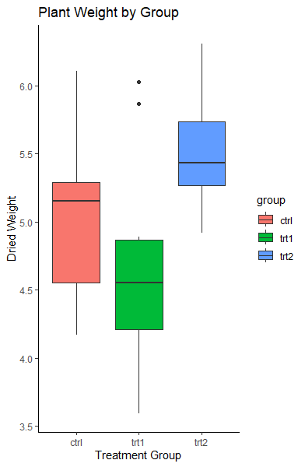
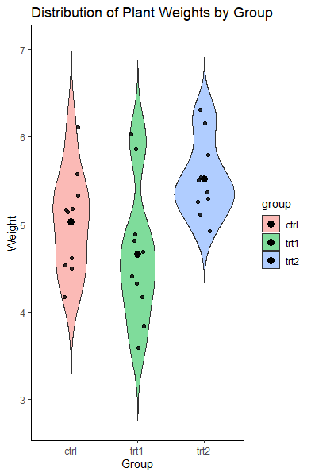

Assumption #5: Normality. The dependent variable should be approximately normally distributed for each group.
Remark: The weight is approximately normally distributed for each of the treatment groups, as assessed by Shapiro-Wilk’s test (p > .05.)
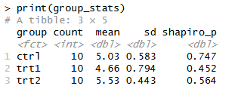
Assumption #6: Homogeneity of variances. The variance of the dependent variable should be equal in each group.
Remark: There was homogeneity of variances of the dependent variable for all treatment groups, as assessed by Levene’s test of homogeneity of variances (p > .05).
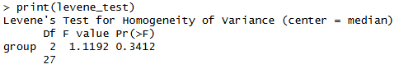
Computation
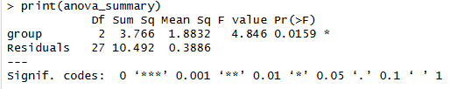
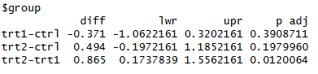

Reporting
A one-way ANOVA was conducted to compare plant weights across three equal-sized groups (n = 10). Assumptions of normality and homogeneity of variances were met. Although two mild outliers were identified in the Treatment 1 group, they were included in the analysis.
There was a statistically significant difference in weight between the groups, F (2,27) = 4.85, p = .016, η² = 0.26. Weight was highest in Treatment 2 (M = 5.53, SD = 0.44), followed by the Control group (M = 5.03, SD = 0.58), and lowest in Treatment 1 (M = 4.66, SD = 0.79).
Tukey post hoc analysis revealed that the difference between Treatment 1 and Treatment 2 was statistically significant (M_{diff}​ = 0.87, 95% CI [0.17,1.56], p = .012). However, the Control group did not differ significantly from either treatment condition.

