ACM Word Template for SIG Site
Student number

INTRODUCTION
Information Retrieval is a field that deals with the representation, storage, organization, and retrieval of information items such as documents. It focuses on developing techniques and algorithms to efficiently search and retrieve relevant information from large collections.
We have been tasked to design and code a more complex search engine then analyse, evaluate, and discuss its retrieval performance.

NLTK
This stands for the Natural Language Toolkit. It provides easy-to-use interfaces to accomplish tasks such as tokenization, stemming etc. :
Tokenization: Breaking down text into words or sentences is a common preprocessing step in NLP. NLTK provides functions for tokenizing text.
Stopwords: NLTK includes a list of common stop words that can be filtered out from text to focus on more meaningful words.
Stemming: Reducing words to their base or root form is known as stemming. It helps in reducing the dimensionality of the feature space.
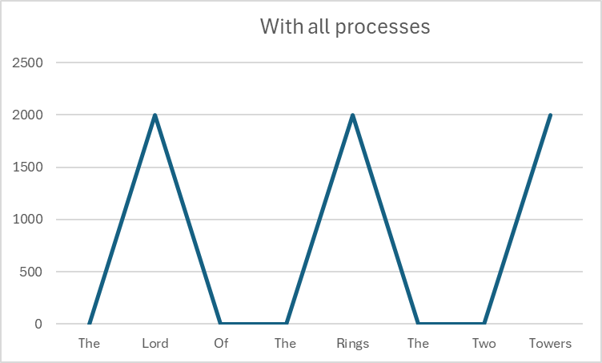
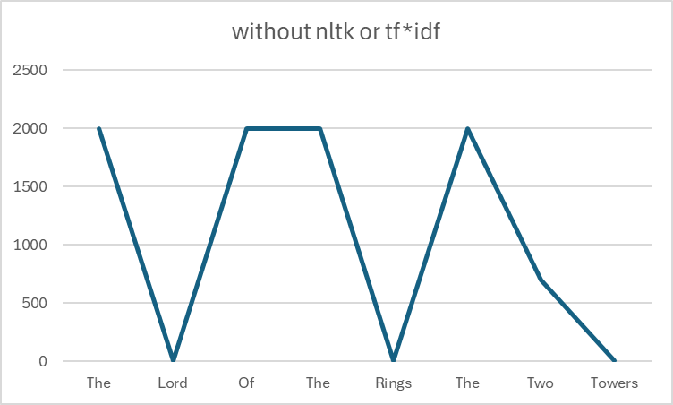
Named Entity Recognition (NER): Identifying entities (such as names, locations, organizations) in text.

TF*IDF
TF-IDF stands for Term Frequency-Inverse Document Frequency. It is a numerical statistic used in information retrieval and text mining to evaluate the importance of a word in a document relative to a collection of documents
Term Frequency (TF):
It measures how often a term appears in a document.
It is calculated as the number of times a term occurs in a document divided by the total number of terms in that document.
he TF-IDF score for a term in a document is the product of its TF and IDF scores. The idea is that a term is important to a document if it occurs frequently in that document (high TF), but also if it is rare across the entire corpus (high IDF). This helps to identify terms that are both distinctive to a document and not overly common in the entire corpus.

Cosine Similarity
Cosine similarity is a metric used to measure how similar two vectors are. In the context of natural language processing (NLP) and text analysis, these vectors often represent the numerical representations of documents or terms.
convert the text data into numerical vectors.
Each document is represented as a vector in a high-dimensional space, where each dimension corresponds to a term or feature.
Cosine similarity measures the cosine of the angle between two vectors.
Cosine similarity is widely used in information retrieval, document clustering, recommendation systems, and other tasks where measuring the similarity between documents or texts is essential.

My Code
My code is written in python and provides a basic vector space retrieval system that incorporates TF-IDF calculations and experiments with pre-processing techniques. It reads HTML documents from a specified file, extracts text and title information, and preprocesses the data using the different process that have been coded such as stemming etc..
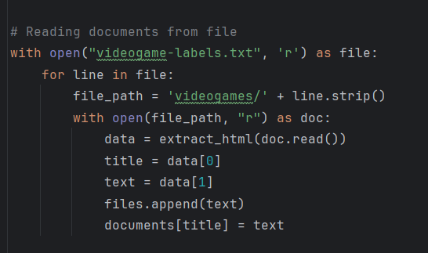

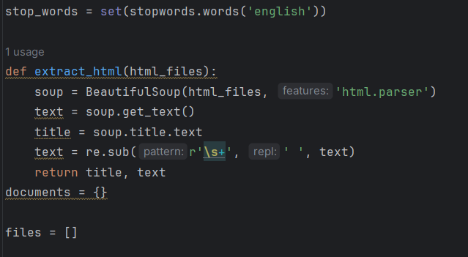

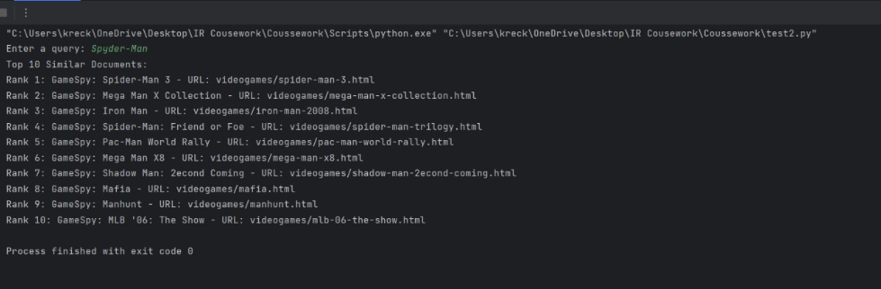
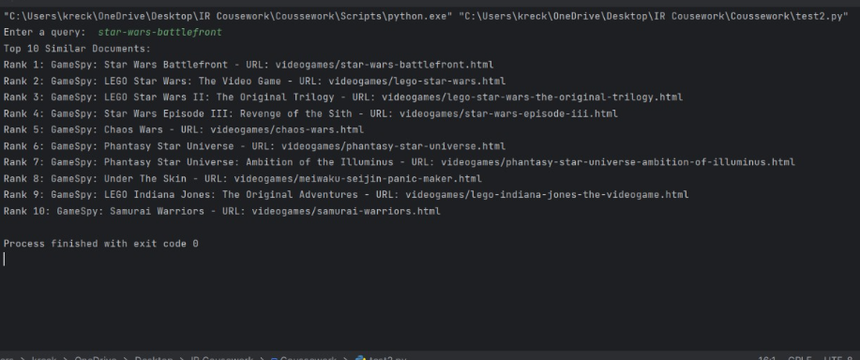
It has a command line which will ask you to input a query and will then rank the output from 1 to 10.

Conclusion
After all my experimentations I have concluded that each technique has a role to play in order to create an efficient system and that all should be utilized to produce the most efficient system
My code can provide an accurate and correct output for queries provided by the user This has shown how effective and important each technique plays for the search engine; TF*IDF was used for ranking the output, Cosine similarity for comparing documents across the database, NLTK being used to remove irrelevant. My Search engine proves to be useful however through the process of creating it I have come to see the complexities of IR. In order to improve on my work I would need a better understanding and improved knowledge on IR to create a more efficient system

REFERENCES
UEA Computer science Information Retrieval course Lecture slides

