Introduction to Observability & Dynatrace Architecture
Observability vs Monitoring
Monitoring
- Predefined metrics
- Threshold-based alerts
- Known failure detection
Examples:
- CPU > 80%
- Memory > 90%
- HTTP 500 errors
Observability
- Understand unknown failures
- Explore system behavior
- Deep visibility into:
  - Metrics
  - Logs
  - Traces
Three Pillars:
- Metrics
- Logs
- Distributed Traces
Architecture Visualization
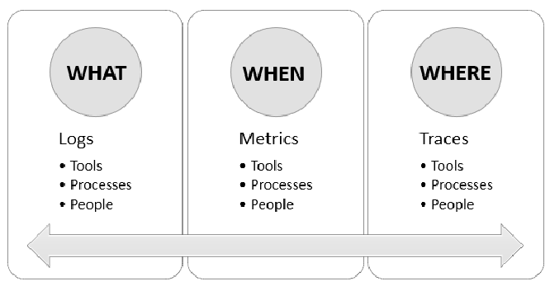
APM Fundamentals
APM = Application Performance Monitoring
What APM Monitors
- Request response time
- Error rate
- Throughput
- Service dependencies
- Database calls
- External API calls
APM Metrics
Metric | Meaning
Response Time | How long request takes
Throughput | Requests per second
Error Rate | % failed requests
Apdex | User satisfaction score

APM Flow
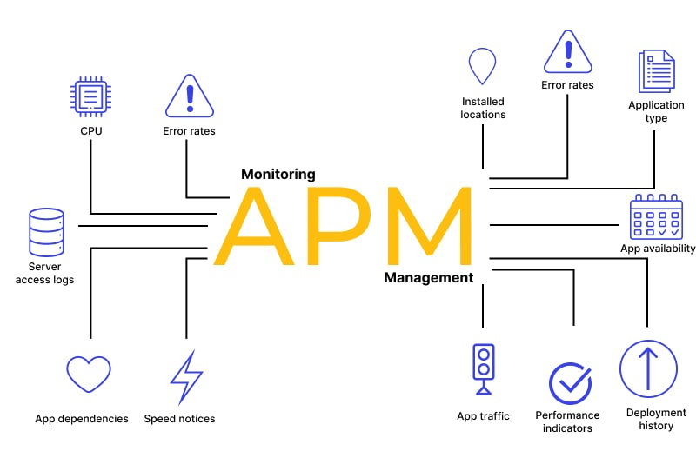
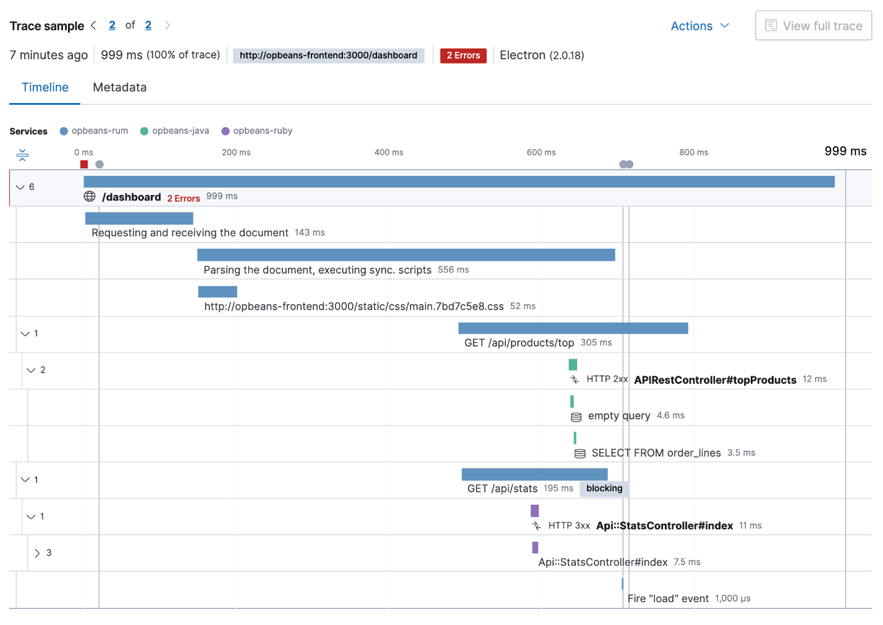Dynatrace Architecture
What is Dynatrace?

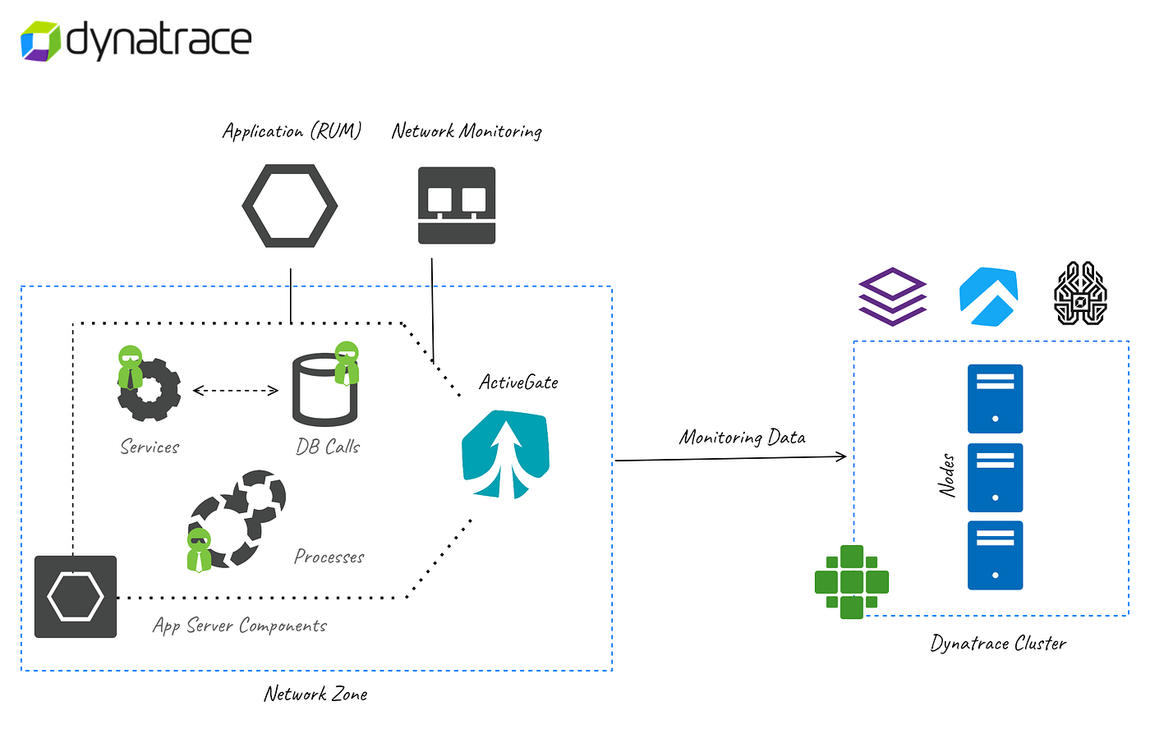
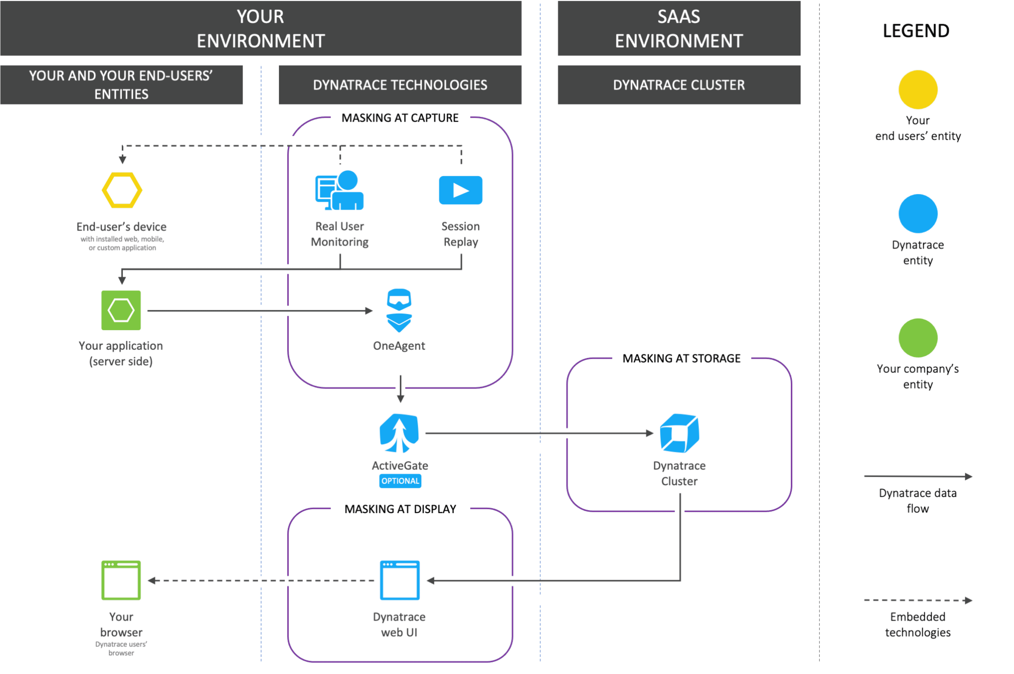

Dynatrace is an AI-powered observability platform that provides:
- Full-stack monitoring
- Infrastructure monitoring
- Application monitoring
- Log analytics
- Digital experience monitoring
Core Components
- OneAgent
- Dynatrace Cluster (SaaS or Managed)
- ActiveGate
- Davis AI Engine
- Smartscape Topology
Architecture Flow
Application → OneAgent → ActiveGate → Dynatrace Cluster → Davis AI → UI
Key Concept: Automatic Instrumentation
Unlike traditional APM:
- No code changes
- No manual tagging
- Automatic dependency mapping
SaaS vs Managed Deployment
SaaS Deployment
- Hosted by Dynatrace
- Quick setup
- No infra maintenance
- Internet required
Best for:
- Cloud-native apps
- Quick PoC
Managed Deployment
- Hosted in customer data center
- Full control
- Requires cluster setup
- Suitable for regulated industries
Comparison Table
Feature | SaaS | Managed
Hosting | Dynatrace Cloud | Customer
Maintenance | Dynatrace | Customer
Setup Time | Minutes | Hours/Days
Compliance Control | Medium | High

Architecture Comparison Diagram
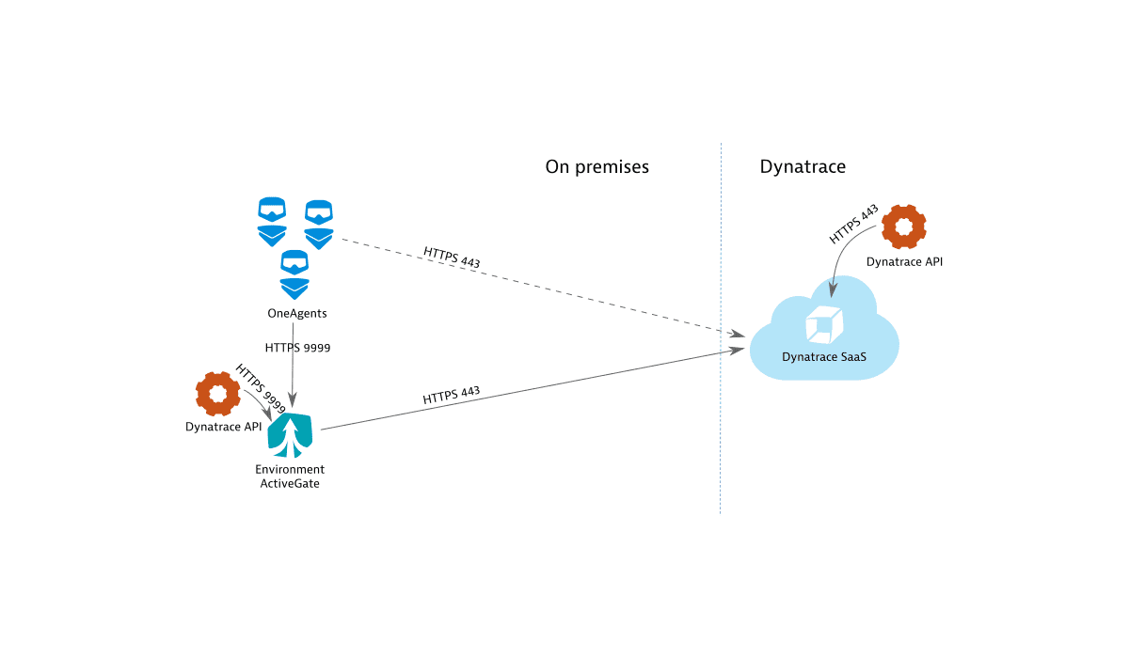
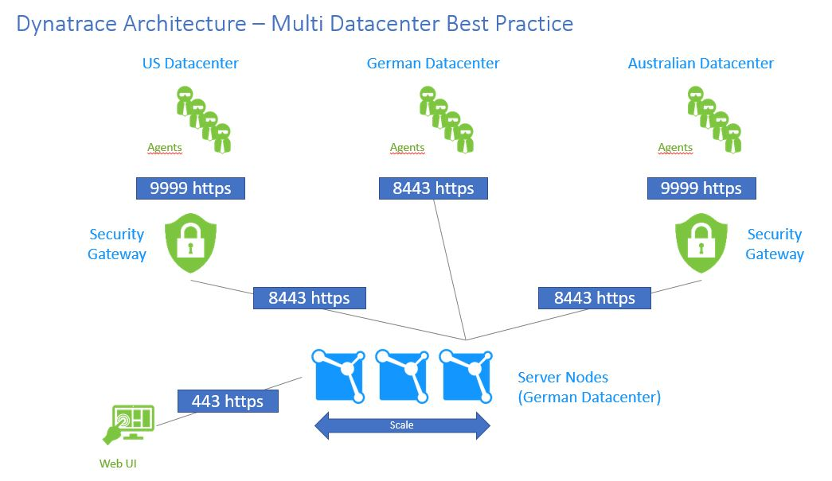
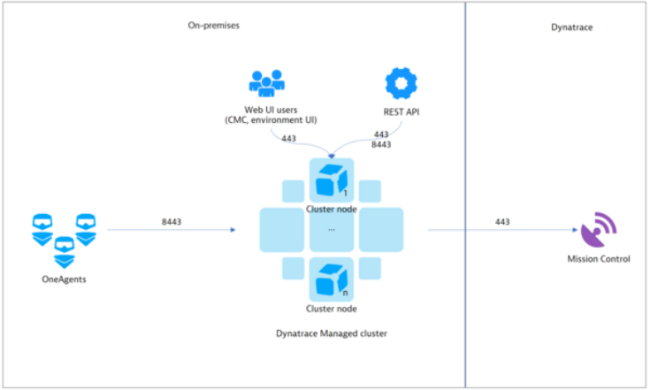
OneAgent Deep Dive
What is OneAgent?
- Lightweight agent
- Auto-discovers:
  - Services
  - Processes
  - Containers
  - Kubernetes
  - Databases
Installation Types
- Linux
- Windows
- Kubernetes operator
- Cloud-native integration
- Azure / AWS
OneAgent Capabilities
- Auto instrumentation
- Distributed tracing
- Infrastructure metrics
- Log ingestion
- Code-level visibility
Smartscape & Topology
Smartscape = Real-time dependency visualization
Layers:
- Applications
- Services
- Processes
- Hosts
- Databases
Visualization
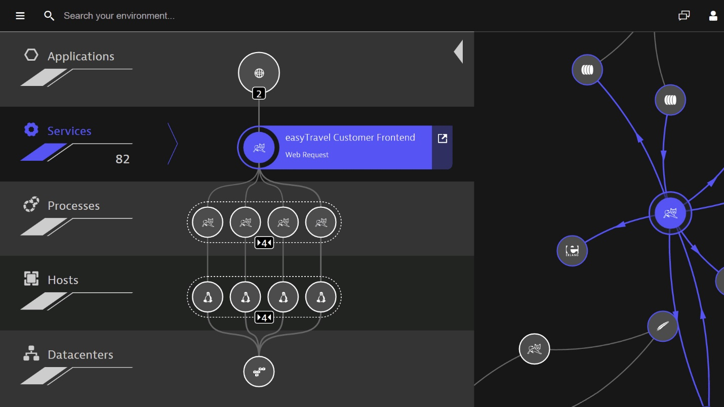
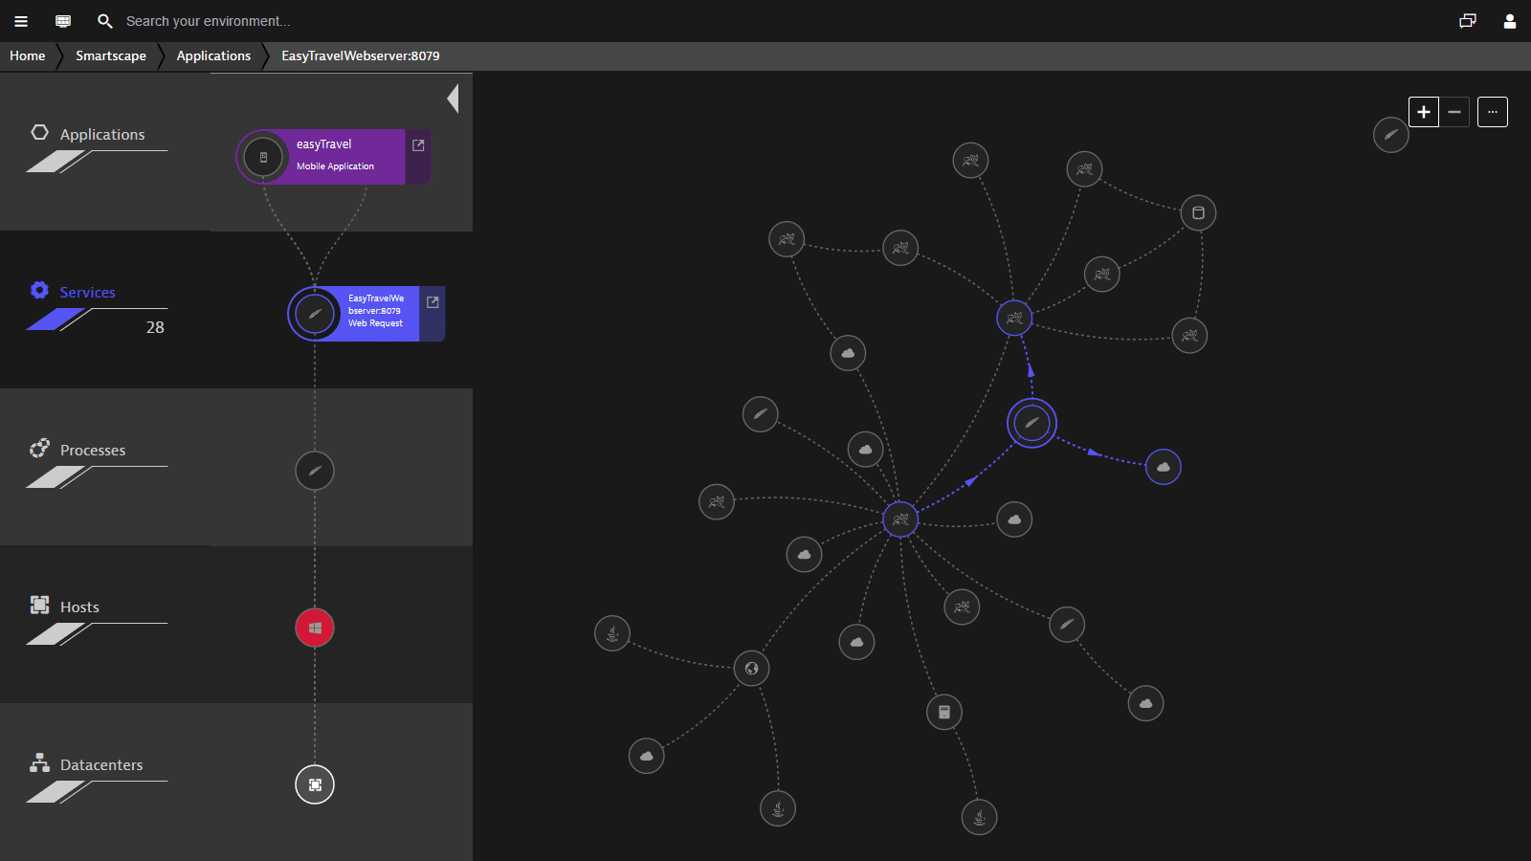
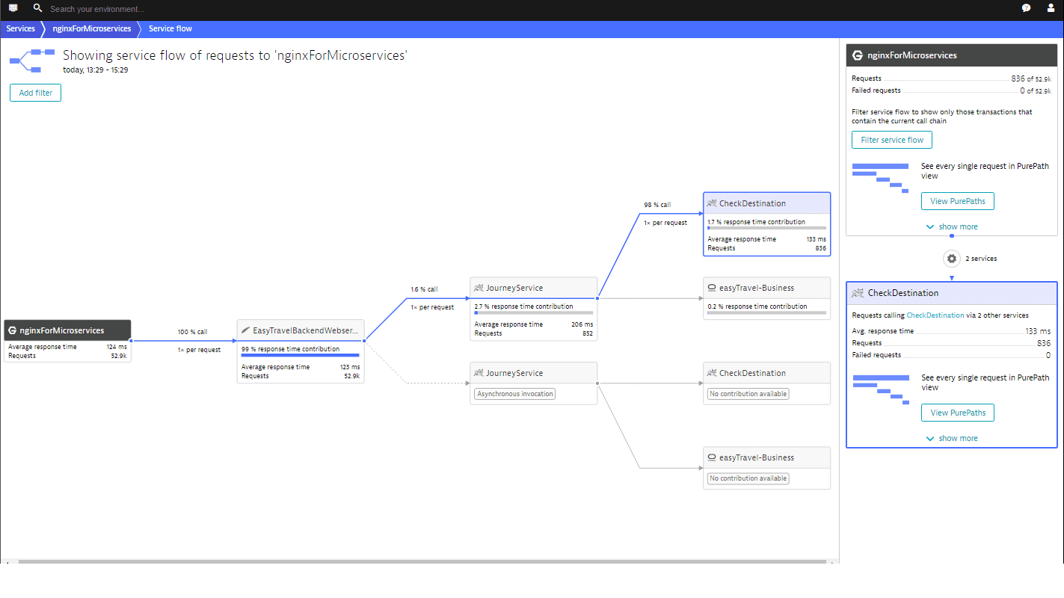
Example:
DB issue → Shows impacted services → Shows impacted applications → Shows impacted users
Observability vs Monitoring
“Monitoring means checking predefined things.”
Example:
- CPU usage > 80%
- Memory usage > 90%
- Disk full
- Service down
Explain Observability
“Observability means understanding what is happening inside the system without guessing.”
Three Pillars of Observability
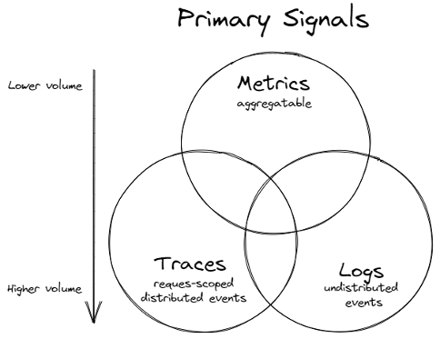

- Metrics
Numbers like CPU, memory, response time
- Logs
Error messages written by application
- Traces
Request flow between microservices
“If one request goes from API → Service → DB → External API, tracing shows full journey.”
APM Fundamentals
What is APM?
APM = Application Performance Monitoring
It monitors:
- Application performance
- User requests
- Errors
- Slow transactions
Important APM Metrics
Metric | Meaning
Response Time | How long request takes
Throughput | Requests per second
Error Rate | % failed requests
Apdex | User satisfaction score
“If user response is fast → satisfied
If slow → frustrated”

How APM Works
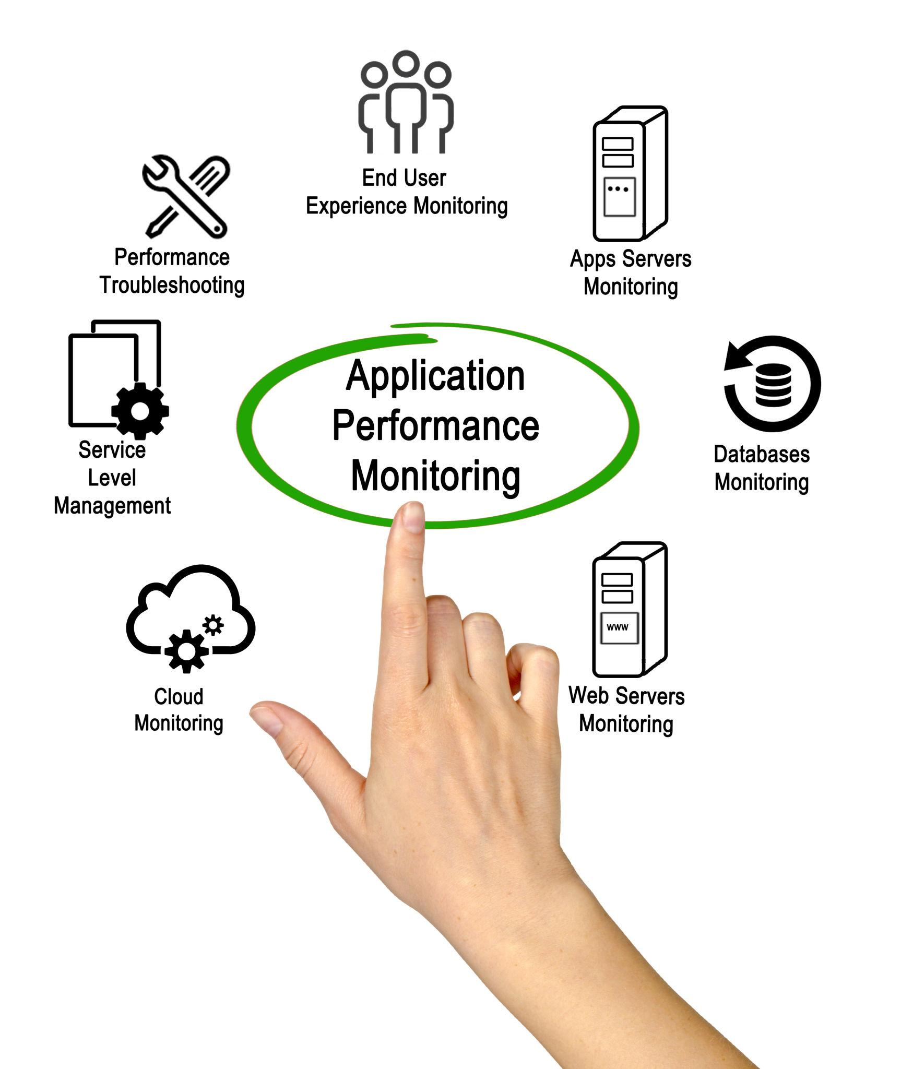
Real-Life Example
“Suppose payment is failing in production.”
APM shows:
- Payment API response time
- Database latency
- External bank API call delay
- Exact method where time is spent
Without APM:
You check logs manually for hours.
With APM:
You know in 2 minutes.
PART 3 – Dynatrace Architecture
What is Dynatrace?

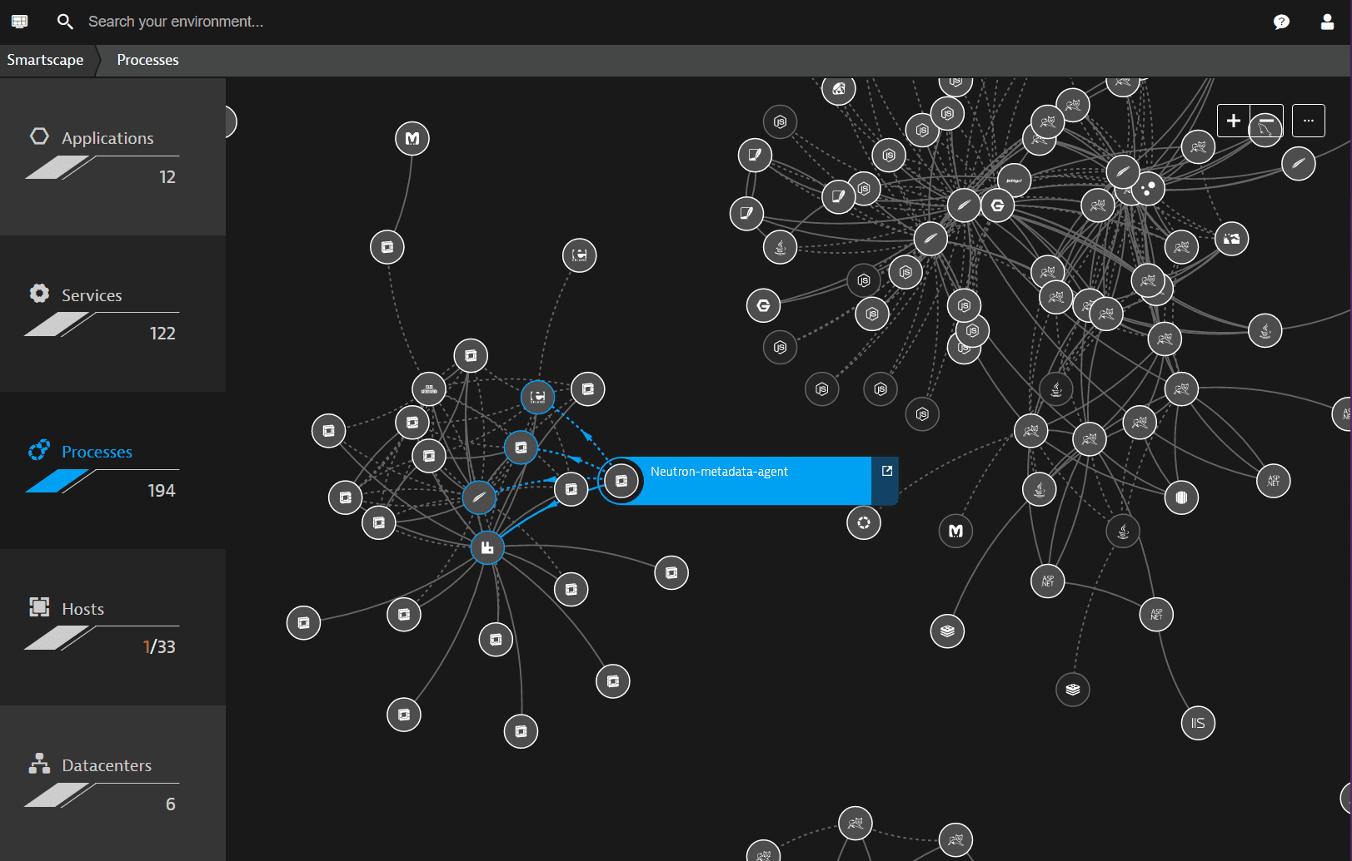
Dynatrace is an AI-powered observability platform.
It provides:
- Infrastructure monitoring
- Application monitoring
- Log monitoring
- Kubernetes monitoring
- Cloud monitoring
- AI-based root cause analysis
Dynatrace Core Components
- OneAgent
- ActiveGate
- Dynatrace Cluster
- Davis AI
- Smartscape
Architecture
Flow:
Application → OneAgent → ActiveGate → Dynatrace → Davis AI → Dashboard
“OneAgent collects data.
ActiveGate transfers data.
Dynatrace stores and analyzes data.
Davis AI finds root cause automatically.”
SaaS vs Managed
SaaS Deployment
Hosted by Dynatrace company
You just sign up and use it
Good for:
- Cloud apps
- Quick setup
- No maintenance
Managed Deployment
Installed in your data center
You manage cluster
Used in:
- Banks
- Government
- Highly secure environments
Explain Comparison Clearly
Feature | SaaS | Managed
Hosting | Dynatrace cloud | Your servers
Maintenance | Dynatrace | You
Setup | Fast | Complex
Security Control | Medium | High

Visual Comparison
OneAgent
What is OneAgent?
Agent installed on:
- Linux
- Windows
- Kubernetes
- Cloud
It automatically:
- Discovers services
- Captures traces
- Captures metrics
- Captures logs
“No code change required.”
Why OneAgent is Powerful
- Auto-instrumentation
- Auto dependency mapping
- Auto service detection
- Real-time monitoring
Explain example:
If .NET app runs:
OneAgent automatically detects:
- IIS
- SQL calls
- External HTTP calls
- Exceptions
Smartscape & Topology
Smartscape shows:
- Application
- Services
- Processes
- Hosts
- Databases
All connected automatically.
Show Visualization
“If database fails, Smartscape shows which services and users are impacted.”
Monitoring → Detect problem
Observability → Understand problem
APM → Monitor application performance
Dynatrace → AI-based observability platform
OneAgent → Data collector
Smartscape → Dependency map

