LAB: Configure Deep Monitoring + IIS + Log Monitoring on Windows
This lab assumes:
- OneAgent is installed
- Windows Server is visible in Dynatrace
- You want to validate real application monitoring
Architecture Flow
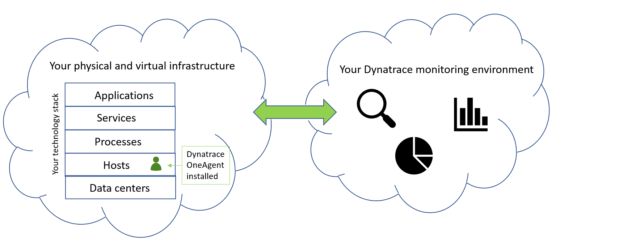
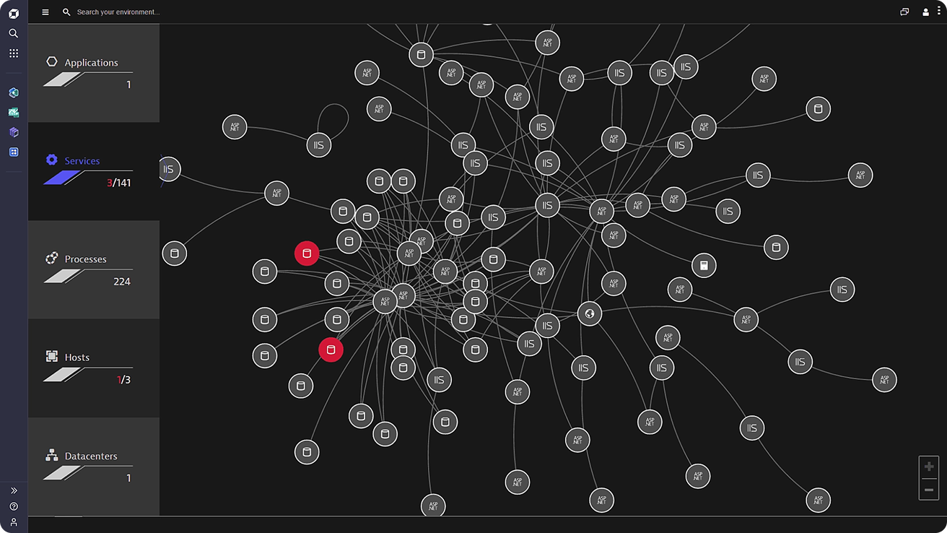
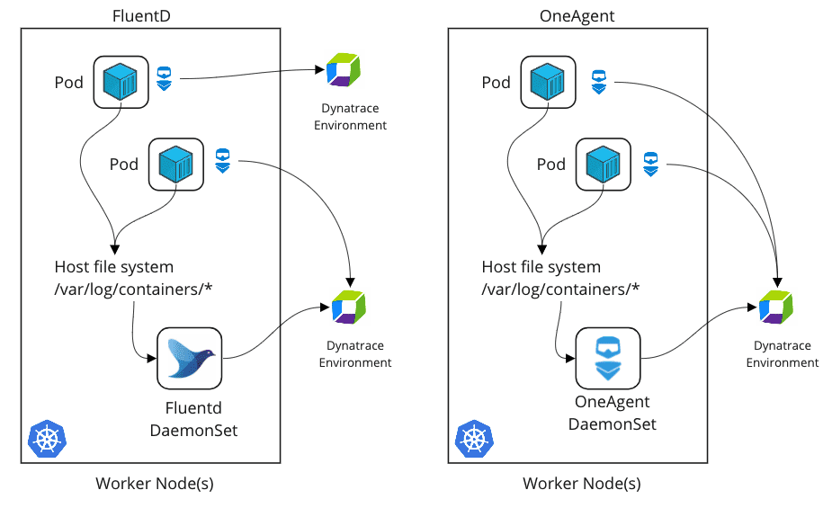
Step 1 – Verify Full Stack Monitoring
Open PowerShell (Admin):
Go to:
C:\Program Files\Dynatrace\OneAgent\agent\tools
Run:
.\oneagentctl.exe --get-infra-only
If output:
Infrastructure-only mode: true
Enable full stack:
.\oneagentctl.exe --set-infra-only false
Restart-Service ruxitagentservice
Step 2 – Install & Configure IIS
If IIS not installed:
Install-WindowsFeature -name Web-Server -IncludeManagementTools
Verify IIS running:
iisreset
Open browser:
http://localhost
You should see IIS default page.
Step 3 – Generate Application Traffic
Open browser and refresh page multiple times.
OR use PowerShell:
for ($i=1; $i -le 20; $i++) { Invoke-WebRequest http://localhost }
This generates monitoring data.
Step 4 – Verify IIS Service in Dynatrace
Go to:
Applications & Microservices → Services
You should see:
- IIS Service
- ASP.NET Service (if app exists)
Click service → Check:
- Response Time
- Failure Rate
- Throughput
Step 5 – Validate PurePath Traces
Go to:
Services → Requests
Click a request.
You should see:
- Method execution breakdown
- Database calls (if present)
- External dependencies
- CPU time vs Wait time
This confirms deep monitoring is active.
Step 6 – Enable Log Monitoring
In Dynatrace UI:
Go to:
Settings → Log Monitoring → Log Sources
Ensure:
- Windows Event Logs enabled
- IIS log folder detected
Default IIS log path:
C:\inetpub\logs\LogFiles
Now generate traffic again.
Then go to:
Observe & Explore → Logs
Search:
status:500
Step 7 – Simulate Failure
To simulate app error:
Stop IIS:
Stop-Service W3SVC
Wait 1 minute.
Go to Dynatrace → Problems
Davis AI should detect:
- IIS service unavailable
- Root cause = IIS stopped
Start IIS again:
Start-Service W3SVC
Observe problem auto-resolution.
Step 8 – Create Custom CPU Alert
Go to:
Settings → Anomaly Detection → Host → Custom thresholds
Create rule:
CPU usage > 80% for 5 minutes.
Now simulate CPU spike:
while ($true) { }
(Stop manually after 1–2 minutes using Ctrl+C)
Observe:
Dynatrace should detect high CPU.
Step 9 – Create Dashboard
Go to:
Dashboards → Create Dashboard
Add tiles:
- Host CPU
- IIS response time
- Failure rate
- Request count
- Log errors
Save dashboard as:
Windows Monitoring Lab
Step 10 – Verify Smartscape Topology
Go to:
Observe & Explore → Smartscape
You should see:
Host → IIS Process → Service → Requests
Click each layer and observe dependencies.

