LAB: Install Dynatrace OneAgent on Windows Server
Architecture Overview
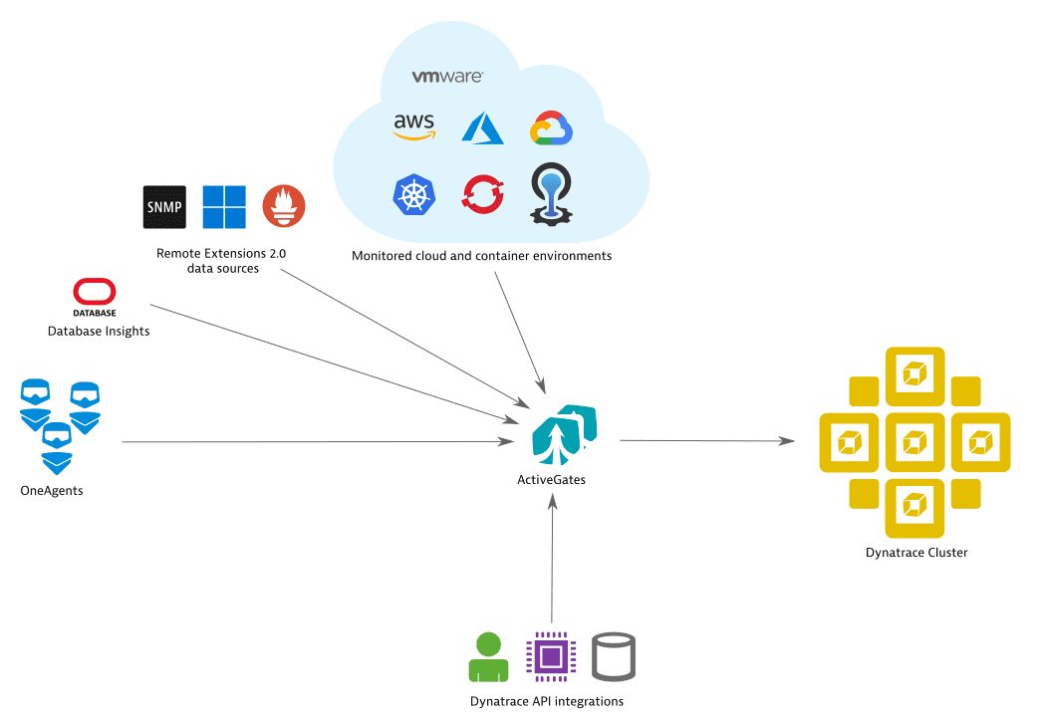
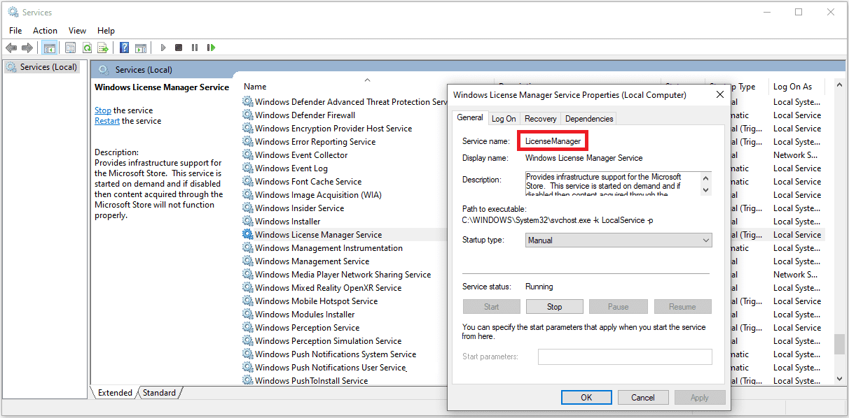
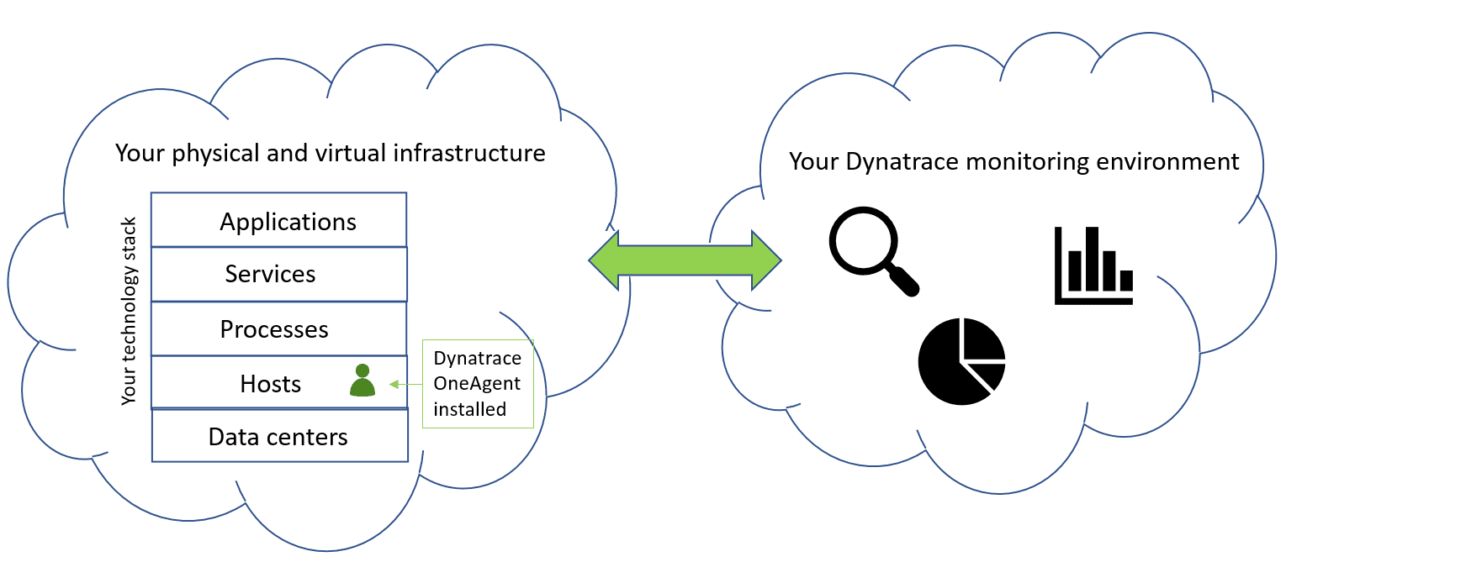
Step 1: Login to Dynatrace
Login to your Dynatrace environment.
Example:
https://abc123.live.dynatrace.com
(If using Managed cluster, login to your cluster URL)

Step 2: Download OneAgent for Windows
- Go to Deploy Dynatrace
- Select Start installation
- Choose:
  - Windows
- Select architecture:
  - 64-bit (recommended)
You will see a command like:
Dynatrace-OneAgent-Windows.exe APP_LOG_CONTENT_ACCESS=1
Download the installer.

Step 3: Install OneAgent (GUI Method)
Option A: Double-click installer
- Run installer as Administrator
- Accept license
- Select install path (default recommended)
- Enable:
  - Deep Monitoring
  - Log Monitoring
- Click Install
Installation takes 2–3 minutes.

Step 4: Install via Command Line (Enterprise Method)
Open PowerShell as Administrator:
cd C:\Users\Administrator\Downloads

.\Dynatrace-OneAgent-Windows.exe APP_LOG_CONTENT_ACCESS=1 /quiet
Silent install for automation.

Step 5: Verify Windows Service
Open Services (services.msc)
Look for:
Dynatrace OneAgent Service
Status should be:
Running
You can verify via PowerShell:
Get-Service *dynatrace*

Step 6: Verify in Dynatrace UI
Go to:
Hosts & Infrastructure → Hosts
You should see:
- Windows host auto-detected
- CPU/Memory metrics
- Network usage

Step 7: Enable IIS Monitoring (If Web App Exists)
If IIS is installed:
OneAgent auto-detects:
- Application pools
- Websites
- ASP.NET apps
To verify:
Services → Your IIS Service
Check:
- Response time
- Failure rate
- Throughput

Step 8: Validate PurePath Distributed Tracing
- Open your web app in browser
- Generate traffic
- Go to:
- Services → Requests
- Click on a request
- View PurePath trace
You will see:
- Method execution time
- Database calls
- External API calls

Step 9: Validate Log Monitoring
If logs exist:
Enable:
Settings → Log Monitoring → Log Sources
Check:
- Windows Event Logs
- Application logs
Search logs:
Logs & Events → Logs

