E-Commerce Application Performance Issue – Production Simulation
Scenario Overview
You are the Site Reliability Engineer (SRE) for an online retail company called ShopNow.
The application stack:
- Linux VM (Ubuntu)
- Apache Web Server
- Python Backend API
- SQLite Database (local)
- Monitored using Dynatrace OneAgent
Problem Statement:
Customers report slow checkout response during peak traffic.
Management wants root cause within 1 hour.
You must:
- Deploy app
- Monitor using Dynatrace
- Simulate traffic
- Introduce performance bottlenecks
- Identify root cause using Host, Process & Service monitoring

Architecture of Case Study
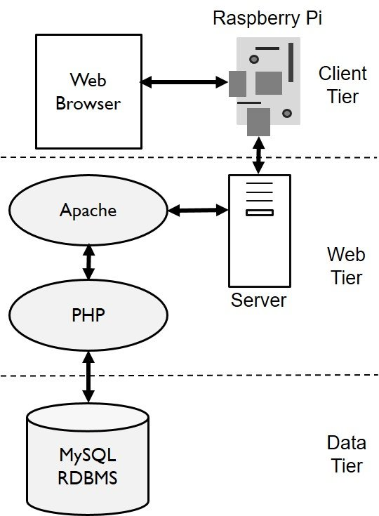
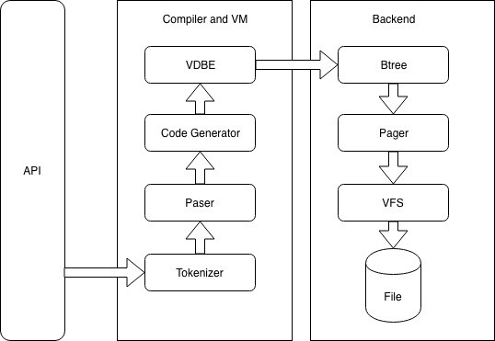
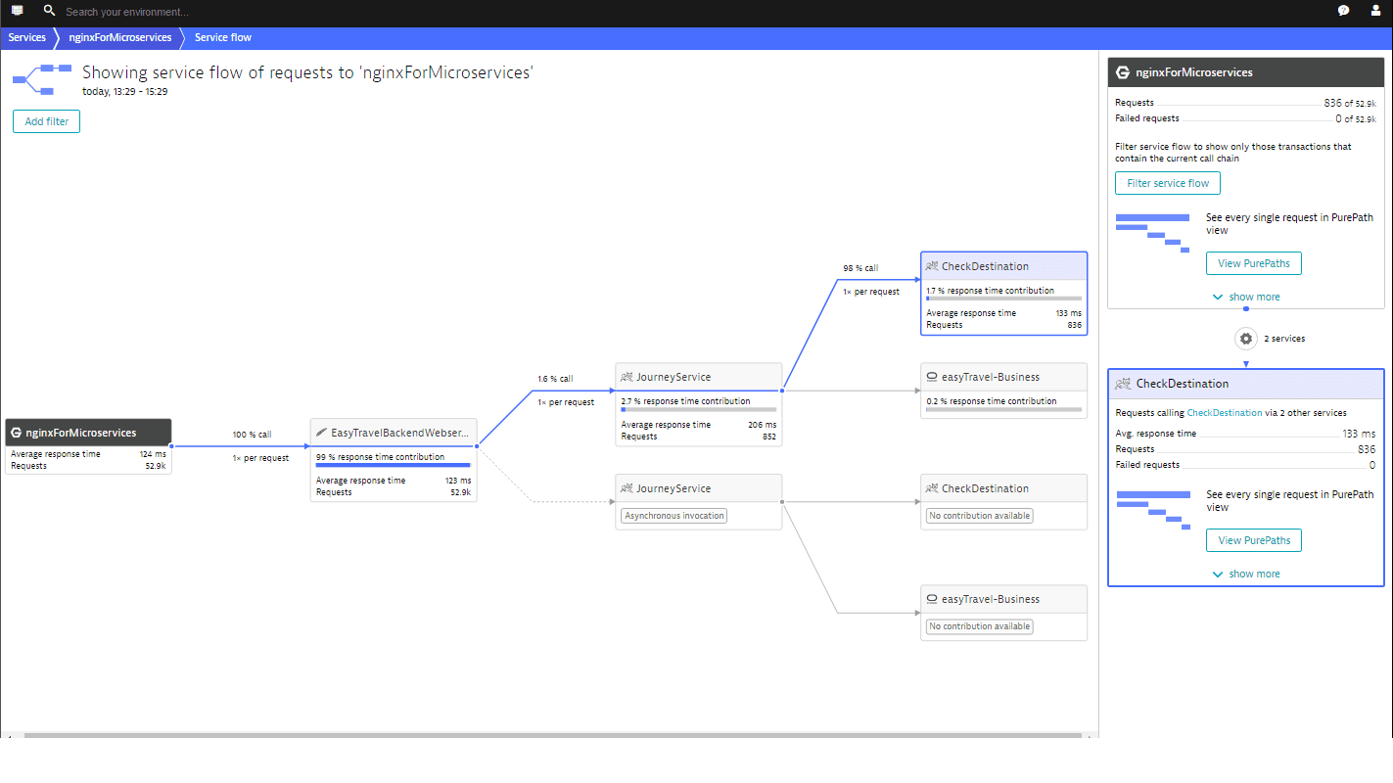
Architecture Flow:
User → Apache → Python API → SQLite DB → Response
Part 1 – Environment Setup
Step 1 – Install Required Packages
sudo apt update
sudo apt install apache2 python3 python3-pip sqlite3 -y
Install Flask:
pip3 install flask
Step 2 – Create Backend Application
Create file:
nano app.py
Paste:
from flask import Flask
import sqlite3
import time

app = Flask(__name__)

@app.route("/")
def home():
conn = sqlite3.connect("shop.db")
cursor = conn.cursor()
cursor.execute("SELECT COUNT(*) FROM products")
count = cursor.fetchone()
conn.close()
return f"Total Products: {count}"

@app.route("/checkout")
def checkout():
time.sleep(2)
return "Checkout Complete"

if __name__ == "__main__":
app.run(host="0.0.0.0", port=5000)

Step 3 – Create Database
sqlite3 shop.db
Inside SQLite:
CREATE TABLE products(id INTEGER PRIMARY KEY, name TEXT);
INSERT INTO products(name) VALUES ('Item1'), ('Item2'), ('Item3');
.exit

Step 4 – Run Application
python3 app.py
Access:
http://<VM-IP>:5000

Part 2 – Install OneAgent & Enable Monitoring
Install:
Deploy Dynatrace → Linux → Copy install command.
Verify:
sudo systemctl status oneagent
Wait 2–3 minutes.
Check:
- Host detected
- Python process detected
- Service auto-created
Navigate:
Services → Observe Python service

Part 3 – Traffic Simulation
Simulate load:
for i in {1..500}; do curl http://localhost:5000/checkout; done
Observe in Dynatrace:
- Response time
- Throughput
- CPU usage

Part 4 – Introduce Performance Problems (Real Incident Simulation)

Scenario 1 – CPU Bottleneck
Run:
sudo apt install stress
stress --cpu 4 --timeout 180
Symptoms:
- High CPU
- Slow response
- Increased response time in Dynatrace
must check:
Host → CPU saturation
Service → Response time
Root Cause:
CPU contention

Scenario 2 – Database Slowdown
Modify checkout API:
Replace:
time.sleep(2)
With:
time.sleep(5)
Restart app.
Simulate traffic again.
Symptoms:
- Response time spike
- Service degradation
- No CPU spike
Root Cause:
Application delay (backend logic)

Scenario 3 – Disk IO Bottleneck
Run:
dd if=/dev/zero of=bigfile bs=1M count=3000
Symptoms:
- High disk IO
- Increased response time
- IO wait increase
analyze:
Host → Disks → Queue length
Root Cause:
Disk saturation

Part 5 – Root Cause Analysis Using Dynatrace
- Open Smartscape
- Identify affected service
- Check service response time
- Check host CPU/memory
- Check process-level metrics
- Identify bottleneck

Smartscape Analysis
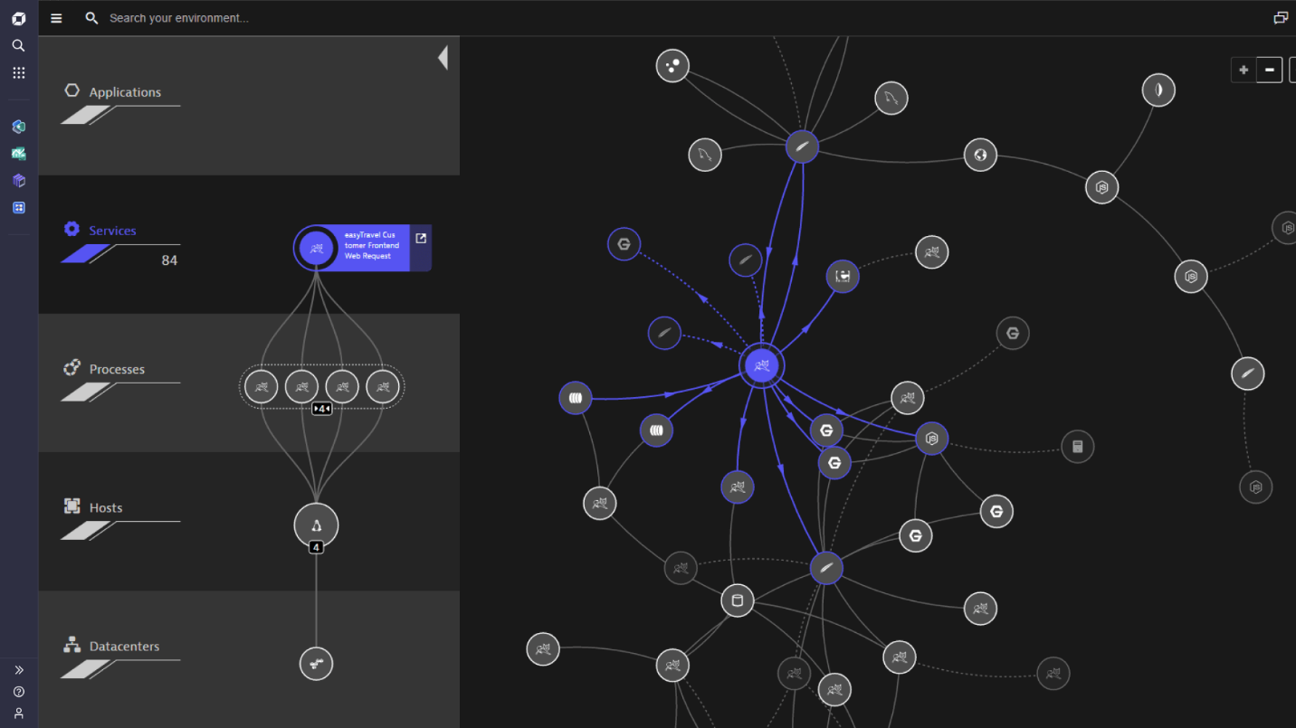
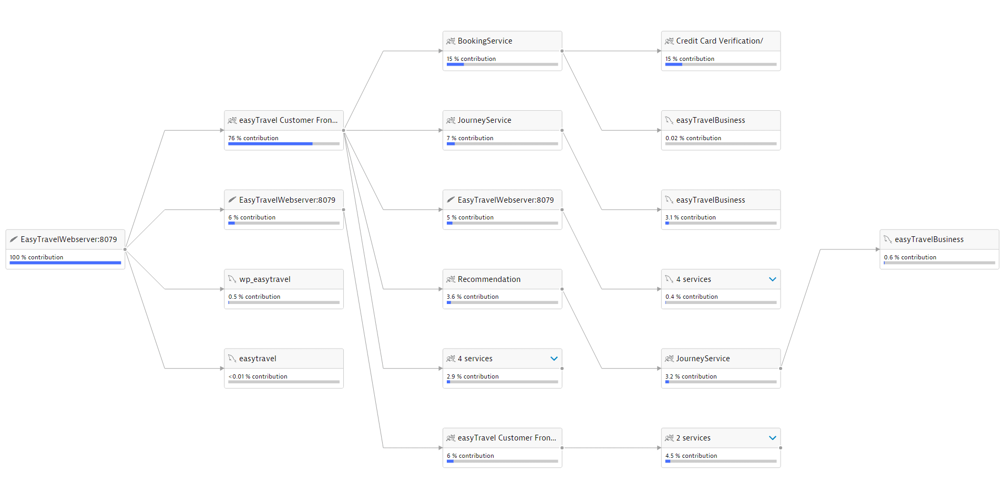
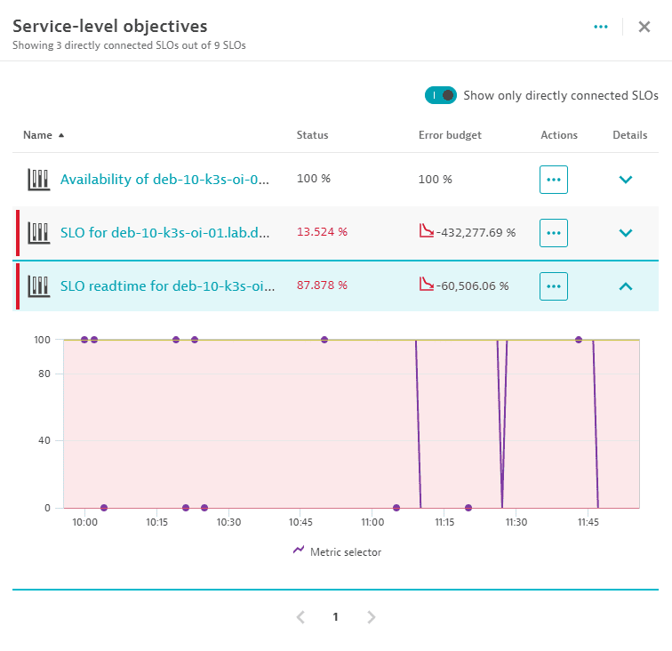
must answer:
- Is issue infrastructure-level?
- Is issue code-level?
- Is issue disk-related?

Part 6 – Create Alert (Optional Advanced)
Create custom metric event:
Condition:
CPU > 85% for 5 minutes
Trigger:
Problem event
Explain:
This is how production alerting works.

Final Deliverables
Each student must submit:
- Screenshot of Host overview
- Screenshot of Service response spike
- Root cause explanation (1 page)
- Recommendation to fix
Real-World Learning Outcomes
- Full-stack monitoring on Linux
- How application issues reflect in host metrics
- Difference between CPU vs code delay vs IO bottleneck
- How Dynatrace automatically detects service topology
- How to perform production-grade RCA
Discussion Questions
- How would this scale in Kubernetes?
- What if DB was external?
- How would ActiveGate help?
- What if network latency was high?
- How does AI engine correlate problem?

