LAB 1 – Deploy Manufacturing Production API
Objective
Deploy a simulated Production Order API.

Step 1 – Install Dependencies
sudo apt update
sudo apt install python3 python3-pip -y
pip3 install flask

Step 2 – Create Application
Create file:
nano manufacturing_app.py
Paste:
from flask import Flask, jsonify
import sqlite3
import time
import random

app = Flask(__name__)

@app.route("/")
def home():
return "Smart Manufacturing Production API"

@app.route("/createProductionOrder")
def create_production_order():

# Simulate raw material check delay
time.sleep(0.5)

# Simulate machine allocation logic
processing_time = random.uniform(0.3, 0.8)
time.sleep(processing_time)

conn = sqlite3.connect('manufacturing.db')
cursor = conn.cursor()

cursor.execute("""
CREATE TABLE IF NOT EXISTS production_orders (
id INTEGER PRIMARY KEY,
product TEXT,
quantity INTEGER
)
""")

cursor.execute("INSERT INTO production_orders (product, quantity) VALUES ('EnginePart', 100)")

conn.commit()
conn.close()

return jsonify({
"status": "Production Order Created",
"processing_delay": processing_time
})

if __name__ == "__main__":
app.run(host="0.0.0.0", port=6000)

Step 3 – Run Application
python3 manufacturing_app.py
Test:
curl http://localhost:6000
curl http://localhost:6000/createProductionOrder

LAB 2 – Observe Automatic Service Detection
Step 1 – Wait 1–2 Minutes
Dynatrace auto-detects new service.
Go to:
Applications & Microservices → Services
Expected:
Service running on port 6000 detected automatically.

Step 2 – Open Service Flow
Observe:
- API service
- Database dependency
- Host relationship
Deliverable:
Screenshot of service flow diagram.

LAB 3 – Generate Manufacturing Load (30 Minutes)
Simulate production load:
for i in {1..300}; do curl http://localhost:6000/createProductionOrder; done

Observe in Dynatrace:
Service → Overview
Check:
- Throughput
- Response time
- Failure rate
Discussion:
If production line increases orders, what happens to performance?

LAB 4 – PurePath Transaction Analysis
Step 1 – Open Requests
Service → View Requests
Sort by Response Time.
Select a slow request.

Step 2 – Analyze PurePath
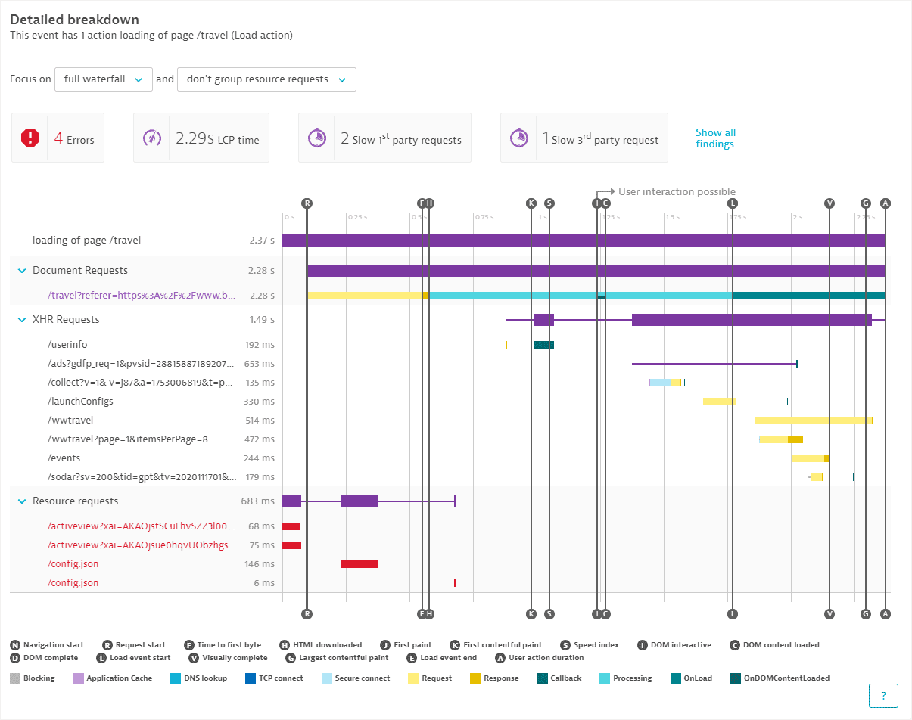
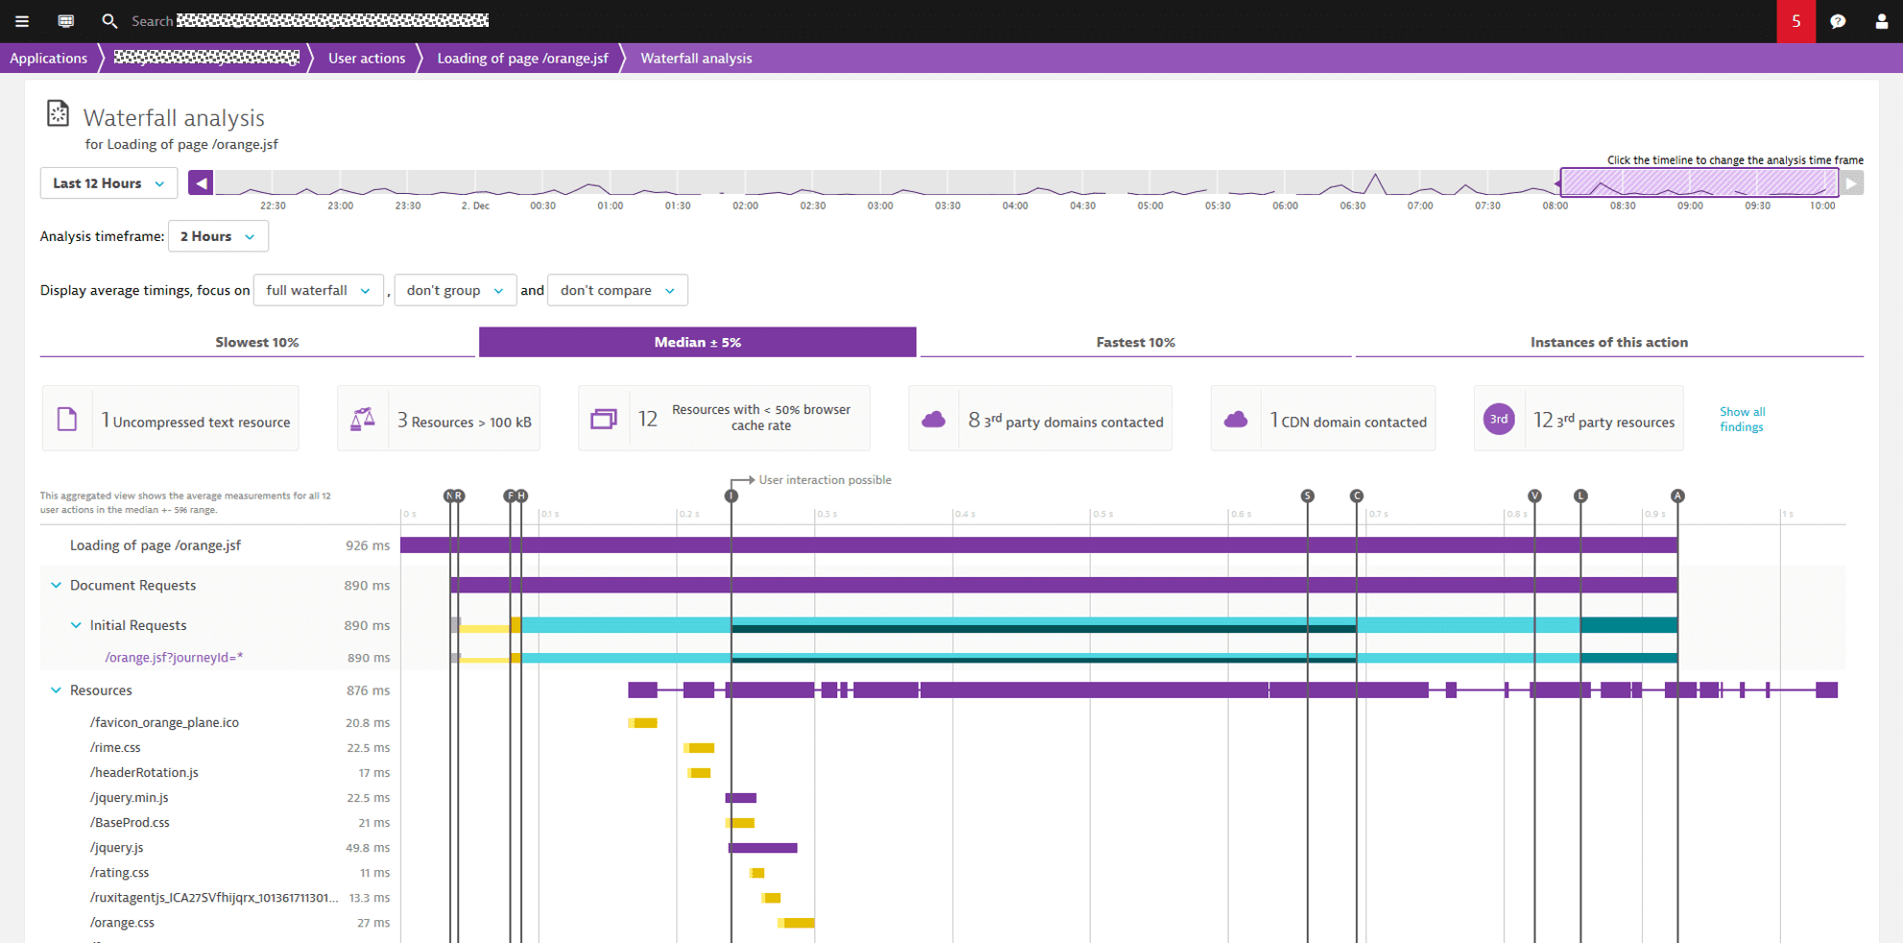
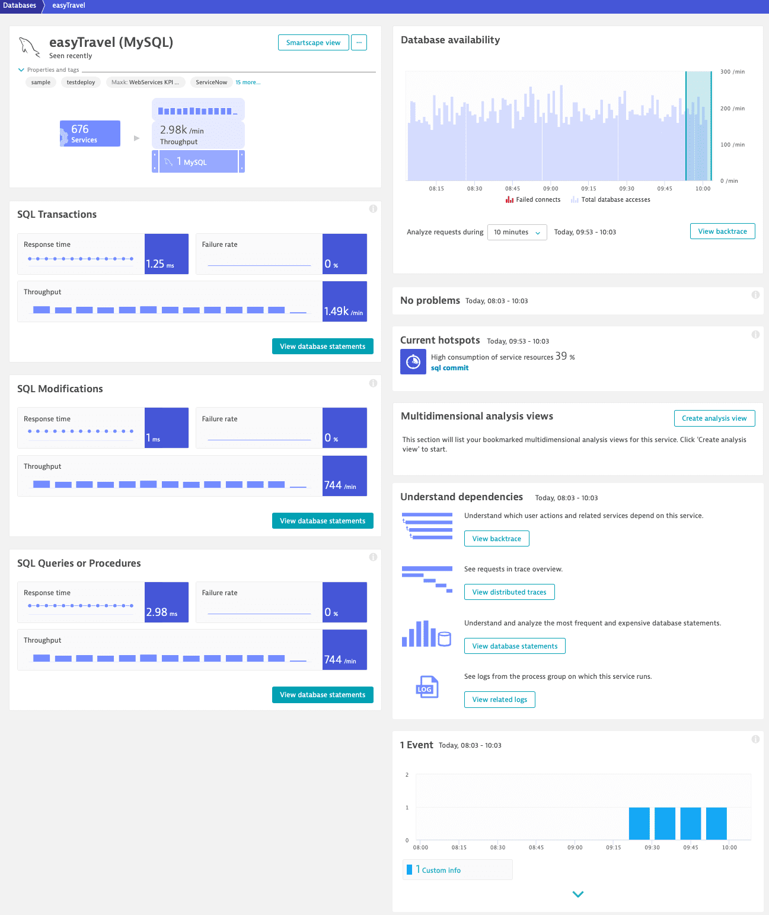Observe:
- Raw material delay (sleep 0.5 sec)
- Machine allocation delay
- SQL insert time
- Total request time
Question:
Which layer consumes most time?

LAB 5 – Code-Level Diagnostics
Step 1 – Drill into Method Calls
Inside PurePath:
Click:
create_production_order()
Observe:
- time.sleep(0.5)
- time.sleep(random)
- SQLite execution

Step 2 – SQL Visibility
Click Database node.
Observe:
- SQL statement
- Execution duration
Explain:
Dynatrace captures SQL automatically without code change.

LAB 6 – Simulate Manufacturing Performance Issue
Objective
Create real performance bottleneck.

Step 1 – Modify Application
Change:
time.sleep(0.5)
To:
time.sleep(2)
Also change:
processing_time = random.uniform(0.3, 0.8)
To:
processing_time = random.uniform(1.5, 2.5)
Restart app.

Step 2 – Generate Load Again
for i in {1..200}; do curl http://localhost:6000/createProductionOrder; done

Step 3 – Observe in Dynatrace
Check:
- Response time spike
- Service health degradation
- Problem detection (if AI enabled)

Step 4 – Identify Root Cause
Open slow request → PurePath
You should see:
Major time spent in:
- Raw material validation delay
- Machine allocation logic
Conclusion:
Application logic bottleneck.

