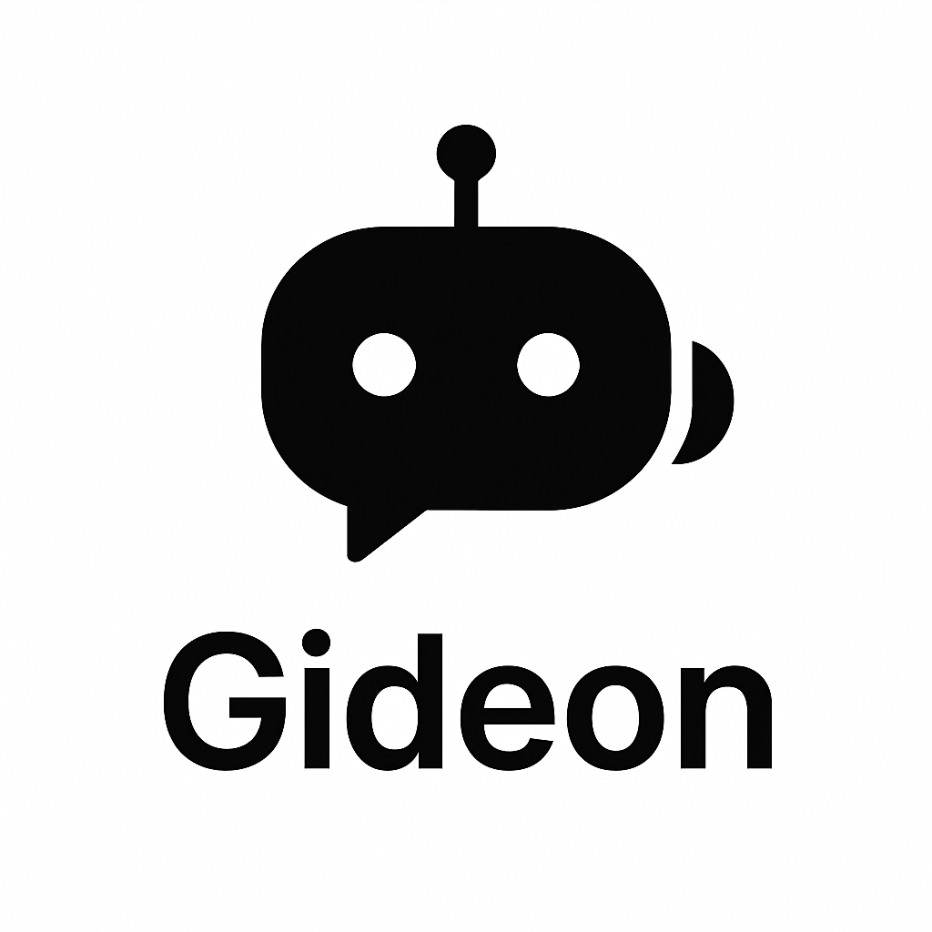**Chat bot Assistant**

User Guide

# **How to Use Gideon**

1. **Start the Chatbot**
   * Open the link provided to access the Gideon chatbot
   * You’ll be greeted with a welcome message and a menu of options
2. **Choose What You Want to Do**
   * 📘 Learn Something → explore AI topics
   * 📝 Take a Quiz → test your knowledge
   * ❓ Ask a Question → ask anything about AI or ML
3. **Learning Section**
   * Click on a topic to receive a short lesson
   * Topics include NLP, Neural Networks, Ethics, and more
4. **Quiz Section**
   * Answer each multiple-choice question
   * Get instant feedback with emojis 😄 / 😞
5. **Ask a Question**
   * Just type your question (e.g., "What is NLP?")
   * Gideon will provide a concise, accurate response
6. **Unsupported Questions**
   * If you ask something unrelated, you’ll get an error message like:

"🤖 Oops! Gideon’s trained only on AI stuff. Please ask something related to AI or Machine Learning."

1. **Theme & Interaction**
   * The UI follows a dark theme
   * Interaction is clean, mobile-responsive, and supports multimedia