a. Allow admin staff to contact OAPs to book in health checks: Select all members over the age of 60, returning their name, email, and contact number.

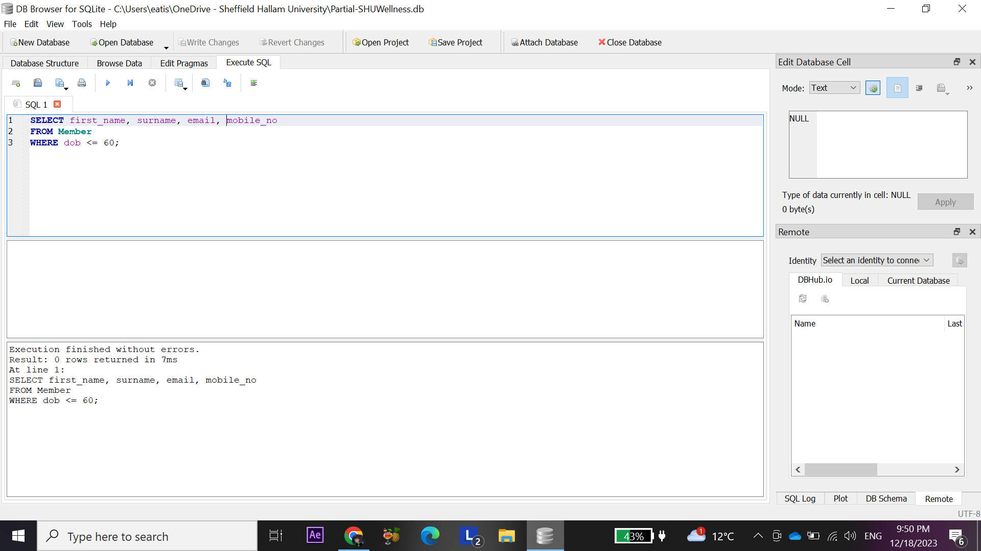

b.HR are reviewing certifications: Select all staff for clinics where the training review is older than one year, and include the clinic details

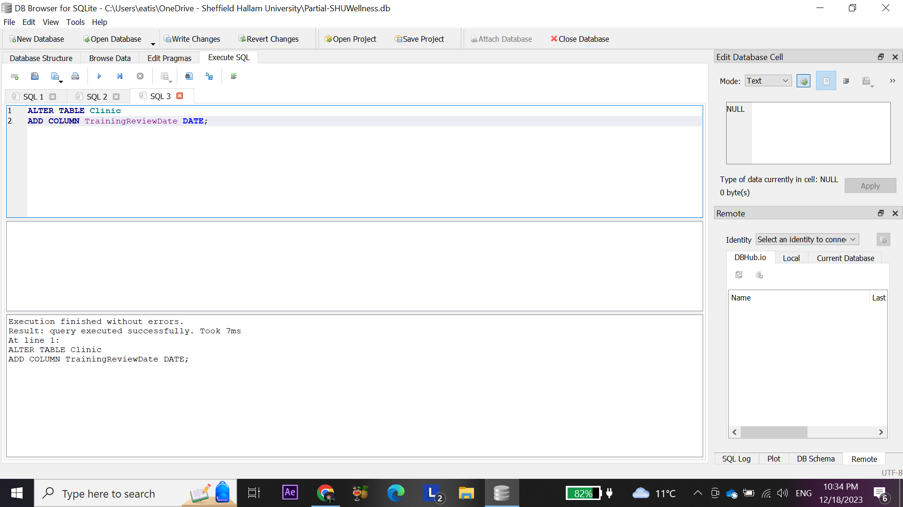

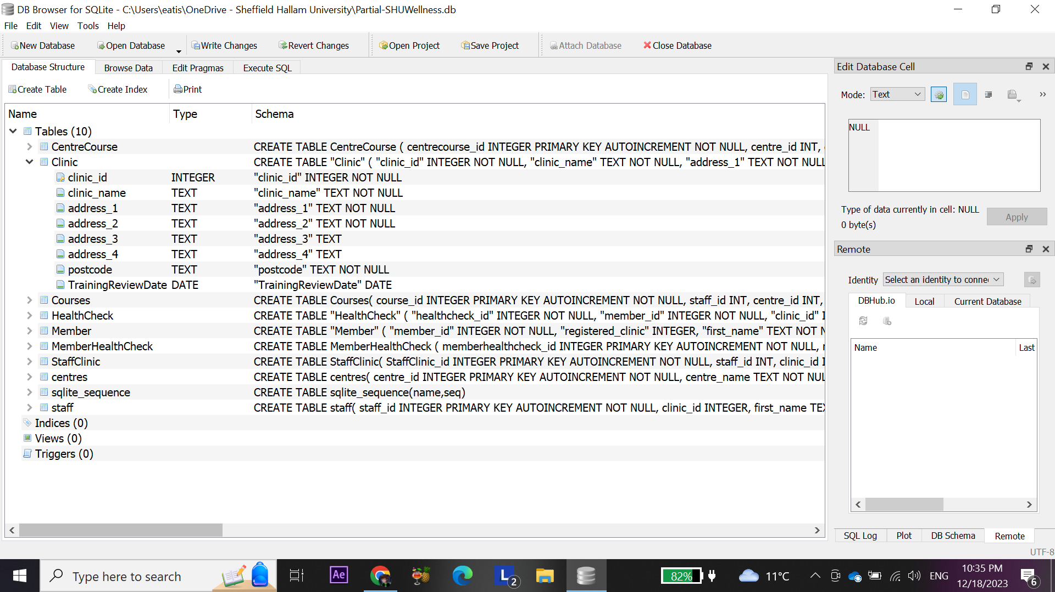

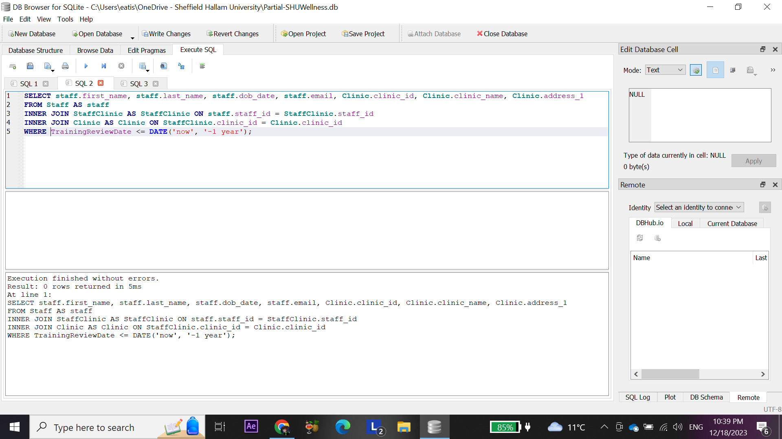

Produce a demographic report based on the age of attendees to courses: Use the following age brackets:

1. under 25

2. 25 to 35

3. over 35

