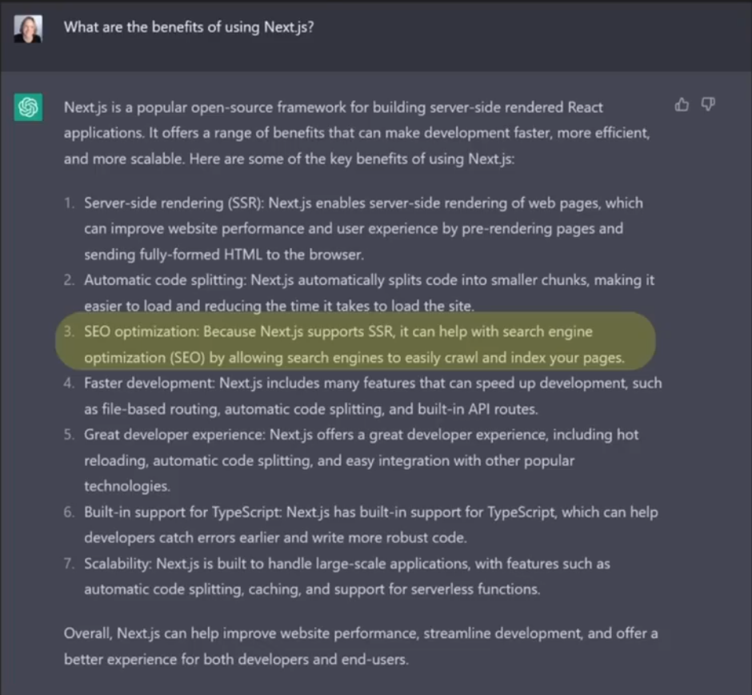

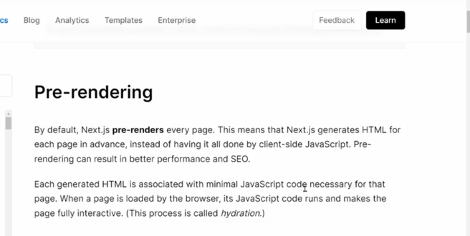

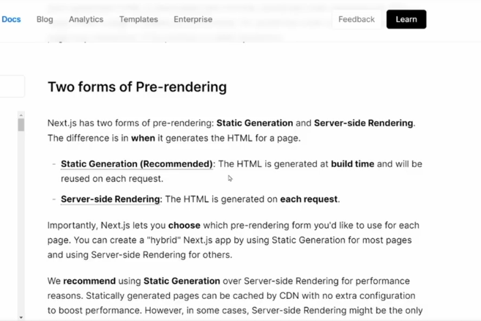

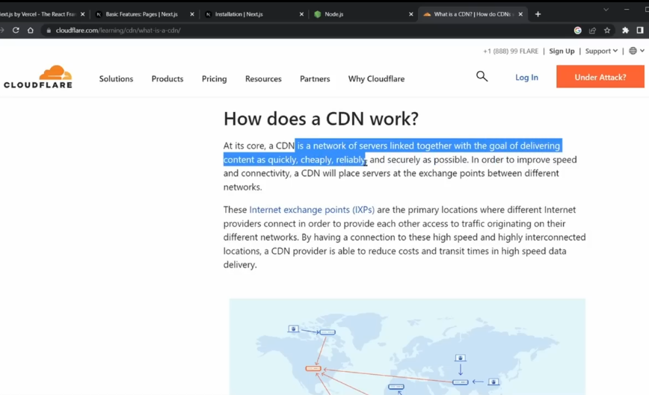

* To create a NextJs app **npx** [**create-next-app@13.1.6**](mailto:create-next-app@13.1.6)

The source directory is the parent directory for you app directory

* npm run dev to start a basic app

Simple navigation in NextJs

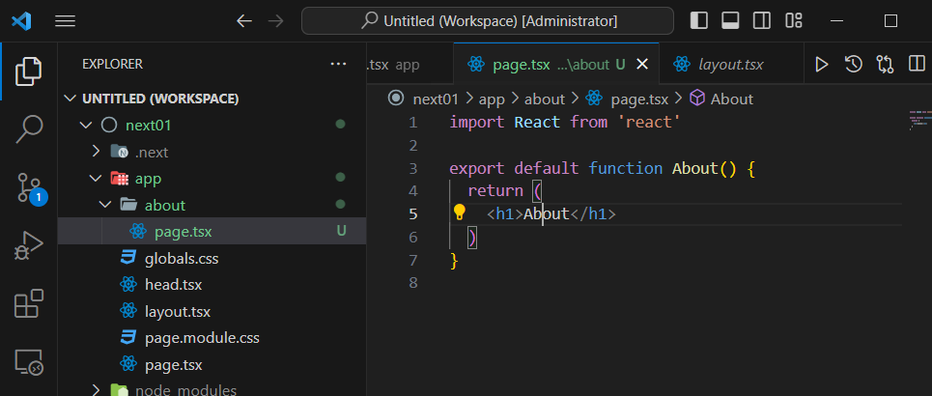

The layout page applies to all the pages in the website

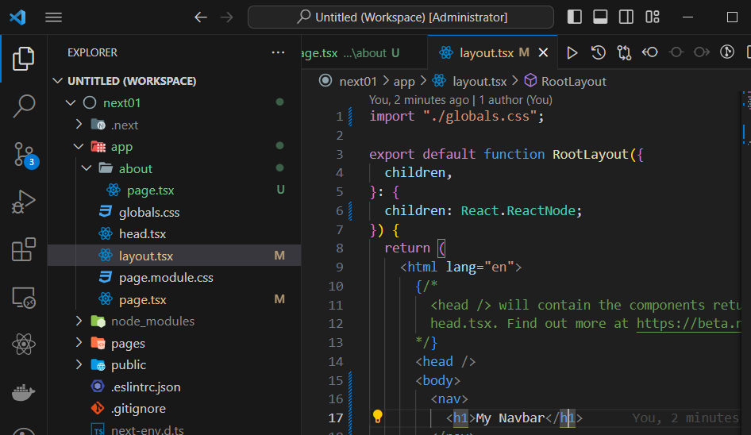

Not putting a ./ at the beginning means you’re referencing the public file

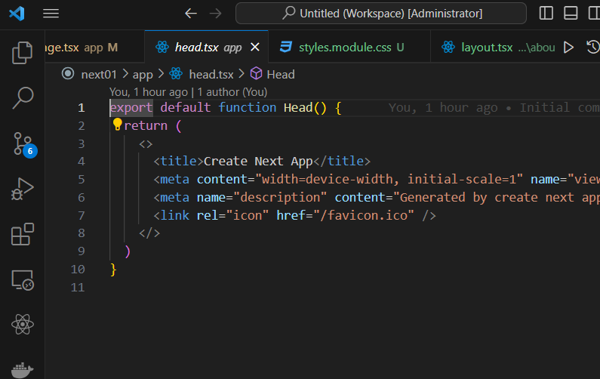

Static meta data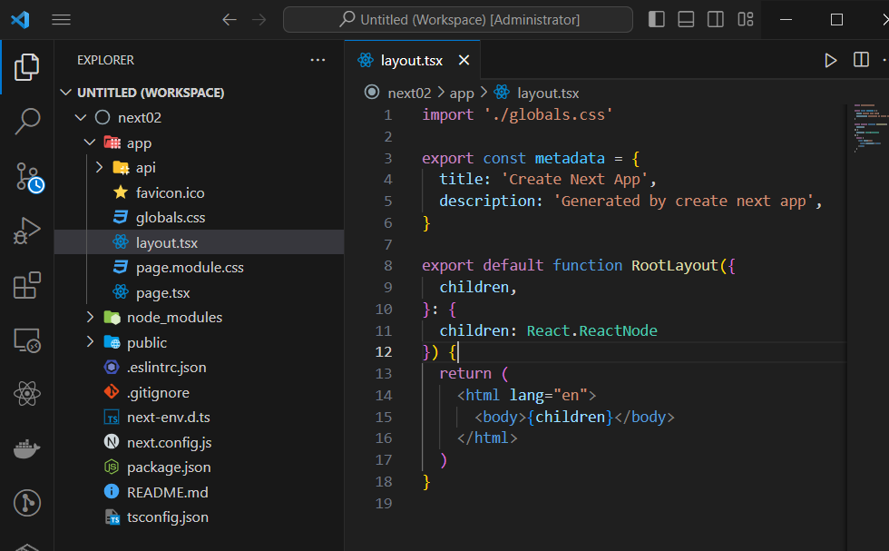

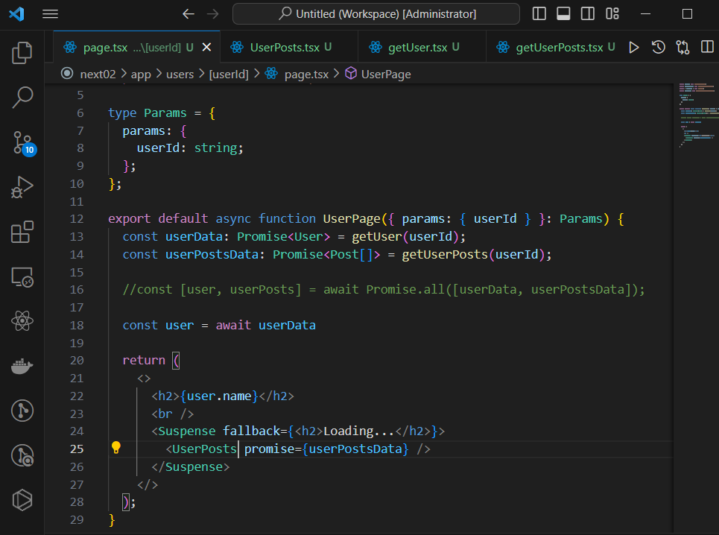

Up above allows you to display the name immediately then use Suspense to incrementally show the user post data.

SSG – allows you to tell NextJs what parameters it’s going to receive such that it generates them from the server and sends them to the content delivery networks. Eg the users/{} route

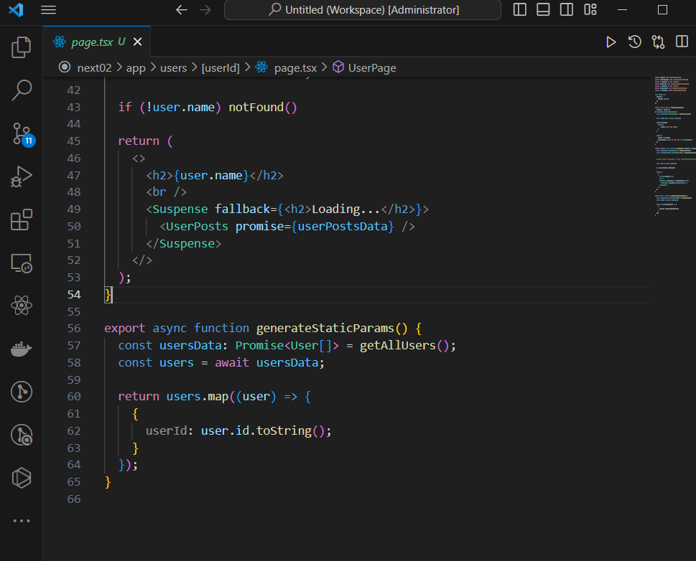

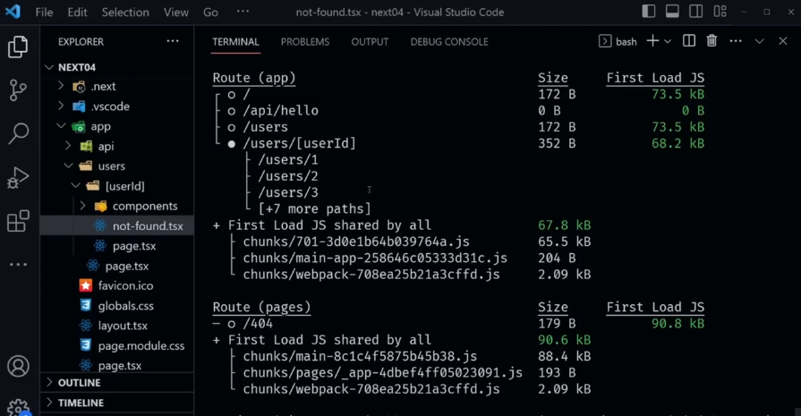

Next04 used

* npm i gray-matter
* npm i remark remark-html

Static route handlers are statically evaluated when using a GET method and you don’t use a request object.

* A partial Todo allows you to define part of the attributes of a type instead of all attributes.

**NOTE:** A middleware by default in NextJs applies to **ALL the requests / routes** in your project.

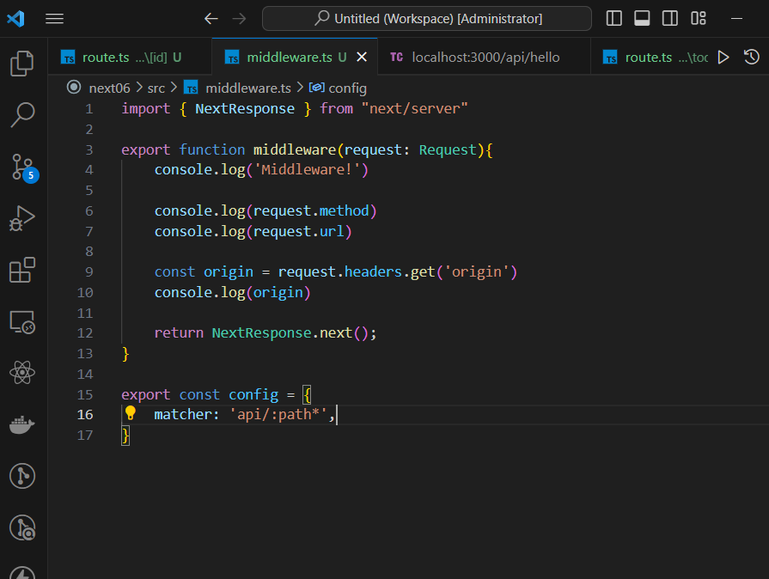

Use a matcher to isolate the routes for which a middleware should be applied.

You can also use conditionals and regex

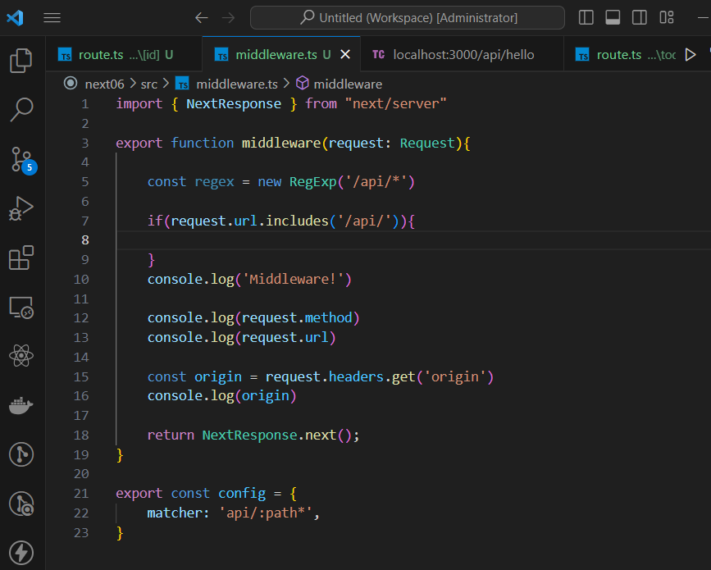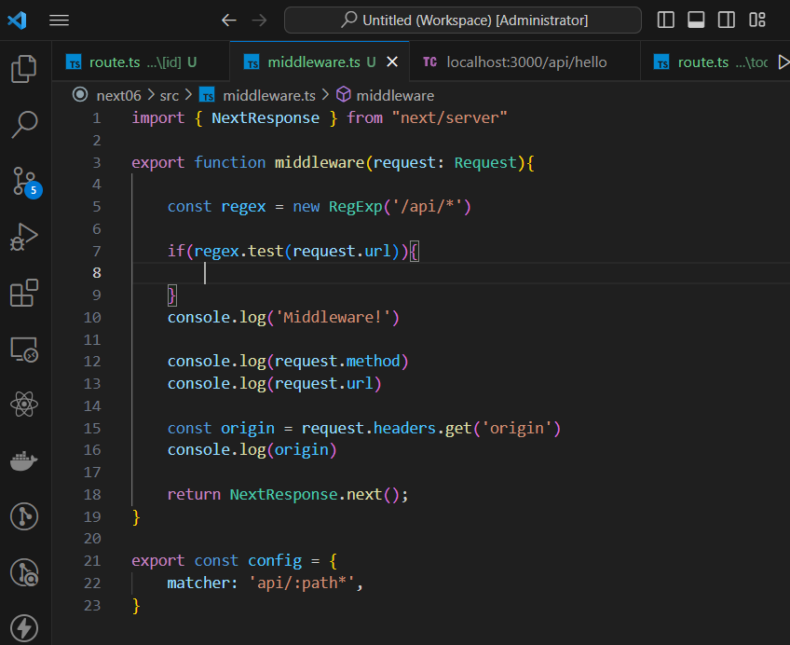

* npm i limiter – a rate limiter protects an application from being overloaded with abusive requests.
* When you update a static generated page under revalidate, the first refresh triggers the revalidation but still displays the cached data. Then the second request will send the new data.
* require(‘crypto’).randomBytes(16).toString(‘hex’) in command after typing node to enter a node environment
* npx json-server -w db.json -p 3500 -H 127.0.0.1 starting json server

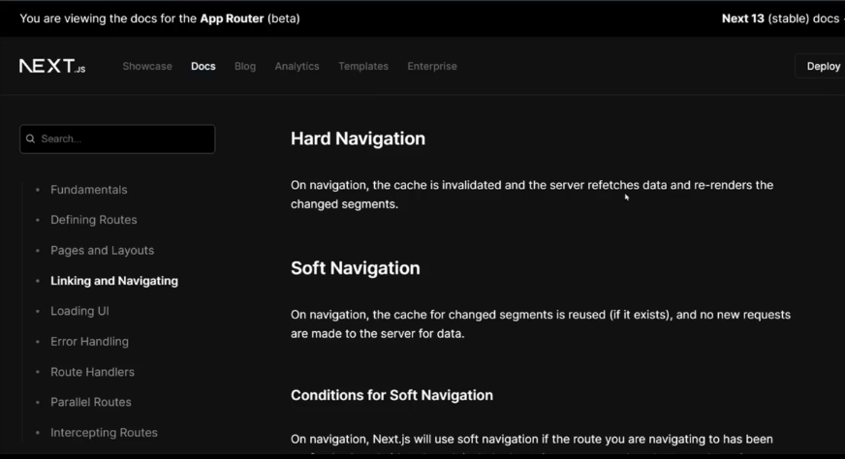

npm i next@canary – an unstable latest version that changes many times

5:40:00 => interacting with github api

How to forcefully solve the eslint error for apostrophes

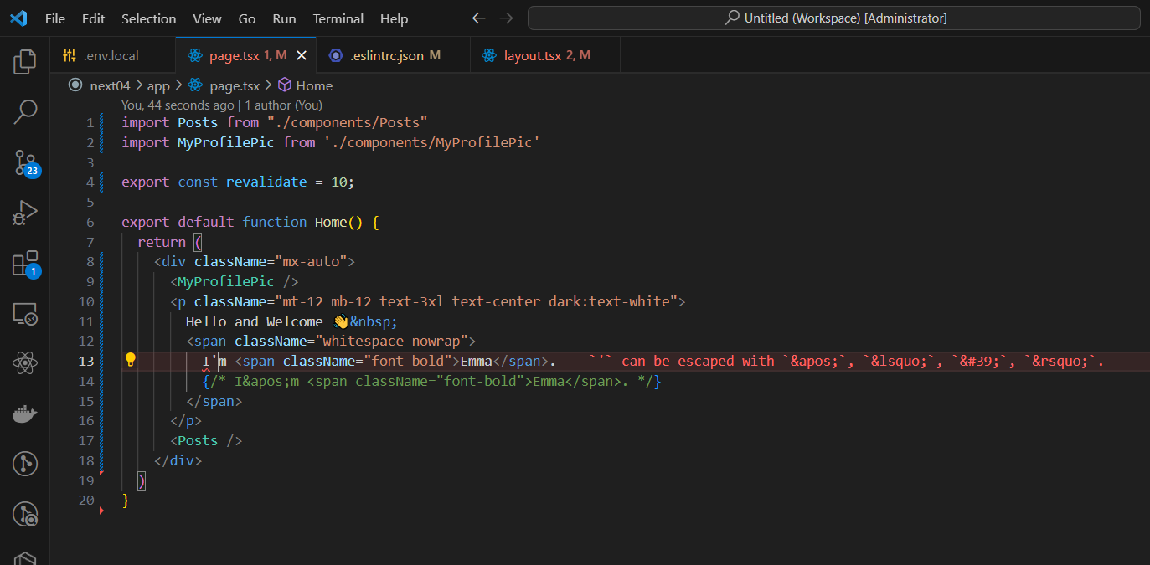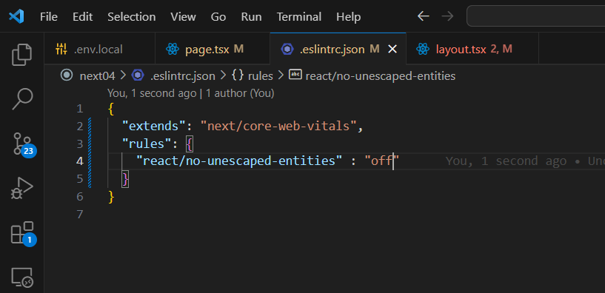

For remote MDX the recommended package dependency is next-mdx-remote

Highlight js helps us to highlight our code to make it look better

Rehype-slug adds and id to headings

* npm i highlight.js rehype-highlight rehype-slug rehype-autolink-headings
* npm i @tailwindcss/aspect-ratio@latest -D

Aspect ratio of 16/9 is the optimal ratio for a video.

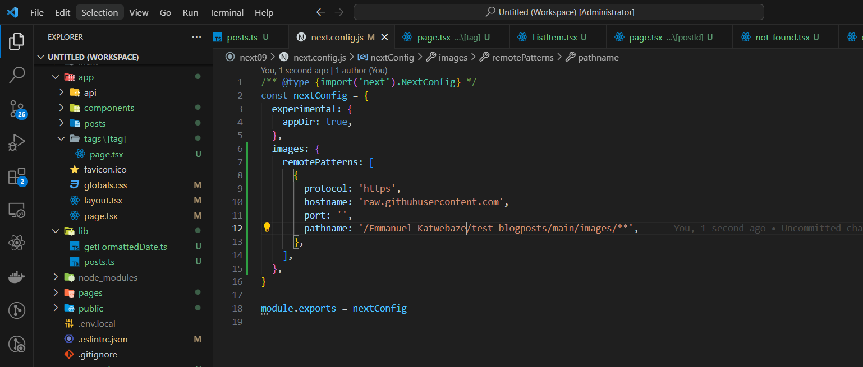

Whenever you add images from an external file, you have to settle this in the nextconfig file.

NextJS recommends you install sharp and sitemap.. for sharp, just install it and no settings are needed.

* npm i sharp
* npm i sitemap