First initialize an npm project

* npm init -y : -y is a shortcut to say yes to all the prompts

**To install Jest**

* npm install –save-dev jest

Modify the package.json scripts to run tests with Jest

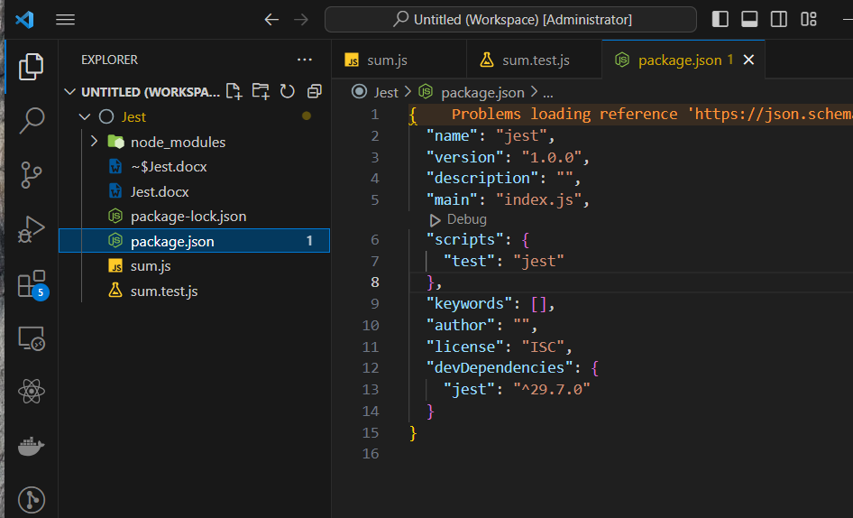

* Unit testing – testing small blocks of code like basic functions and basic classes. Helps us identify errors early in the development phase.
* To run a test, type the command **npm test**
* Matcher includes functions like toBe(), toEqual(), toFalsy(), toTrue();
* toBe() is basically used for primitive values like numbers, strings and Booleans.
* If we’re dealing with objects and arrays we say toEqual().
* Mocks are fake implementations of real functions and spies are tools used to track the behavior of those functions.

**Integration Testing**

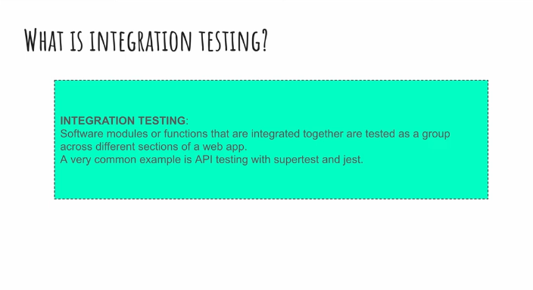

* npm i express express-validator
* npm i -D jest supertest
* npm i -g nodemon

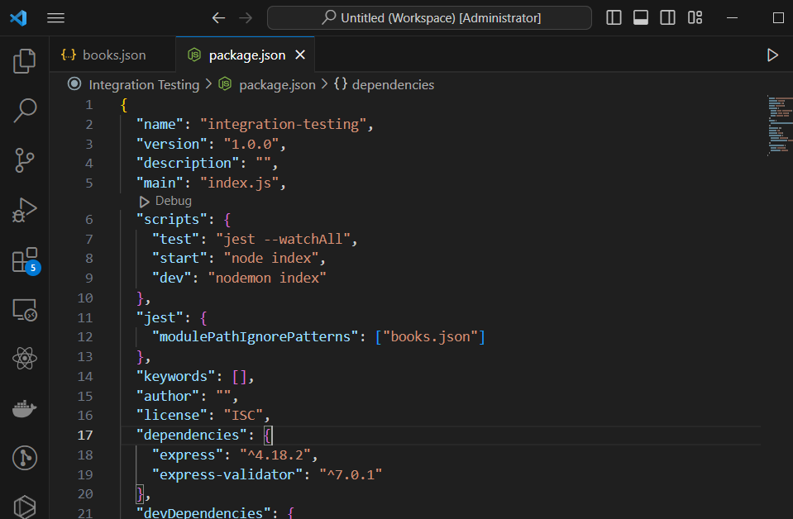

* npm run dev – starts the server with nodemon

**NOTE:** Only test modules you created on your own

PART THREE

* yarn ts-jest-config:init to initialize a jest config file

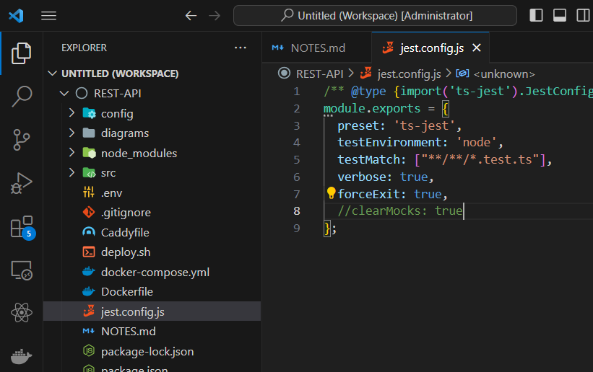

Some pre-configurations to use.