Modeling Human Activity States Using Hidden Markov Models
Formative 2 — Hidden Markov Models (Individual submission)
Student: Emmanuel Nsabagasa (e.nsabagasa@alustudent.com) | GitHub: https://github.com/Emmanuel-NS/hmm-human-activity-recognition

1. Background and Motivation
Smartphone inertial sensors continuously emit accelerometer and gyroscope streams, but the true activity (standing, walking, jumping, or still) is hidden behind noise and device orientation. Hidden Markov Models (HMMs) capture both temporal persistence of activities and noisy emissions, making them suitable for sequential human activity recognition (HAR).
Unique use case (individual): I model short indoor activity bursts for a personal student wellness / sedentary-break reminder. A phone already carried in hand or pocket should distinguish desk still/standing from walking or jumping during a movement break, without cameras. Human activity recognition is needed here so reminders fire only when the user is sedentary, and active breaks can be verified privately from IMU signals alone.

2. Data Collection and Pre-processing
This is an individual submission. I collected real sequential IMU data with Sensor Logger (Android) on one phone. Each session exports Accelerometer.csv and Gyroscope.csv with a seconds_elapsed timestamp column; I merged gyroscope onto accelerometer timestamps, kept takes of about 5–10 s, and wrote flat labelled CSVs under data/raw and data/test. In total the repository contains 88 well-labelled cleaned files (80 train + 8 unseen test), with each activity exceeding 1 min 30 s of training signal. Breakdown — jumping: 20 train + 2 test (161.9s train, mean fs≈99.9 Hz); standing: 20 train + 2 test (174.7s train, mean fs≈99.9 Hz); still: 20 train + 2 test (166.8s train, mean fs≈99.9 Hz); walking: 20 train + 2 test (167.9s train, mean fs≈99.9 Hz).
Sampling rate (individual device documented for the report): SM-A325N (~99.9 Hz, sampleRateMs=10.0). Even with a single phone, Sensor Logger can be configured differently across sessions; therefore every file is linearly resampled to a common 50 Hz grid before windowing so FFT bins and feature windows stay comparable. If multiple phones/rates had been used, the same harmonisation step would align them.
Windowing: at the harmonised 50 Hz rate we use 1.0 s windows (50 samples) with 0.5 s hop. Native phone rate was ~100 Hz (10 ms Sensor Logger setting); after downsampling, FFT frequency resolution is about 1 Hz — enough to separate still/standing (near 0 Hz) from walking cadence (~1.5–2 Hz) and jumping (~2–3 Hz), while remaining short enough to track transitions.
Video evidence of data collection (4 activities; full body + face visible while holding the phone):
Standing video: https://youtube.com/shorts/fWiTltw83o8
Walking video: https://youtube.com/shorts/m0d-yOL5tSE
Jumping video: https://youtube.com/shorts/JhfENFsJmo8
Still video: https://youtube.com/shorts/YM_wLnQTzg0
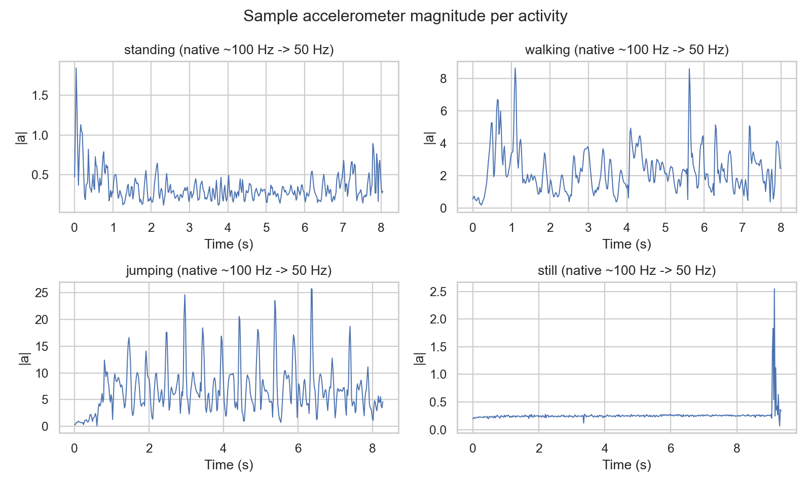
Figure 1. Sample |a| traces after resampling.

3. HMM Setup and Implementation
Hidden states Z = {standing, walking, jumping, still}. Observations X are 10-D Z-scored feature vectors per window. Transition matrix A stores P(z_{t+1}|z_t). Emissions B are diagonal Gaussians N(x|μ_i, σ²_i). π is the initial state distribution.
Features — time domain: mean, variance, std, RMS, SMA of accelerometer magnitude, corr(x,y), gyro mean/std magnitude (energy and axis coupling separate locomotion from stillness). Frequency domain (FFT): dominant frequency and spectral energy (cadence / periodic power). Z-score normalisation is fit on training only so heterogeneous units do not dominate Gaussian emissions.
Algorithms: Baum–Welch (EM) learns π, A, and Gaussian parameters with convergence when |Δll| < 1e-4. Forward–Backward supplies the E-step. Viterbi returns the MAP state path used to compute sensitivity, specificity, overall accuracy, and the confusion matrix on unseen files. Implementation is NumPy-only in src/hmm.py, executed via notebooks/hmm_activity_recognition.ipynb.
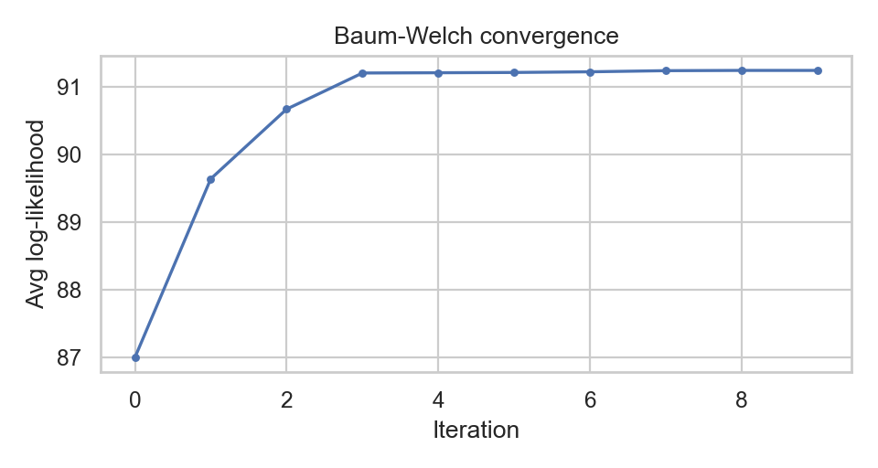
Figure 2. Baum–Welch log-likelihood convergence.

4. Results and Interpretation
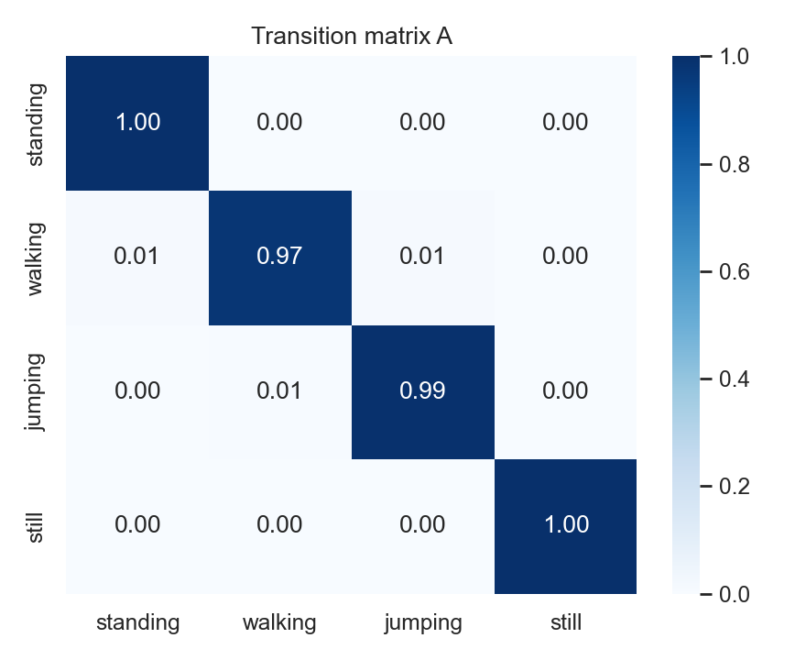
Figure 3. Learned transition matrix A.
High diagonal mass in A reflects realistic behaviour for short continuous takes: the model prefers to remain in the current activity across consecutive 1 s windows.
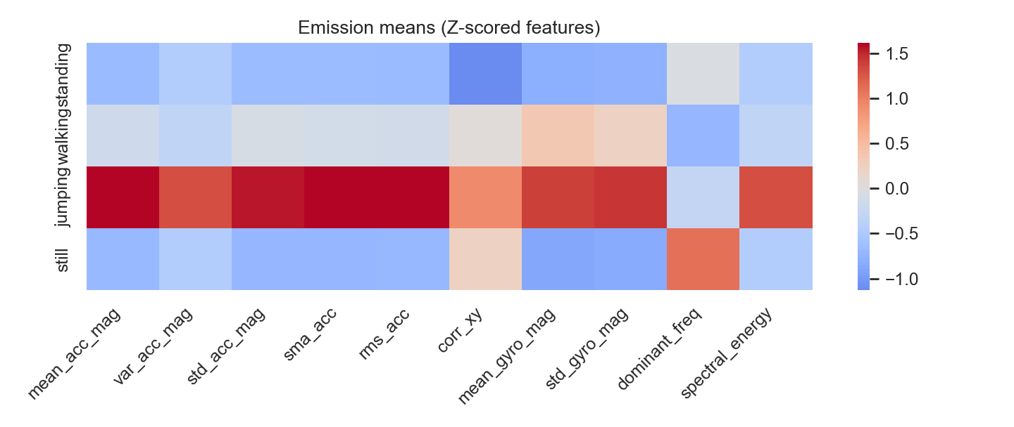
Figure 4. Emission means (B) in Z-scored feature space.
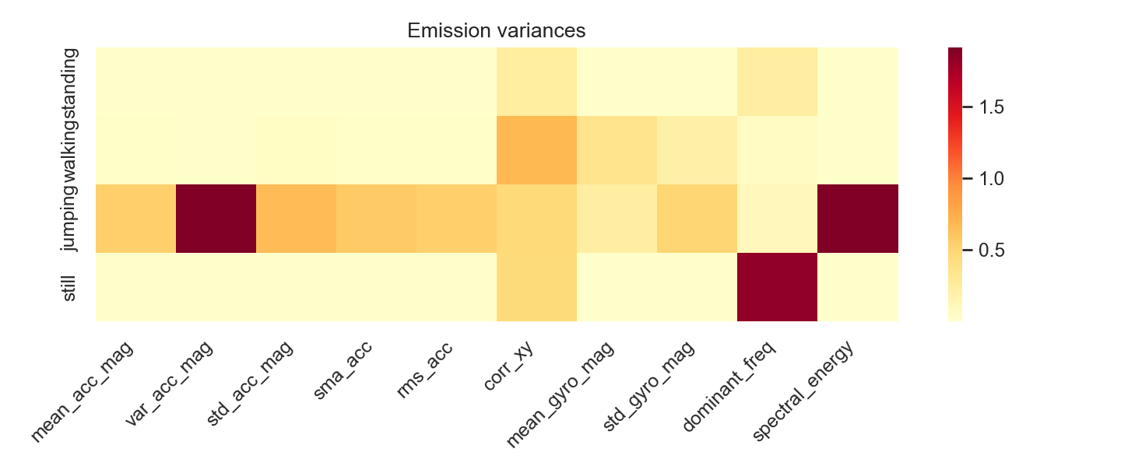
Figure 5. Emission variances (diagonal Gaussian B).
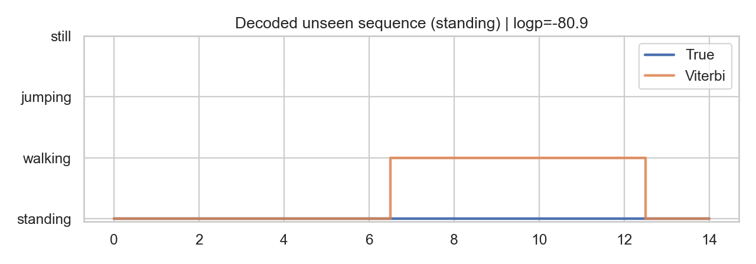
Figure 6. Viterbi decoding on an unseen test sequence.
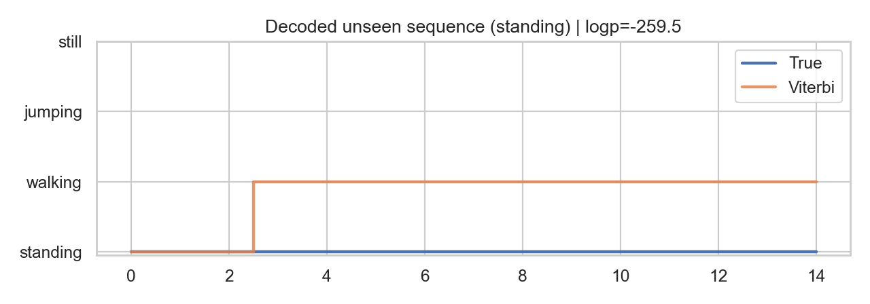
Figure 7. Additional decoded unseen sequence (activity transition view).

5. Evaluation on Unseen Data
Unseen evaluation used 8 held-out Sensor Logger sessions in data/test (later recording folders not used during training). This is a new-session split from the same collection day/device, testing whether the HMM generalises beyond the exact takes seen in training.
State (Activity) | Number of Samples | Sensitivity | Specificity | Overall Accuracy
standing | 30 | 0.4000 | 1.0000 | 0.8333
walking | 29 | 1.0000 | 0.7802 | 0.8333
jumping | 30 | 0.9333 | 1.0000 | 0.8333
still | 31 | 1.0000 | 1.0000 | 0.8333
Generalisation: still and jumping are recognised reliably on held-out takes; standing remains the main error mode (often decoded as walking when handheld micro-motion raises energy features). Overall accuracy on unseen windows is 83.3%, which is usable for a break-reminder filter but would benefit from placement-consistent training.
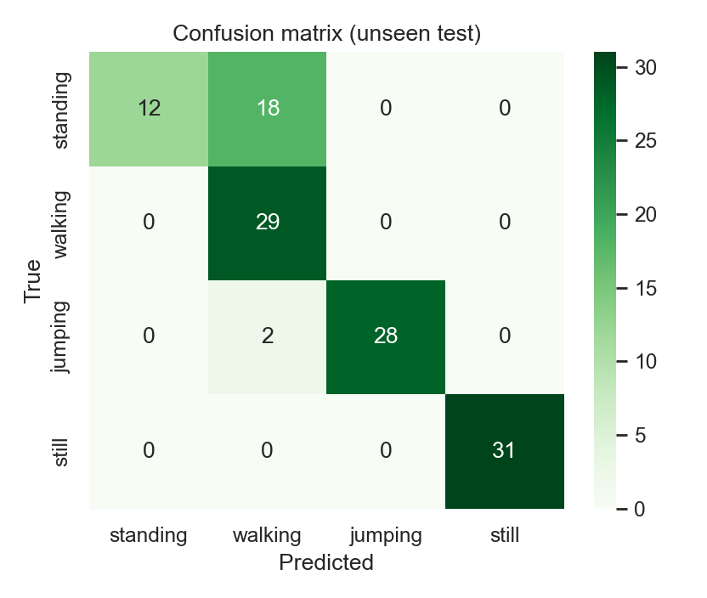
Figure 8. Confusion matrix on unseen test data.

6. Discussion and Conclusion
On unseen Sensor Logger takes the model reached overall accuracy 83.3%. Easiest state by sensitivity: walking (sensitivity=1.00). Hardest: standing (sensitivity=0.40). In our confusion matrix, standing is most often confused with walking — both can show mild phone motion and overlapping spectral energy when the user shifts weight or the phone is handheld rather than pocket-fixed. Still and jumping separate cleanly via magnitude and FFT energy.
Transition probabilities remain strongly diagonal, matching realistic behaviour: within an 8 s labelled take the activity rarely switches every 0.5 s hop. Native sampling was ~100 Hz (SM-A325N, Sensor Logger 10 ms); resampling to 50 Hz harmonises members/devices but can soften high-frequency impact peaks in jumping. The 1.0 s window after resampling keeps ~1 Hz FFT resolution for cadence features.
Improvements: more participants and phone placements (waist vs hand), magnetometer features, full-covariance Gaussians, orientation-invariant features (e.g., gravity-removed linear accel), and longer multi-activity sessions to enrich off-diagonal transitions. Overall, the Gaussian HMM with Baum–Welch training and Viterbi decoding recovers activity states from real IMU feature sequences and supports our wellness-break reminder use case by separating sedentary versus active phone contexts.

