Modeling Human Activity States Using Hidden Markov Models
Formative 2 – Hidden Markov Models (individual)
Emmanuel Nsabagasa (e.nsabagasa@alustudent.com). Repo: https://github.com/Emmanuel-NS/hmm-human-activity-recognition

1. Background and Motivation
I spent a lot of this semester sitting for long stretches, so I wanted a simple phone-based check that can tell when I am actually still at a desk versus when I get up to walk or do a short active break (including jumping). Cameras feel invasive for that, but the phone already has an accelerometer and gyroscope. The catch is that the true activity is not written in the CSV – it is hidden behind noisy readings. That is why I used a Hidden Markov Model: it can keep track of which activity I am likely in over time, instead of treating every window as independent.

2. Data Collection and Pre-processing
I recorded standing, walking, jumping, and still with Sensor Logger on my SM-A325N at about 99.9 Hz (Sensor Logger sampleRateMs=10.0). Each take is roughly 5 to 10 seconds. For every session I kept the accelerometer and gyroscope streams, aligned them on the seconds_elapsed timestamp, and saved labelled CSV files. The GitHub dataset has 88 cleaned files (80 for training, 8 held out for testing). Training time per activity is about standing 175s, walking 168s, jumping 162s, still 167s (each above the 1 min 30 s minimum).
My phone logged near 100 Hz. I resampled everything to 50 Hz so window length and FFT bins stay consistent. At 50 Hz I used 1.0 s windows (50 samples) with a 0.5 s hop. One second gives about 1 Hz frequency resolution, which is enough to see walking cadence versus near-zero motion when I am still or standing, without making the windows so long that short changes disappear.
Collection videos (full body, face visible, phone in hand):
Standing: https://youtube.com/shorts/fWiTltw83o8
Walking: https://youtube.com/shorts/m0d-yOL5tSE
Jumping: https://youtube.com/shorts/JhfENFsJmo8
Still: https://youtube.com/shorts/YM_wLnQTzg0
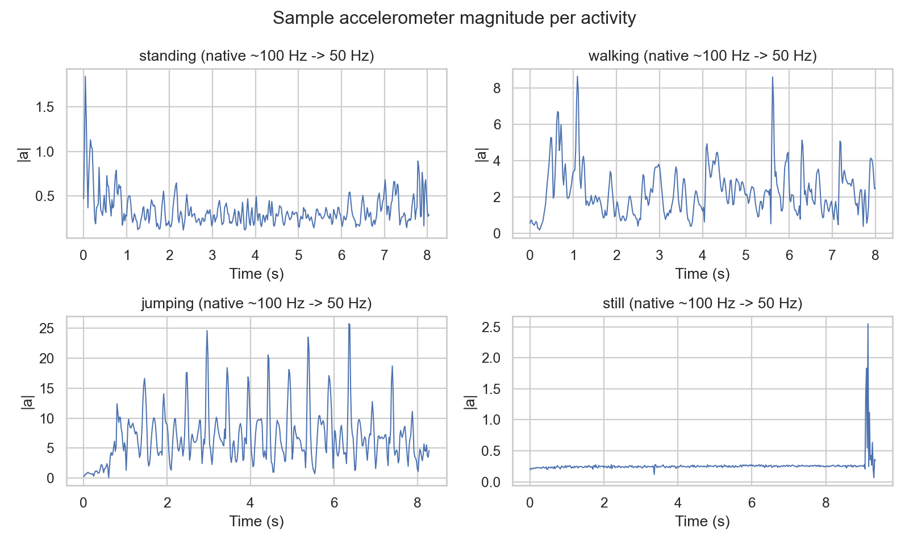
Figure 1. Example accelerometer magnitude after resampling.

3. HMM Setup and Implementation
Hidden states are the four activities. Each observation is a feature vector from one window. I used time-domain features on accel magnitude (mean, variance, std, RMS, SMA), xy correlation, and gyro magnitude mean/std – these mainly capture how strong and shaky the motion is. From the FFT of accel magnitude I took dominant frequency and spectral energy so walking and jumping can show a clearer beat than still. Features are Z-scored using training statistics only; otherwise Hz and m/s^2 values would unfairly dominate the Gaussian emissions.
I implemented a diagonal-Gaussian HMM in NumPy. Baum-Welch updates pi, A, and the emission means/variances and stops when the average log-likelihood change drops below 1e-4. Viterbi then picks the most likely activity path. I need Viterbi's hard labels to build sensitivity, specificity, accuracy, and the confusion matrix; Baum-Welch is what fits the parameters those metrics depend on. Code lives in the hmm module and the notebook runs the full pipeline.
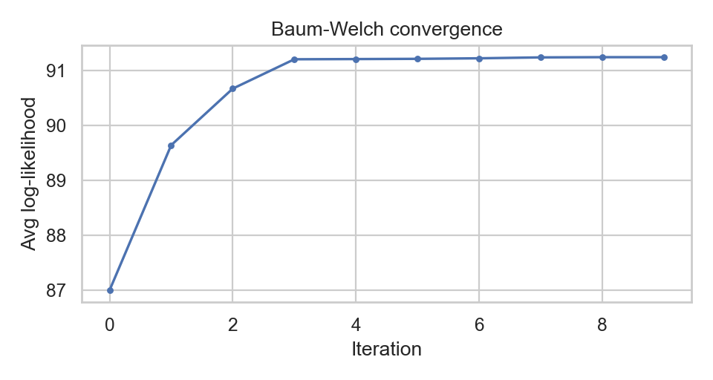
Figure 2. Baum-Welch training curve.

4. Results and Interpretation
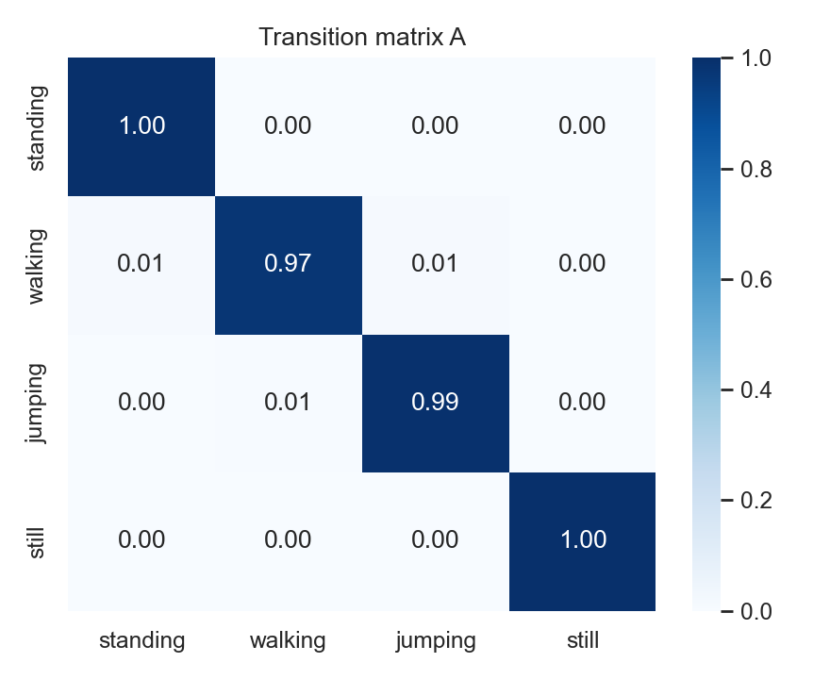
Figure 3. Transition matrix A.
The transition matrix is heavily diagonal. That matched how I recorded: each file is one activity for several seconds, so the model mostly learns to stay put from one 0.5 s hop to the next rather than jumping between labels.
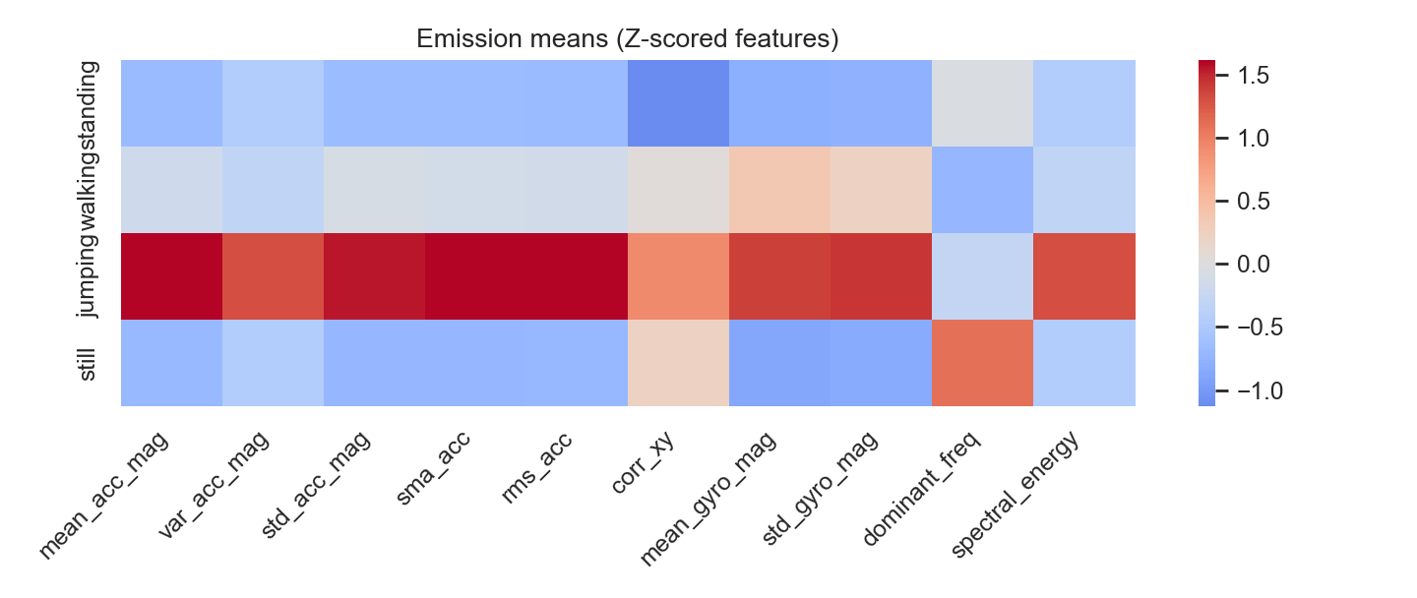
Figure 4. Emission means by state.
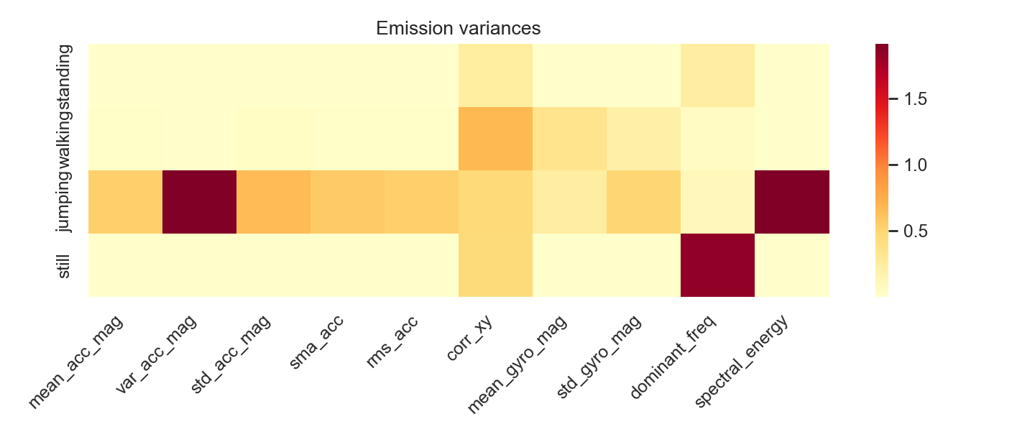
Figure 5. Emission variances by state.
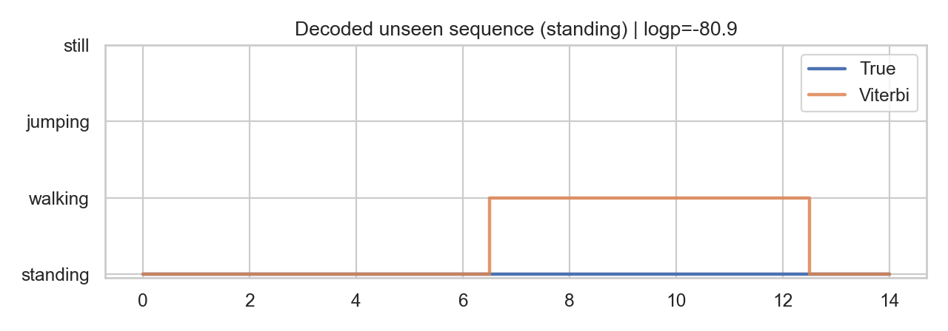
Figure 6. True vs Viterbi labels on a held-out take.

5. Evaluation on Unseen Data
I kept 8 recordings out of training (later sessions from the same phone, not used while fitting). That is my unseen set.
State (Activity) | Number of Samples | Sensitivity | Specificity | Overall Accuracy
standing | 30 | 0.4000 | 1.0000 | 0.8333
walking | 29 | 1.0000 | 0.7802 | 0.8333
jumping | 30 | 0.9333 | 1.0000 | 0.8333
still | 31 | 1.0000 | 1.0000 | 0.8333
Overall accuracy on unseen windows was 83.3%. Still and jumping were clear. Standing was the weak spot (sensitivity 0.40 when standing was hardest): small hand motion while 'standing' often looked a bit like walking to the model. That is honest for handheld logging – I was not always perfectly still.
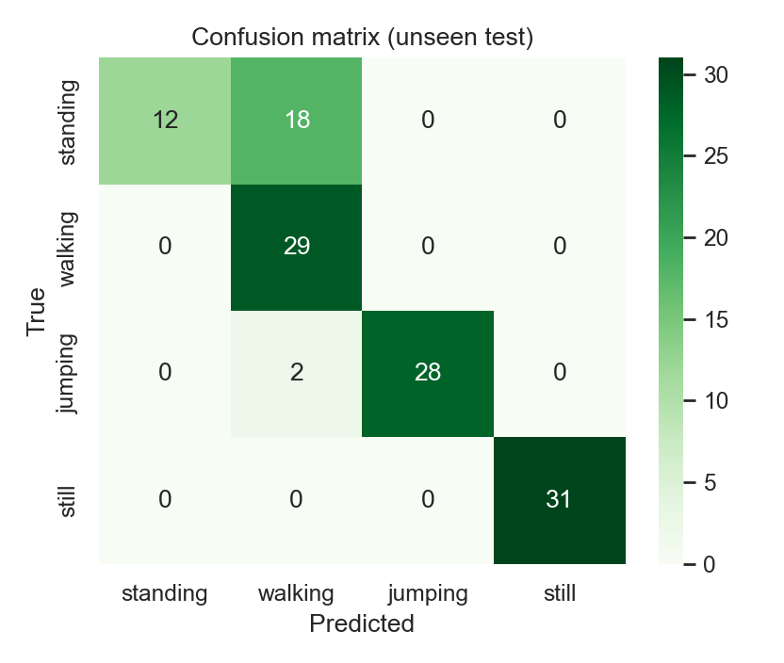
Figure 7. Confusion matrix on unseen data.

6. Discussion and Conclusion
Easiest activity overall: walking. Hardest: standing, mostly mixed with walking. The high self-loop probabilities in A feel realistic for my short single-activity clips. Resampling 100 Hz down to 50 Hz made the pipeline consistent, but it can blunt sharp jump impacts a little; the 1 s window was my compromise for FFT resolution after that downsample.
If I continue this, I would fix phone placement (pocket vs hand), add a few more people, and try gravity-removed linear acceleration so orientation matters less. Even with standing errors, the HMM already separates quiet desk time from clear movement well enough for the break-reminder idea I started with.

