SmartCare v0.3 - Domain Model Workbook
Week 6 student resource

Requirement-to-Concept Trace
Requirement | Concept | State/behaviour | Decision
FR-01: Add patient record | Patient | Stores patientId, name | Include: core domain object
FR-02: Search patient by ID | Patient | Looked up by ID | Include
FR-03: Search patient by name | Patient | Looked up by name | Include
FR-04: Add practitioner | Practitioner | Stores practitionerId, name | Include: core domain object
FR-05: Book appointment | Appointment | Stores patient, practitioner, dateTime, status | Include: links Patient and Practitioner
FR-06: Reject double-booking | Appointment | Check for time conflict | Include: validation rule
FR-07: Cancel appointment | Appointment | Change status to Cancelled | Include: status change not deletion
FR-08: Retain cancelled appointments | Appointment | Status stays in list | Include: supports history
FR-09: Display practitioner schedule | Appointment, Practitioner | Filter by practitioner and date | Include
FR-10: Display patient appointments | Appointment, Patient | Filter by patient | Include

CRC Cards

Patient
Responsibilities | Collaborators
Store patient ID and name | None
Provide details for search and display | Appointment (referenced by)

Practitioner
Responsibilities | Collaborators
Store practitioner ID and name | None
Provide details for schedule display | Appointment (referenced by)

Appointment
Responsibilities | Collaborators
Store patient, practitioner, date/time and status | Patient, Practitioner
Support booking, cancellation and schedule queries | Patient, Practitioner

ClinicSystem (coordinator)
Responsibilities | Collaborators
Manage lists of patients, practitioners and appointments | Patient, Practitioner, Appointment
Handle booking with double-booking check, cancellation, search and schedule display | Patient, Practitioner, Appointment

UML Class Diagram
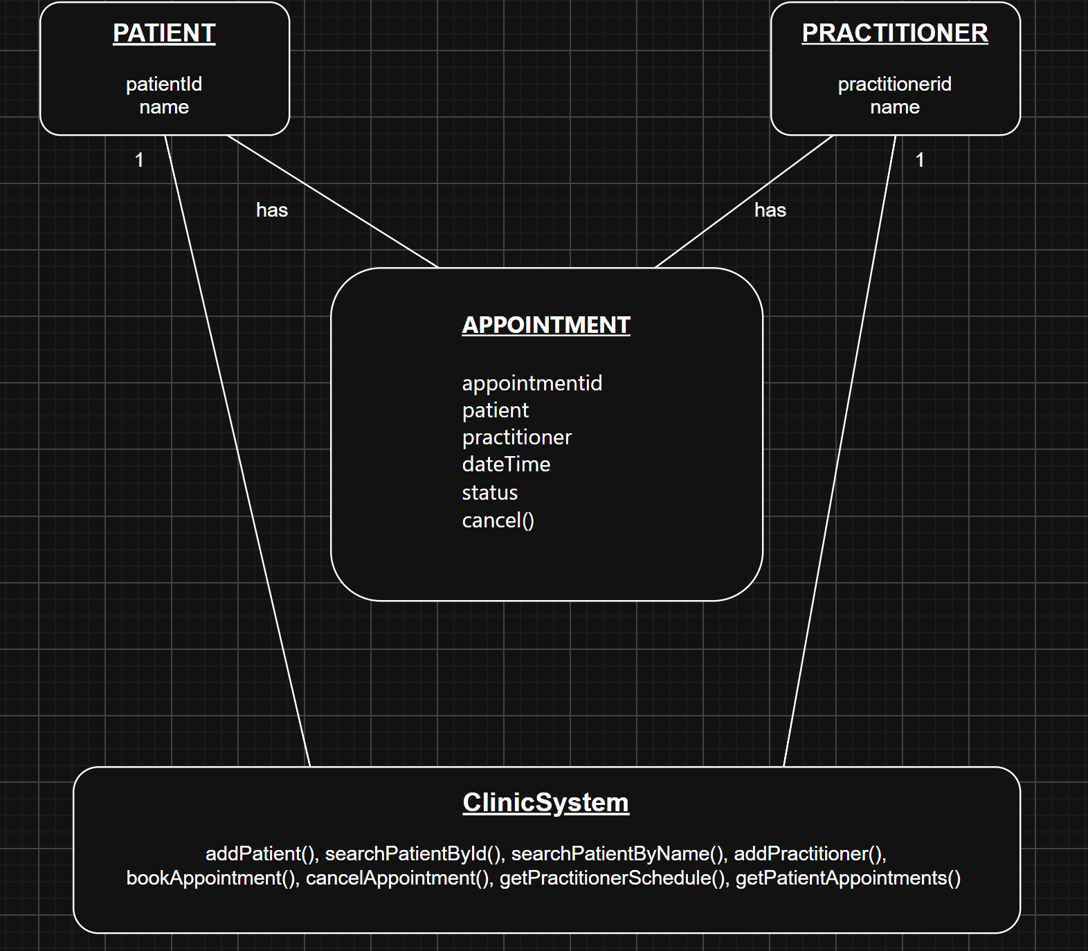

Design Rationale
I picked three main classes: Patient, Practitioner and Appointment. Each one comes straight from the requirements. Patient stores a name and ID and gets searched by both. Practitioner is the same idea. Appointment connects a patient to a practitioner at a specific time, and it has a status that can change from Scheduled to Cancelled.
I also added ClinicSystem as a coordinator that holds the lists and does things like booking, cancelling and searching. Copilot suggested the same thing. I didn't use three separate manager classes because that felt like overkill for a small system. I also said no to NotificationManager (nobody asked for notifications) and ScheduleEngine (showing a schedule is just one method, not a whole separate thing).

AI Design Review Record
AI suggestion | Evidence | Decision | Reason | Model change
Patient, Practitioner, Appointment as core classes | FR-01 to FR-10 | Accepted | Same as what I came up with. Each class maps to the requirements. | No change needed
ClinicSystem as single coordinator | FR-01 to FR-10 | Accepted | Makes sense to have one class that manages everything for a small system. | Added to model
Three separate managers instead of one | Not really needed | Rejected | Too complicated for a small clinic system. One coordinator is enough. | No change
NotificationManager | None | Rejected | Nobody asked for notifications or reminders. | No change
ScheduleEngine | FR-09 sort of | Rejected | Showing a schedule is just one method, doesn't need its own class. | No change

