**Hector SLAM Tutorials**

**Tutorial 1: Introduction to hector_slam**

**Ref** <http://emanual.robotis.com/docs/en/platform/turtlebot3/simulation/#ros-packages-for-gazebo>

* Specify model of the turtlebot 3 you are using. Since we are using Gazebo, model name is not so important. Just pick one of the models.

export TURTLEBOT3_MODEL=waffle_pi

**NOTE:** You have to export each time from each terminal before calling the necessary ros functions. If you do not want to do this, you can add this to .bashrc file.

* Open Gazebo environment with specified world environment

roslaunch turtlebot3_gazebo turtlebot3_world.launch

* Launch the hector_slam

roslaunch turtlebot3_slam turtlebot3_slam.launch slam_methods:=hector

* Move turtlebot 3 with keyboard

roslaunch turtlebot3_teleop turtlebot3_teleop_key.launch

* You can now see the map in Rviz Screen.

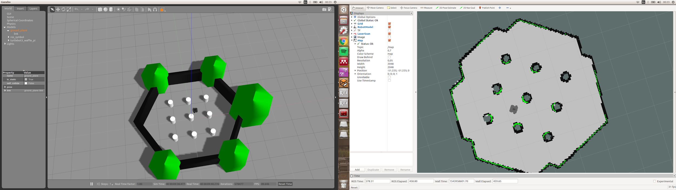

Figure 1: Simulation environment in Gazebo (left) and resulted map in rviz (right)

* After obtained full map you can save it to anywhere you like.

rosrun map_server map_saver -f ~/map1

**Tutorial 2: Move Turtlebot 3 using rosbag file**

Generally people want to make a comparison with different configurations and for these situations using teleoperation to move turtlebot 3 does not make any sense. For these situations, one can record the movement of turtlebot 3 with teleop just one time using rosbag and then this rosbag file can be used to move turtlebot 3 in the same way every time.

* Open Gazebo environment with specified world environment

roslaunch turtlebot3_gazebo turtlebot3_world.launch

* Launch the hector_slam

roslaunch turtlebot3_slam turtlebot3_slam.launch slam_methods:=hector

* Go to our example rosbag file that keeps movement commands to turtlebot 3.

cd ros_ws/bagfiles

* Play our bagfile.

rosbag play turtlebot3_movement.bag

**NOTE:** We used waffle_pi as TURTLEBOT3_MODEL. It is highly possible that this bag file is specific to waffle_pi. If you are using another model, you need to save your own bag file.

**Tutorial 3: Customize LIDAR Parameters in Gazebo**

* Go to turtlebot3_description

cd ros_ws/src/turtlebot3/turtlebot3_description

* Go to urdf directory. Open turtlebot3_waffle_pi.gazebo.xacro (if you use different model change it accordingly)

cd urdf & gedit turtlebot3_waffle_pi.gazebo.xacro

**NOTE:** It is a good idea to copy original xacro file if you need to use default values later.

* Change LIDAR parameters as you wish. We modified with our own LIDAR parameters as can be seen in Figure 1.

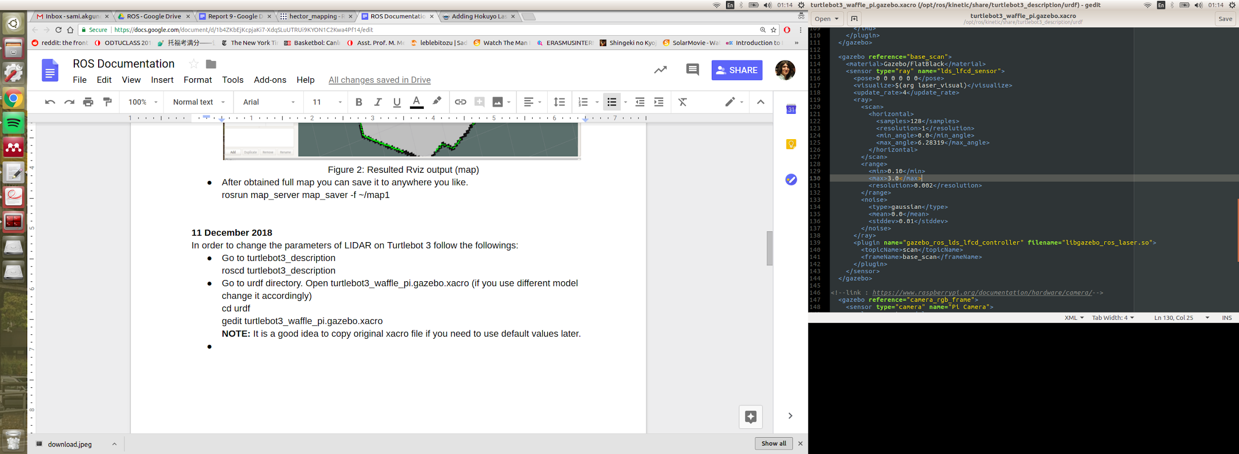

Figure 1: Manipulated turtlebot 3 LIDAR parameters

**Tutorial 4: Hector_SLAM with your own data and without Gazebo simulation**

**Reference**: <https://www.youtube.com/watch?v=3C_eRtSoU78>

* Go to hector_slam_launch directory

cd ros_ws/src/hector_slam/hector_slam_launch/launch

* Our launch file is named as oko_hector_launcher.launch. This file calls the main launch file in ros_ws/src/hector_slam/hector_mapping/launch/oko_hector_mapping.launch

You can use these launch files to create your own launch files later.

* Call our launch file. Do not forget to source setup.bash!

roslaunch hector_slam_launch oko_hector_launcher.launch

* Go to bagfiles directory and play our bag file.

cd ros_ws/bagfiles & rosbag play turtlebot3_scan2.bag --clock

**NOTE:** Please note that this bag file only publishes laser scan data to /scan topic. We do not use any odometry information.

* If everything is okay, you should be able to see Rviz output like below:

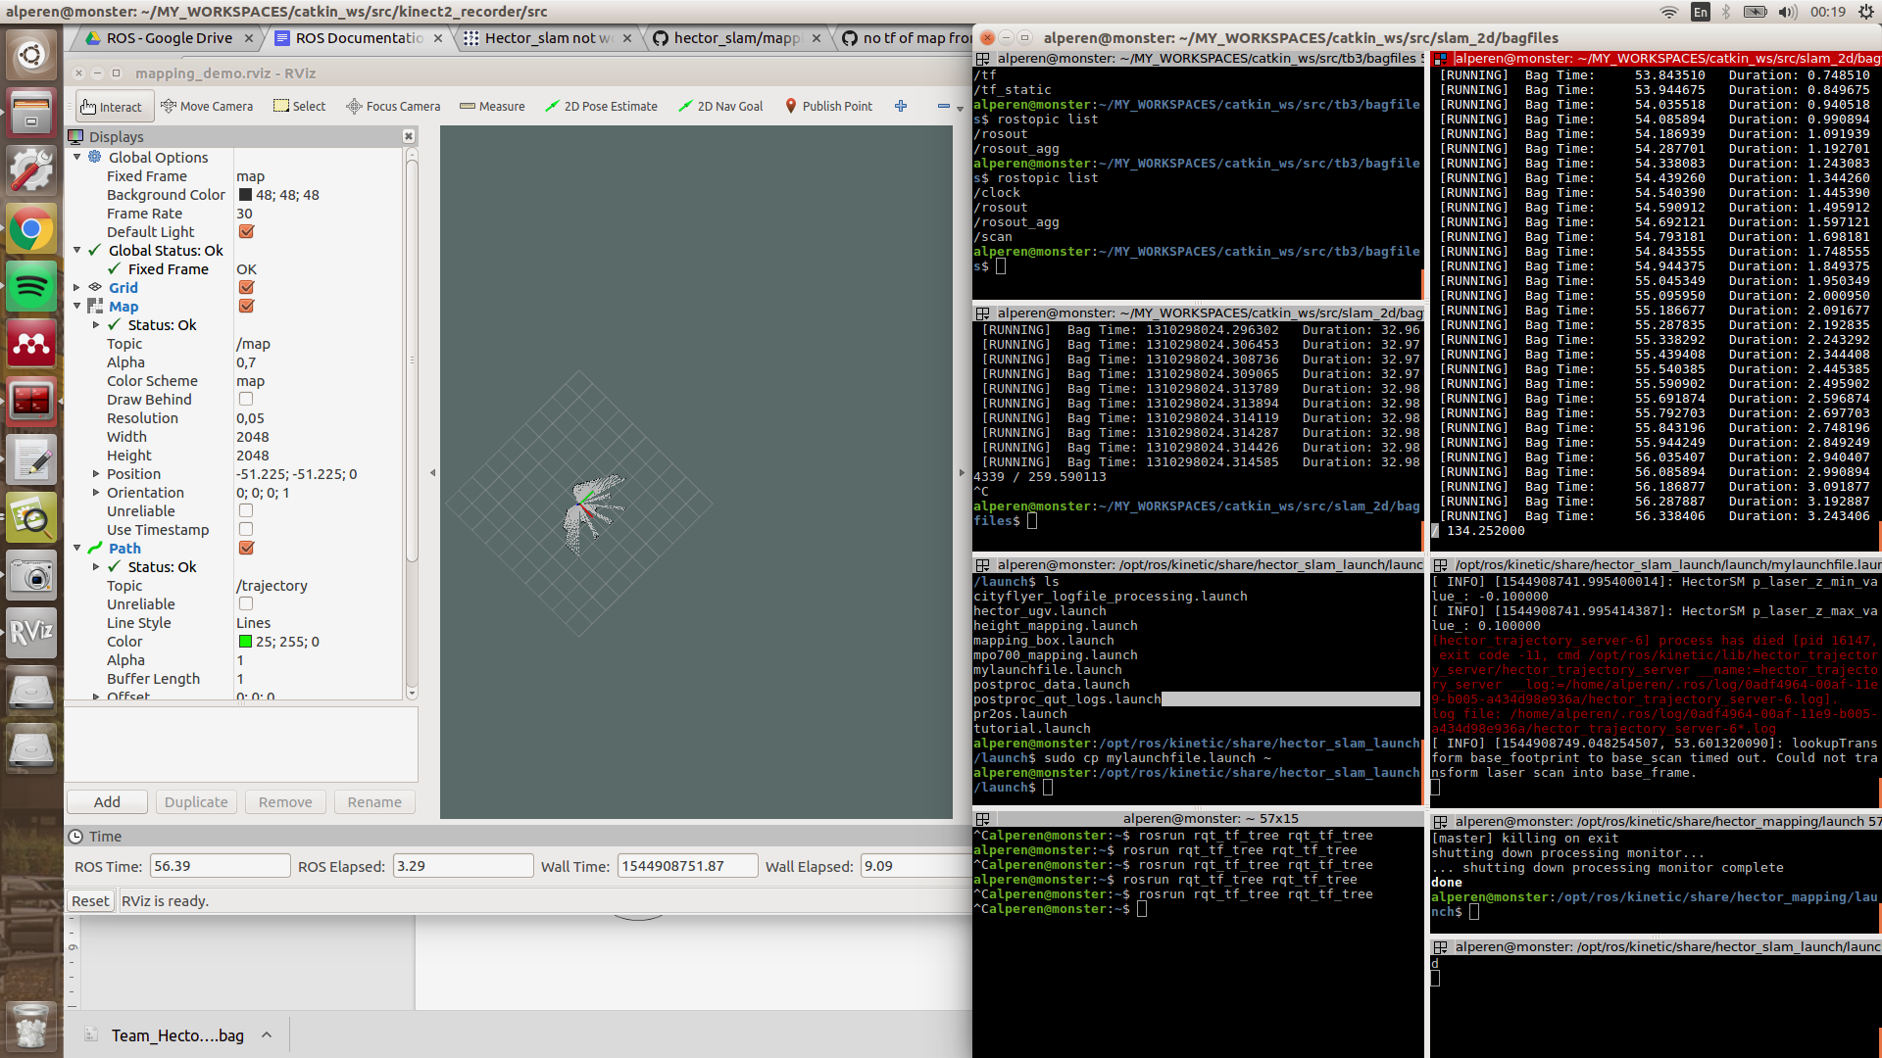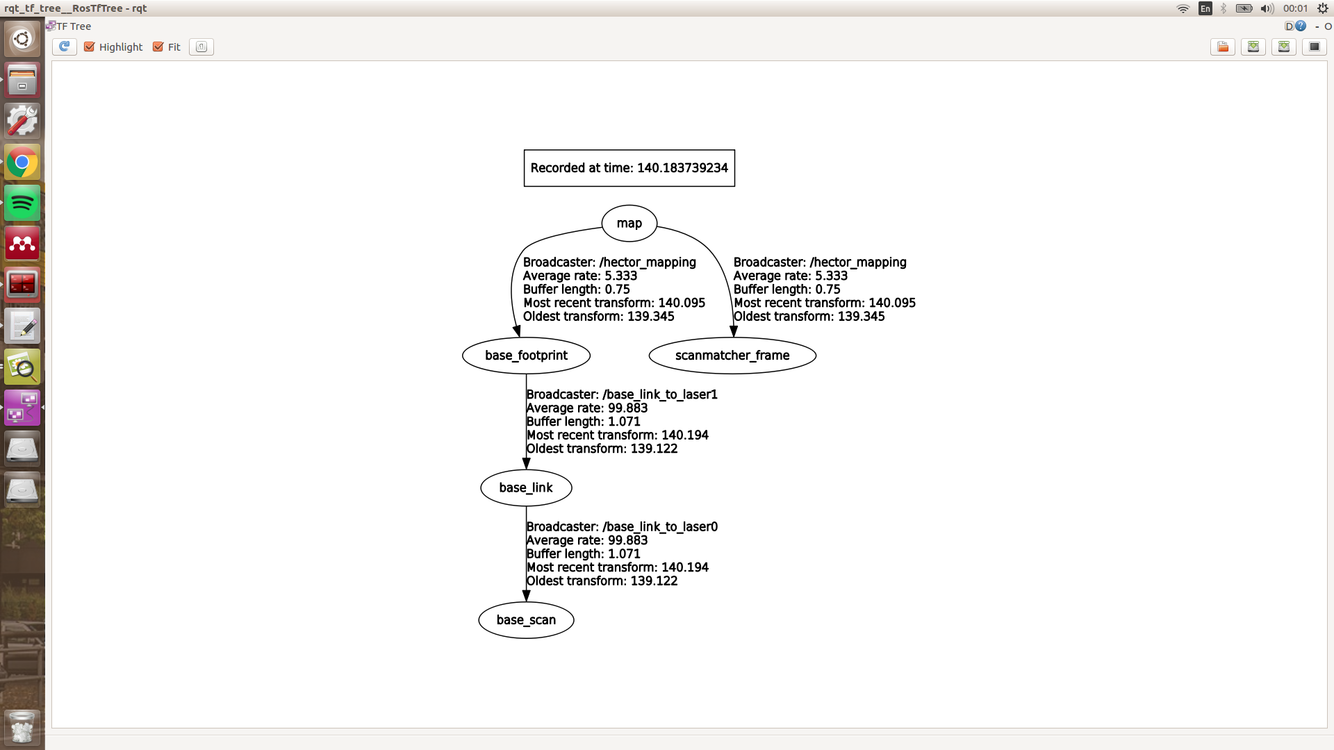

Figure 1: Rviz output (left) and TF tree (right)

**Important NOTE:** Hector_slam package needs specific transform tree(tf) configuration to work properly. In our case, required transformations are done by robot_state_publisher in launch files. For more information one can check [hector_slam tutorial.](http://wiki.ros.org/hector_slam/Tutorials/SettingUpForYourRobot)

**Important NOTE:** You can also use our launcher with a real data without saving as a rosbag file. LIDAR should publish to /scan topic by default, but it can be changed by modifying launch files mentioned before. However, one should set set /use_sim_time parameter as false while using real time data. On the other hand, it should be set true to use with rosbag files.