**Specifications for the Air Traffic Time Machine**

**1. Data**

Order TZ data : each trajectory needs to be uploaded

(to be done later)

**2. Map display**

- display trajectories and flight plans

- be able to select whether to display either the trajectories or the flight plans or both at once

- when we select a few trajectories within a radius of a latlon point, could we display the radius on the map?

**3. Statistics display**

**3.a. Simple trajectory statistics**

Compute :

- the actual flight distance : the length of the trajectory can be computed by summing the distances between each TZ point from 40 NM away from the departure airport to 40 NM close to the arrival airport

- the achieved distance 40 – 40 distance: distance (segment) between the first point 40 NM away from the departure airport and the last point 40 NM close to the arrival airport

- the achieved distance 40 – 100 distance: distance (segment) between the first point 40 NM away from the departure airport and the last point 100 NM close to the arrival airport

- the achieved distance 100 – 100 distance: distance (segment) between the first point 100 NM away from the departure airport and the last point 100 NM close to the arrival airport

- the great circle distance between departure and arrival airport minus 80 (40+40) NM

- the flight time from the TZ point from 40 NM away from the departure airport to the TZ point 40 NM close to the arrival airport

- the flight time from the TZ point from 40 NM away from the departure airport to the TZ point 100 NM close to the arrival airport

- the flight time from the TZ point from 100 NM away from the departure airport to the TZ point 100 NM close to the arrival airport

Plot :

- one the same plot: distance versus flight time for 40-40, 40-100, 100-100

For instance, the plot will be similar to this one, with the corresponding legend:

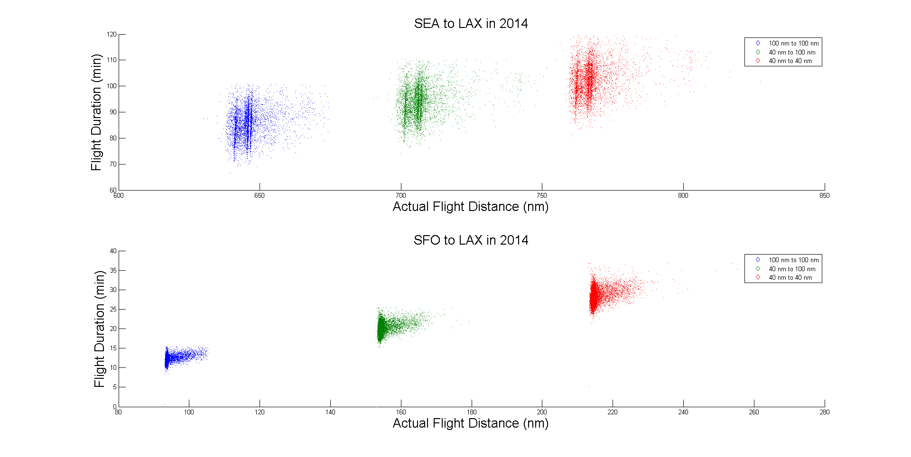

These basic statistics would be displayed automatically. I would like to be able to visualize them for all the data selected with elastic search : several city pairs, or one city pair, or just the trajectories selected manually with the radius search.

Next to the plots, we would like to display some numbers in a table next to the plots, such as:

* The average flight distance versus the average flight duration, for 40-40, 40-100, 100-100
* The standard deviation of the flight distance versus the standard deviation of the flight duration, for 40-40, 40-100, 100-100
* The spread in flight distance: the difference between the max flight distance and the min flight distance, for 40-40, 40-100, 100-100
* The spread in flight duration: the difference between the max flight duration and the min flight duration, for 40-40, 40-100, 100-100
* Some percentages: the spread in flight distance is x % of the average flight distance, and the spread in flight duration is x % of the average flight duration

**3.b. Flow statistics**

Choose a flow definition

Number of flows

Average Trajectory in a flow

Best Achieved Trajectory in a flow

Number of outliers

Ideally, I would like to have a way to choose which flows to display.