Emmanuel Fabre
CS 210 – SDLC – Prof Chan
Final Project 2/22/2026

Final Project: Corner Grocer Item Tracker

The Corner Grocer Item Tracker is a C++ console app that reads a grocery item log from a file, counts the frequency of each item in the list, and provides an interactive menu for the user to query the data. The program uses object-oriented design, separating the program across three files: main.cpp, ItemTracker.h, and ItemTracker.cpp.

Class Design: ItemTracker
This is the program’s core, as declared in ItemTracker.h. I used encapsulation with private data members and public methods.
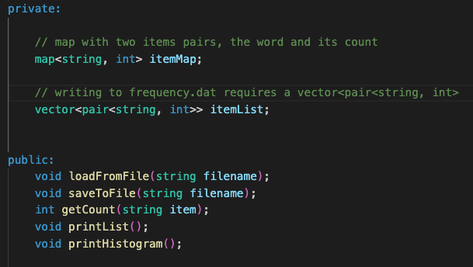

File I/O:
loadfromFile() opens the input file CS210_Project_Three_Input_File.txt using ifstream, reads each line with getline(), strips Windows ‘returns’ (\r), and increments the item’s count in itemMap using the map’s operator []. Then, it populates itemList using push_back(). saveToFile creates frequency.dat using ofstream, and writes each item and its count.
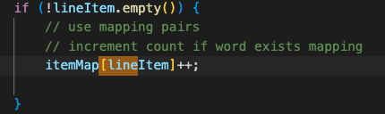
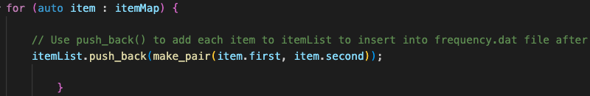

Main.cpp Menu Loop:
main.cpp instantiates an ItemTracker object, loads and saves the data, then enters a while loop that continues until the user enters 4 to quit. Aside from the quit option, here are the other menu options:
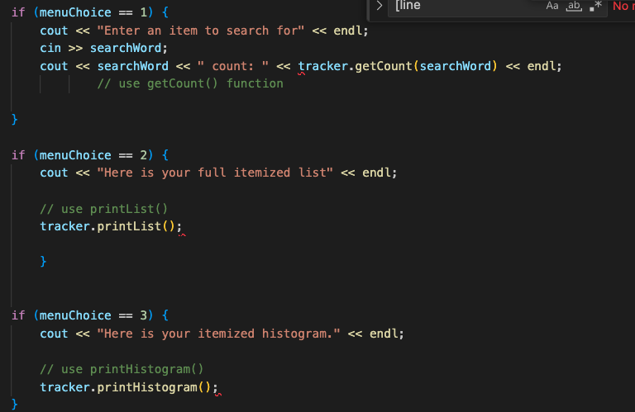

Histogram Output:
printHistogram() uses a nested for loop. The outer loop iterates over itemMap, while the inner loop runs once per count, printing an asterisk (*) for each occurrence.
