KUMASI TECHNICAL UNIVERSITY
FACULTY OF APPLIED SCIENCES AND TECHNOLOGY
COMPUTER SCIENCE DEPARTMENT

TOPIC
KOMFO ANOKYE IT TAST MANAGEMENT SYSTEM
A PROJECT SUBMITTED TO THE COMPUTER SCIENCE DEPARTMENT
IN PARTIAL FULFILLMENT OF THE REQUIREMENT FOR THE AWARD OF
YOUR NAME
Your name here
INDEX NUMBER
Your index number here

ACKNOWLEDGEMENT
I would like to express my sincere gratitude to God Almighty for giving me the strength, knowledge and guidance throughout the development of this project.
I am grateful to my lecturers and supervisors for their guidance, corrections and valuable suggestions throughout the project. Their support and advice helped me improve both the technical and academic aspects of this work.
I also wish to express my appreciation to the management and staff of Komfo Anokye Teaching Hospital (KATH), especially the IT department, for providing me with the opportunity to undertake my industrial attachment and for the experience and knowledge gained during the period.
I am also thankful to my colleagues, friends and family members for their encouragement, support and assistance throughout the project.
Finally, I appreciate everyone who contributed directly or indirectly to the successful completion of this project. May God bless you all.

ABSTRACT
Information Technology plays an important role in supporting the daily activities of healthcare institutions. However, when IT tasks and technical problems are recorded manually or in different locations, it can be difficult to monitor the activities performed by IT staff and identify common technical problems. This project therefore focused on the development of a Web-Based IT Task Management and Reporting System for Komfo Anokye Teaching Hospital (KATH).
The system was developed to provide a centralized platform where IT staff can record tasks they perform, update task progress and view their task history. Administrators and supervisors can manage IT staff, departments, task categories and task records. The system also provides dashboards, reports and simple statistics to help identify common IT problems and areas requiring more attention.
The system was developed using PHP, MySQL, HTML, CSS, Bootstrap and JavaScript, with XAMPP used as the development environment. Testing showed that the main functions of the system, including user authentication, task submission, task management, status tracking, searching, reporting and dashboard statistics, worked successfully. The system can therefore improve the documentation and monitoring of IT activities and support better decision-making within the IT department.
Keywords: IT Task Management, IT Support, Reporting System, Web-Based System, KATH, MySQL.

Table of Contents
ACKNOWLEDGEMENT 1
ABSTRACT 3
CHAPTER ONE 8
INTRODUCTION 8
1.0 Introduction 8
1.1 Background of the Study 9
1.2 Problem Statement 9
1.3 Aim of the Study 10
1.4 Objectives of the Study 10
1.5 Significance of the Study 11
1.6 Limitations of the Study 11
1.7 Organization of the Study 12
1.8 Chapter Summary 13
CHAPTER TWO 14
LITERATURE REVIEW 14
2.0 Introduction 14
2.1 Concept of Information Technology Service Management 15
2.2 IT Support in Healthcare Institutions 15
2.3 IT Help Desk Systems 16
2.4 IT Incident Management 17
2.5 IT Task Management 18
2.6 Ticketing Systems 19
2.7 Categorization of IT Problems 19
2.8 Task Prioritization 20
2.9 Task Status Tracking 21
2.10 IT Knowledge and Documentation 21
2.11 IT Performance Monitoring 22
2.12 Reporting in IT Service Management 22
2.13 Data Analytics in IT Task Management 23
2.14 Information Systems and Organizational Decision-Making 23
2.15 Technology Acceptance and System Usability 24
2.16 Web-Based Information Systems 25
2.17 Database Management Systems 25
2.18 User Authentication and Access Control 26
2.19 Importance of Centralized IT Task Records 26
2.20 Review of Related Systems 27
2.21 Comparison of Existing Systems and the Proposed System 28
2.22 Theoretical Framework 29
2.23 Conceptual Framework of the Proposed System 30
2.24 Benefits of the Proposed System 30
2.25 Challenges Associated with IT Task Management Systems 31
2.26 Research Gap 32
2.27 Summary of Literature Review 32
CHAPTER THREE 34
METHODOLOGY AND SYSTEM DESIGN 34
3.0 Introduction 34
3.1 Research Methodology 34
3.2 System Development Methodology 34
Figure 3.1: Waterfall Development Model 35
3.3 Requirements Gathering 35
3.4 Analysis of the Existing System 36
3.5 Proposed System 36
3.6 Functional Requirements 36
3.7 Non-Functional Requirements 37
3.8 System Users 38
3.9 Use Case Description 38
Figure 3.2: Use Case Diagram 38
3.10 System Architecture 39
Figure 3.3: System Architecture 39
3.11 Database Design 39
Table 3.1: Main Database Tables 40
3.12 Database Relationship 40
Figure 3.4: Entity Relationship Diagram 41
3.13 Input Design 41
3.14 Output Design 41
3.15 System Process Flow 42
Figure 3.5: System Flowchart 42
3.16 Development Tools 42
Table 3.2: Development Tools 43
3.17 Security Design 43
3.18 Testing Approach 44
Table 3.3: Sample System Testing 44
3.19 System Requirements 45
Table 3.4: Hardware Requirements 45
Table 3.5: Software Requirements 45
3.20 Chapter Summary 46
CHAPTER FOUR 47
SYSTEM IMPLEMENTATION, TESTING AND RESULTS 47
4.0 Introduction 47
4.1 System Implementation 47
4.2 Development Environment 48
4.3 Database Implementation 48
4.4 Login and Authentication 49
4.5 Administrator Dashboard 50
4.6 Staff Dashboard 51
4.7 Task Submission 52
4.8 Task Categories 53
4.9 Department Management 53
4.10 System Security 54
4.11 System Testing 54
4.12 Functional Testing Results 55
4.13 User Interface Results 55
4.14 System Results 56
4.15 Comparison with the Existing Method 56
4.16 Achievement of System Objectives 57
4.24 Chapter Summary 57
CHAPTER FIVE 59
DISCUSSION, CONCLUSION AND RECOMMENDATIONS 59
5.0 Introduction 59
5.1 Summary of the Study 59
5.2 Summary of Findings 59
5.3 Discussion of Results 60
5.4 Achievement of Objectives 60
5.5 Advantages of the System 60
5.6 Challenges Encountered 61
5.7 Limitations of the System 61
5.8 Implications of the Study 61
5.9 Recommendations 62
5.10 Suggestions for Future Work 62
5.11 Conclusion 63
REFERENCES 64

CHAPTER ONE

INTRODUCTION

1.0 Introduction
Information Technology (IT) plays an important role in the effective operation of modern healthcare institutions. Hospitals depend on computer systems, networks, software applications, communication systems, CCTV systems and other IT infrastructure to support healthcare delivery and administrative activities. As the number of IT systems in a hospital increases, the need for effective management and documentation of IT support activities also becomes important.
Komfo Anokye Teaching Hospital (KATH) is a major healthcare institution where different IT-related activities are carried out to support the operations of various departments and units. These activities may include troubleshooting network problems, resolving GHIMS network issues, installing and maintaining computer systems, fixing printers, configuring IP addresses and DNS, maintaining CCTV systems, resolving software problems, and providing general technical support to staff.
During an industrial attachment at KATH, it was observed that IT staff handle different technical problems and tasks on a daily basis. However, when these activities are recorded manually or through informal methods, it may be difficult to maintain a complete history of the work performed. It may also be difficult for the IT department to determine the most common types of problems, departments requiring the most IT support, and the workload handled by individual staff members.
This project therefore proposes the development of a Web-Based IT Task Management and Reporting System for the IT department. The system will allow IT staff to log in and record the tasks they have performed. Tasks can be classified into categories such as networking, GHIMS network, CCTV, computer hardware, software installation, printer support and other IT-related activities. The system will also provide administrators with dashboards, statistics and reports to support better monitoring and decision-making.

1.1 Background of the Study
The increasing use of information technology in healthcare has made IT support an important part of hospital operations. Computer systems and networks are used to support communication, information management, patient-related systems, administrative processes and other hospital activities. When these systems experience problems, IT personnel are required to identify and resolve the problems as quickly as possible.
An IT department may handle several tasks within a single day. For example, an IT staff member may resolve a network connectivity problem in one department, another staff member may troubleshoot a printer, while another may work on a CCTV or GHIMS network problem. Without a centralized method of recording these activities, it can become difficult to track the tasks that have been performed.
Task documentation is useful because it creates a record of technical activities and allows an organization to review previous problems and solutions. It can also help supervisors monitor the workload of IT staff and identify areas that require additional attention or resources.
During the industrial attachment at Komfo Anokye Teaching Hospital, various IT activities were observed, including network troubleshooting, DNS and IP configuration, computer maintenance, Windows installation, printer troubleshooting, CCTV-related activities, access point configuration and GHIMS network support. These activities demonstrated the need for an organized system that can capture and manage IT tasks in one location.
The proposed system will therefore provide a centralized platform where IT staff can document their work while administrators can monitor, analyze and generate reports from the recorded information.

1.2 Problem Statement
The IT department of a large healthcare institution may handle numerous technical tasks across different departments every day. These tasks can range from simple computer and printer problems to more complex networking, CCTV, GHIMS and system-related issues.
When information about these tasks is recorded manually or using different methods, it can be difficult to maintain a complete and organized history of IT activities. This can make it challenging for supervisors to quickly determine the number of tasks completed, pending problems, types of problems frequently encountered and departments that require the most IT support.
The absence of a centralized IT task management system may also make it difficult to evaluate the workload of IT personnel and identify areas where additional resources, maintenance or technical support may be required.
Therefore, there is a need for a computerized system that can provide a centralized platform for recording, monitoring and analyzing IT support activities. The proposed IT Task Management and Reporting System is intended to address this problem by providing a structured way for IT staff to submit their completed tasks and for administrators to monitor and analyze the information.

1.3 Aim of the Study
The main aim of this project is to develop a web-based IT Task Management and Reporting System that will enable the IT department of Komfo Anokye Teaching Hospital to record, monitor and analyze IT support activities and technical problems.

1.4 Objectives of the Study
The specific objectives of the study are to:
- Develop a secure web-based system that allows IT staff to log in and record tasks they have performed.
- Provide a centralized database for storing information about IT tasks and technical problems.
- Categorize IT tasks into areas such as networking, GHIMS network, CCTV, hardware, software, printers and other IT services.

1.5 Significance of the Study
The proposed system will provide benefits to the IT department and the institution as a whole.
Benefit to the IT Department
The system will provide a centralized platform for recording IT tasks. IT staff will be able to document the problems they encounter and the solutions they provide. This will reduce dependence on informal or manual methods of recording activities.
Benefit to IT Supervisors
Supervisors will be able to monitor the activities of IT staff and view the status of reported tasks. The system will also help supervisors understand the workload of the IT team.
Benefit to the Institution
he system will provide information that can help the institution identify areas where IT support is frequently required. This information can support decisions concerning maintenance, equipment and other IT resources.
Benefit to IT Staff
IT staff will have access to records of previously handled tasks. This can make it easier to review previous problems and the solutions applied to them.

1.6 Limitations of the Study
The project may have some limitations.
First, the accuracy of the reports and statistics will depend on the information entered by IT staff. If staff fail to record their activities correctly or consistently, the resulting statistics may not fully represent the actual IT workload.
Second, the proposed system is primarily designed for managing IT support activities and does not replace specialized hospital systems such as GHIMS or other clinical applications.
Third, the initial implementation will be developed as a web-based system using PHP and MySQL and will initially run within an environment supported by XAMPP. Deployment on the hospital's production network may require additional configuration, security measures and approval from the appropriate authorities.
Finally, access to the system and its reports will depend on proper user authentication and authorization.

1.7 Organization of the Study
The project is organized into five main chapters.
Chapter One: Introduction presents the background of the study, problem statement, aim, objectives, research questions, significance, scope, limitations and methodology of the project.
Chapter Two: Literature Review discusses related concepts, technologies and existing systems related to IT task management, help desk systems, technical support management and reporting systems.
Chapter Three: Methodology and System Design explains the methodology used for the project and presents the system requirements, system architecture, database design, process diagrams and interface design.
Chapter Four: System Implementation and Results presents the implementation of the proposed system, including the development environment, system interfaces, database implementation and testing results.
Chapter Five: Discussion, Conclusion and Recommendations discusses the results of the project, summarizes the findings, presents the conclusion and provides recommendations for future improvements.

1.8 Chapter Summary
This chapter introduced the proposed Web-Based IT Task Management and Reporting System for Komfo Anokye Teaching Hospital. It discussed the background of the study and identified the challenges associated with documenting and monitoring IT support activities. The chapter also presented the aim, objectives, research questions, significance, scope and limitations of the study. The methodology and organization of the project were also outlined. The next chapter will review related literature and existing systems relevant to IT task management and reporting.

CHAPTER TWO

LITERATURE REVIEW

2.0 Introduction
This chapter presents a review of literature related to the development of the proposed Web-Based IT Task Management and Reporting System for Komfo Anokye Teaching Hospital (KATH). The purpose of the literature review is to examine existing knowledge, concepts, technologies, frameworks and related systems that are relevant to the management of information technology support activities. The chapter discusses information technology service management, IT help desk systems, incident management, task management, ticketing systems, IT support in healthcare institutions, information management, reporting and analytics, web-based systems, database management systems, user authentication and system usability. It also reviews existing related systems and identifies the gap that the proposed system seeks to address.
Information technology has become an important component of modern organizations because many organizational activities depend on computers, networks, software applications, databases and communication infrastructure. Healthcare institutions are particularly dependent on information systems because IT supports both clinical and administrative activities. Consequently, when network infrastructure, computers, software applications, printers or other IT services experience problems, the ability of staff to perform their duties may be affected. Effective IT support therefore requires not only technical skills but also proper recording, monitoring and management of support activities.
IT service management provides a structured approach to managing IT services and supporting users. Service desk and incident management practices are particularly relevant because they provide mechanisms for receiving, recording, classifying, prioritizing, resolving and closing IT-related issues. Literature on IT service management indicates that centralized help desk systems can improve the organization of support requests and provide information that can be used to measure IT performance [1], [2]. The proposed system applies these principles to the specific environment of KATH by focusing on the recording and analysis of tasks performed by IT personnel.

2.1 Concept of Information Technology Service Management
Information Technology Service Management, commonly referred to as ITSM, is concerned with the planning, delivery, management and continuous improvement of IT services provided to users within an organization. ITSM moves beyond simply maintaining computers and networks and focuses on ensuring that IT services support the operational needs of the organization.
According to the literature on healthcare information systems management, IT departments in healthcare facilities are responsible for activities such as maintaining servers, networks, computers and printers, providing service desk support and ensuring that information systems remain available to users [2]. These activities are particularly important in healthcare because interruptions to information systems can affect the ability of healthcare workers to perform their duties.
ITSM provides a structured approach to managing these activities. The Information Technology Infrastructure Library (ITIL) is one of the best-known frameworks associated with IT service management. ITIL provides practices for areas such as service desk, incident management, problem management, service request management, monitoring and measurement [2], [3]. The purpose of these practices is to ensure that IT services are delivered in a controlled and organized manner.
The proposed KATH IT Task Management and Reporting System is related to ITSM because it provides a centralized platform for documenting IT support activities. Although the proposed system is not intended to implement the complete ITIL framework, it incorporates some relevant concepts such as task logging, categorization, prioritization, status tracking, documentation and reporting.

2.2 IT Support in Healthcare Institutions
Healthcare institutions depend heavily on information technology to support their daily activities. Computers, networks, hospital information systems, printers, communication systems and other digital infrastructure are used by different departments. IT support personnel are therefore responsible for ensuring that these systems remain functional and available to users.
Healthcare information systems require operational support that includes maintaining computer systems, supporting networks, managing user accounts and responding to technical incidents. Research on information systems management in healthcare facilities indicates that operational support may include service desk operations, server maintenance, network maintenance and repair of computers and printers [2]. Because healthcare services can depend on the availability of information systems, systematic IT service management is particularly important in healthcare environments [2].
At a hospital such as KATH, different departments may have different IT requirements. One department may experience a network connectivity problem while another may have a printer problem or require assistance with a hospital information system. CCTV systems, wireless access points, computers, network cables, IP configurations and software applications may also require technical support.
The diversity of these activities creates a need for proper documentation. If IT support activities are recorded systematically, the organization can maintain a history of problems and solutions. Such information can help IT personnel understand recurring problems and enable management to identify areas that require additional technical resources.
The proposed system is designed around this requirement. Instead of allowing IT staff to depend on separate notebooks, informal records or memory to document their activities, the system provides a centralized electronic platform where tasks can be entered and stored in a database.

2.3 IT Help Desk Systems
An IT help desk system is a computerized system that facilitates communication between users requiring technical assistance and IT personnel responsible for providing support. Help desk systems are commonly used in organizations where users regularly experience technical problems or require IT services.
Al-Hawari and Barham explained that a help desk system can serve as a single point of contact between users and IT staff. Such systems can support the management of tickets and automate activities such as assigning, classifying, prioritizing, resolving and closing IT incidents [1]. A help desk can therefore provide an organized method for managing IT support activities.
Traditional IT support environments may rely on telephone calls, direct communication, paper records, instant messaging or verbal reports. Although these methods can be useful for immediate communication, they may not provide an organized historical record of all support activities. A computerized help desk system can centralize these records and make them easier to search and analyze.
The proposed KATH system follows the general concept of a help desk system but focuses particularly on IT task documentation and institutional reporting. The system allows IT staff to record the work they have performed rather than focusing only on requests submitted by hospital users. This distinction is important because the purpose of the project is not only to resolve individual IT incidents but also to help the institution understand the overall IT workload and areas of technical activity.

2.4 IT Incident Management
An IT incident can generally be described as an event that interrupts or reduces the quality of an IT service. Examples include a computer that cannot connect to a network, a printer that does not print, a failed software application, a faulty CCTV camera or a network connection problem.
Incident management is an important part of IT service management. Its purpose is to restore normal IT service as quickly as possible and reduce the negative effect of incidents on users. ITIL-related literature identifies activities such as incident identification, logging, classification, prioritization, assignment, diagnosis, resolution and closure as important elements of incident management [1], [2].
A computerized task or ticket management system can support these activities by ensuring that every reported task has a record. For example, when a networking problem occurs, the issue can be recorded with a unique task number. The task can then be classified under the networking category, assigned an appropriate priority and updated as work progresses.
The proposed system incorporates these concepts by allowing staff to record the problem description, work performed, priority and status. The status can be changed from pending to in progress and eventually to completed. This provides a simple history of the technical work.
Incident management is especially important in a healthcare environment because IT problems can affect the operations of hospital departments. A systematic record of incidents can help IT management identify recurring problems and determine where preventive maintenance may be required.

2.5 IT Task Management
IT task management refers to the process of creating, recording, organizing, monitoring and completing tasks associated with IT support and maintenance activities. An IT task may be initiated because of a user request, a system failure, scheduled maintenance or an identified technical problem.
Task management is important because IT staff may handle several activities within a single day. Without proper documentation, it can be difficult to determine which tasks have been completed and which remain outstanding. A centralized task management system provides a structured record of these activities.
The proposed system allows IT staff to enter a task title, department, category, problem description, work performed, priority, status and relevant dates. This information creates a structured record of the activity. The administrator can subsequently view the task and use the stored information for monitoring and reporting.
Task management also supports accountability. When each task is associated with the staff member who handled it, supervisors can understand the distribution of workload. This does not necessarily mean that the system is intended to punish staff based on the number of tasks completed. Instead, the information can help management understand workload patterns and identify areas where additional personnel or resources may be needed.

2.6 Ticketing Systems
Ticketing is a common technique used by IT support systems to represent individual support requests or incidents. Each ticket normally receives a unique identification number and contains information about the problem, user, category, priority, status and resolution.
A ticketing system makes it easier to track an issue from the time it is reported until it is resolved. Al-Hawari and Barham identified ticket opening, classification, prioritization, assignment, resolution, documentation and closure as important functions in help desk systems [1].
The proposed system will use a similar concept. Each IT task will automatically receive a unique reference number, such as KATH-IT-000001. This number will make it easier to identify and retrieve a particular task.
The system will also maintain task history. When an IT staff member adds an update to a task, the update will be stored with the date and the identity of the staff member. This creates an audit trail of the work performed.
Ticketing systems are particularly useful when an organization handles a large number of technical issues. Instead of relying on memory or scattered records, the organization can search the database using the task number, department, category, staff member, priority or status.

2.7 Categorization of IT Problems
Categorization involves grouping IT problems according to their type or service area. Proper categorization makes it easier to understand the types of problems occurring within an organization.
For the proposed KATH system, IT tasks will be categorized into areas such as networking, GHIMS network, CCTV, computer hardware, software installation, Windows/operating system, printer support, DNS/IP configuration, user account/domain, telephone and communication, network cabling, access point/Wi-Fi, IT security and general IT support.
Categorization is important because it allows the organization to identify trends. For example, if the system records a large number of networking tasks over several months, management may investigate whether the network infrastructure requires improvement. Similarly, frequent printer-related tasks may indicate the need for better maintenance or replacement of equipment.
Research on help desk systems has also identified ticket classification as an important issue. Al-Hawari and Barham noted that classification can be challenging and that appropriate classification supports better ticket handling and performance measurement [1]. The proposed system therefore provides predefined categories while allowing the administrator to manage the available categories.

2.8 Task Prioritization
Not all IT problems have the same level of importance. Some technical problems may have a minor effect on users, while others may affect an entire department or an important hospital service.
Task prioritization allows IT staff or supervisors to indicate the urgency of a problem. The proposed system will use four priority levels: Low, Medium, High and Critical.
A low-priority task may involve a minor problem that does not significantly interrupt the user's work. A medium-priority task may affect an individual user but still allow some work to continue. A high-priority task may affect an important department or multiple users. A critical task may involve a major IT service disruption requiring immediate attention.
Prioritization helps IT personnel organize their workload. It also provides useful information for reporting. For example, administrators can determine how many critical tasks occurred during a particular period.
In a healthcare environment, prioritization can be particularly important because the effect of an IT problem may vary depending on the department and system involved. A network problem affecting a large department may require faster attention than a minor issue affecting one workstation.

2.9 Task Status Tracking
Task status tracking is the process of monitoring the current state of an IT task. Common statuses include pending, in progress and completed. A cancelled status can also be used when a task is no longer required.
Status tracking provides visibility into the progress of IT activities. An administrator can quickly determine how many tasks have been completed and how many remain outstanding.
The proposed system will allow IT staff to update the status of their tasks. When a problem is first recorded, it may be marked as pending. Once technical work begins, it can be changed to in progress. After the problem has been resolved, the task can be marked as completed.
This approach provides a simple workflow that is suitable for the mini-project and can also be expanded in future versions. The system can therefore provide a historical record of task progress without requiring a complex workflow engine.

2.10 IT Knowledge and Documentation
Documentation is an important component of IT support because technical knowledge can be lost when problems and solutions are not properly recorded. An IT staff member may solve a particular problem today, but another staff member may encounter the same problem several months later.
Research on IT maintenance has emphasized the importance of organization-specific knowledge in IT service support and maintenance [4]. Such knowledge includes information about internal operations, systems and technical environments. When this knowledge is properly captured, it can become useful to other members of the IT team.
The proposed system supports knowledge documentation by allowing staff to record the problem encountered and the work performed. For example, if a staff member resolves a DNS configuration problem, the task record can contain information about the symptoms and solution. Future staff can potentially review previous records to understand how similar problems were handled.
The system is not intended to replace a complete knowledge management system. However, the historical task records can serve as a useful source of technical knowledge for the IT department.

2.11 IT Performance Monitoring
Performance monitoring involves collecting and analyzing information about IT activities to determine how effectively the IT department is performing its responsibilities.
A help desk system can support performance measurement through reports and key performance indicators. Research on help desk systems has identified the ability to generate reports and measure IT process indicators as an important feature [1].
The proposed system will provide an administrator dashboard containing statistics such as total tasks, completed tasks, pending tasks, tasks in progress and critical tasks. It will also provide statistics based on categories, departments and staff.
For example, management may be able to determine that networking problems represent the largest proportion of recorded IT tasks. This information can support discussions about network maintenance, equipment replacement or additional technical resources.
Staff workload can also be examined. If one IT staff member is consistently assigned or records a large number of tasks, management may investigate whether workload is appropriately distributed. Again, the purpose is to provide information for better management rather than simply ranking employees.

2.12 Reporting in IT Service Management
Reporting is the process of presenting collected information in a form that can support decision-making. In IT service management, reports may include the number of incidents, resolution status, incident categories, response times, workloads and other performance indicators.
A computerized system provides an advantage because reports can be generated directly from stored database records. Instead of manually counting tasks from paper records, the administrator can select a date range and obtain the required information.
The proposed KATH system will allow administrators to filter reports by date, staff member, department, category, priority and status. The resulting information can be displayed in a table and prepared for printing or export.
Reporting will also support historical analysis. For example, the IT department may compare task activity during different months to identify changes in workload. The organization may also identify departments that frequently require IT assistance.

2.13 Data Analytics in IT Task Management
Data analytics involves examining stored data to identify patterns, trends and useful information. In an IT task management system, analytics can help transform individual task records into information that can support organizational decisions.
For example, if 500 task records are stored in the system, the administrator may want to know how many relate to networking, CCTV, GHIMS, hardware or software. A dashboard can automatically calculate these values and display them using charts.
The proposed system will use simple statistical analysis and charts rather than advanced artificial intelligence. Chart-based visualization can make the information easier to understand. A category chart can show the distribution of IT tasks, while a monthly chart can show whether task volume is increasing or decreasing.
Historical records can also help identify recurring problems. If a particular department repeatedly reports the same type of network problem, the IT department can investigate whether the underlying infrastructure needs improvement.

2.14 Information Systems and Organizational Decision-Making
Information systems are important because they provide organizations with information that can support operational and managerial decisions. A system is more valuable when the information it produces is accurate, relevant and useful.
The DeLone and McLean Information Systems Success Model provides a widely used framework for evaluating information system success. The model considers factors such as system quality, information quality, service quality, use, user satisfaction and net benefits [5]. Research has continued to use and extend this model for evaluating information system effectiveness [6].
The proposed KATH system can be considered from this perspective. System quality relates to whether the application is reliable, usable and functional. Information quality relates to whether the task information recorded by staff is accurate, complete and useful. User satisfaction relates to whether IT staff and administrators find the system useful and easy to use. Net benefits relate to the extent to which the system improves IT task documentation, monitoring and reporting.
Therefore, the proposed system should not only store information but should provide information that is useful to the IT department.

2.15 Technology Acceptance and System Usability
The success of an information system also depends on whether its intended users are willing and able to use it. A technically functional system may not provide significant benefits if users find it difficult to operate.
Davis introduced the Technology Acceptance Model (TAM) to explain factors that influence people's acceptance of information technology. The model emphasizes perceived usefulness and perceived ease of use as important factors affecting technology acceptance [7]. Later studies have continued to examine and apply TAM in different technology contexts [8].
For the proposed KATH system, usability is important because IT staff will need to enter task information regularly. If the task submission process is too complicated, staff may be less willing to use the system.
The interface will therefore be designed to be simple and understandable. The staff dashboard will contain clear navigation options such as Dashboard, Submit Task, My Tasks, Profile and Logout. The task form will use familiar fields such as task title, department, category, problem description, work done, priority and status.
The system will also use responsive design so that it can be accessed on different screen sizes. This supports ease of use and can encourage consistent adoption by users.

2.16 Web-Based Information Systems
A web-based information system is an application that users access through a web browser. Web-based systems have become common because they allow users to access applications without installing specialized software on every computer.
The proposed system will be web-based and will use PHP for server-side processing, MySQL for database management, HTML and CSS for the interface, Bootstrap for responsive design and JavaScript for client-side functionality.
A web-based approach is suitable for this project because IT staff can access the system through computers connected to the appropriate network. It also makes centralized data management possible because task information can be stored in one database.
The proposed system will initially be developed and tested using XAMPP. XAMPP provides Apache and MySQL components that allow PHP applications to be developed locally. Once tested and approved, the system could potentially be deployed on an institutional server subject to the appropriate security and infrastructure requirements.

2.17 Database Management Systems
A database management system is software used to create, store, organize, retrieve and manage data. Databases are important for information systems because they provide structured storage and allow applications to retrieve information efficiently.
The proposed system will use MySQL as its database management system. MySQL is appropriate for this project because it supports relational database structures and can be integrated with PHP applications.
The database will contain tables such as users, departments, categories, tasks and task updates. Relationships between these tables will allow the system to associate each task with the staff member who submitted it, the department where the work was performed and the category of the IT problem.
A centralized relational database also allows administrators to search historical records. For instance, the administrator can retrieve all networking tasks recorded for a particular department during a selected period.

2.18 User Authentication and Access Control
User authentication is the process of verifying the identity of a person attempting to access a system. Access control determines what an authenticated user is allowed to do.
The proposed system will use username and password authentication. Passwords will not be stored as plain text. Instead, PHP password hashing functions will be used to protect stored credentials.
The system will also implement role-based access control. Two major roles will be provided: administrator and IT staff. Administrators will have access to management functions, while IT staff will have access to task submission and their own task records.
Role-based access is important because not every user should be able to modify system settings or access all information. For example, an IT staff member should not be able to create another administrator account or modify system categories without authorization.
Security is particularly important in a healthcare environment because information systems may contain sensitive organizational information. Although the proposed system will not store patient medical records, it should still follow basic security practices such as authentication, authorization, input validation, password hashing and protection against SQL injection.

2.19 Importance of Centralized IT Task Records
Centralization refers to storing information in a common system rather than keeping it in multiple separate locations. Centralized IT task records can provide several benefits to an organization.
First, centralization improves accessibility. Authorized users can retrieve task information from one system rather than searching through different files or notebooks.
Second, centralization improves consistency. All staff members can use the same categories, task statuses and priority levels.
Third, centralization supports reporting. Since the information is stored in a structured database, the system can automatically calculate statistics.
Fourth, centralization supports historical analysis. Previous tasks can be searched to identify recurring technical issues.
Finally, centralization can improve accountability because each task is associated with a user and timestamp.
These benefits support the main purpose of the proposed KATH system, which is to provide a centralized record of IT activities.

2.20 Review of Related Systems
Several systems and studies have explored the use of computerized platforms for managing IT support activities.
Al-Hawari and Barham developed a machine learning-based help desk system for IT service management. Their system was designed to serve as a single point of contact between users and IT staff and supported activities such as ticket classification, prioritization, assignment, resolution, documentation and closure. The study also emphasized reporting and key performance indicators for evaluating IT processes [1]. This work is closely related to the proposed KATH system because both systems recognize the importance of centralized IT task records and reporting.
A study of IT incident management at the University of Oviedo examined IT incidents across multiple academic environments. The study analyzed incidents over several academic years and demonstrated how incident records can provide information for understanding patterns of IT problems and supporting decision-making [9]. This supports the idea that systematically recorded IT incidents can provide useful organizational information.
A recent study on a Technical Support Management Solution at Accra Technical University examined the use of a centralized technical support system to address challenges related to support requests, technician assignments and reporting. The proposed solution was intended to streamline technical support workflows and improve operational efficiency [10]. The study is particularly relevant to the Ghanaian context because it demonstrates that educational institutions in Ghana can benefit from computerized technical support management.
Another related project, TISSA, was developed as a web-based helpdesk support system for tertiary institutions. The system focused on managing technological inquiries and communication while also using historical ticket data for forecasting [11]. This demonstrates how help desk records can provide information beyond individual issue resolution and can potentially support planning.
Research into IT maintenance has also highlighted the importance of organization-specific technical knowledge. Organizations may possess technical knowledge about their internal systems, infrastructure and operating environment that needs to be captured and managed [4]. A task management system can contribute to this knowledge base by preserving information about problems and solutions.

2.21 Comparison of Existing Systems and the Proposed System
Existing help desk systems provide useful ideas for the development of the proposed KATH system. Many existing systems focus on users submitting service requests to an IT department, after which support staff classify, assign and resolve the requests. The proposed system will adopt some of these principles but will place greater emphasis on recording the work performed by IT staff and analyzing the institution's IT workload.
For example, the system developed by Al-Hawari and Barham includes advanced features such as automatic ticket classification and performance measurement [1]. While such features demonstrate the possibilities of modern help desk systems, they may be unnecessarily complex for the current mini-project. The proposed system will instead use predefined categories that IT staff can select when submitting tasks.
The proposed KATH system will also focus specifically on categories relevant to the observed hospital IT environment. These include GHIMS network problems, networking, CCTV, computer hardware, printer support, DNS/IP configuration, access points, software installation and general IT support.
Another difference is the emphasis on institutional reporting. The proposed system will allow administrators to determine which categories and departments generate the most IT activity. This can help the institution understand where technical resources are most frequently required.

2.22 Theoretical Framework
The proposed system can be supported by the DeLone and McLean Information Systems Success Model and the Technology Acceptance Model.
The DeLone and McLean model is relevant because the proposed system needs to provide useful information and achieve organizational benefits. System quality will be reflected in the reliability, functionality and usability of the web application. Information quality will depend on the completeness and accuracy of task records. User satisfaction will depend on whether staff find the system useful and easy to operate. The overall benefit will be reflected in improved task documentation, monitoring and reporting [5], [6].
The Technology Acceptance Model is also relevant because the system depends on regular use by IT staff. According to TAM, perceived usefulness and perceived ease of use are important factors influencing technology acceptance [7]. Therefore, the proposed system will be designed so that staff can submit a task with minimal difficulty while administrators can quickly obtain useful information from the dashboard.
These two theoretical perspectives complement each other. TAM focuses more strongly on user acceptance, while the DeLone and McLean model provides a broader perspective for evaluating information system success.

2.23 Conceptual Framework of the Proposed System
The conceptual framework of the proposed system is based on the relationship between IT staff activities, task information, system processing, database storage, and management information.
The first component is the input. IT staff provide information such as the task title, department, category, problem description, work performed, priority, status and dates.
The second component is processing. The system validates the information, generates a unique task number and stores the information in the MySQL database. The system also processes the stored records to produce statistics.
The third component is storage. The database stores users, departments, categories, tasks and task updates. This provides a centralized repository for IT task information.
The fourth component is output. The system produces dashboards, charts, task lists and reports. These outputs provide information that administrators can use to understand IT activities.
The final component is decision-making. Management can use the information generated by the system to identify common IT problems, departments requiring frequent support and areas where additional resources may be needed.

2.24 Benefits of the Proposed System
The proposed system is expected to provide several benefits to the IT department of KATH.
One major benefit is improved documentation. Instead of relying on informal records, IT staff will have a centralized platform for documenting their activities.
Another benefit is improved monitoring. Administrators can see which tasks are pending, in progress or completed. This provides better visibility into the current IT workload.
The system will also support historical analysis. Previous tasks can be searched to determine whether particular technical problems occur repeatedly.
Another benefit is improved reporting. Administrators can generate reports based on categories, departments, staff, priorities and dates.
The system can also support resource planning. If reports show that networking problems occur frequently, the institution can investigate whether additional networking equipment, maintenance or technical personnel may be required.
The system may also improve knowledge sharing because staff can review previous task descriptions and solutions. This can be particularly useful when a similar technical problem occurs in the future.

2.25 Challenges Associated with IT Task Management Systems
Although computerized IT task management systems provide many benefits, they can also present challenges.
One challenge is user adoption. If IT staff do not consistently record their activities, the database will not accurately represent the actual workload. This makes system usability and user acceptance important considerations.
Another challenge is data quality. Incorrect categories, incomplete descriptions or inaccurate task statuses can affect the quality of reports. The system should therefore use validation and clearly defined fields.
Security is another challenge. Unauthorized users must not be allowed to access administrative functions or modify task information without permission.
Another challenge is infrastructure availability. A web-based system depends on the availability of the server and network infrastructure. If the system is deployed on an institutional network, appropriate backup and maintenance arrangements will be required.
There may also be challenges associated with integrating the proposed system with existing hospital systems. The initial project will therefore operate as an independent IT task management platform rather than attempting to replace or directly modify existing hospital applications.

2.26 Research Gap
The reviewed literature demonstrates that IT help desk and service management systems can support incident recording, categorization, prioritization, assignment, resolution, documentation and reporting [1], [2]. Existing systems have also demonstrated the usefulness of centralized technical support records for performance measurement and decision-making [9]–[11].
However, many existing help desk systems are designed primarily around users reporting problems to IT staff. The proposed project has a slightly different focus. It is intended to provide KATH with a system through which IT staff themselves can document the technical work they perform across different hospital departments.
The project also focuses on categories that are relevant to the observed KATH IT environment, including networking, GHIMS network problems, CCTV, computer maintenance, printer support, DNS/IP configuration, software installation and other technical activities.
The proposed system therefore addresses the gap by combining task documentation, status tracking, categorization, staff records, departmental information, analytics and reporting in a relatively simple web-based platform. The system is designed to help the institution understand not only individual technical problems but also the broader pattern of IT support activities.

2.27 Summary of Literature Review
This chapter reviewed concepts and previous studies related to the development of the Web-Based IT Task Management and Reporting System for KATH. The review established that IT service management provides a structured approach to managing IT services and that service desk and incident management practices are important for recording, categorizing, prioritizing and resolving technical problems.
The chapter also discussed IT task management, ticketing, categorization, prioritization, status tracking, knowledge documentation, performance monitoring and reporting. The importance of web-based systems, relational databases, authentication and usability was also examined.
Related systems demonstrated that centralized help desk platforms can improve the management of IT support activities and provide useful information for measuring IT performance. Studies also showed that recorded IT incidents can support decision-making and identify patterns in technical problems.
The literature further indicated that system usefulness and ease of use are important for successful adoption, while system quality and information quality contribute to overall information system success. These findings have influenced the design of the proposed KATH system.
The major gap identified is that many existing systems focus primarily on managing user-submitted support requests, whereas the proposed system emphasizes documenting the actual IT tasks performed by staff and using the collected information to understand the institution's IT workload and support needs. The next chapter will present the methodology, system requirements and design of the proposed system.

CHAPTER THREE

METHODOLOGY AND SYSTEM DESIGN

3.0 Introduction
This chapter explains the methodology used to develop the proposed Web-Based IT Task Management and Reporting System for Komfo Anokye Teaching Hospital (KATH). It describes how information was gathered, the requirements of the system, the development methodology, system design, database design and technologies used to develop the system.

3.1 Research Methodology
The project adopted an observational and development-based approach. Observation was used during the industrial attachment at Komfo Anokye Teaching Hospital to understand the activities performed by IT staff and the challenges associated with recording and monitoring those activities.
During the attachment, different IT activities were observed, including networking support, GHIMS network problems, computer maintenance, printer troubleshooting, Windows installation, CCTV-related activities, DNS and IP configuration, access point configuration and other technical support activities. The observations helped identify the need for a centralized system for recording IT tasks.
The information obtained from the observation was used to determine the requirements and features of the proposed system.

3.2 System Development Methodology
The Waterfall Model was selected for the development of the system. The Waterfall Model provides a simple step-by-step approach where development activities are completed in stages. It was selected because the requirements of the proposed system are relatively clear and the project is suitable for a structured development process.
The main stages used are requirements analysis, system design, implementation, testing and deployment.

Figure 3.1: Waterfall Development Model
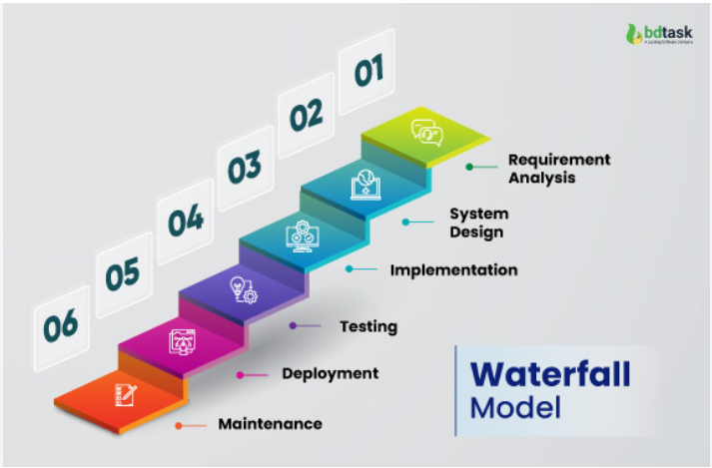

3.3 Requirements Gathering
The requirements of the system were identified mainly through observation during the industrial attachment. The activities performed by IT personnel were studied to understand the types of tasks that needed to be recorded.
The proposed system requires IT staff to log in and submit information about tasks they have performed. Administrators require access to all submitted tasks so that they can monitor activities and generate reports. These requirements formed the basis for the system design.

3.4 Analysis of the Existing System
The existing approach to recording IT activities may involve manual documentation, verbal communication or separate records. Such methods can make it difficult to maintain a centralized history of all IT activities.
It may also be difficult to quickly determine how many networking, CCTV, GHIMS or hardware-related tasks have been handled. Similarly, identifying departments that frequently require IT support may require manually reviewing several records.
The proposed system addresses these limitations by providing one centralized database where IT staff can record their activities and administrators can retrieve and analyze the information.

3.5 Proposed System
The proposed system is a web-based application that will allow IT staff to record and manage their daily IT tasks. Each task will contain information such as the task title, department, IT category, problem description, work performed, priority, status and date.
The system will store the information in a MySQL database. Administrators will be able to view all tasks and use filters and reports to understand the IT workload. The system will also provide dashboard statistics and charts showing task distribution by category, department and status.

3.6 Functional Requirements
The functional requirements describe what the system should be able to do.
Requirement | Description
User Login | The system shall allow authorized users to log in.
Staff Management | The administrator shall be able to add, edit and deactivate IT staff accounts.
Task Submission | IT staff shall be able to submit IT tasks.
Task Management | Users shall be able to view and manage permitted tasks.
Task Categorization | Tasks shall be categorized according to the type of IT problem.
Status Management | Tasks shall have statuses such as Pending, In Progress and Completed.
Search and Filter | Users shall be able to search and filter task records.
Reports | Administrators shall be able to generate task reports.
Analytics | The system shall provide statistics and charts.
Department Management | Administrators shall be able to manage departments.
Category Management | Administrators shall be able to manage IT categories.
Logout | Users shall be able to securely log out of the system.

3.7 Non-Functional Requirements
The system should be easy to use and should respond reasonably quickly to user requests. It should also provide security by preventing unauthorized users from accessing restricted functions.
The system should be reliable enough to store task information correctly and should be maintainable so that new categories, departments and features can be added in the future. It should also have a responsive interface that can work on desktop computers, tablets and mobile devices.

3.8 System Users
The system will have two main categories of users: Administrator and IT Staff.
The administrator will have full access to the management functions of the system. The administrator can manage staff, departments and categories, view all tasks, monitor task status and generate reports.
IT staff will have access to functions related to their work. They can submit tasks, view their tasks, update task information where permitted and view their personal task statistics.

3.9 Use Case Description
The main interaction between users and the system is shown in Figure 3.2.

Figure 3.2: Use Case Diagram
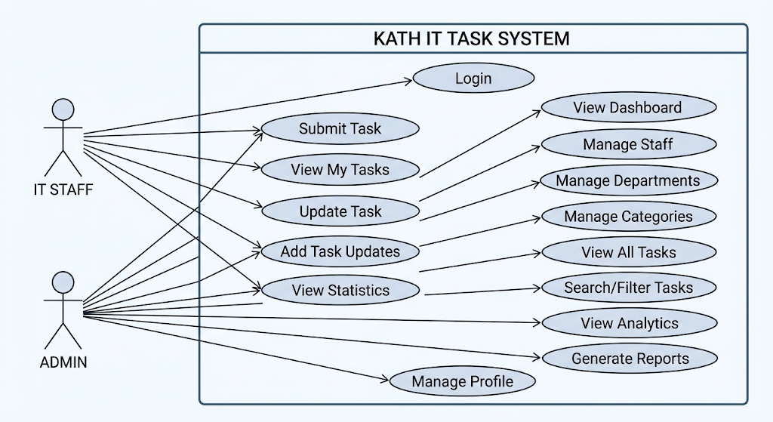

3.10 System Architecture
The proposed system will use a simple three-layer architecture consisting of the presentation layer, application layer and database layer.
The presentation layer will provide the user interface using HTML, CSS, Bootstrap and JavaScript. The application layer will contain the PHP code responsible for processing user requests and communicating with the database. The database layer will use MySQL to store users, departments, categories, tasks and task updates.

Figure 3.3: System Architecture
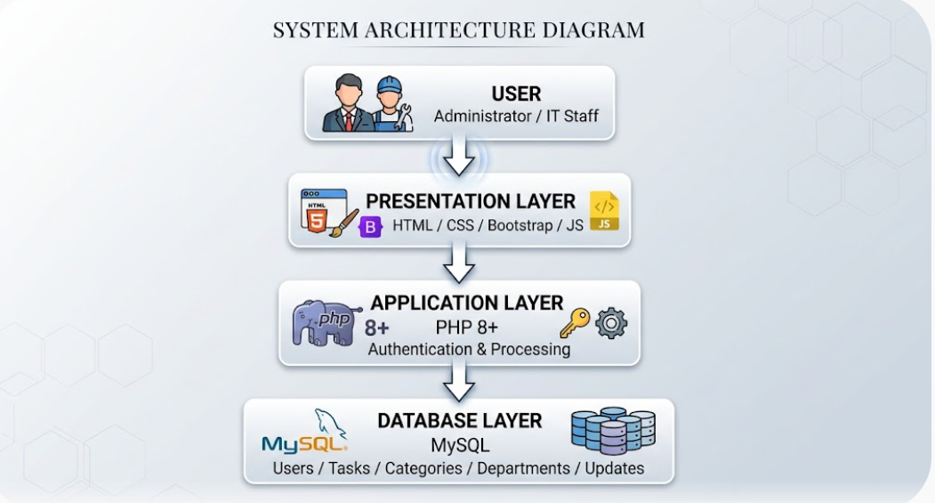

3.11 Database Design
The database will be created using MySQL through XAMPP/phpMyAdmin. The database will be named kath_it_task_management.
The database will contain tables for users, departments, categories, tasks and task updates. The users table will store information about administrators and IT staff. The departments table will contain hospital departments, while the categories table will store the different types of IT problems.
The tasks table will store the main information about each IT task. The task updates table will store additional updates made to tasks.

Table 3.1: Main Database Tables
Table | Purpose
users | Stores administrator and IT staff information
departments | Stores hospital departments
categories | Stores IT task categories
tasks | Stores submitted IT tasks
task_updates | Stores updates made to tasks

3.12 Database Relationship
The database uses relationships between the major tables. A user can submit many tasks, while each task belongs to one user. A department can have many tasks, and a category can also have many tasks. A task can have multiple updates.

Figure 3.4: Entity Relationship Diagram
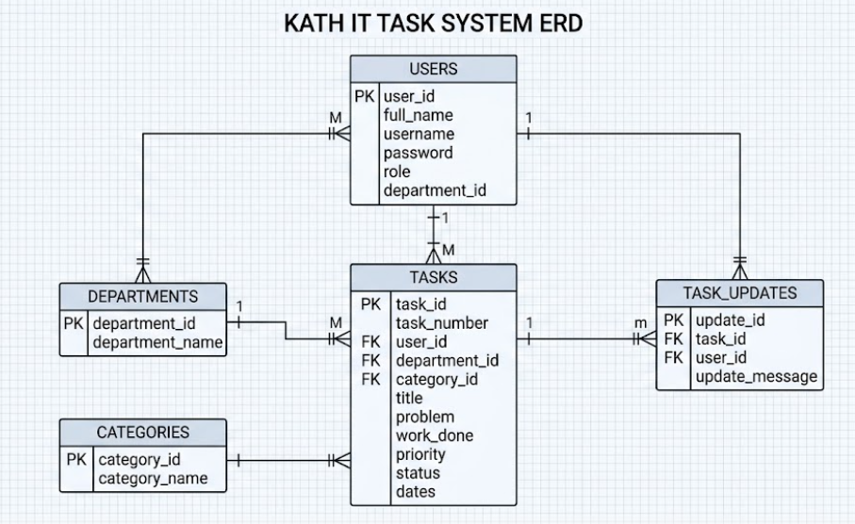

3.13 Input Design
Input design focuses on the information entered into the system by users. The main input form will be the task submission form.
IT staff will enter the task title, department, category, problem description, work performed, priority, status, dates and remarks. An optional attachment can also be uploaded where necessary.
The system will validate required fields before the information is saved. This will help reduce incomplete or incorrect records.

3.14 Output Design
The system will produce different outputs based on the user's role. IT staff will receive information about their submitted tasks, while administrators will receive information about all IT activities.
The main outputs will include the administrator dashboard, task lists, task details, statistics, charts and reports. Reports can be filtered by date, department, category, staff, priority and status.

3.15 System Process Flow
The general operation of the system begins when a user opens the login page. The user enters a username and password, and the system checks the information against the database.
If the credentials are correct, the system identifies the user's role and directs the user to the appropriate dashboard. IT staff can submit and manage their tasks, while administrators can manage and analyze the activities of the IT department.

Figure 3.5: System Flowchart
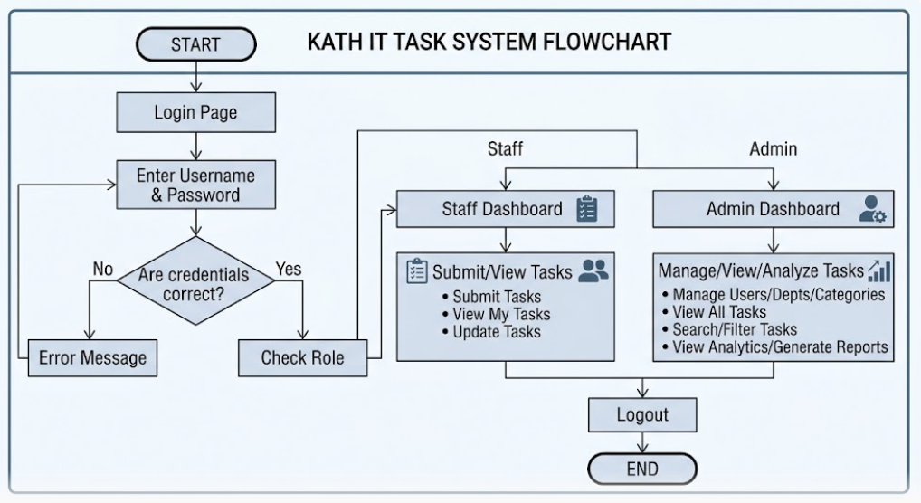

3.16 Development Tools
The system will be developed using PHP, MySQL, HTML, CSS, Bootstrap and JavaScript. XAMPP will provide the local Apache web server and MySQL database environment.
PHP will be used to process requests and communicate with the database. MySQL will store the system data. HTML and CSS will be used to structure and style the pages, while Bootstrap will provide responsive interface components. JavaScript and Chart.js will be used for interactive features and dashboard charts.

Table 3.2: Development Tools
Tool/Technology | Purpose
PHP | Backend development
MySQL | Database management
XAMPP | Local development server
HTML5 | Web page structure
CSS3 | Styling
Bootstrap 5 | Responsive interface
JavaScript | Interactive functions
Chart.js | Dashboard charts
phpMyAdmin | Database administration
Cursor | Code development assistance

3.17 Security Design
Security will be considered during the development of the system. Users will be required to log in before accessing protected pages. Passwords will be stored using secure password hashing rather than plain text.
The system will also use role-based access control to ensure that IT staff cannot access administrator functions. Prepared statements will be used when communicating with the database to reduce the risk of SQL injection.
Input validation will be used to prevent invalid information from being stored. File uploads will also be restricted to appropriate file types and sizes.

3.18 Testing Approach
Testing will be performed after implementation to ensure that the system works as expected. Each major function will be tested using different inputs.
The login function will be tested with correct and incorrect credentials. The task submission function will be tested with complete and incomplete information. Search and filtering functions will also be tested to ensure that the correct records are returned.
The administrator functions will be tested to ensure that staff, categories and departments can be managed correctly. Dashboard statistics and reports will also be checked against the actual database records.

Table 3.3: Sample System Testing
Test | Expected Result
Login with correct credentials | User is taken to the appropriate dashboard
Login with wrong credentials | Error message is displayed
Submit complete task | Task is saved successfully
Submit incomplete task | System requests required information
View task | Correct task details are displayed
Search task | Matching tasks are displayed
Change task status | New status is saved
Add staff | Staff account is created
Generate report | Correct report is displayed
Logout | User session is terminated

3.19 System Requirements
The system requires a computer with enough resources to run XAMPP, a modern web browser and sufficient storage for the application and database.

Table 3.4: Hardware Requirements
Hardware | Minimum Requirement
Processor | Intel Core i3 or equivalent
RAM | 4 GB
Storage | At least 10 GB free space
Monitor | Standard monitor
Network | Local network/internet where required
Keyboard/Mouse | Standard

Table 3.5: Software Requirements
Software | Requirement
Operating System | Windows 10/11 or compatible OS
XAMPP | Current compatible version
PHP | PHP 8 or above
MySQL | MySQL/MariaDB through XAMPP
Browser | Chrome, Edge or Firefox
Code Editor | Cursor
Database Tool | phpMyAdmin

3.20 Chapter Summary
This chapter presented the methodology and design of the proposed Web-Based IT Task Management and Reporting System for Komfo Anokye Teaching Hospital. The project adopted an observational and development-based approach, while the Waterfall Model was selected as the system development methodology.
The chapter described the functional and non-functional requirements, system users, proposed system, architecture, database design, input and output design, system flow, development tools, security and testing approach. The next chapter will present the implementation of the system, including the developed interfaces, database implementation, system functions and testing results.

CHAPTER FOUR

SYSTEM IMPLEMENTATION, TESTING AND RESULTS

4.0 Introduction
This chapter presents the implementation, testing and results of the Web-Based IT Task Management and Reporting System developed for Komfo Anokye Teaching Hospital (KATH). The chapter explains how the proposed system was developed and how its main functions work. It also presents the interfaces of the system, database implementation, testing process and results obtained from the system.
The system was developed as a web-based application using PHP, MySQL, HTML, CSS, Bootstrap and JavaScript. XAMPP was used to provide the Apache web server and MySQL database environment during development.

4.1 System Implementation
The implementation stage involved converting the system design into a working web application. The system was developed to allow IT staff to record tasks they perform and allow authorized supervisors or administrators to monitor the activities.
The system has two main categories of users. These are the Administrator/Supervisor and the IT Staff. Each user has different permissions based on their role.
The administrator can manage users, departments, categories and tasks. The administrator can also view reports and statistics about the work performed by IT staff.
IT staff can log into the system, submit tasks, view their previous tasks and update the status of tasks assigned to them.

4.2 Development Environment
The system was developed and tested on a computer using XAMPP. XAMPP provided Apache for running the PHP application and MySQL for storing the system data. phpMyAdmin was used to create and manage the database.
The main technologies used in the implementation are shown below.
Technology | Purpose
HTML5 | Structure of web pages
CSS3 | Styling of the system
Bootstrap 5 | Responsive user interface
JavaScript | Interactive functions
PHP | Server-side programming
MySQL | Database management
XAMPP | Local development server
phpMyAdmin | Database administration
Chart.js | Dashboard charts

4.3 Database Implementation
The database was created using MySQL and was named kath_it_task_management. It stores information about users, departments, task categories, tasks and task updates.
The main tables implemented in the system include:
Table | Purpose
users | Stores administrator and IT staff information
departments | Stores hospital departments
categories | Stores IT task categories
tasks | Stores submitted IT tasks
task_updates | Stores updates made to tasks
The database allows the system to keep IT task information in a centralized location. This makes it easier to search, update and retrieve information when needed.

4.4 Login and Authentication
The login page is the first major interface of the system. Users are required to enter their username and password before they can access the system.
The system checks the login details against the information stored in the database. When the details are correct, the user is allowed to access the appropriate dashboard.
Administrators are directed to the administrator dashboard, while IT staff are directed to the staff dashboard.
The system also uses password hashing to avoid storing users' passwords as plain text. Sessions are used to keep users logged in while they are using the system.
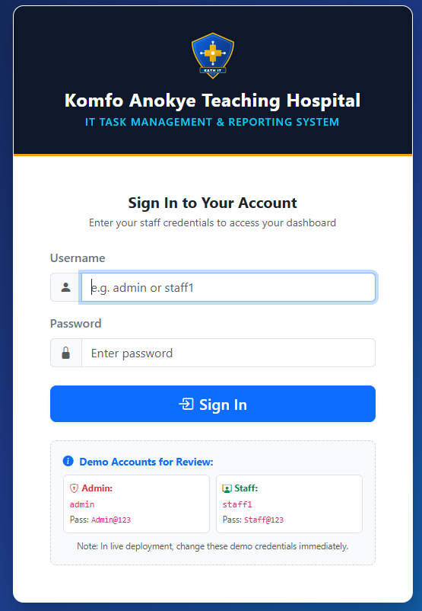
Figure 4.1: Login Page

4.5 Administrator Dashboard
The administrator dashboard provides an overview of IT activities in the organization. It displays important information such as the total number of tasks, completed tasks, pending tasks and tasks currently in progress.
The dashboard also provides information about the number of IT staff, departments and task categories.
Charts can be used to show the distribution of tasks according to categories, departments and status. This helps the administrator quickly understand the type of IT support being provided.
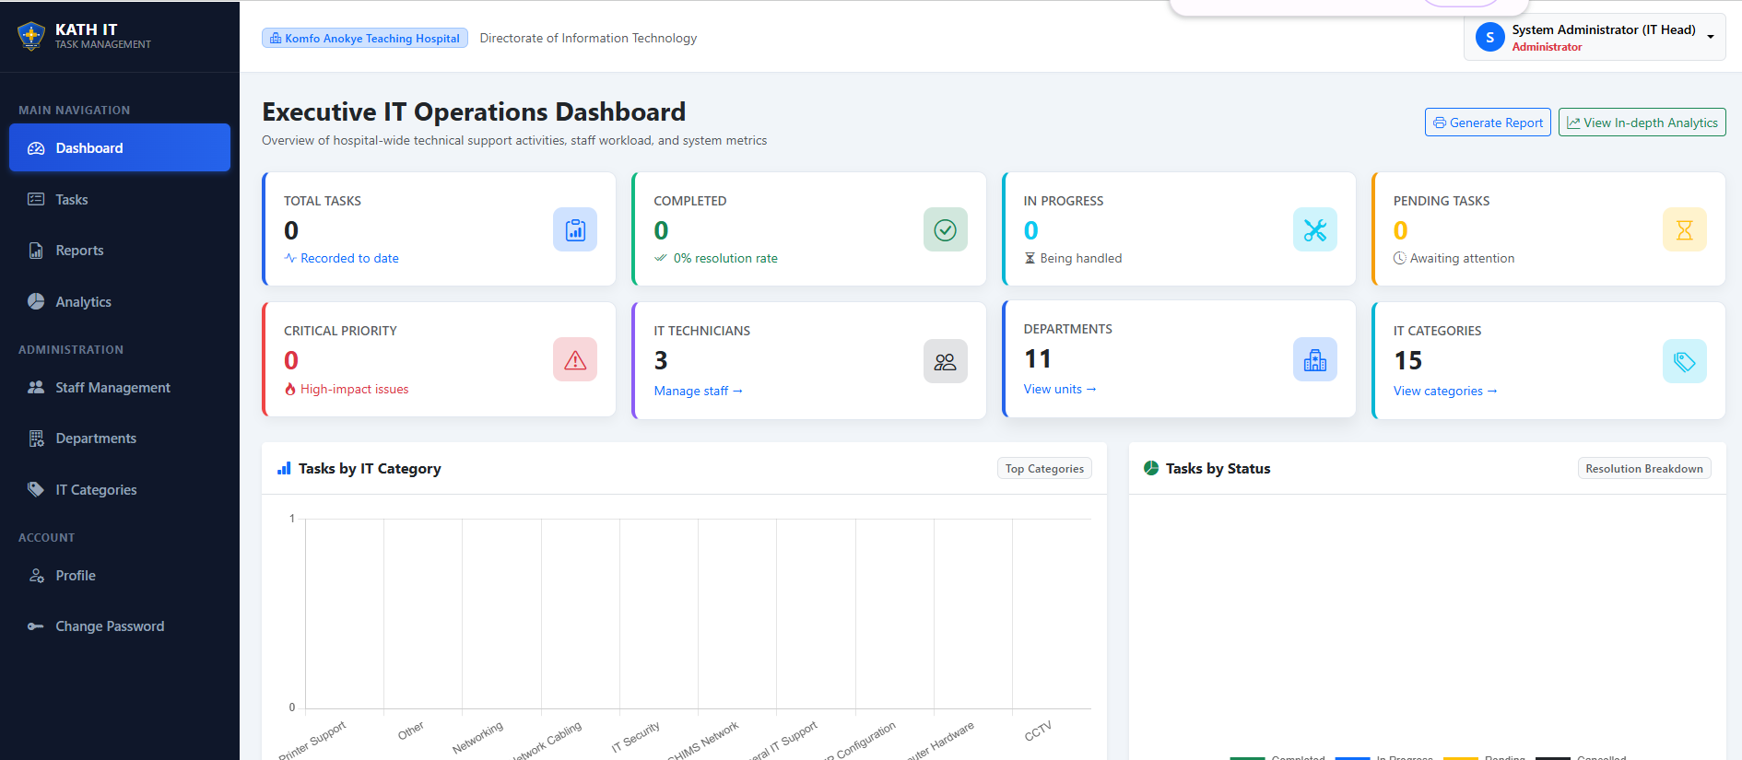
Figure 4.2: Administrator Dashboard

4.6 Staff Dashboard
The staff dashboard is designed for IT personnel. After logging in, an IT staff member can see the tasks they have submitted and the current status of their tasks.
The dashboard provides a simple way for staff to access the task submission page and review their task history.
This allows each staff member to keep a record of the work they have performed.
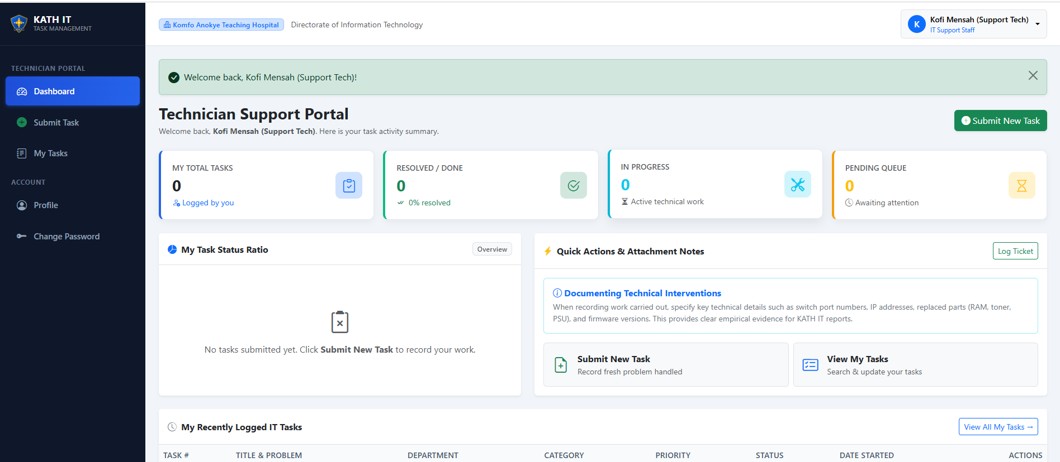
Figure 4.3: IT Staff Dashboard

4.7 Task Submission
The task submission page allows IT staff to record work that they have performed or are currently handling.
The user enters information such as the task title, department, category, problem description, work carried out, priority and task status. The user can also enter the date the task started and the date it was completed.
For example, an IT staff member who solves a network problem in the Pharmacy Department can record the task under the Networking category and select Pharmacy as the department.
After the form is submitted, the system stores the information in the database and generates a unique task number.
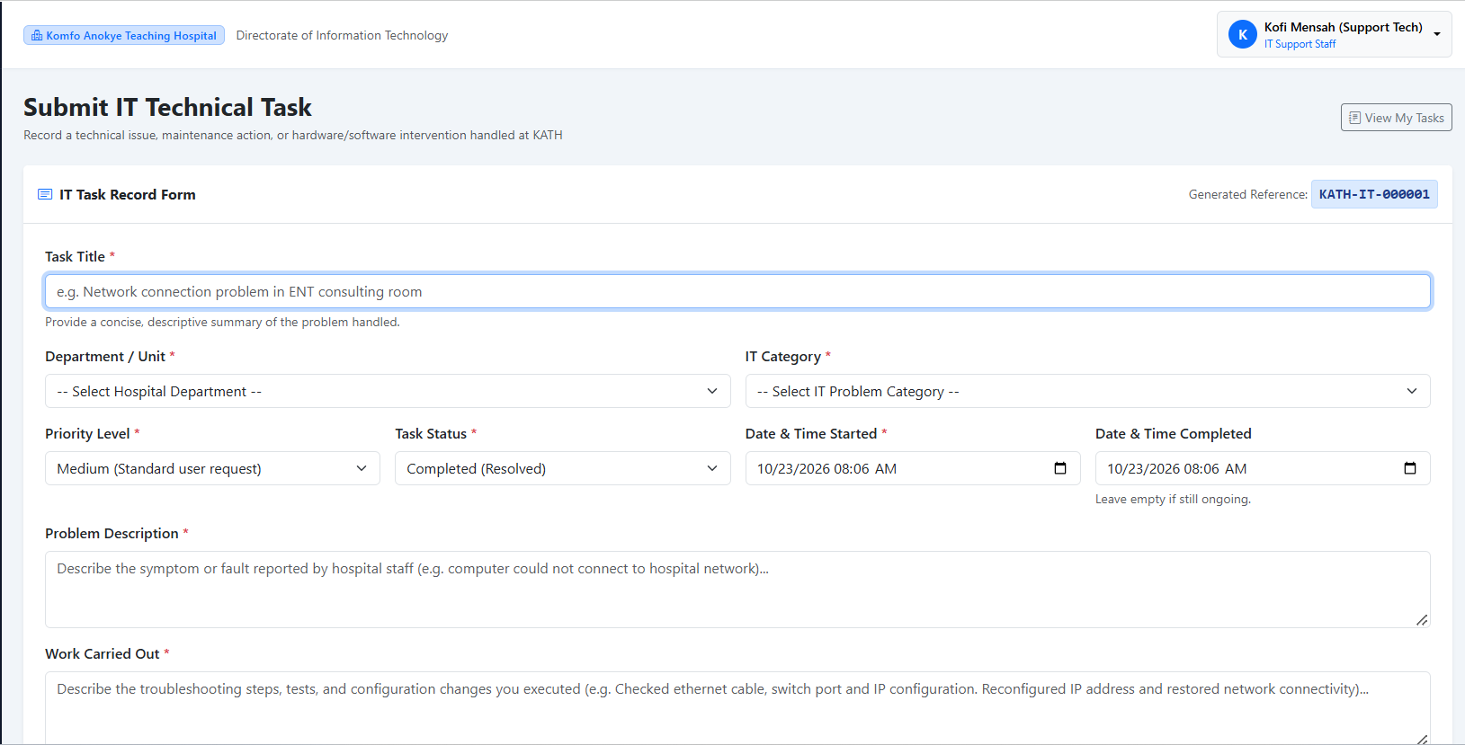
Figure 4.4: Task Submission Form

4.8 Task Categories
Task categories are used to organize IT activities. The administrator can create, edit and manage categories.
Some of the categories implemented in the system include Networking, GHIMS Network, CCTV, Computer Hardware, Software Installation, Windows/Operating System, Printer Support, DNS/IP Configuration, User Account/Domain, Telephone/Communication, Network Cabling, Access Point/Wi-Fi and General IT Support.
The use of categories makes it easier to identify the types of IT problems that occur frequently.

4.9 Department Management
The system allows the administrator to manage the departments where IT support is provided.
A task submitted by an IT staff member is associated with a particular department. This makes it possible to determine which departments receive the most IT support.
For example, if several tasks are recorded for the ENT Department, the administrator can easily identify the department as one that requires frequent IT support.
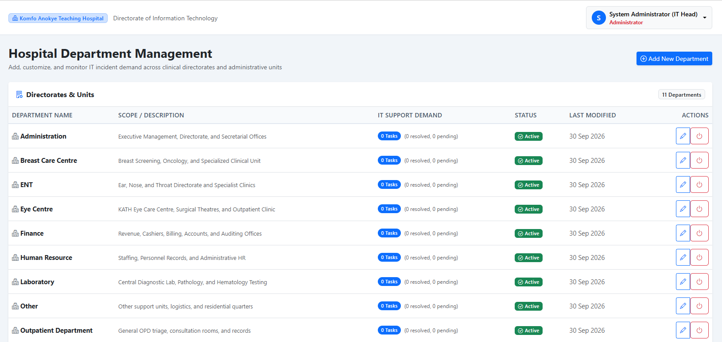
Figure 4.5: Department Management Page

4.10 System Security
Security was considered during the implementation of the system. Users must log in before accessing protected pages.
The system uses role-based access control to ensure that users can only access functions appropriate to their roles.
Passwords are stored using password hashing. Database queries use prepared statements to reduce the risk of SQL injection.
The system also validates user input before storing information in the database. Sessions are used to prevent unauthorized access to protected pages.
Users can also log out of the system when they finish their work.

4.11 System Testing
Testing was carried out to determine whether the system functions according to the requirements. Different parts of the system were tested separately and then tested together.
The major functions tested included login, task submission, task editing, task updates, user management, department management, category management, searching, reporting and dashboard statistics.
The testing results are presented below.
Test Case | Expected Result | Result
Valid login | User enters the correct dashboard | Passed
Invalid login | System rejects incorrect details | Passed
Submit task | Task is saved in database | Passed
Edit task | Task information is updated | Passed
Update task status | New status is saved | Passed
Add department | Department is added successfully | Passed
Add category | Category is added successfully | Passed
Search task | Matching task is displayed | Passed
Filter tasks | Records are filtered correctly | Passed
View dashboard | Statistics are displayed | Passed
Logout | User session is ended | Passed

4.12 Functional Testing Results
The testing showed that the main functions of the system worked as expected.
The login function successfully authenticated users and directed them to the correct dashboard. The task submission function successfully stored task information in the database.
The task management function allowed authorized users to view and manage task records. The search and filtering functions also worked correctly.
The dashboard displayed task statistics based on information stored in the database. This showed that the system was able to retrieve and process task information correctly.

4.13 User Interface Results
The system interface was designed to be simple and easy to use. Bootstrap was used to make the system responsive on different screen sizes.
The navigation menu provides access to the major functions of the system. Forms were designed with clear labels so that users could understand the information required.
The use of cards, tables and charts on the dashboard makes important information easier to understand.

4.14 System Results
The completed system provides a centralized platform for recording and monitoring IT tasks.
The system makes it possible to know the type of work performed by IT staff, the departments receiving IT support and the categories of problems being handled.
It also provides a history of completed and ongoing tasks. This can help reduce the problem of losing important IT task information.
The reporting and analytics functions provide useful information that can support IT planning and decision-making.

4.15 Comparison with the Existing Method
Before the proposed system, IT task information could be recorded using manual notes, separate documents or other informal methods. Such methods can make it difficult to maintain a complete history of IT activities.
The proposed system provides a centralized database where task information can be stored and retrieved.
Existing Method | Proposed System
Manual recording | Digital recording
Difficult to search | Easy search
Information may be scattered | Centralized database
Limited reporting | Automated reports
Difficult to monitor workload | Dashboard and analytics
Difficult to track task status | Status tracking
Limited task history | Task update history
The proposed system therefore provides a more organized method of managing IT support activities.

4.16 Achievement of System Objectives
The first objective was to provide a secure platform for IT staff to record their activities. This objective was achieved through the login and task submission functions.
The second objective was to create a centralized database for storing IT task records. This was achieved through the MySQL database.
The third objective was to categorize IT problems. This was achieved through the category and department management functions.
The fourth objective was to monitor task progress. This was achieved through the task status and task update functions.
The fifth objective was to provide reports and statistics. This was achieved through the reporting and dashboard functions.
The final objective was to help identify common IT problems and areas requiring more attention. This was achieved through the category, department and analytics features.

4.24 Chapter Summary
This chapter presented the implementation and testing of the Web-Based IT Task Management and Reporting System for KATH. The chapter explained the development environment, database implementation, user interfaces and major system functions.
The testing results showed that the main functions of the system worked successfully. The system provides a centralized platform for recording, monitoring, searching and reporting IT activities.
The results indicate that the proposed system can improve the way IT tasks are documented and monitored and can provide useful information for understanding IT workload and common technical problems.

CHAPTER FIVE

DISCUSSION, CONCLUSION AND RECOMMENDATIONS

5.0 Introduction
This chapter presents the discussion, conclusion and recommendations of the Web-Based IT Task Management and Reporting System developed for Komfo Anokye Teaching Hospital (KATH). It discusses the main findings of the project, the achievements of the system, challenges encountered and recommendations for future improvement.

5.1 Summary of the Study
The purpose of this project was to develop a web-based system for recording, monitoring and managing IT tasks performed by IT staff at KATH.
The study identified the need for a centralized system where IT staff could record the technical problems they handled and the work they performed. The system was designed to organize these activities according to categories, departments, priority and status.
The system was developed using PHP, MySQL, HTML, CSS, Bootstrap and JavaScript. XAMPP was used as the development environment.

5.2 Summary of Findings
The study found that keeping IT task information in a centralized system makes it easier to manage and retrieve information.
The developed system allows IT staff to submit their tasks and allows administrators or supervisors to monitor the tasks. It also provides information about the departments receiving IT support and the types of technical problems being handled.
The system also makes it easier to identify common IT activities such as networking, computer support, software installation, CCTV support, printer problems and other technical issues.

5.3 Discussion of Results
The results from the implementation and testing showed that the system was able to perform its main functions successfully.
The login system provided controlled access to the application. IT staff were able to submit tasks, update task information and view their task history. Administrators were able to manage users, departments, categories and task records.
The dashboard and reporting features also provided a simple way of viewing IT activities. This can help supervisors understand the workload of the IT department and identify areas where more attention may be required.

5.4 Achievement of Objectives
The objectives of the project were achieved.
The system provides a secure login system for authorized users. It also provides a centralized database for storing IT task records.
The system allows tasks to be categorized according to the type of technical problem and the department involved. It also allows the status of each task to be monitored.
Reports and dashboard statistics provide useful information about IT activities. The system can therefore help management identify common IT problems and understand the workload of IT staff.

5.5 Advantages of the System
The developed system has several advantages.
First, it reduces dependence on manual recording of IT activities. Second, it provides a centralized location for storing task information. Third, it makes searching for previous tasks easier.
The system also improves task tracking because users can see whether a task is pending, in progress or completed.
Another advantage is that the system can provide information that helps supervisors understand the areas where IT support is frequently required.

5.6 Challenges Encountered
Some challenges were encountered during the development of the system.
One challenge was determining the appropriate categories for different IT tasks. Since IT problems can be different from one department to another, the system needed flexible categories.
Another challenge was ensuring that the system was simple enough for IT staff to use while still providing the required information.
Technical challenges were also encountered during database development, system testing and integration of the different system components.

5.7 Limitations of the System
The system mainly focuses on recording and managing IT tasks. It does not manage patient medical information, hospital billing, clinical diagnosis or other non-IT activities.
The current version is also designed mainly for internal IT task management. It does not automatically detect network problems or computer faults.
The accuracy of reports and statistics also depends on IT staff entering correct and complete information into the system.

5.8 Implications of the Study
The project shows that a simple web-based system can improve the documentation of IT support activities in an organization.
By keeping records of IT tasks, the organization can understand the type of technical support being provided and the departments that require frequent assistance.
The information can also help supervisors plan staff activities, identify areas for training and make better decisions about IT resources.

5.9 Recommendations
The following recommendations are made based on the findings of the project.
The system should be used consistently by IT staff so that all important tasks are properly recorded.
Regular backups should be performed to prevent the loss of task information.
The system can be connected to the hospital's internal network so that authorized IT staff can access it from different locations.
Future versions can include email or SMS notifications for important tasks. A mobile-friendly version can also be developed to make it easier for IT staff to submit tasks using mobile phones.
The system can also be improved to include more advanced analytics and automatic identification of frequently occurring IT problems.

5.10 Suggestions for Future Work
Future researchers and developers can improve the system by adding automatic alerts for critical IT problems.
The system can also be integrated with network monitoring tools so that some network problems can be detected automatically.
Another possible improvement is the addition of a mobile application that allows IT staff to record tasks while moving between departments.
Future versions can also include artificial intelligence to analyze previous task records and predict areas where IT problems are likely to occur.

5.11 Conclusion
The project successfully developed a Web-Based IT Task Management and Reporting System for KATH.
The system provides a centralized platform for recording, monitoring and reporting IT activities. It allows IT staff to document the work they perform and allows administrators or supervisors to monitor the activities.
The system also provides useful information about IT task categories, departments, task status and workload. This can help improve IT documentation and support better decision-making.
Overall, the project demonstrates that a simple web-based IT task management system can provide a more organized and efficient way of managing IT support activities within an organization.

REFERENCES
[1] F. Al-Hawari and H. Barham, “A machine learning based help desk system for IT service management,” Journal of King Saud University – Computer and Information Sciences, vol. 33, pp. 702–718, 2021.
[2] A. Hübner, M. Ammenwerth, and colleagues, “Management Perspective: Scopes and Tasks of Managing Health Information Systems,” in Health Information Systems, Springer, 2022.
[3] J. O. Long, ITIL® 2011 At a Glance. New York, NY, USA: Springer, 2012.
[4] M. A. Jennex and L. Olfman, “A knowledge management success model: An extension of DeLone and McLean's IS success model,” in Proc. Americas Conference on Information Systems, 2003.
[5] W. H. DeLone and E. R. McLean, “The DeLone and McLean model of information systems success: A ten-year update,” Journal of Management Information Systems, vol. 19, no. 4, pp. 9–30, 2003.
[6] P. Seddon and M.-Y. Kiew, “A partial test and development of DeLone and McLean's model of IS success,” Australasian Journal of Information Systems, vol. 4, no. 1, 1996.
[7] F. D. Davis, “Perceived usefulness, perceived ease of use, and user acceptance of information technology,” MIS Quarterly, vol. 13, no. 3, pp. 319–340, 1989.
[8] P. Legris, J. Ingham, and P. Collerette, “Why do people use information technology? A critical review of the technology acceptance model,” Information & Management, vol. 40, no. 3, pp. 191–204, 2003.
[9] J. Fombona Cadavieco, C. Rodríguez Pérez, and C. Barriada Fernández, “Information technology incident management: A case study of the University of Oviedo and the Faculty of Teacher Training and Education,” International Journal of Educational Technology in Higher Education, vol. 9, pp. 280–295, 2012.
[10] G. Amanortsu, D. Ahiawortor, and D. Oppong, “Developing a technical support management solution for enhanced service delivery at Accra Technical University,” International Journal of Innovative Science and Research Technology, vol. 9, no. 12, 2024.
[11] G. M. I. Alcober, A. J. Rubio, J. P. Lazaro, J. B. Mangaba, et al., “TISSA: A web-based helpdesk support system for tertiary institutions with knowledge-based management and ticket forecasting using time series methods,” in Proc. IEEE 14th International Conference on Humanoid, Nanotechnology, Information Technology, Communication and Control, Environment, and Management (HNICEM), 2022, doi: 10.1109/HNICEM57413.2022.10109478.
[12] F. D. Davis, R. P. Bagozzi, and P. R. Warshaw, “User acceptance of computer technology: A comparison of two theoretical models,” Management Science, vol. 35, no. 8, pp. 982–1003, 1989.
[13] W. H. DeLone, E. R. McLean, and later research, “The DeLone and McLean Information Systems Success Model: What is the future evolution for its foundations, components, and applications?” Communications of the Association for Information Systems, vol. 57, 2026.
[14] M. Ramakrishnan, S. Gregor, A. Shrestha, and J. Soar, “Addressing knowledge gaps in ITSM practice with ‘Learning Digital Commons’: A case study,” Information Systems Frontiers, vol. 27, pp. 965–989, 2025.
[15] G. C. A. Wibowo, D. M. Simanjuntak, and H. J. Christanto, “Web-based IT helpdesk system with Naive Bayes automatic ticket classification using Laravel,” NUANSA INFORMATIKA, vol. 20, no. 2, pp. 102–109, 2026.

