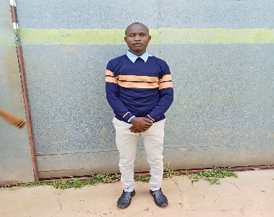

**Personal Information**

**Name**: Emmanuel Ongera Mose

**Phone**: 0718146250

**Email**: emmanuelmose806@gmail.com

**Github**: https://github.com/EmmanuelMose

**Occupation**: Computer Science student at Masinde Muliro University of Science and Technology.

**Nickname**: Emmanuel Guru

**Summary Statement**

A self-motivated, passionate and responsible undergraduate student at Masinde Muliro University of Science and Technology. I love computer programming, networking data analysis and exploratory research especially in cyber security machine learning and artificial intelligence.

**Educational Background**

***2022 to date*:**

Computer Science Student at Masinde Muliro University of Science and Technology.

***2018 – 2022*:**

Kenya Certificate of Secondary Education( KCSE).

Ringa boys High School,Homabay

Achieved a B of 66 points.

***2007 – 2017***

Kenya Certificate of Primary Education (KCPE).

Kiango Primary School,Kisii

Marks Scored: 329 Marks out of 500, Grade: B.

**Skills**

* Mobile Development(Android App Development using java).
* Desktop Development using java(javaFX).
* GUI design using Tkinter in python
* Data analysis using Python and SPSS
* Front-end web design using HTML5, CSS3,ReactJs,AngularJs and Java Script.
* Back-end web Development using PHP and Python, Django, git and SQL.
* Machine Learning
* Graphic design

**Achievements**

* Created several computer games in python which are in my github.
* Created an online voting system using python and SQL DBMS.
* Created arious software systems like hospital,inventory and school management systems.
* Created several Desktop applications using Java and the JavaFX API.
* Designed and administered a relational database using MySQL DBMS.

**Experience**

May 2024 – August 2024:

Took part and completed the industrial training program offered at Masinde Muliro University of Science and Technology.

**Hobbies and Interests**

* During my free time,
* I love reading and researching to gain new knowledge.
* I enjoy works of art such as designing, experimenting and implementing new ways of doing things.
* I also love making new friends, socializing with friends and family, watching animations and movies and listening to music.

**Languages**

English.

Swahili.

**Referees**

1.

**Name**: Dr. Raphael Angulu

**Phone**: 0729260641

**Email**: [rangulu@mmust.ac.ke](mailto:rangulu@mmust.ac.ke)

**Occupation**: Lecturer and Head of Department, Department of Information Technology, school of Computing and Informatics.

2.

**Name**: George Mageto.

**Phone**: 0724225552

**Occupation**: Lecturer Dedan Kimathi University.