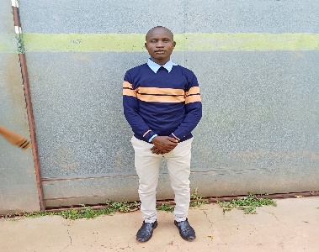
Personal Information
Name: Emmanuel Ongera Mose
Phone: 0718146250
Email: emmanuelmose806@gmail.com
Github:
Portfolio:
Occupation: Computer Science student at Masinde Muliro University of Science and Technology.
Nickname: Emmanuel Guru
Summary Statement
A self-motivated, passionate and responsible undergraduate student at Masinde Muliro University of Science and Technology. I love computer programming, networking data analysis and exploratory research especially in cyber security machine learning and artificial intelligence.
Educational Background
2022 to date:
Computer Science Student at Masinde Muliro University of Science and Technology.
2018 – 2022:
Kenya Certificate of Secondary Education( KCSE).
Ringa boys High School,Homabay
Achieved a B of 66 points.
2007 – 2017
Kenya Certificate of Primary Education (KCPE).
Kiango Primary School,Kisii
Marks Scored: 329 Marks out of 500, Grade: B.
Skills
- Mobile Development(Android App Development using java).
- Desktop Development using java(javaFX).
- GUI design using Tkinter in python
- Data analysis using Python and SPSS
- Front-end web design using HTML5, CSS3,ReactJs,AngularJs and Java Script.
- Back-end web Development using PHP and Python, Django, git and SQL.
- Machine Learning
- Graphic design
Achievements
- Created several computer games in python which are in my github.
- Created an online voting system using python and SQL DBMS.
- Created arious software systems like hospital,inventory and school management systems.
- Created several Desktop applications using Java and the JavaFX API.
- Designed and administered a relational database using MySQL DBMS.
Experience
May 2024 – August 2024:
Took part and completed the industrial training program offered at Masinde Muliro University of Science and Technology.
Hobbies and Interests
- During my free time,
- I love reading and researching to gain new knowledge.
- I enjoy works of art such as designing, experimenting and implementing new ways of doing things.
- I also love making new friends, socializing with friends and family, watching animations and movies and listening to music.
Languages
English.
Swahili.
Referees
1.
Name: Dr. Raphael Angulu
Phone: 0729260641
Email: rangulu@mmust.ac.ke
Occupation: Lecturer and Head of Department, Department of Information Technology, school of Computing and Informatics.
2.
Name: Dr. Jasper Ondulo.
Phone: 0727716382
Email
Occupation: Lecturer and Head of Department, Department of Computer Science, school of Computing and Informatics.

