ITEC610 – Introduction to Data Science With Python
(Assessment 3)
Critical Analysis and Visualisation of BRFSS Health Data Introduction
Semester 1, 2025

Submitted To:
Professor Walayat Hussain

Submitted By:
Emmanuel Uchenna Orunta, S00403657, S00403657@myacu.edu.au

Date of submission: 30, May 2025.

TABLE OF CONTENT

REPORT 3
1.1 Introduction 3
1.2 Section 1: Summary Statistics and Visualization Analysis 3
1.3 Section 2: Grouped Analysis, Hierarchical Indexing, and Ethical Reflection 5
1.4 Section 3: Data Cleaning, BMI Prediction Modelling, and Ethical Reflection 8
1.5 Section 4: Conclusion 11

REPORT

Introduction
The CDC oversees the Behavioral Risk Factor Surveillance System (BRFSS), a comprehensive survey that uses self-reported telephone interviews to learn about health-related risk behaviors in populations. The 20,000 entries in the OpenIntro version of this dataset (cdc.csv) include gender, age, height (in inches), weight (in pounds), and other factors. Exploratory data analysis, group-based aggregation with hierarchical indexing, and predictive modeling for BMI are the three primary steps of this report's critical examination, which also incorporates ethical considerations and data restrictions.

Section 1: Summary Statistics and Visualization Analysis
Techniques: The distribution and spread of height and weight among age groups was shown using boxplots. The following relevant intervals were used to classify age: <20, 20–29,..., 80+.

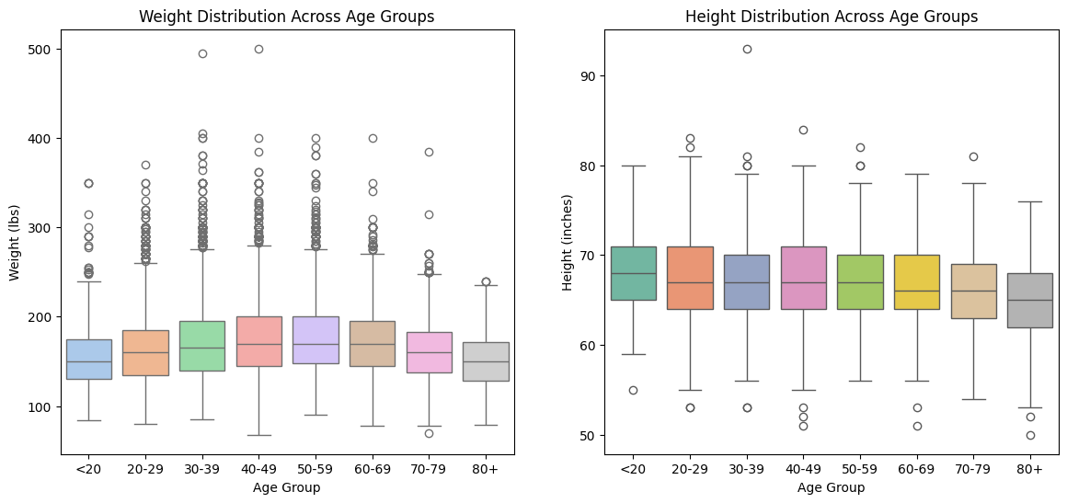

CRITICAL REFLECTION
- Observed Patterns

- Weight Trends:
The median weight gradually increased from the <20 group to the 50–59 group, according to the weight distribution. This implies that people typically acquire weight as they age, most likely as a result of modifications to their metabolism, amount of activity, or way of life.
The median weight begins to decrease around 60 to 69. This could be a reflection of aging-related weight loss in elderly persons or sarcopenia, a loss of muscle.

- Height Trends:
Across age groups, the median height somewhat decreases, particularly at the ages of 60 and 69, supporting the biological impact of aging-related posture deterioration and spine compression.
Height between the ages of 20 and 59 is relatively constant over the course of decades, indicating a population of fully grown adults with steady physical maturity.

- Data Limitations and Biases
Due to data gotten via telephone surveys, this may lead to significant limitations and bias such as:
- Recall Bias: Respondents may not remember or know their exact height or weight, leading to inaccurate or incorrect reporting.
- Social Desirability Bias: Some participants in the telephone survey especially teenagers or older adults may underreport or overestimate their weight or height to conform to social ideals due to peer pressure or societal stereotypes.
- Demographic Bias: Certain age or socio-economic like the older populace groups might have lower access to accurate health measurements, further skewing data quality.
Examples of Likely Bias:
Young adults (20–29) and teenagers (<20) may exaggerate height and understate weight due to body image pressures.
Elderly participants (70+) may overstate both height and weight, relying on past values rather than current measurements.

- Impact on Findings and Mitigation Strategies
- Potential Impacts:
Misconceptions in Public Health: Estimates of BMI or obesity may be distorted by biases, which could result in poor resource allocation or poorly thought-out solutions.
Age-related Falsehood: Inaccurate self-reports may conceal undetected age-related shrinking or weight loss in seniors caused by sickness.
- Strategies to Mitigate Bias:
Studies on Calibration: Adjust self-reported data using correction factors by incorporating recurring in-person measurements on a subset of respondents.
Statistical Models using Weights: Regression calibration and propensity scoring are two examples of statistically correcting for known biases using demographic data.

Section 2: Grouped Analysis, Hierarchical Indexing, and Ethical Reflection
We applied hierarchical indexing grouping data first by gender and then by age_group, then computed the mean weight and height for each subgroup. Pivot tables and grouped bar charts were used for visualisation.

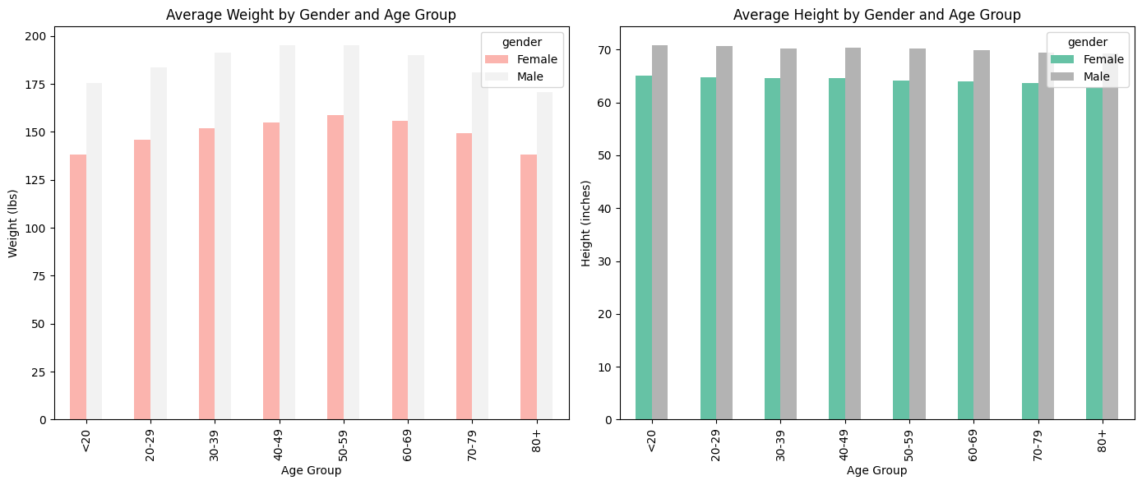

Average Height by Gender and Age Group
Age Group | Height (Inches) - Female | Height (Inches) - Male
<20 | 65.01038062283737 | 70.81666666666666
20-29 | 64.7444089456869 | 70.6414364640884
30-39 | 64.65764111977971 | 70.26471996170416
40-49 | 64.55849783341358 | 70.38003933136676
50-59 | 64.18217306441119 | 70.23595505617978
60-69 | 63.97870452528838 | 69.89959016393442
70-79 | 63.73733195449845 | 69.45977011494253
80+ | 62.888 | 69.30962343096235

Average Weight by Gender and Age Group
Age Group | Weight (lbs) – Female | Weight (lbs) - Male
<20 | 137.97923875432525 | 175.25
20-29 | 145.7374866879659 | 183.61325966850828
30-39 | 152.01422670949978 | 191.31450454763043
40-49 | 154.69041887337505 | 195.05948869223207
50-59 | 158.63500325309045 | 195.09550561797752
60-69 | 155.68589174800354 | 190.12704918032787
70-79 | 149.48397104446744 | 180.91954022988506
80+ | 62.888 | 69.30962343096235

CRITICAL REFLECTION
- The Impact of Hierarchical Indexing on the Analysis - An effective and organized method of analyzing data across the two categorical dimensions of gender and age group was made possible by hierarchical (multi-level) indexing. It made it possible to aggregate the mean weight and height for each subgroup rather than flattening these into a single index or distinct charts. This arrangement made it possible for separated considerations (gender vs. age effects) to make patterns easier to understand and it facilitated the building of pivot tables and their display (bar plots), which allow for a clear comparison of trends between groupings.

- The Risks of Group Data Oversimplification - Although using group averages to summarize is helpful, it can obscure inequality and within-group variance. The model assumes that every gender-age combination is the same, although this rarely captures the complexity of the real world. The risks of oversimplification could lead to variation brought on by dietary habits, ethnicity, lifestyle, or medical issues being overlooked. It could also lead to stereotypes, such as the belief that all old people are shorter or lighter.

- Real-World Example
Based on your chart: Females between the ages of 30 and 39 typically weigh around 152 pounds and stand about 64.7 inches tall. This doesn’t tell the entire picture because this overlooks different situations like women with greater muscular mass and postpartum weight might have an impact on women especially mothers or pregnant women. This could risk running to a biased conclusion because many people might be incorrectly labeled as "unhealthy" or "at risk" when they are not if a public health initiative used this average as a target or baseline.

- Ethical Responsibilities of Data Scientists - Results must be communicated by data scientists with moderation and context. When presenting health statistics at the group level, it is important to make it clear that not every individual is affected by aggregated values and steering clear of generalizations like "Women aged 30–39 are X" in titles and conclusions.

Section 3: Data Cleaning, BMI Prediction Modelling, and Ethical Reflection
- Techniques used for Data Cleaning
Removed biologically implausible values (height/weight < 50). These defined limits aid in removing unrealistic self-reported values that could distort modeling and BMI computations.

- BMI Calculation:
BMI = (weight (lbs)/ height (in)^2) x 703. This standard formula converts weight and height into a BMI value.

BMI Categories: - Categorizing the BMIs to different categories like underweight, healthy, overweight and obese.
  - Underweight: <18.5
  - Healthy: 18.5–24.9
  - Overweight: 25–29.9
  - Obese: ≥30
The sorting makes it possible to categorize people according to their overall physical conditions, which is helpful for tracking public health.

- Results of the Linear Regression Model Predicting BMI
A linear regression model was developed to predict Body Mass Index (BMI) based on individuals’ height and weight. The dataset was split into training and testing sets (80/20) and trained using the LinearRegression class from scikit-learn.

Model Equation (based on learned coefficients):
BMI = (0.1554×weight) + (−0.7975×height) + intercept

Model Performance:
R² Score: 0.9832
The model explains 98.32% of the variance in BMI. This high accuracy is expected since BMI is a direct function of height and weight.
Mean Squared Error (MSE): 0.44
Indicates very small average prediction error, confirming the model’s effectiveness.
Model Coefficients:
  - Weight: +0.1554 — For every additional pound, BMI increases by ~0.155 units (holding height constant).
  - Height: –0.7975 — For every extra inch in height, BMI decreases by ~0.80 units (holding weight constant).

Conclusion:
The regression model reflects the standard BMI formula, reaffirming that BMI is tightly determined by height and weight. Though highly accurate, its usefulness lies in validating data consistency rather than discovering new patterns.

CRITICAL REFLECTION
- Limitations and Risks:
  - Predictive models may fail at individual level due to variability.
  - Self-reported data amplifies prediction error and can be misused.
  - BMI assumes constant body composition, which ignores muscle vs. fat or bone density.
- Ethical Considerations:
  - BMI has known flaws and cultural sensitivities. Used in personal health decisions, it can lead to misdiagnosis, stigma, or anxiety.
  - Risk of stigmatization in public messaging. Deployed in public messaging without nuance, it may generalize complex health issues and reinforce stereotypes (e.g., equating BMI with health or fitness).
- To address these risks:
Provide context: Always clarify BMI’s limitations in reports.
Report ranges or distributions, not single-point estimates.
Avoid using BMI alone to label individuals—complement it with clinical metrics or surveys.
Engage stakeholders (health professionals, communities) when reporting results for decision-making.

- SFIA Reflection:
SFIA Skill Area | Level | Reflection
Data Analysis (DAta) | 3 | Applied statistical reasoning and visualisation effectively. Used tools like regression and filtering.
Critical Thinking | 3 | Interpreted results and questioned assumptions; acknowledged limitations in BMI and self-reports.
Information Management (RLMT) | 2–3 | Managed sensitive health data responsibly and prepared structured outputs for reporting.
Ethics (EMRG) | 2–3 | Reflected on potential harms and took steps to ensure the responsible use of predictive insights.

1.5 Section 4: Conclusion
This examination of the CDC's BRFSS health dataset revealed a number of significant findings:
- Age-related physical changes are confirmed by Task 1, which showed that height steadily decreases with age, particularly beyond 60, whereas weight increases until middle age and then drops. Age-based boxplots were used to visualize them.
- Task 2 highlighted consistent gender disparities in both height and weight by grouping data by age group and gender using hierarchical indexing. These discrepancies were easily interpreted because to the pivot charts.
- In task three, the data was cleaned and a linear regression model was used to estimate BMI based on weight and height. The model confirmed the mathematical association
between these variables with a strong R2 value of 0.9832.

Notwithstanding the insightful information, the dataset is constrained by the characteristics of self-reported data:
- Because of social desirability bias, respondents could exaggerate height and underestimate weight.
- Particularly with elderly participants, recall errors are likely to occur.
- Because the poll was done over the phone, some groups may not have been included (e.g., low-income or elderly persons without access to a phone).

These restrictions highlight how crucial critical and moral data practices are. Biased policies, poorly informed healthcare decisions, or unintentional harm to vulnerable groups might result from misinterpreting or overgeneralizing such data.

The results have greater implications to our public health communication and research:
- It is important to use caution when interpreting aggregated health data, particularly when it comes to establishing standards or directing treatments.
- It is not appropriate for policymakers to use population averages as benchmarks for individual health.
- Public health messaging can be informed but not dictated by this type of analysis; it needs to be paired with medical advice and contextual knowledge.

Some of the following are recommendations for responsible data use especially when reporting to the public
- When reporting conclusions, always include context by outlining the methodology, data source, and limits.
- To prevent disparities from being concealed, use visual aids that depict distribution (such as boxplots and histograms) as opposed to merely averaging data.
- Don't use deterministic messaging; instead, explain the limitations of BMI before equating it with health condition.
- To represent uncertainty and variability, use standard deviations or confidence intervals with means.

To conclude, this dataset provides a helpful starting point for investigating population health patterns, it serves as a reminder that each data point represents a real person with a complex background. It is our duty as data analysts to make sure that our analysis is not just technically correct but also morally and socially sound and carefully conveyed.

