Final Data1030
Emmanuel Peters, anmol_peters@brown.edu

Dataset – South German Credit Data

Introduction
For my Final project I will be working with South German Credit Data. The dataset is a sample from creditors in South Germany (in 1970) with their application info as well as whether they paid their debt or not. It has 20 predictor variables like the quality of person’s job, their age, their most valued property, and the target variable is whether they complied with their credit contract (did they pay off their debt) or not.

This problem is a classification problem, we are classifying profiles of people into whether they are going to be a “good” debtor or “bad” debtor. This is an important problem for banks because they want the people they loan money to not default on these loans, and if we had a sufficiently smart/effective machine learning algorithm that could vastly speed up application processing time which would help not only the banks but also a large amount of creditors who would like to receive a loan.

The Dataset
The data set has data for 1000 debtors. 700 of these 1000 are “good” credits while 300 of these are “bad” credits. This is a stratified sample from actual credits with “bad” credits heavily oversampled. We have 20 predictor variables and one target variable. A description for each feature can be found on the link to its UCI page. It should be noted that the column names are initially in German and thus, for the purpose of this paper, I will be using the variable names as described in the UCI link instead.
Papers on The same dataset
The dataset is initially in German so the few papers I could find that worked on it were also on German. Instead I will talk about two projects done on the parent dataset Statlog. Paper 1 - In this paper, the authors are working on change mining, where some previous knowledge about the data is known and the data has since changed. They look at change mining specifically in the case of classification. They made two contributions in the paper – how to extract changes from potentially very dissimilar old and new classifiers using correspondence tracing (this is a new technique they describe in the paper) and a ranking of importance of changes with respect to the goal of classification and a method of presenting changes such that the user need only know a small number of changes. They tried their findings on real datasets like the aforementioned and their methods were effective.
Paper 2 - This paper works on combining feature selection with neural networks for classification problems. They motivate the use of neural networks because of their high accuracy and robustness to noise. This was fairly effective for the German credit dataset as they only saw an approximate 10% drop-off in accuracy for a 33% feature selection rate.

Figures from EDA
The first figure I am going to look at is between two continuous variable – amount and duration. We would expect that they have a strong positive correlation. I plot a scatter plot for this and add a line of best fit as well:
Figure 1: Scatter plot - Duration of loan vs Amount of loan

The second figure plots the relationship between age and whether a person pays their debt or not, I use a violin plot for this:
Figure 2: Violin plot - Age vs. Target variable
We note that the average age for the bad debtor is slightly lower than the average age for the good debtor. Also, by looking at the plot we can say that the variance around the lower age is also lower in “bad” debtors. Both of these violins are on the lower end of the age spectrum, probably because people are likely to take loans when they are still relatively young and this likelihood decreases with financial stability and higher income that comes with higher ages.

The last figure is a stacked bar plot between two categorical variables – whether the credit is good (our target variable) and whether the person is a foreign worker.
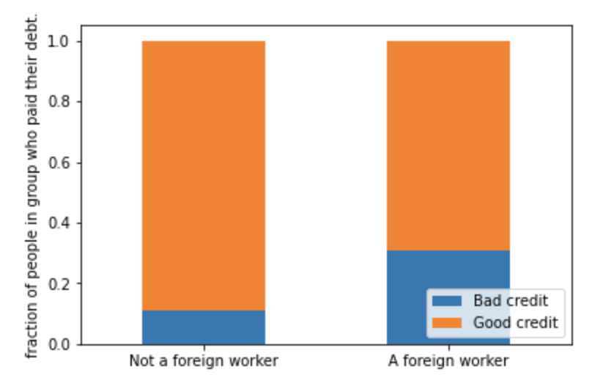
Figure 3: Stacked bar plot - Foreign worker status vs Target variable

We see that a greater percentage of those persons who identified as a domestic worker were good debtors. This could be a trend that would suggest a bank should be more open to lending domestic workers than foreign ones given their relatively lower rate of defaulting on their loans.

This could be explained by the fact that in 1970 there was massive immigration of low-skilled labor from Turkey and thus foreign immigration status had correlation with income levels.

METHODS:

Data Preprocessing
For the splitting of the Dataset I use a train_test_split to separate out the test set, alongside a K-fold split for the train/validation set. I do this to minimize randomness in model performance, validation scores and test scores. The dataset is IID, since all the creditors are sampled the same way and independently of each other. One could argue that a creditor is likely to also take loans in their family’s name, but due to the large number of creditors and the random sampling, there is negligible group structure in the dataset.

While I did not choose this dataset for this property, luckily, most of the features come preprocessed. Thus, I do not have to figure out which transformer to apply to which column, I can just look in the description.

Feature | Preprocessor | Reason
Status | OneHotEncoder | Categorical data
Duration | MinMaxScaler | Reasonably bounded and continuous
Credit history | OneHotEncoder | Categorical data
Purpose | OneHotEncoder | Categorical data
Amount | StandardScaler | Continuous and no reasonable bounding.
Savings | OneHotEncoder | Categorical data
Employment Duration | OrdinalEncoder | Ordinal data
Installment rate | OrdinalEncoder | Ordinal data
Personal status/sex | OneHotEncoder | Categorical data
Other debtors | OneHotEncoder | Categorical data
Present Residence | OrdinalEncoder | Ordinal data
Property | OrdinalEncoder | Ordinal data
Age | MinMaxScaler | Reasonably bounded and continuous
Other installment Plans | OneHotEncoder | Categorical data
Housing | OneHotEncoder | Categorical data
Number credits | OrdinalEncoder | Ordinal data
Job | OrdinalEncoder | Ordinal data
People liable | OneHotEncoder | Categorical
Telephone | OneHotEncoder | Categorical
Foreign worker | OneHotEncoder | Categorical

There are 49 features in the preprocessed dataset.

Metric
The evaluation metric I used for this is f_beta score. The fact is that the bank is more likely to suffer from giving out a loan to a person who is going to default than not giving out a loan to a person who would pay it back in time.
So, we want to weight the precision more than the recall. For this reason, I chose beta = 0.5. The dataset has 700 good debtors and 300 bad debtors, therefore, I calculated the base accuracy score to be 0.7 and the base f_beta score came out to 0.75.

Algorithm 1: Support Vector Classification (SVC)
The first algorithm used is support vector classification. The hyperparameters being tuned are gamma and C. I range the values of gamma from 10⁻³ to 10⁴ and try values of C ranging between 1 and a 100.
I loop through different random_states 10 times to account for randomness in splitting and see that for majority of the splits I get the highest f_beta score at C = 10 and gamma = 10⁻².

Mean test score (f_beta): 0.81
Mean test score (accuracy): 0.765

Algorithm 2: Random Forrest Classifier
The second algorithm used is Random forest classifier. The hyperparameters being tuned are max_depth and max_features. For max_depth I use a linearly spaced integer array from 1 to number of features in the dataset – 1. I range the values of max_features from 0.5 to 1.
I loop through different random_states 10 times to account for randomness in splitting and see that for majority of the splits I get the highest f_beta score at max_depth = 9 and max_features = 0.75.

Mean test score (f_beta): 0.81
Mean test score (accuracy): 0.762

Algorithm 3: K nearest Neighbors (KNN)
The third algorithm used is K nearest neighbors. The only hyperparameter tuned for KNN is number of neighbors. I range the values for n_neighbors from 1 to 250.
I loop through different random_states 10 times to account for randomness in splitting and see that for majority of the splits I get the highest f_beta score at n_neighbors = 10

Mean test score (f_beta): 0.80
Mean test score (accuracy): 0.75

Results:

The best algorithm for our current dataset and evaluation metric seems to be SVC. It gives us an 8% improvement over the base f_beta score and 9.2% improvement over the base accuracy score. This might not seem like much but it should be noted that the dataset is inherently unbalanced and thus any improvements in the base score are going to be relatively small increases to it.

Feature Importance
For feature importance, I will look at KNN at n_neighbors set to 10. I get the following plot: 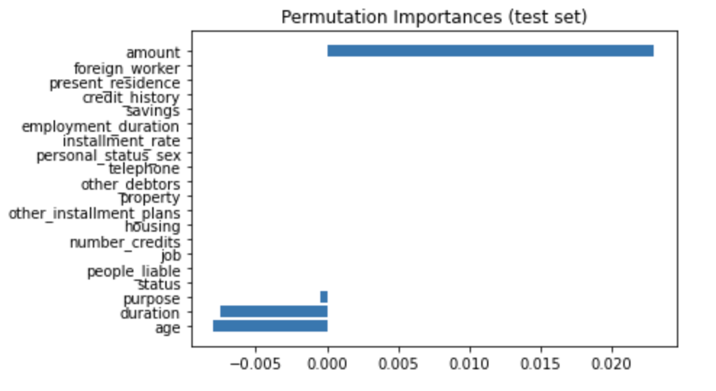
Figure 4: Permutation importance for features.

As we see most features do not have an impact on the final prediction for KNN according to permutation importance. In fact, it seems amount is the only important variable. The negative values for purpose, duration and age signify that the algorithm was doing better on the shuffled column than the actual data so it is not particularly relevant. Maybe it is a better idea to look at a different way of evaluating feature importance.

I, thus, made a plot for SHAP values:
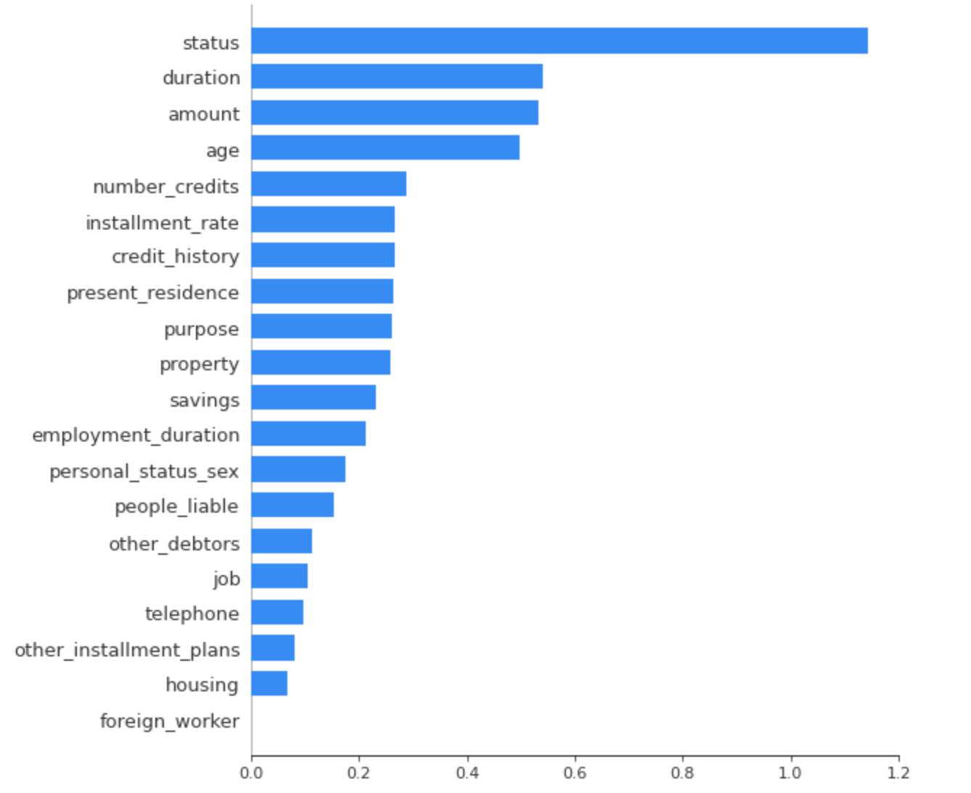
Figure 5: SHAP values for features

Now we see that the status, duration, amount and age are important indicators to whether someone is going to be a good debtor, which matches up with our figures in EDA.
What is surprising is the fact that foreign_worker is so low given what we saw from the EDA. This is why it is important to use multiple methods for feature importance.

Outlook:
Currently the model we would want to use the most is SVC. The weakest spot of using SVC is certainly the fact that it is harder to interpret than a linear or logistic model.
Looking at feature importance, it seems that feature engineering would be a very helpful step to take for the data, but it would require the in-depth knowledge of an expert in the credit risk field not just because of their knowledge of creditor profiles but also what feature engineering would be legally and socially acceptable.

For example, it might be the case that the law prevents us from considering the foreign_worker status of a loan applicant.

There is two features that I would like more data on that would possibly very strongly impact the predictions of our model. We currently have no feature for income of the applicant. This feature, in theory, seems like it would have the highest impact on whether a person is likely to pay back a loan when taken in context with the amount of the loan.

Also, because of the poor programming of the initial dataset, the information about a person’s marital status and gender is coded into a single feature which results in –
1) Sex cannot be recovered from the variable, because male singles and female non-singles are coded with the same code .
(2) Female widows cannot be easily classified, because the code table does not list them in any of the female categories.

So to improve the data, these two facets would be the first things to focus on.

GitHub repo
https://github.com/EmmanuelPeters/data1030final

References
Grömping, U. (2019). South German Credit Data: Correcting a Widely Used Data Set. Report 4/2019, Reports in Mathematics, Physics and Chemistry, Department II, Beuth University of Applied Sciences Berlin.

https://archive.ics.uci.edu/ml/datasets/South+German+Credit

https://archive.ics.uci.edu/ml/datasets/statlog+(german+credit+data)

Ke Wang and Shiyu Zhou and Ada Wai-Chee Fu and Jeffrey Xu Yu. Mining Changes of Classification by Correspondence Tracing. SDM. 2003

Paul O' Dea and David Griffith and Colm O' Riordan. DEPARTMENT OF INFORMATION TECHNOLOGY. P. O'Dea

Grömping, U. (2019). South German Credit Data: Correcting a Widely Used Data Set. Report 4/2019, Reports in Mathematics, Physics and Chemistry, Department II, Beuth University of Applied Sciences Berlin.
https://archive.ics.uci.edu/ml/datasets/South+German+Credit
https://archive.ics.uci.edu/ml/datasets/statlog+(german+credit+data)
Ke Wang and Shiyu Zhou and Ada Wai-Chee Fu and Jeffrey Xu Yu. Mining Changes of Classification by Correspondence Tracing. SDM. 2003
Paul O' Dea and David Griffith and Colm O' Riordan. DEPARTMENT OF INFORMATION TECHNOLOGY. P. O'Dea

