Beyond Offensive Words: A Comparative Study of Linguistic Features for Multiclass Cyberbullying Detection Using Classical NLP
[Emmanuel Phelps Afoakwa] ·[Davina Adeboyega] · | National College of Ireland | Text Analytics & NLP CA1
Abstract: This study examines how word-level and character-level lexical representations support six-class cyberbullying classification. A 47,692-record Kaggle corpus was audited for duplicate texts and contradictory labels, yielding 43,884 cleaned records. Nine combinations of word, character and combined TF-IDF with Logistic Regression, Multinomial Naive Bayes and Linear SVM were evaluated by stratified three-fold cross-validation. Combined TF-IDF with Logistic Regression led cross-validation (macro-F1 = 0.8654) and attained 0.8735 macro-F1 and 0.8856 accuracy on 8,777 held-out tweets. Confusion between non-cyberbullying and other cyberbullying accounted for 440 of 1,004 errors. Reintroducing 3,221 ambiguously labelled training examples reduced macro-F1 to 0.8688. Findings show the utility of transparent lexical baselines while highlighting annotation consistency and contextual ambiguity.
Index Terms: Cyberbullying, multiclass classification, TF-IDF, Logistic Regression, character n-grams, annotation ambiguity.

I. INTRODUCTION
Automatic detection of online abuse is difficult because words associated with harassment also occur in quotation, counterspeech, reporting and non-abusive conversation. A useful benchmark should therefore assess not only aggregate classification scores but also where specific labels become indistinguishable. Prior work has documented the challenge of separating hateful from merely offensive language [1] and the sensitivity of text-abuse tasks to corpus definitions and annotation practice [2].
This paper examines six labels—age, ethnicity, gender, religion, not_cyberbullying and other_cyberbullying—using transparent classical NLP methods. The aim is not to introduce a new classifier or claim state-of-the-art performance. Instead, it provides a controlled comparison of lexical representations, category-level diagnostic evidence and an annotation-sensitivity experiment on a common corpus.

A. Research Questions
RQ1: How accurately do Logistic Regression (LR), Multinomial Naive Bayes (MNB) and Linear SVM classify the six labels? RQ2: How do word, character and combined TF-IDF representations compare, and which features are informative? RQ3: Which labels are most frequently confused, and what lexical or contextual properties plausibly contribute to the errors?

B. Contributions
The study offers (i) a 3 × 3 controlled model–feature comparison, (ii) interpretable per-class metrics and directed confusion analysis, and (iii) a sensitivity experiment on contradictory annotations. Its prospective impact is to identify a precise weakness for a later contextual-model extension, not to provide a production-ready moderation system.
The distinction among the six labels matters analytically. Age, gender, ethnicity and religion refer to topical or identity-related categories, whereas not_cyberbullying and other_cyberbullying are broad behavioural categories. A model can exploit distinctive topic terms for the former without reliably determining whether a statement is abusive. The evaluation therefore asks both whether a tweet can be assigned a label and whether the class distinctions correspond to robust linguistic evidence. This asymmetry informs the choice of macro-F1 and the later qualitative error review.

II. RELATED WORK
Davidson et al. [1] showed that lexical indicators can confuse hate speech with offensive language, motivating analysis beyond overall accuracy. Fortuna and Nunes [2] reviewed the methodological and definitional complexity of automatic hate-speech detection. Prior cyberbullying research has used neural approaches and this Kaggle collection [3]; therefore six-way classification and hybrid features are not claimed as new inventions. The present study focuses on a reproducible lexical baseline with explicit attention to duplicated and contradictory texts.
TF-IDF and linear learners remain useful as transparent baselines because model coefficients and sparse n-grams can be inspected. In contrast, contextual encoders such as BERT [4] can represent word meaning in context; this motivates a future same-split comparison rather than an unsupported assumption that a transformer will outperform the present models.

III. DATA AND PREPROCESSING

A. Corpus and Provenance
The corpus is the Kaggle Cyberbullying Classification dataset (andrewmvd) [5], provided locally as cyberbullying_tweets.csv. It has 47,692 rows and two fields: tweet_text and cyberbullying_type. Initial class counts are approximately balanced (7,823–7,998 per class); these proportions are not evidence of real-world prevalence. The dataset was not collected or annotated by this group. Its original collection dates, annotation protocol, agreement statistics and redistribution rights were not independently established from the local CSV. They must not be inferred from the label names.

B. Quality Audit and Cleaning
The audit found no missing values, 43 exact duplicate rows, 1,686 repeated tweet-text occurrences and 1,640 distinct original texts associated with multiple labels. A primary benchmark excluded contradictory-label texts rather than arbitrarily choosing a “correct” class. Exact duplicate rows and duplicate cleaned texts were removed; URLs and user mentions were replaced by consistent placeholders and excess whitespace normalised. Punctuation and other potentially informative surface patterns were retained. The final analytical corpus contained 43,884 unique cleaned texts. This filtering can alter label distributions and task difficulty.
A stratified 80/20 split (random_state = 42) produced 35,107 training and 8,777 test items, with no exact cleaned-text overlap. Near-duplicates and paraphrases could still occur across partitions. The held-out set was reserved for final evaluation; model selection used training-only cross-validation.
The audit also illustrates a reproducibility trade-off. Retaining contradictory duplicates allows the model to see more records but exposes it to inconsistent supervision; removing them makes the remaining labels more internally consistent but excludes genuinely ambiguous discourse. Neither choice can be assumed correct without re-annotation. Our primary and sensitivity conditions make the decision visible. Importantly, a cleaned corpus is not necessarily an unbiased corpus: excluded cases may be precisely the cases a moderation system would encounter in practice.

IV. EXPERIMENTAL DESIGN

A. Features and Classifiers
Three representations were compared: word TF-IDF with unigram/bigram tokens; character TF-IDF with 3–5 character n-grams; and a FeatureUnion combining both. Each was paired with LR, MNB and Linear SVM, yielding nine configurations. Vectorisers were fitted within each training fold to avoid vocabulary and inverse-document-frequency leakage.

B. Evaluation Protocol
Three-fold stratified cross-validation on the training partition was used for model selection. Macro-F1, the unweighted mean of six class F1 values, was primary because performance on less easily distinguished categories should not be hidden by overall accuracy. Accuracy, macro-precision, macro-recall and class-specific F1 were secondary. The selected pipeline was then refitted on the training set and evaluated once on the 8,777-item test set. The robustness comparison later reused this test set solely as a sensitivity analysis, not for selecting a replacement model.
Each pipeline combines vectorisation and classification so that vocabulary statistics are estimated only from the relevant training fold. Identical fold construction and metrics are used across configurations. This design supports within-corpus comparisons of model and representation choices; it does not establish that one learner is globally superior on other datasets. Reported means should be interpreted alongside fold-to-fold variation, which for the leading LR configuration was approximately 0.0041 standard deviation in macro-F1. A formal paired significance test was not performed, and the small gaps among leading configurations should be interpreted cautiously.

V. RESULTS

A. Nine-Configuration Comparison
Table I reports mean cross-validation metrics. Combined TF-IDF + LR ranked first (macro-F1 0.8654), ahead of character TF-IDF + LR (0.8622) and combined TF-IDF + Linear SVM (0.8617). The advantage of the combined representation over character-only LR is 0.0032 macro-F1, so the evidence supports a modest improvement, not a large or statistically established superiority.
Representation | Classifier | Acc. | Macro-F1
Combined | LR | 0.8783 | 0.8654
Character | LR | 0.8752 | 0.8622
Combined | Linear SVM | 0.8760 | 0.8617
Character | Linear SVM | 0.8737 | 0.8594
Word | LR | 0.8656 | 0.8514
Word | Linear SVM | 0.8646 | 0.8489
Character | MNB | 0.8065 | 0.7824
Combined | MNB | 0.8011 | 0.7723
Word | MNB | 0.7775 | 0.7348
TABLE I. Training-only three-fold cross-validation. LR = Logistic Regression; MNB = Multinomial Naive Bayes.
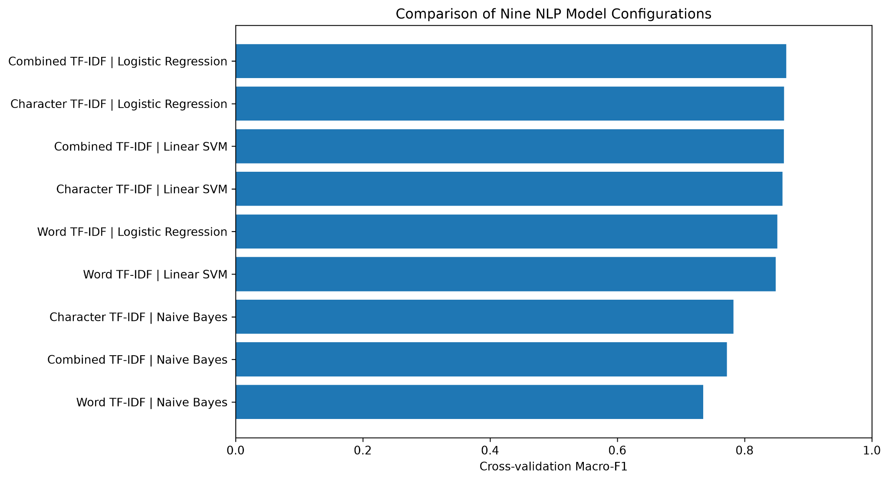
Fig. 1. Cross-validation comparison across the nine configurations.

B. Held-Out Six-Class Performance
The selected combined TF-IDF + LR pipeline achieved test accuracy 0.8856, macro-precision 0.8742, macro-recall 0.8742 and macro-F1 0.8735: 7,773 correct predictions and 1,004 errors. These scores reflect this curated, cleaned split and should not be interpreted as expected deployment performance.
Class | Precision | Recall | F1 | n
Age | 0.9630 | 0.9781 | 0.9705 | 1595
Ethnicity | 0.9874 | 0.9874 | 0.9874 | 1586
Gender | 0.9153 | 0.8588 | 0.8862 | 1523
Not bullying | 0.7127 | 0.6733 | 0.6924 | 1264
Other bullying | 0.7059 | 0.7857 | 0.7437 | 1213
Religion | 0.9606 | 0.9618 | 0.9612 | 1596
TABLE II. Held-out per-class classification performance; n = support.
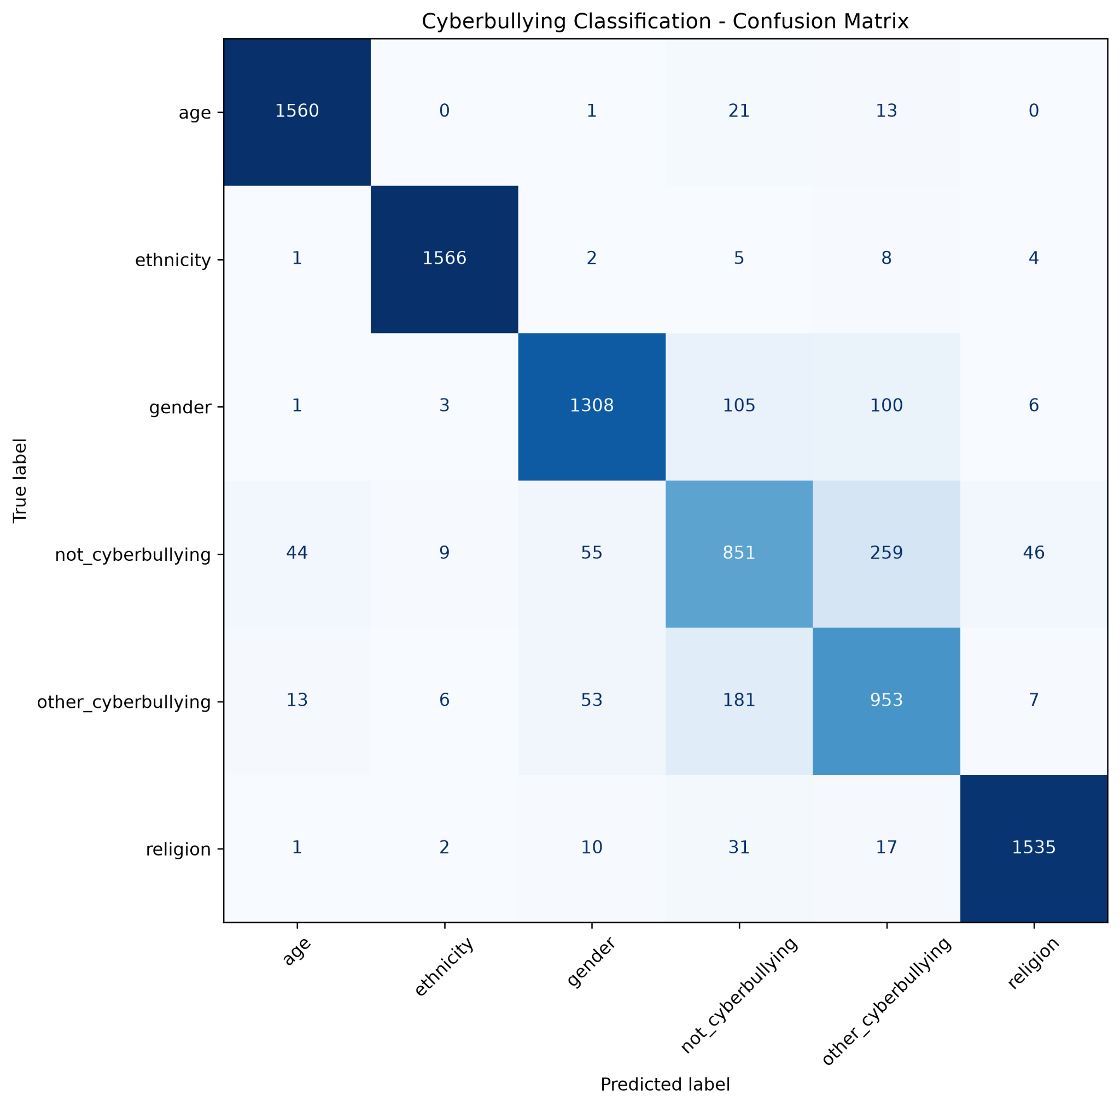
Fig. 2. Held-out confusion matrix for the selected six-class classifier.

C. Answer to RQ1
All three learners can produce six-way predictions, but LR with combined features had the strongest training-only macro-F1 among the evaluated configurations. On the test set, its high overall accuracy coexists with materially lower F1 for the two general categories, underscoring why per-class evaluation is necessary.
Differences among the six class F1 scores are substantial. Ethnicity (0.9874), age (0.9705) and religion (0.9612) show strong discrimination within this corpus, while gender (0.8862), other_cyberbullying (0.7437) and not_cyberbullying (0.6924) are harder. These values do not establish that ethnicity-related or religious harassment is intrinsically easier to detect; the dataset may contain strong topical markers or sampling artifacts. Moreover, high F1 for an identity-related label does not indicate that the classifier has identified targets, severity, intent or social harm. The model predicts dataset categories only.

VI. LINGUISTIC AND ERROR ANALYSIS

A. Answer to RQ2: Representation and Signals
The strongest LR results were combined (macro-F1 0.8654), character-only (0.8622), then word-only (0.8514). Inspection of positive LR coefficients identified class-associated terms including school and bullies for age; racism-related vocabulary for ethnicity; sexist and jokes for gender; and muslim, christian and islam for religion. Some influential tokens (e.g., mkr and the USER placeholder) appear corpus-specific. Coefficients describe associations within the training corpus, not causal explanations of bullying intent.

B. Answer to RQ3: Directed Confusions
The dominant errors were not_cyberbullying → other_cyberbullying (259) and the reverse (181), totaling 440/1,004 errors (43.8%). Gender was also predicted as not_cyberbullying 105 times and other_cyberbullying 100 times. Recall was 0.6733 for not_cyberbullying and 0.7857 for other_cyberbullying, versus above 0.96 for age, ethnicity and religion.
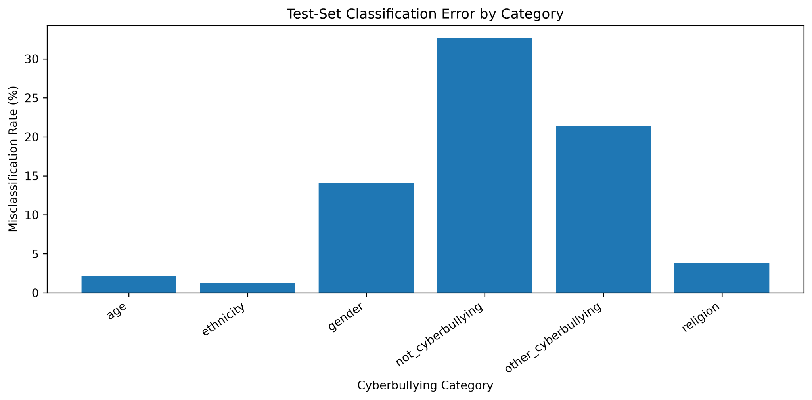
Fig. 3. Error rate by annotated class on the held-out test set.
A targeted review of saved misclassifications found bullying-related words in both confusion directions, occasional short or context-poor texts, and terms associated with ordinary discussion rather than direct attacks. These patterns are compatible with lexical overlap, missing conversational context and/or uncertain annotation. No independent re-annotation was conducted; the analysis therefore does not establish the true cause of individual mistakes or prove that any dataset label is incorrect.
The two-way confusion is especially informative because the classes are semantically close but operationally different. A tweet can discuss bullying, quote an insult or condemn abusive behaviour without itself constituting harassment. Conversely, hostile intent can be conveyed without an explicit insult, especially in replies to previous messages. Word and character n-grams can capture repeated surface patterns but cannot reconstruct absent conversational history. These are plausible mechanisms for the observed confusion, not verified causal explanations. A stronger follow-up would use a pre-specified sample of errors, blinded dual annotation and agreement statistics to distinguish model failure from label uncertainty.

VII. ANNOTATION-SENSITIVITY EXPERIMENT
The primary model excluded texts whose original copies carried conflicting labels. To examine sensitivity to that policy, 3,221 additional ambiguous training rows were introduced after removing overlaps with the held-out set, expanding training size from 35,107 to 38,328. The same combined TF-IDF + LR specification was retrained and tested on the unchanged 8,777 records. Accuracy decreased from 0.8856 to 0.8807; macro-F1 decreased from 0.8735 to 0.8688 (0.47 percentage points).

Metric | Primary | Ambiguous included
Train n | 35,107 | 38,328
Test n | 8,777 | 8,777
Accuracy | 0.8856 | 0.8807
Macro-F1 | 0.8735 | 0.8688
TABLE III. Annotation-sensitivity comparison on the same filtered held-out set.
The small reduction suggests that contradictory training annotations may modestly impair performance in this configuration. It does not demonstrate a causal general law: the training sizes also differ, only one split was tested, and the evaluation excludes the ambiguous texts themselves. This analysis should be reported as a sensitivity check rather than a second independent test.

VIII: NOVELTY, SIGNIFICANCE AND IMPACT
- Novelty and Research Contribution
The novelty of this study lies not in proposing a new classification algorithm, but in systematically examining the relationship between linguistic feature representation, category-specific classification errors, and annotation consistency within a six-class cyberbullying dataset. Although previous research has investigated cyberbullying detection using traditional machine learning and deep learning techniques, the present study contributes a focused experimental framework that combines three complementary analytical components: controlled feature–classifier comparison, interpretable linguistic error analysis, and annotation-sensitivity evaluation.
First, nine configurations were evaluated by combining word-level TF-IDF, character-level TF-IDF, and their combined representation with Logistic Regression, Multinomial Naive Bayes, and Linear Support Vector Machine. All configurations were evaluated using the same stratified cross-validation procedure, allowing differences in predictive performance to be attributed more consistently to the selected representations and classifiers. The combined TF-IDF and Logistic Regression configuration achieved the highest cross-validation macro-F1 score of 0.8654, although its improvement over character-only Logistic Regression (0.8622) was modest.
Second, rather than relying exclusively on overall accuracy, the study investigates directed classification errors between individual cyberbullying categories. The analysis revealed that confusion between not cyberbullying and other cyberbullying accounted for 440 of the 1,004 errors (43.8%) on the held-out test set. This finding highlights a distinction between recognising topic-specific vocabulary and identifying general harassment, demonstrating the value of category-level diagnostic analysis.
Third, the study investigates the sensitivity of model performance to contradictory dataset annotations. Reintroducing 3,221 ambiguously labelled training examples reduced macro-F1 from 0.8735 to 0.8688 on the unchanged test set. Although this reduction is small and cannot establish a causal effect of annotation inconsistency, it provides empirical evidence that dataset-handling decisions can influence reported classification performance.
Collectively, these contributions establish a transparent and reproducible within-corpus comparison that extends beyond reporting classifier accuracy. The research provides a focused assessment of how lexical representation choices, category confusion, and annotation decisions interact in multiclass cyberbullying detection, without claiming algorithmic novelty or superiority over existing published methods.
- Practical Impact and Implications
The practical significance of this research lies in demonstrating that high overall classification accuracy does not necessarily indicate reliable discrimination between harmful and non-harmful online communication. Although the selected classifier achieved 88.56% accuracy on the held-out test set, its performance varied considerably across the six categories. In particular, the F1 scores for not_cyberbullying (0.6924) and other_cyberbullying (0.7437) were substantially lower than those for ethnicity (0.9874), age (0.9705), and religion (0.9612). This variation suggests that models relying on lexical features may identify strongly topic-associated language more reliably than they distinguish general harassment from non-harassing communication.
These findings have implications for the design and evaluation of automated content-moderation systems. Incorrectly classifying non-cyberbullying content as cyberbullying could result in unnecessary moderation of legitimate expression, while failing to identify genuine harassment could allow potentially harmful interactions to remain unflagged. The observed 440 errors between the two general categories therefore identify an important area for further investigation. However, the dataset labels do not independently establish the harmfulness of individual posts, and the present study does not measure actual moderation outcomes.
The results also demonstrate the importance of evaluating individual categories rather than relying exclusively on aggregate performance measures. For researchers developing cyberbullying detection systems, reporting macro-F1, per-class recall, and directed confusion counts can reveal weaknesses that might otherwise remain concealed behind high overall accuracy. This is particularly important when classification categories differ in their linguistic specificity and when annotation uncertainty may affect model predictions.
Furthermore, the findings offer a practical direction for future model development. The substantial confusion between not cyberbullying and other cyberbullying motivates evaluating contextual language models such as BERT and RoBERTa, which can represent linguistic information beyond fixed word and character n-grams. A subsequent study could investigate whether contextual representations improve these specific class distinctions using the same held-out evaluation protocol, rather than assuming that a more complex model will necessarily perform better.
Nevertheless, the present classifier should be regarded as a research baseline rather than a deployable content-moderation system. Its performance has not been validated across platforms, time periods, languages, or demographic subgroups. Its principal impact is therefore methodological: it identifies a measurable classification weakness, establishes an interpretable benchmark, and provides evidence to guide more targeted future investigations into contextual understanding and annotation reliability.

IX. LIMITATIONS, ETHICS AND REPRODUCIBILITY
Dataset provenance is incompletely documented: the exact upstream annotation procedure, collection period and licence must be verified before public redistribution.

The near-balanced sample is not representative prevalence. Removing conflicting texts may simplify the test task and introduce selection bias. Exact deduplication prevents one form of leakage but not semantic near-duplicate leakage. Only one train/test split and three-fold CV were used, without confidence intervals or independent external validation. Feature weights may capture spurious topical or formatting cues. Context, sarcasm, multilingual use and distribution shift remain largely untested.

Tweets can contain identifying information and abusive language. The paper therefore reports aggregates rather than publishing raw harmful examples. Code and model outputs should be shared with access and licence restrictions respected. Reproduction requires the notebook, Python dependencies, fixed split seed, Kaggle acquisition instructions and saved evaluation artifacts. The dataset access date, version, exact package versions and group author details must be filled in before submission.
An additional threat is the possibility that the test data reflect the same collection and annotation conventions as training data. Performance may decline when evaluated on newer posts, another platform, another dialect or content lacking explicit topic words. A responsible downstream evaluation would report precision–recall trade-offs for each category, demographic subgroup audits where ethically and legally appropriate, and human-review pathways for uncertain predictions. No such deployment evaluation was conducted here. Because the corpus may include sensitive text, the reproducible release should provide acquisition instructions rather than assume unrestricted redistribution.

X. FUTURE EXTENSION AND CONCLUSION
The later module assessment can fine-tune a contextual encoder (e.g., BERT [4] or RoBERTa) on the same six labels and a leakage-controlled partition. The comparison should preserve macro-F1 as primary, audit the 440 dominant error cases, examine performance by text length and perform a manual annotation review. A separate external corpus would test generalisation. Hyperparameters must be chosen without using the final test labels.

In conclusion, combined word and character TF-IDF with LR achieved 0.8735 test macro-F1 in six-way classification. Topic-associated categories were easier to identify than general bullying versus non-bullying; 43.8% of mistakes occurred between the latter pair. Including conflicting-label training records slightly lowered performance. Together, these findings support an interpretable CA1 baseline and motivate a context-aware extension, while remaining bounded by the dataset and evaluation design.

For the extension, an appropriate design would use a training-only validation partition to select transformer learning rates, maximum sequence lengths and early stopping. The original test set should remain sealed during this process. Report overall macro-F1, per-class F1 and the same directed confusion counts, not only a single accuracy value. Compare inference cost and training resources, because a small gain from a large contextual encoder may not justify its operational complexity. A human evaluation of a stratified sample of false positives and false negatives would help assess whether the model has learned contextual meaning or simply memorised alternative lexical cues.

The present results answer the research questions with differing strength. RQ1 is answered quantitatively by the nine-configuration cross-validation and final six-way test evaluation. RQ2 is answered by representation ablations and inspected coefficients, but not by a causal feature-importance experiment. RQ3 is answered quantitatively by directed confusion counts and descriptively by an error sample; its linguistic mechanisms remain hypotheses pending blinded annotation. Distinguishing observed evidence from plausible explanations is essential to avoid overstating what a single curated dataset can demonstrate.

Before final submission, the group should record the Kaggle dataset access date and current licensing terms, confirm the notebook runs in a clean environment, and compare generated metrics with the archived CSV outputs. Reproducibility also requires documenting any platform-dependent paths and library versions. The project should include its final code and paper in the group-named ZIP requested by the module brief; the supporting research notes need not be treated as separate assessed reports.
A future annotation audit should define a coding protocol before viewing the predictions. At least two annotators could independently classify a stratified sample of the ambiguous and frequently confused items, including both model-correct and model-incorrect records. Agreement could be quantified, disagreements discussed, and a third adjudicator used where necessary. This would help separate cases where the original label is unstable from cases where the lexical classifier genuinely fails to recognise an otherwise clear category. Such a study would require careful protection of annotators exposed to harmful content and transparent documentation of sampling, instructions and adjudication. No such audit is claimed in the present CA1.
Finally, the lexical model should not be described as detecting the legal or psychological fact of cyberbullying. The labels are inherited from a dataset and may reflect annotation choices that are not equivalent to real-world policy definitions. A reliable moderation workflow would need explicit policy rules, a method for representing uncertainty, a human appeal or review process, and an assessment of harms from false positive and false negative classifications. This study contributes diagnostic evidence toward that larger research agenda, while making no claim that its outputs should be used to make automatic punitive decisions about users.

REFERENCES
[1] T. Davidson, D. Warmsley, M. Macy, and I. Weber, “Automated Hate Speech Detection and the Problem of Offensive Language,” Proc. ICWSM, vol. 11, no. 1, pp. 512–515, 2017. doi: 10.1609/icwsm.v11i1.14955.
[2] P. Fortuna and S. Nunes, “A Survey on Automatic Detection of Hate Speech in Text,” ACM Computing Surveys, vol. 51, no. 4, art. 85, 2018. doi: 10.1145/3232676.
[3] “Cyberbullying Identification System Based Deep Learning Algorithms,” Electronics, vol. 11, no. 20, art. 3273, 2022. doi: 10.3390/electronics11203273.
[4] J. Devlin, M.-W. Chang, K. Lee, and K. Toutanova, “BERT: Pre-training of Deep Bidirectional Transformers for Language Understanding,” Proc. NAACL-HLT, pp. 4171–4186, 2019.
[5] andrewmvd, “Cyberbullying Classification,” Kaggle dataset. Available: https://www.kaggle.com/datasets/andrewmvd/cyberbullying-classification (access date to be added).
[6] F. Pedregosa et al., “Scikit-learn: Machine Learning in Python,” Journal of Machine Learning Research, vol. 12, pp. 2825–2830, 2011.

