7/30/2022

Eric HITIMANA

University of Rwanda – CST - SoICT

**Final Report Template for Web Technology Course**

***Project title: E-Thesis Archiving – Case of Final Year Project, Department of Computer and Software Engineering – SoICT, UR***

**Submitted by**: 2201283393838

**Year 2, CSE**

**Academic year 2021-2022**

Table of Contents

LIST OF FIGURES 2

1. Introduction 3

1.1 Project Summary 3

1.2 Problem statement 3

1.3 Objectives 3

1.4 Project Rationale 3

2. Methodologies and Methods 3

2.1 Data collection methodology 3

2.2 Tools to be used 3

2.2.1 Hardware tools 3

2.2.2 Software tools 3

3. System Analysis and Design 3

3.1 Requirement Specifications 3

3.1.1 Functional requirements 3

3.1.2 Data Requirements 3

3.1.3 User Requirements 3

3.1.4 Security Requirements 3

3.1.5 Non-functional Requirements 3

3.2 System Design 4

3.2.1 System overall architecture 4

3.2.2 System information flow 4

4. System Implementation 4

4.1 Landing page 4

4.2 Login page 5

4.3 And so on, at least 5 pages of you 6

5. Conclusion 7

6. Recommendation 7

7. Appendix 7

# LIST OF FIGURES

Figure 1: Overall structure 3

Figure 2: Project landing page 4

Figure 3: Login page 4

Figure 4: List of users 5

Figure 5: User details 5

Figure 6: Edit option 6

# Introduction

## Project Summary

* What is your project about?

## Problem statement

* State the problem you want to address.

## Objectives

* State your project objectives.

## Project Rationale

* Importance of your project solution. Beneficiaries.

# Methodologies and Methods

## Data collection methodology

* How did you know the problem? By observation? Did you make a site visit? Details?

## Tools to be used

### Hardware tools

* What are your required hardware tools for your project? List them

### Software tools

* What are your required software tools for your project? List them

# System Analysis and Design

## Requirement Specifications

### Functional requirements

* E.g.: User authentication module, user registration modules…

### Data Requirements

* What are data required for your system. ERD is needed here

### User Requirements

* What are the main actors of your system? Admin, Customer, Financial Manager…

### Security Requirements

* What are the security measures of your system? Password encryption, Sessions for timeout,…

### Non-functional Requirements

* What is the system performance?
* What is the system reliability?
* What is the system accessibility?

## System Design

### System overall architecture

* E.g.: overall system flow.

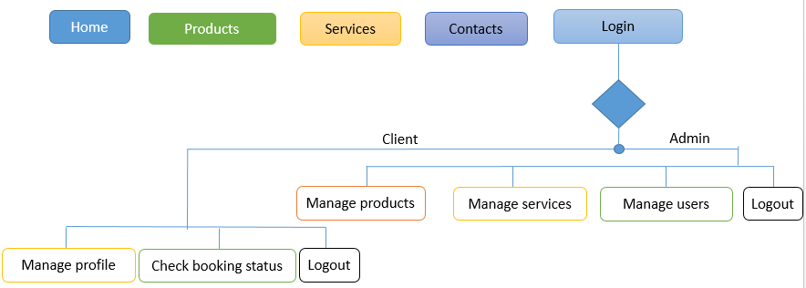

Figure : Overall structure

### System information flow

* Flow chart for Login, user registration, and Booking process.

# System Implementation

* Some screenshots.

## Landing page

This picture detail the landing page of the proposed project. From this page you can see the books with its details. You can be given the option of searching and also seeing more details. When you click on more details button, you will be given the option to read the book or download it.

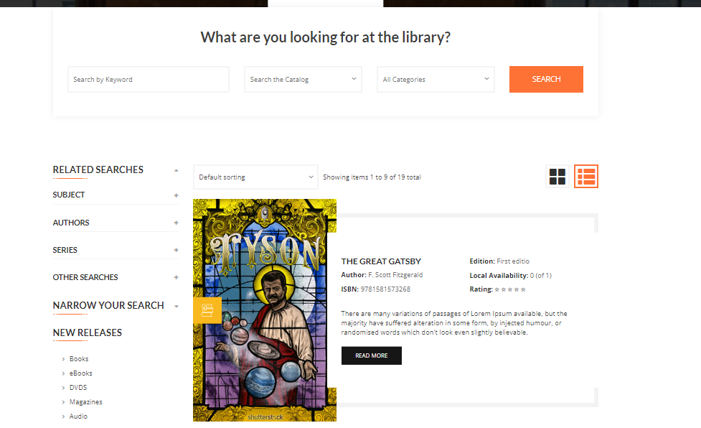

Figure : Project landing page

## Login page

This page detail the login process of the proposed project. This page detail the login process of the proposed project. This page detail the login process of the proposed project.

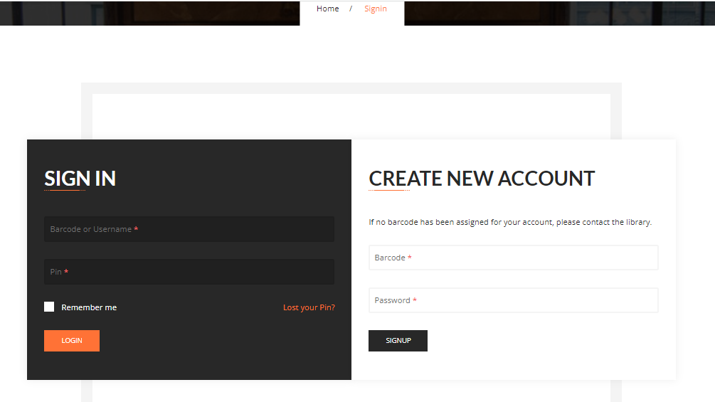

Figure : Login page

## And so on, at least 5 pages of you

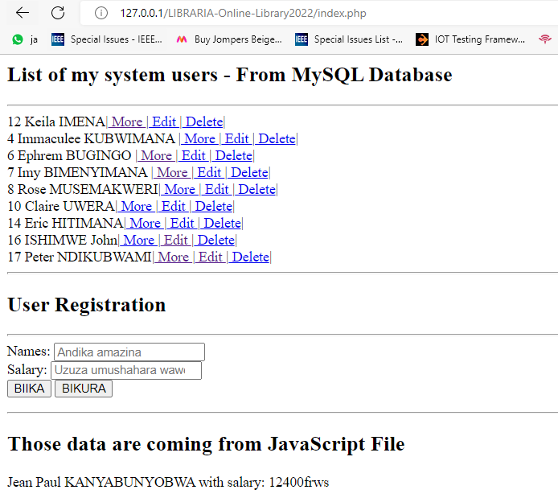

Figure : List of users

Details of a selected user

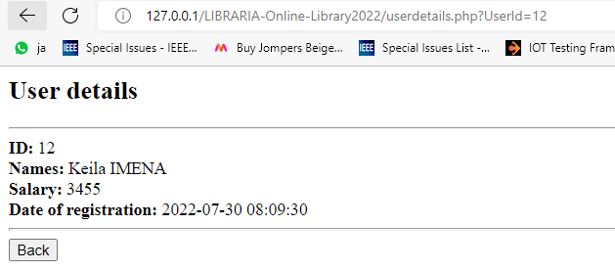

Figure : User details

Edit option put more details.

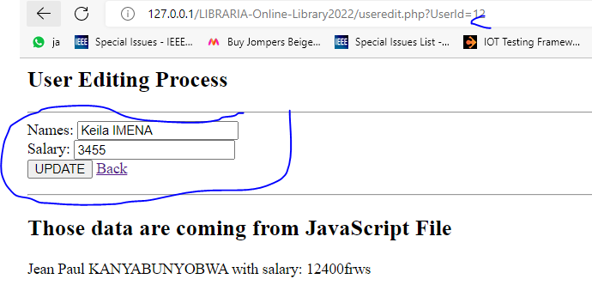

Figure : Edit option

# Conclusion

* Conclude your project against your problem and implementation objectives. What did you do at which percentage?

# Recommendation

* Lessons learned.
* What do you recommend to:

1. **Other students**
2. **Department**
3. **Beneficiaries** of your project proposal (E.g.: transport companies, if you are doing E-ticketing, Restaurants if you are doing food reservation, UR if you are doing Hostel reservation …)

# Appendix

* Link for your GitHub account with your project, if there is a need of password share it too.