How to SETUP Node.js and Visual Studio Code
Step 1: We look up the internet for Node JS installer and Visual Studio Code installer.
Step 2: Install one installer at a time, clicking necessary requirements before finally installing
Step 3: Open Up VSC then check for node version.
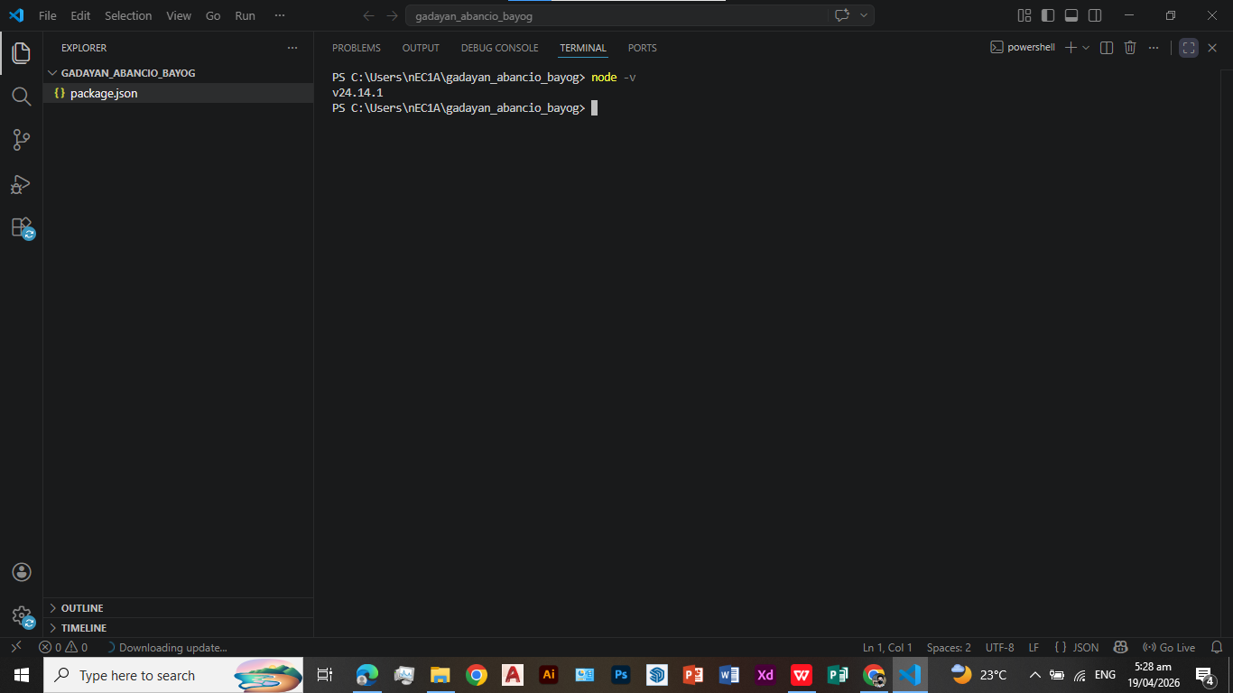
Running Node on VSC terminal and trying to print Hello World!
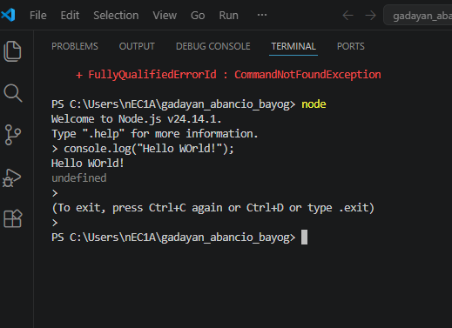
Executing index.js that has code in it in terminal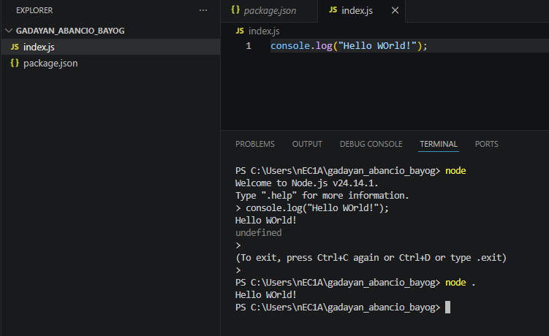
MEMBERS
April Rey Bayog
Raven Gadayan
Jann Mhareoul Abancio

