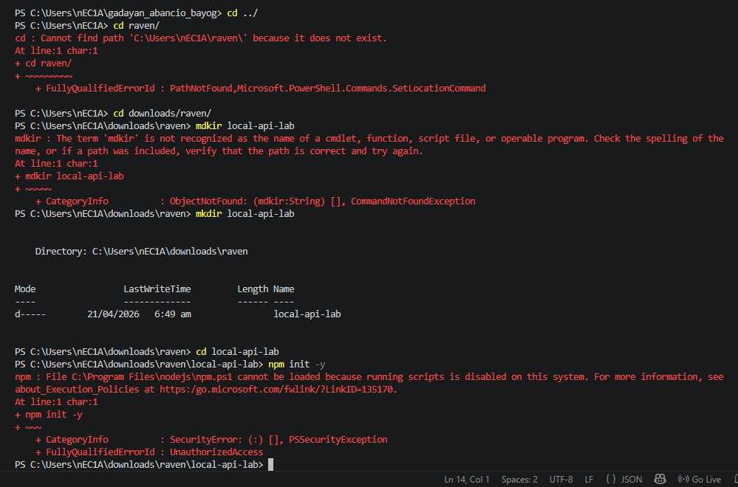

- Navigated the directory back to my proper folder.
We encountered some errors but we kept on learning anyways and eventually succeeded.
- We created a folder using the terminal.
- Navigated inside before initializing it.
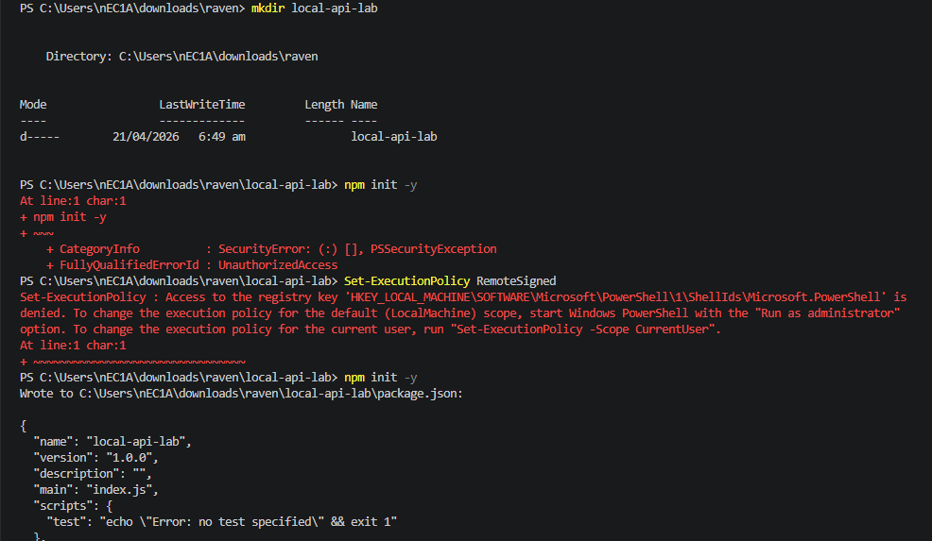

- Had to ask chatgpt to fix the error and forgot to take a screenshot. It’s just a permission problem because of the policy maybe, but it prevented us from running “npm init -y” and eventually succeeded.
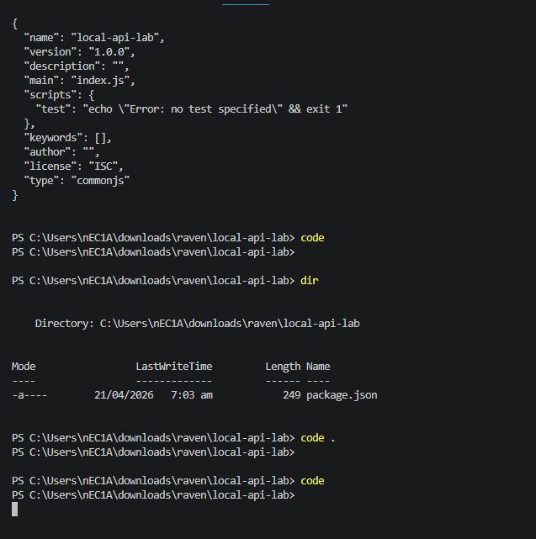
- Learned to open the folder using terminal and modify the code.

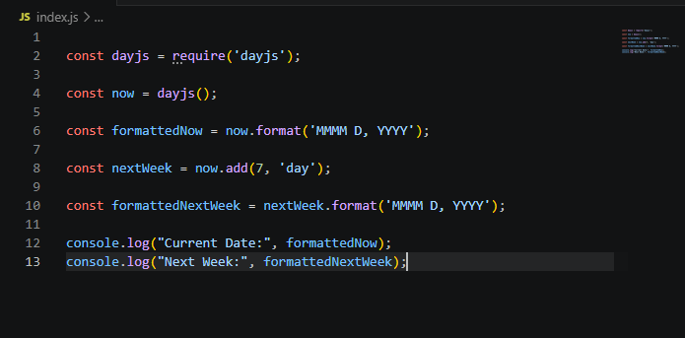
- Then this.

Question: How does using dayjs demonstrate the concept of "abstraction" compared
to writing a function that calculates leap years and days of the month manually?

- Abstraction in dayjs makes the code much more shorter and efficient. Users do not need to see the full code working in the background. It’s simply by calling the built-in syntax or function from the package and it will do the work for me. Abstraction really hide the complicated logic of the date calculations like leap years, month lengths, and time zones behind simple methods like .add() and .format().

MEMBERS:
April Rey Bayog
Jann Mhareoul Abancio
Raven Gadayan

