WE INSTALLED THE PACKAGE FROM THE LAB INSTRUCTION
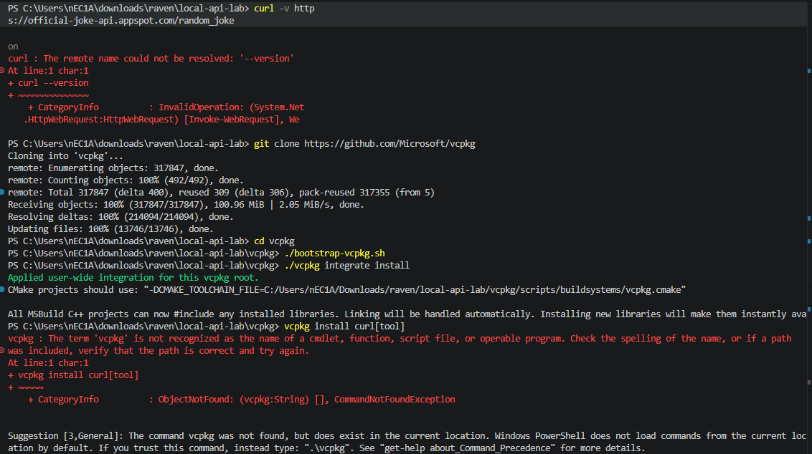

Then we ran: curl -v https://official-joke-api.appspot.com/random_joke
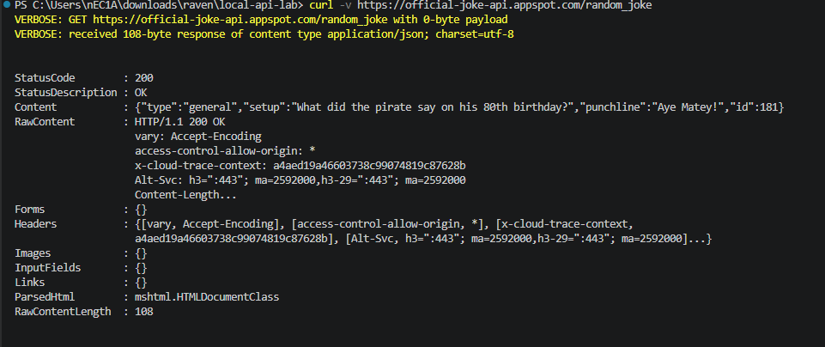

Then tried this one: curl.exe -v https://official-joke-api.appspot.com/random_joke
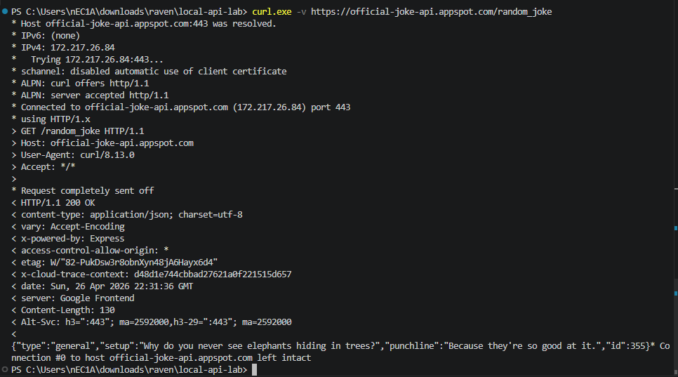

Questions
- Identify the Method used in the output.
- From > GET /random_joke HTTP/1.1
The Method used is GET.
- Identify one Header returned by the server (e.g., Content-Type).
- One header returned by the server is access-control-allow-origin: *
- What format is the Payload (the actual joke data) returned in?
The payload is in JSON format.

MEMBERS:
April Rey Bayog
Jann Mhareoul Abancio
Raven Gadayan

