- PROJECT INITIALIZED
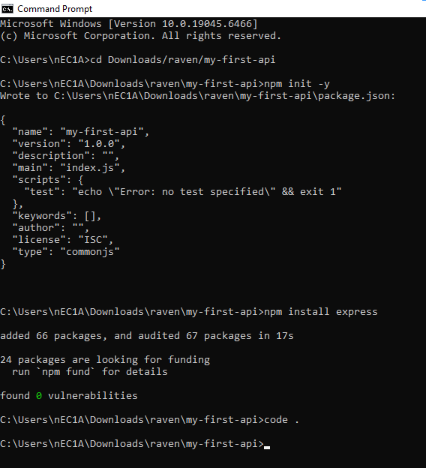

- THE CODE
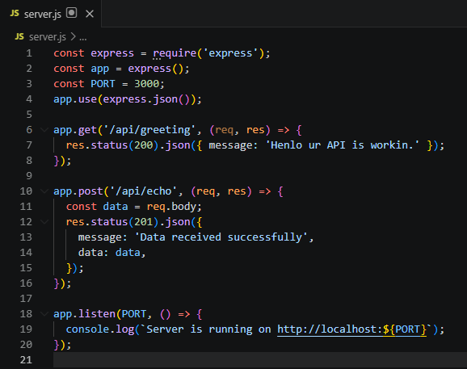

- SERVER RUNNING
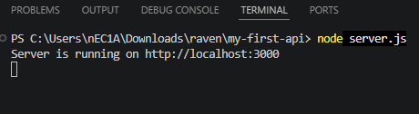

- IT’S WORKING! TESTED GET
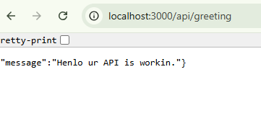

- TESTED POST
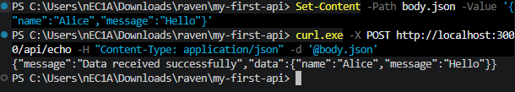
MEMBERS:
April Rey Bayog
Jann Mhareoul Abancio
Raven Gadayan

