- INSTALLED BETTER_SQLITE3
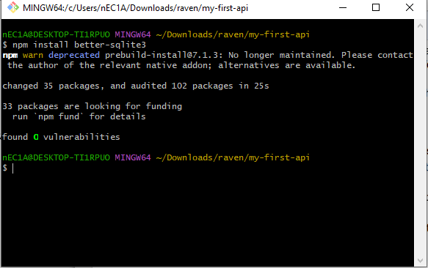

- THE CODE

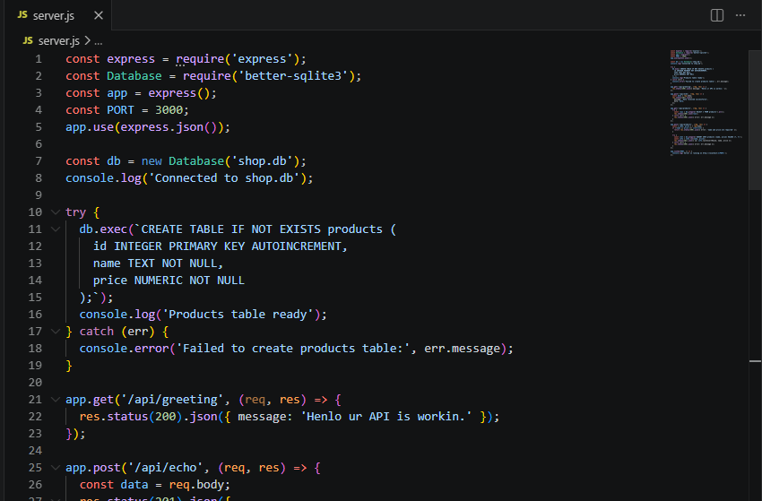

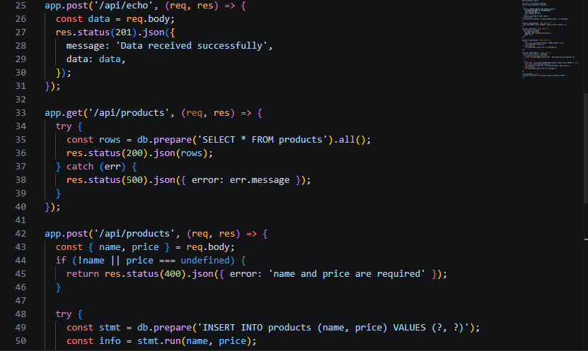
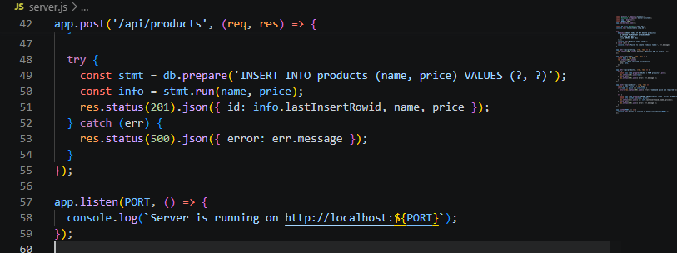

- SERVER RUNNING
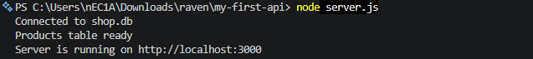

- IT’S WORKING! POST
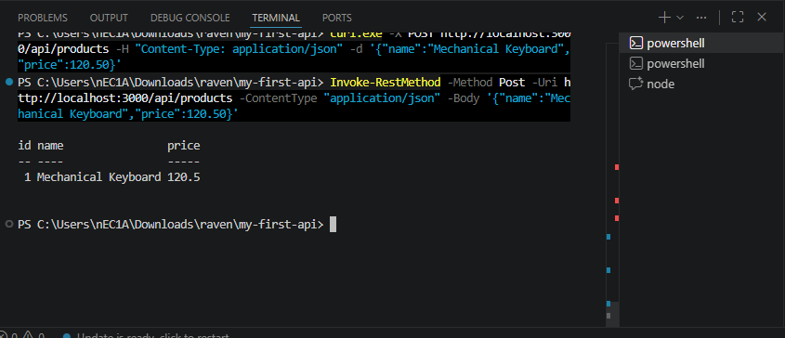

- TESTED GET

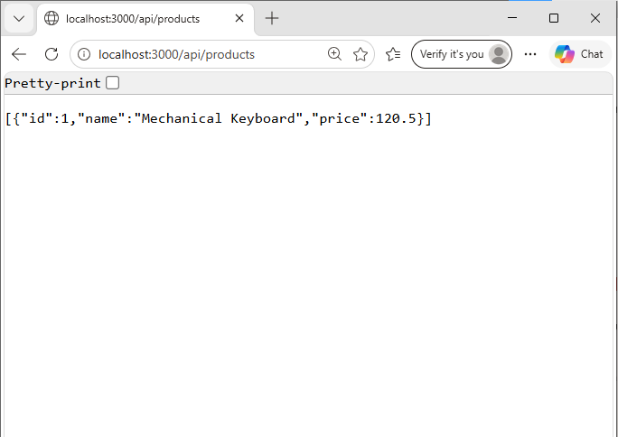
6. PERSISTENCE TEST: Yes, the keyboard is still there.
MEMBERS:
April Rey Bayog
Jann Mhareoul Abancio
Raven Gadayan

