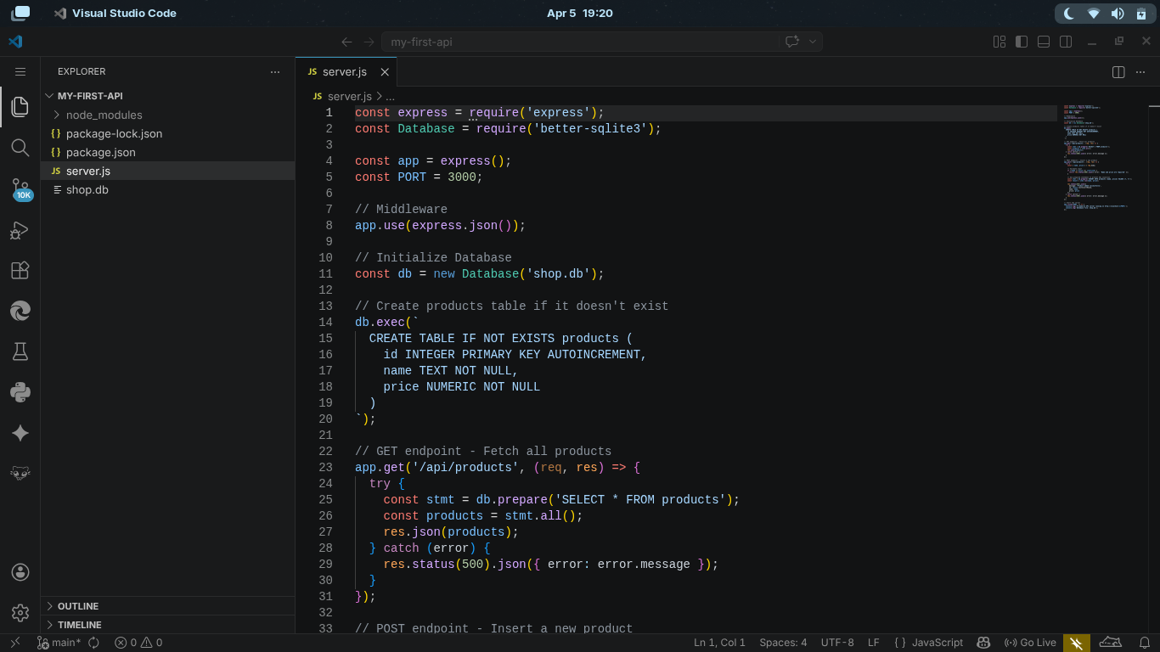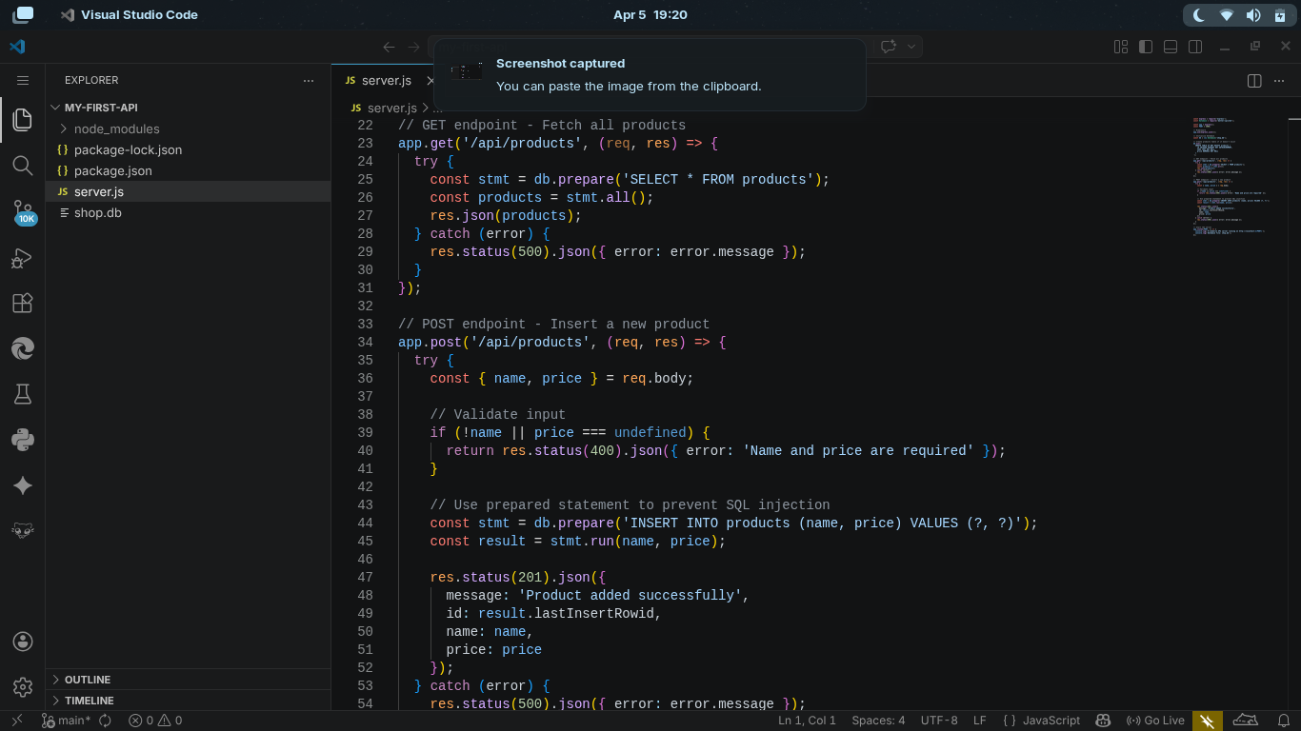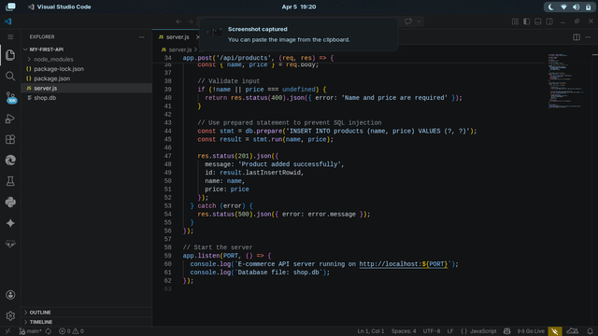
Gee. V. B. Parohinog
Dave Charl Inbañez
Arjemaye Peñafiel
John Rey Carbaquel
Chadrich Vincent Samillano

