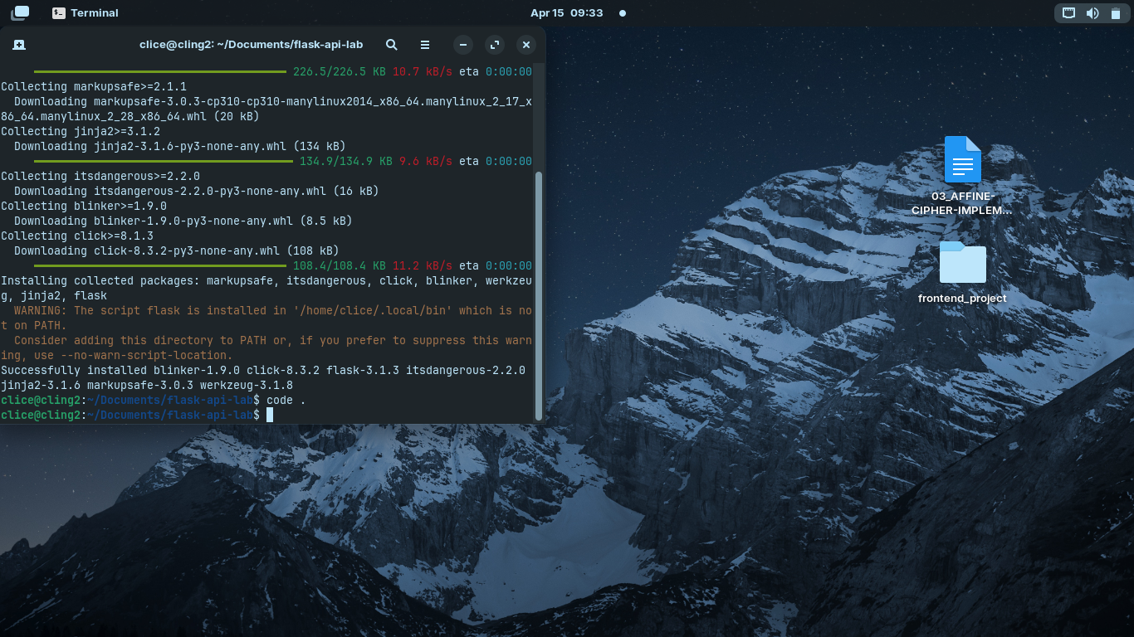

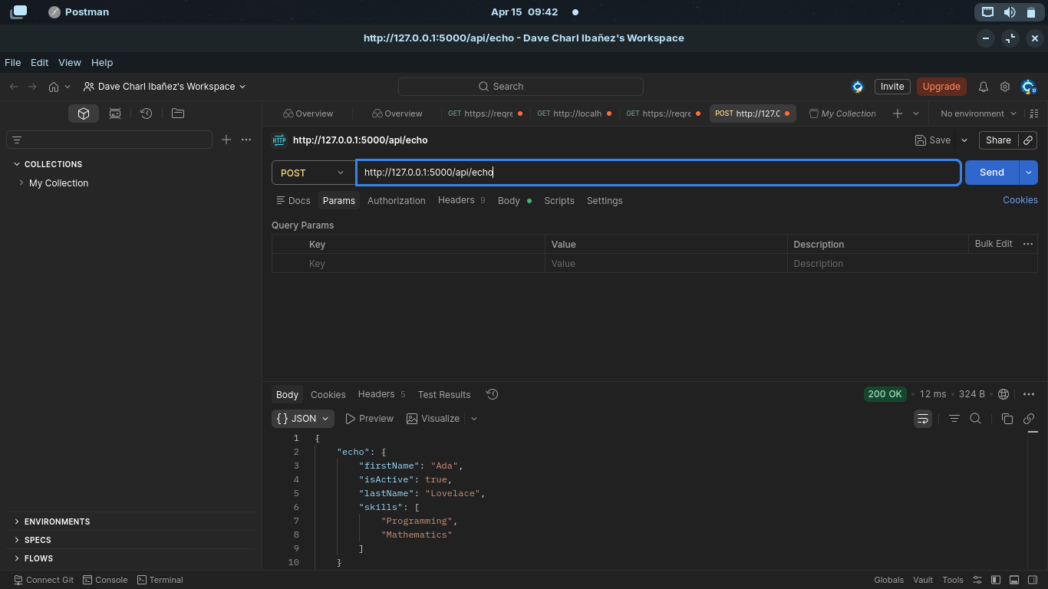

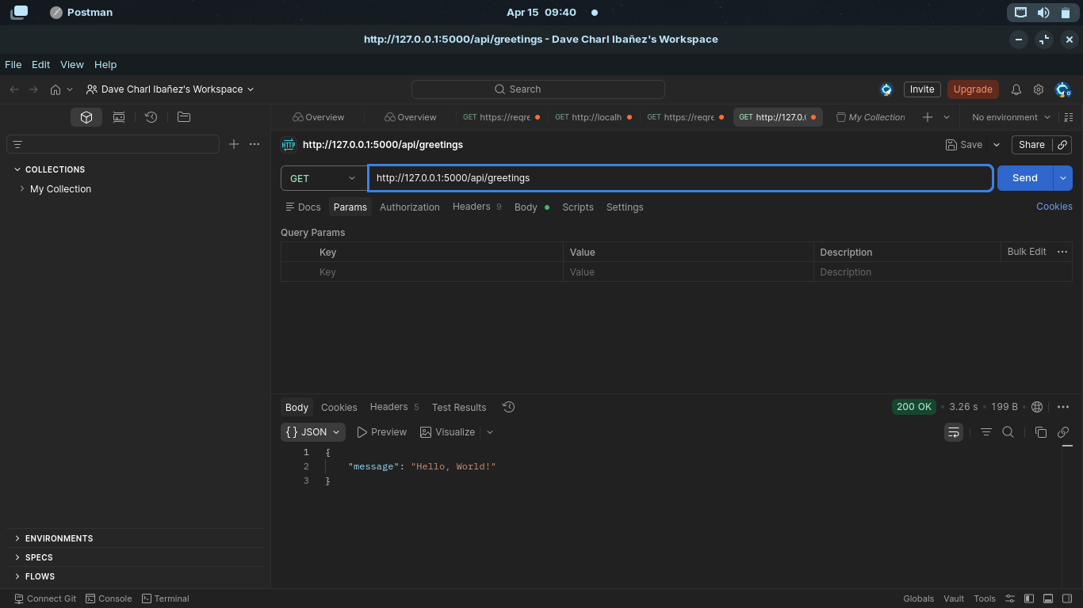

1.which is more intuitive(Express vs Flask)?
-Flask’s @app.route() is simple and readable because it’s uses python decorators, while Express uses app.get(). Many find flask cleaner, but it depends on familarity.

2.Why is Flask called a “micro-framework”?
-flask is lightweight and does not include built-in tools like automatic JSON parsing unlike express. You manually handle things like request.get_json().

3.Did Endpoint,Method, Payload change?
-No, Even if the language changed:
The Endpoint are the same (/api/greeting) and the method uses (GET, POST) the payload is same (JSON). This shows that HTTP follows a standardized contract, independent of programming language.

