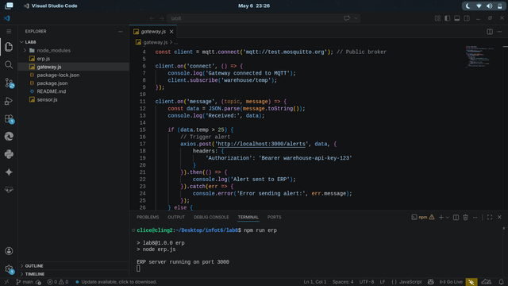
Gee. V. B. Parohinog
Dave Charl Inbañez
Arjemaye Peñafiel
John Rey Carbaquel
Chadrich Vincent Samillano
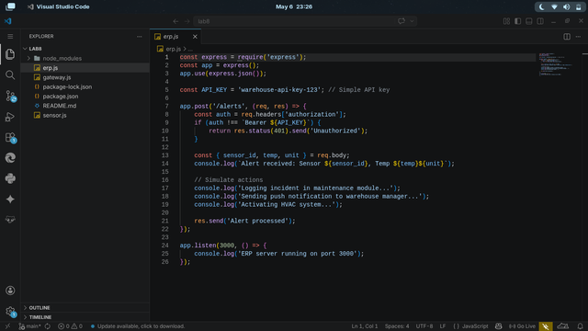

Answers:

1.
Express puts the URL parameters inside an object called `req.params`, while Flask just passes them as arguments directly into the function. To me, Flask feels more natural because it works like a regular function call, so it's easier to see exactly what data the function is using.

2.
Express uses method chaining (calling `.status()` then `.json()`), while Flask just lets you return a tuple with the data and the code. I think the Flask approach is easier to read for a large API because it's shorter and more direct, whereas chaining in Express can get a bit long.

3.
No, the `curl` command didn't change at all.
Reflection: This is a huge benefit because the client (the user) doesn't need to know what language the server is using. As long as the server follows the HTTP protocol, the developers can change the entire backend from JavaScript to Python (or any other language) without the user ever noticing or having to change their own code.

4.
Using a `.env` file is much better because it keeps secret keys and passwords out of the actual source code. If you type the secret key directly into `server.js` or `app.py` and then upload your code to GitHub, anyone can see your keys and steal them. A `.env` file keeps that sensitive info separate and safe.

