

Unconventional Inspirations in Metaheuristics

Analysing the advantages and disadvantages of introducing unusual inspiration in computational intelligence methods for balancing exploration and exploitation in search/optimization problems.

Date: May 2024

Location: Birmingham – United Kingdom

Student: ID: 190079330

Word count: 1800

# Table of Contents

Table of Contents 1

1 Introduction 2

2 Literature Review 2

2.1 Method 1: The Firefly Algorithm: 2

2.2 Method 2: Exploitation-focused Cuckoos CSA : 5

3 Comparison and Analysis (400-500 words): 7

4 Conclusion 8

5 References: 8

# Introduction

This report investigates the advantages and disadvantages of using unusual sources of inspiration in metaheuristic algorithms, focusing on how these influence the balance between exploration and exploitation in search and optimization problems. Specifically, it examines the Firefly Algorithm (FA) and the Cuckoo Search Algorithm (CSA), which draw from the bioluminescent behavior of fireflies and the brood parasitism of cuckoos, respectively. FA uses light intensity as a metaphor to guide solution enhancement, while CSA employs Lévy flights to replace less effective solutions with better ones. This analysis highlights how these nature-inspired strategies contribute to computational intelligence, enhancing the performance and diversity of solutions in complex scenarios like the Traveling Salesman Problem (TSP).

# Literature Review

## Exploration and Exploitation in Metaheuristics with Unusual inspiration.

Metaheuristic algorithms, often inspired by natural phenomena, play a vital role in addressing complex optimization problems through a nuanced balance of exploration and exploitation. Among these, the Whale Optimization Algorithm (WOA), inspired by humpback whales' hunting behavior, exemplifies innovative adaptation. WOA employs a nonlinear control strategy using the arcsine function, which adjusts its distance control parameter, allowing it to navigate the search space more effectively. This approach enhances both the explorative and exploitative capabilities of the algorithm, leading to marked improvements in performance on benchmark functions (Wu et al., 2019).

Similarly, multi-objective evolutionary algorithms leverage the dynamics of natural evolution to maintain a crucial balance between exploring a wide array of potential solutions and exploiting known efficacious solutions to achieve optimal outcomes. This dual approach is essential for deriving high-quality solutions applicable across varied problem domains, effectively addressing the intertwined needs for diversity and solution quality in complex optimization scenarios (Binh et al., 2023).

However, it is important to note the varying levels of recognition and application among different metaheuristic algorithms. Algorithms like the Firefly Algorithm (FA) and the Cuckoo Search Algorithm (CSA), although innovative and inspired by fascinating biological behaviors, are among the least cited according to recent statistical analyses – **see figure 1**. This underrepresentation might reflect a potential underutilization in broader applications or a need for further development to enhance their robustness and applicability in more diverse scenarios. Despite this, their unique mechanisms—FA's attraction-based movement and CSA's brood parasitism-inspired replacement strategy—offer valuable perspectives on optimization that merit further exploration and integration into more complex or hybrid metaheuristic frameworks.

Figure 1 Citation trends for various nature-inspired metaheuristic algorithms from 1980 to 2015 adapted from Fausto et al. (2019)

## Method 1: The Firefly Algorithm (FA):

The Firefly Algorithm (FA), inspired by the bioluminescent communication of fireflies, utilizes the concept where the brightness of each firefly corresponds to the quality of a solution. Fireflies in nature use their light intensity to attract mates and signal prey, and similarly in FA, artificial fireflies gravitate towards brighter ones, thereby navigating towards better solutions. This attraction is not only determined by brightness but also diminishes with distance, reflecting the decrease in light intensity over space (Yang, 2010).

FA is recognized for its robust mechanism that facilitates extensive exploration of the solution space. This attribute is crucial in avoiding local optima, making FA particularly effective for complex optimization problems like the Traveling Salesman Problem (TSP), which is a quintessential NP-hard problem that requires efficient handling of combinatorial data (Fister et al., 2013; Jaradat et al., 2019). The probabilistic attraction combined with randomization allows the algorithm to explore widely and unpredictably across the solution landscape, enhancing the diversity of solutions and the likelihood of finding a global optimum.

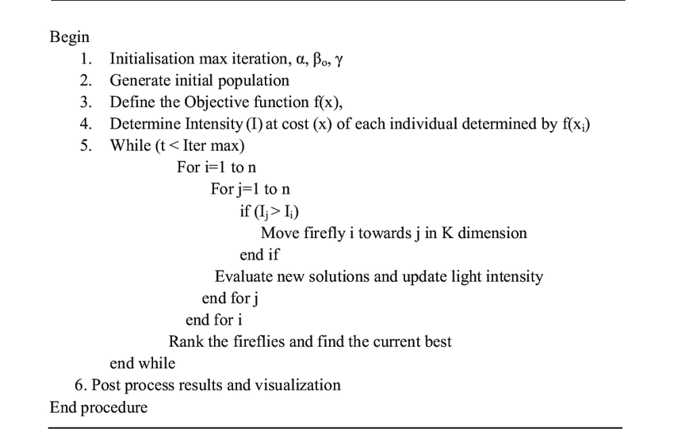

Figure 2 A basic Firefly algorithm Implementation (Yang, 2008)

However, the advantages of FA also introduce certain disadvantages. The extensive search capability, while beneficial in avoiding premature convergence, can result in slower overall convergence rates. This trade-off is evident in scenarios requiring rapid solutions where the delay in converging can be a significant drawback (Fister et al., 2013). Additionally, FA's performance is highly sensitive to its parameters, such as the light absorption coefficient and the scale of attractiveness, necessitating careful tuning to maintain efficacy across different applications (Yang, 2010).

Recent studies have applied FA to TSP, either as a standalone approach or in hybrid forms. Jaradat et al. (2019) combined FA with k-means clustering to tackle TSP, enhancing the algorithm's efficiency by dividing the problem into manageable clusters before employing FA for intra-cluster optimization. This method showed improved outcomes compared to other algorithms, indicating that such modifications could offset some inherent weaknesses of the original FA, like its slow convergence.

In another innovative approach, Xu and Yao (2023) integrated FA with the Ant Colony Algorithm to optimize parameter settings, thereby improving the execution time and the quality of the solution for TSP. This hybrid strategy demonstrates the adaptability of FA when combined with other algorithms to enhance performance and address specific challenges such as parameter sensitivity and local optima issues.

In essence, the Firefly Algorithm stands out in the field of swarm intelligence due to its simplicity, effectiveness, and the natural inspiration behind its design. While it offers significant advantages in exploring complex solution spaces and ensuring diversity in solutions, its efficiency can be affected by slow convergence and parameter sensitivity. Ongoing research into hybrid models and parameter optimization reflects the dynamic evolution of FA, showcasing its potential to meet diverse problem-solving needs in practice (Fister et al., 2013; Xu & Yao, 2023).

## Method 2: Cuckoos Search Algorithm (CSA):

The Cuckoo Search Algorithm (CSA) is a metaheuristic optimization method inspired by the brood parasitism behavior of some cuckoo species. In this biological phenomenon, cuckoos lay their eggs in the nests of other birds, often leading to the hosts unwittingly nurturing the cuckoo's offspring. This strategy is simulated in CSA where poorer solutions are replaced with new, potentially superior ones generated through Lévy flights—a random walk whose step lengths are determined by a Lévy distribution, allowing for both local and global search capabilities (Yang & Deb, 2009).

The primary advantage of CSA lies in its exploitation efficiency, primarily through the mechanism of host nest replacement. This feature ensures a continuous refinement of existing solutions, inherently focusing on improving the quality of the solution pool. Additionally, the use of Lévy flights enables a broad exploration of the search space, significantly enhancing the algorithm's ability to discover global optima (Yang & Deb, 2009; Gandomi & Alavi, 2012). These characteristics make CSA particularly effective for complex optimization problems, including the Traveling Salesman Problem (TSP), where it balances exploration and exploitation to find efficient routes (Tzy-Luen et al., 2016).

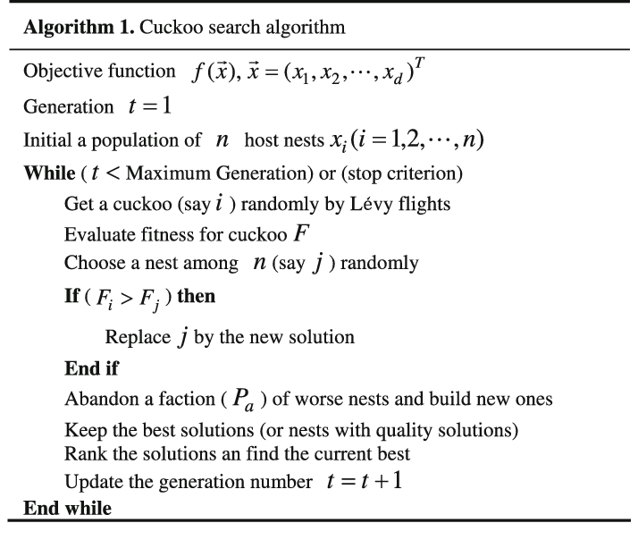

Figure 3 A Basic CSA Implementation Pseudo code (Yang and Deb, 2009)

However, CSA is not without its challenges. One notable disadvantage is its tendency towards premature convergence, particularly if the initial solutions are not diverse enough. This can lead the algorithm to settle on suboptimal solutions early in the search process (Walton et al., 2011). Moreover, the performance of CSA is highly sensitive to its parameters, such as the rate of discovery of non-cuckoo eggs, requiring careful tuning to achieve optimal performance (Yang & Deb, 2009).

Recent studies have extended CSA's utility through hybridization with other algorithms to leverage complementary strengths. For instance, the integration of CSA with K-means in clustering problems enhances initial solution quality and accelerates convergence, addressing one of CSA's weaknesses in handling large datasets efficiently (Girsang et al., 2017). Similarly, a novel hybrid approach combining CSA with Genetic Algorithms has shown promise in optimizing electricity forecasts by improving accuracy and robustness through enhanced exploitation capabilities (Navarro & Navarro, 2023).

In retrospect, the Cuckoo Search Algorithm stands out for its innovative emulation of natural parasitic behavior, effectively balancing the dual needs of exploration and exploitation in optimization tasks. Its ability to adapt and integrate with other algorithms further enhances its applicability across a broad spectrum of problems. Nevertheless, the challenges associated with parameter sensitivity and the risk of premature convergence necessitate ongoing research to refine its mechanisms and expand its practical utility in diverse applications (Shehab et al., 2017). This exploration into the depths of CSA's design and application provides a foundation for future enhancements and wider adoption in solving complex real-world problems.

# Comparison and Analysis:

FA is inspired by the bioluminescent communication of fireflies. In this algorithm, each firefly's brightness, representing the quality of a solution, attracts other fireflies. This mechanism promotes extensive exploration of the solution space, crucial for discovering diverse solutions and avoiding local optima. Enhancements in the algorithm, as outlined in the pseudocode for a simple TSP ***(adapted from Figure 2 above),*** include ***dynamic attractiveness adjustment (Beta)*** based on distance and iteration count, and the ***introduction of random walks*** independent of other fireflies' positions. These modifications ensure broader exploration early in the optimization process, gradually honing in on optimal solutions as iterations proceed (Yang, 2010).

Contrastingly, CSA draws inspiration from the brood parasitism of cuckoos. It utilizes Lévy flights to generate new solutions, facilitating jumps out of local optima and broad initial searches. The core of CSA's exploitation capability lies in its nest replacement strategy, where new, potentially superior solutions replace inferior ones. In the adapted CSA implementation ***(adapted using figure 3 above)*** for TSP, adjustments include ***reducing the step size of Lévy flights*** to focus exploration around known good solutions and increasing the ***probability of abandonment*** to refresh the solution pool more aggressively (Yang & Deb, 2009).

In practical applications, FA's enhanced exploration capabilities are beneficial in scenarios where the diversity of solutions is paramount, albeit at the cost of slower convergence. Conversely, CSA tends to converge more rapidly due to its strong exploitation focus, which can be a double-edged sword leading to premature convergence if not carefully managed.

***Note: Implementation based on practical experience can be found*** [***here***](https://github.com/EmmanuelSnr1/Comp-Intelligence/blob/main/Firefly.py)

Both algorithms demonstrate a significant sensitivity to their respective parameters, impacting their effectiveness. For FA, the light absorption coefficient influences the attraction range, affecting the exploration-exploitation balance. For CSA, the rate of alien egg discovery (pa) needs precise tuning to balance between innovative searches and rapid convergence (Walton et al., 2011).

Advancements in hybrid algorithms and adaptive parameter tuning offer promising avenues for enhancing both FA and CSA. The integration of CSA with genetic algorithms, for example, has proven effective in improving robustness and accuracy in complex optimization scenarios such as electricity forecast optimization (Navarro & Navarro, 2023).

# Conclusion

This analysis evaluates the advantages and disadvantages of leveraging unusual natural inspirations in metaheuristic algorithms to balance exploration and exploitation in optimization challenges. While traditional nature-inspired algorithms like Genetic Algorithms have effectively incorporated natural behaviors into robust computational strategies, algorithms such as the Firefly and Cuckoo Search, which are based on less conventional natural phenomena, present a mixed picture. The advantage of these algorithms lies in their innovative approaches, which can lead to novel solutions and pathways in problem-solving. However, their effectiveness is often hindered by issues such as parameter sensitivity and potential for premature convergence. To fully realize their potential, these algorithms require further refinement and integration into more sophisticated or hybrid computational frameworks. Enhancing their adaptability and addressing their limitations is essential for expanding their application across a broader spectrum of optimization scenarios, thereby enriching the field with both theoretical and practical advances.

# References:

1. Yang, X. S. (2010). Firefly Algorithm, Stochastic Test Functions and Design Optimization. International Journal of Bio-Inspired Computation.
2. Alkhateeb, F., Abed-alguni, B. H., & Al-rousan, M. H. (2022). Discrete hybrid cuckoo search and simulated annealing algorithm for solving the job shop scheduling problem. Journal of Supercomputing, 78(4), 4799–4826. https://doi.org/10.1007/S11227-021-04050-6/TABLES/10
3. Bhattacharjee, K. K., & Sarmah, S. P. (2015). A binary cuckoo search algorithm for knapsack problems. IEOM 2015 - 5th International Conference on Industrial Engineering and Operations Management, Proceeding. https://doi.org/10.1109/IEOM.2015.7093858
4. Binh, M. T., Nguyen, L., & Duc, D. N. (2023). An Approach to Maintain the Balance between Exploitation and Exploration of the Evolutionary Process in Multi-objective Algorithms. Proceedings - 2023 6th International Conference on Information and Computer Technologies, ICICT 2023, 29–34. https://doi.org/10.1109/ICICT58900.2023.00012
5. Fister, I., Fister, I., Yang, X.-S., & Brest, J. (2013). A comprehensive review of firefly algorithms. Swarm and Evolutionary Computation, 13, 34–46. https://doi.org/10.1016/j.swevo.2013.06.001
6. Gandomi, A. H., & Alavi, A. H. (2012). Krill herd: A new bio-inspired optimization algorithm. Communications in Nonlinear Science and Numerical Simulation, 17(12), 4831–4845. <https://doi.org/10.1016/J.CNSNS.2012.05.010>
7. Yang, X. S., & He, X. (2013). Bat Algorithm: Literature Review and Applications. International Journal of Bio-Inspired Computation.
8. Girsang, A. S., Yunanto, A., & Aslamiah, A. H. (2017). A hybrid cuckoo search and K-means for clustering problem. ICECOS 2017 - Proceeding of 2017 International Conference on Electrical Engineering and Computer Science: Sustaining the Cultural Heritage Toward the Smart Environment for Better Future, 120–124. https://doi.org/10.1109/ICECOS.2017.8167117
9. Hasan, M. M., Kashem, M. A., Islam, M. J., & Hossain, M. Z. (2021). A Time-varying Mutation Operator for Balancing the Exploration and Exploitation Behaviours of Genetic Algorithm. 3rd International Conference on Electrical and Electronic Engineering, ICEEE 2021, 165–168. https://doi.org/10.1109/ICEEE54059.2021.9718786
10. Jaradat, A., Matalkeh, B., & Diabat, W. (2019). Solving Traveling Salesman Problem using Firefly algorithm and K-means Clustering. 2019 IEEE Jordan International Joint Conference on Electrical Engineering and Information Technology, JEEIT 2019 - Proceedings, 586–589. https://doi.org/10.1109/JEEIT.2019.8717463
11. Kheiri, A., & Keedwell, E. (2015). A sequence-based selection hyper-heuristic utilising a hidden markov model. GECCO 2015 - Proceedings of the 2015 Genetic and Evolutionary Computation Conference, 417–424. https://doi.org/10.1145/2739480.2754766
12. Navarro, M. M., & Navarro, B. B. (2023). Hybrid Cuckoo Search and Genetic Algorithm for Optimizing Electricity Forecast. 2023 IEEE International Conference on Industrial Engineering and Engineering Management, IEEM 2023, 602–606. https://doi.org/10.1109/IEEM58616.2023.10406830
13. Seshagiri, S., & Prema, K. v. (2023). An Empirical Study of On-Policy and Off-Policy Actor-Critic Algorithms in the Context of Exploration-Exploitation Dilemma. Proceedings of the 2023 International Conference on Emerging Techniques in Computational Intelligence, ICETCI 2023, 238–243. https://doi.org/10.1109/ICETCI58599.2023.10331400
14. Shehab, M., Khader, A. T., & Al-Betar, M. A. (2017). A survey on applications and variants of the cuckoo search algorithm. Applied Soft Computing, 61, 1041–1059. https://doi.org/10.1016/J.ASOC.2017.02.034
15. Tzy-Luen, N., Keat, Y. T., & Abdullah, R. (2016). Parallel Cuckoo Search algorithm on OpenMP for traveling salesman problem. 2016 3rd International Conference on Computer and Information Sciences, ICCOINS 2016 - Proceedings, 380–385. https://doi.org/10.1109/ICCOINS.2016.7783245
16. Wu, X., Zhang, S., Xiao, W., & Yin, Y. (2019). The Exploration/Exploitation Tradeoff in Whale Optimization Algorithm. IEEE Access, 7, 125919–125928. https://doi.org/10.1109/ACCESS.2019.2938857
17. Xu, Y., & Yao, X. (2023). A Hybrid Approach Based on Ant Colony and Firefly Algorithm for Traveling Salesman Problem. 2023 8th International Conference on Cloud Computing and Big Data Analytics, ICCCBDA 2023, 167–171. https://doi.org/10.1109/ICCCBDA56900.2023.10154838
18. Yang, X. S., & Deb, S. (2009). Cuckoo search via Lévy flights. 2009 World Congress on Nature and Biologically Inspired Computing, NABIC 2009 - Proceedings, 210–214. <https://doi.org/10.1109/NABIC.2009.5393690>
19. Fausto, F., Reyna-Orta, A., Cuevas, E., Andrade, Á. G., & Perez-Cisneros, M. (2019). From ants to whales: metaheuristics for all tastes. *Artificial Intelligence Review 2019 53:1*, *53*(1), 753–810. https://doi.org/10.1007/S10462-018-09676-2