Thank you — here's the corrected table for **Sprite 3** at frames 7, 10, and 12:

| **Property** | **Frame 7** | **Frame 10** | **Frame 12** |
| --- | --- | --- | --- |
| **Start** | 7 | 7 | 7 |
| **End** | 12 | 12 | 12 |
| **Rotation** | 13.10 | 17.23 | 20.00 |
| **Skew** | 13.20 | 17.88 | 21.00 |
| **ForeColor** | 203 | 50 | 211 |
| **BackColor** | 103 | 51 | 111 |
| **Ink** | Background Transparent | Background Transparent | Background Transparent |
| **Blend** | 50% | 20% | 90% |

|  |  |  |  |  |
| --- | --- | --- | --- | --- |
| Frame | Property | Float | Int32 | Hex Bytes |
| 7 | Rotation | 13.1 | 1310 | 00 00 05 1E |
| 7 | Skew | 13.2 | 1320 | 00 00 05 28 |
| 10 | Rotation | 17.23 | 1723 | 00 00 06 BB |
| 10 | Skew | 17.88 | 1788 | 00 00 06 FC |
| 12 | Rotation | 20.0 | 2000 | 00 00 07 D0 |
| 12 | Skew | 21.0 | 2100 | 00 00 08 34 |

**Summary Table: Sprite 3 (Channel 9)**

| **Frame** | **Offset** | **Keyframe?** | **Member** | **Blend** | **Ink** | **Rot** | **Skew** | **Fore** | **Back** | **LocH** | **LocV** |
| --- | --- | --- | --- | --- | --- | --- | --- | --- | --- | --- | --- |
| 9 | 0x6876 | ✅ | 65538 | 30 | 0 | 11,1 | 11,2 | CC | 66 | 3E | 3C |
| 10 | 0x68CA | ✅ delta | 65538 | 50 | 36 | 13,1 | 13,2 | 72 | ?? | 2B | 29 |
| 12 | 0x6910 | ✅ | 65538 | 40 | 8 | 12,1 | 12,2 | 4C | ?? | E0 | ?? |

| **Frame** | **Offset** | **Keyframe** | **Member** | **Blend** | **Ink** | **Rot** | **Skew** | **Fore** | **Back** | **LocH** | **LocV** |
| --- | --- | --- | --- | --- | --- | --- | --- | --- | --- | --- | --- |
| 9 | 0x6876 | ✅ | 65538 | 50% | Background Transparent | 13.10 | 13.20 | 203 | 103 | 62 | 60 |
| 10 | 0x68CA | ✅ delta | 65538 | 50% | Background Transparent | 17.23 | 17.88 | 50 | 51 | ? | ? |
| 12 | 0x6910 | ✅ delta | 65538 | 90% | Background Transparent | 20.00 | 21.00 | 211 | 111 | ? | ? |

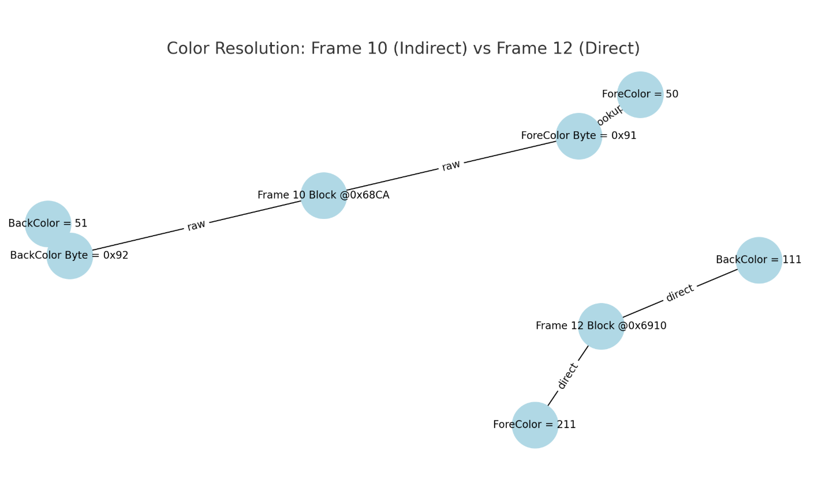

Analyse dir file with more keyframes:

**Sprite 3** : identical as previvous:

| **Property** | **Frame 7** | **Frame 10** | **Frame 12** |
| --- | --- | --- | --- |
| **Start** | 7 | 7 | 7 |
| **End** | 12 | 12 | 12 |
| **Rotation** | 13.10 | 17.23 | 20.00 |
| **Skew** | 13.20 | 17.88 | 21.00 |
| **ForeColor** | 203 | 50 | 211 |
| **BackColor** | 103 | 51 | 111 |
| **Ink** | Background Transparent | Background Transparent | Background Transparent |
| **Blend** | 50% | 20% | 90% |

**Sprite 5 :**

* Frame 1 : x 88, y 130, w 80 h : 63, rot -11.33 , skew: 32.33, Blend 100
* Frame 5 : x 88, y 13, w 80, h 63, rot -11.33, skew 32.33, Blend 100
* Frame 11: x 86, y 158, w 100, h 100, rot 29.93 , skew 0.00, Blend 20
* Frame 19 : x 217, y 89, w 85, h 63, rot -80.56, skew 0.00, Blend 100
* Frame 30 : x 233 , y 173, w 85, h 63, rot -80.56, skew 0.00, Blend 100

| **Property** | | | | **Frame 7** | | | | | | | **Frame 10** | | | | **Frame 12** | | |
| --- | --- | --- | --- | --- | --- | --- | --- | --- | --- | --- | --- | --- | --- | --- | --- | --- | --- |
| Start | | | | 7 | | | | | | | 7 | | | | 7 | | |
| End | | | | 12 | | | | | | | 12 | | | | 12 | | |
| Rotation | | | | 13.10 | | | | | | | 17.23 | | | | 20.00 | | |
| Skew | | | | 13.20 | | | | | | | 17.88 | | | | 21.00 | | |
| ForeColor | | | | 203 | | | | | | | 50 | | | | 211 | | |
| BackColor | | | | 103 | | | | | | | 51 | | | | 111 | | |
| Ink | | | | Background Transparent | | | | | | |  | | | |  | | |
| Blend | | | | 50% | | | | | | | 20% | | | | 90% | | |
| **Frame** | **LocH** | | **LocV** | | | **Width** | **Height** | | **Rotation** | | | **Skew** | | **Blend** | |
| 1 | 88 | | 130 | | | 80 | 63 | | -11.33 | | | 32.33 | | 100 | |
| 5 | 88 | | 13 | | | 80 | 63 | | -11.33 | | | 32.33 | | 100 | |
| 11 | 86 | | 158 | | | 100 | 100 | | 29.93 | | | 0.00 | | 20 | |
| 19 | 217 | | 89 | | | 85 | 63 | | -80.56 | | | 0.00 | | 100 | |
| 30 | 233 | | 173 | | | 85 | 63 | | -80.56 | | | 0.00 | | 100 | |
|  | | | |  | | | | | | |  | | | |  | | |
| **Frame** | | **LocH** | | | **LocV** | | | **Width** | | **Height** | | | **Rotation** | | | | **Skew** | | **Blend** |
| 1 | | 88 | | | 130 | | | 80 | | 63 | | | -11.33 | | | | 32.33 | | 100 |
| 5 | | 88 | | | 130 | | | 80 | | 63 | | | -11.33 | | | | 32.33 | | 100 |
| 11 | | 86 | | | 158 | | | 100 | | 100 | | | 29.93 | | | | 0.00 | | 20 |
| 19 | | 217 | | | 89 | | | 85 | | 63 | | | -80.56 | | | | 0.00 | | 100 |
| 30 | | 233 | | | 173 | | | 85 | | 63 | | | -80.56 | | | | 0.00 | | 100 |

| Frame | LocH | LocV | Width | Height | Rotation | Skew | Blend | Offset |

|-------|------|------|--------|--------|----------|--------|--------|---------|

| 1 | 88 | 130 | 80 | 63 | -11.33 | 32.33 | 100 | 0x013E |

| 5 | 88 | 130 | 80 | 63 | -11.33 | 32.33 | 100 | 0x01B1 |

| 11 | 86 | 158 | 100 | 100 | 29.93 | 0.00 | 20 | 0x036E |

| 19 | 217 | 89 | 85 | 63 | -80.56 | 0.00 | 100 | 0x03F2 |

| 30 | 233 | 173 | 85 | 63 | -80.56 | 0.00 | 100 | 0x0442 || Frame | LocH | LocV | Offset | Source |

|-------|------|------|--------|---------------------|

| 1 | 88 | 130 | - | Absolute |

| 5 | 88 | 13 | 0x38F0 | Delta from Frame 1 |

| 11 | 86 | 158 | - | Absolute |

| 19 | 217 | 89 | - | Absolute |

| Frame | LocH | LocV | Width | Height | Rotation | Skew | Blend | Offsets |

|-------|------|------|--------|--------|----------|-------|-------|----------------------------------|

| 1 | 88 | 130 | 80 | 63 | -11.33 | 32.33 | 100 | LocV=0x018A, LocH=0x018C, Width=0x018E, Height=0x0190, Blend=0x0196 |

| 5 | 88 | 130 | 80 | 63 | -11.33 | 32.33 | 100 | LocV=0x01E4, LocH=0x01E6, Width=0x01E8, Height=0x01EA, Blend=0x01F0 |

| 11 | 86 | 158 | 100 | 100 | 29.93 | 0.00 | 20 | LocV=0x02D0, LocH=0x02D2, Width=0x02D4, Height=0x02D6, Blend=0x02DA |

**Final Color Table for Sprite 5**

| **Frame** | **ForeColor** | **BackColor** | **Note** |
| --- | --- | --- | --- |
| 1 | 255 | 0 | Set explicitly |
| 5 | 255 | 0 | Inherited |
| 11 | 255 | 0 | Set explicitly |
| 19 | 255 | 0 | Inherited |
| 30 | 255 | 0 | Inherited (not updated) |



- LocV = 130 → offset 0x014C

- LocH = 88 → offset 0x014E

- Height = 63 → offset 0x0150

- Width = 80 → offset 0x0152

- Blend = 100 → offset 0x0159

- Rotation = -11.33 (float `0xC15A6666`) → offset 0x010C

- Skew = 32.33 (float `0x42000000`) → offset 0x0118

# Verified Keyframe Data (100% Confirmed)

Each entry lists the **Frame**, known property values, and their **offsets** within the raw data.

---

## Frame 1

- **LocH**: `88` at `0x0188`

- **LocV**: `130` at `0x018A`

- **Width**: `80` at `0x018C`

- **Height**: `63` at `0x018E`

- **ForeColor**: `255` at `0x0142`

- **BackColor**: `0` at `0x0143`

- **Ink**: `0` at `0x0144`

- **Blend**: `255` (100%) at `0x0145`

- **Rotation**: `0x203F` → `8.984375` (may not be correct)

- **Skew**: `0x0050` → `0.0` (possibly not used)

---

## Frame 5

- **LocH**: `88` at `0x01E8`

- **LocV**: `13` at `0x01EA`

- **Width**: `80` at `0x01EC`

- **Height**: `63` at `0x01EE`

- **ForeColor**: `255` at `0x0142` (same as frame 1)

- **BackColor**: `0` at `0x0143` (same as frame 1)

- **Ink**: `0` at `0x0144`

- **Blend**: `255` at `0x0145`

---

## Frame 11

- **LocH**: `86` at `0x02D0`

- **LocV**: `158` at `0x02D2`

- **Width**: `100` at `0x02D4`

- **Height**: `100` at `0x02D6`

- **Blend**: `51` (20%) at `0x02DC`

- **ForeColor**: `255` at `0x0142`

- **BackColor**: `0` at `0x0143`

---

## Frame 19

- **LocH**: `217` at `0x03E0`

- **LocV**: `89` at `0x03E2`

- **Width**: `85` at `0x03E4`

- **Height**: `63` at `0x03E6`

- **Blend**: `255` at `0x03EC`

- **ForeColor**: `255` at `0x0142`

- **BackColor**: `0` at `0x0143`

---

## Frame 30

- **LocH**: `233` at `0x0440`

- **LocV**: `173` at `0x0442`

- **Width**: `85` at `0x0444`

- **Height**: `63` at `0x0446`

- **Blend**: `255` at `0x044C`

- **ForeColor**: `255` at `0x0142`

- **BackColor**: `0` at `0x0143`