Flooding in Ellicott City

[Company name] | [Company address]

Independent Study

Emmanuel S. Vas - vases

2019

# Introduction

Ellicott City's historic downtown lies in the valleys of the Tiber and Patapsco rivers. The city was built around its mills. In 1771. These mills harnessed the power of the water they flowed downwards towards the heart of the town; Main Street, into the Patapsco River. Historically, this town has always been prone to flooding. It was constructed to withstand 100 year floods. However, in 2016, they experienced a 1000 year flood, and another one in 2018.

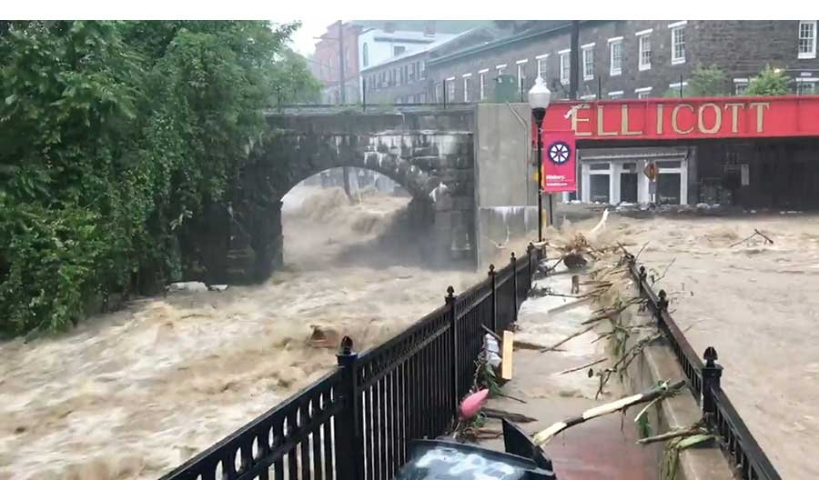

The warming world is a wetter one: For every 1° F increase in temperatures, the atmosphere holds about 4 percent more water vapor. Locals also believe that decades of suburban development patterns in the hills above the historic town replaced forested slopes with impervious surfaces that sluiced storm water into town.

In 2017 the ***Ellicott City Watershed Master Plan*** was unveiled, but after the 2018 flood the plans had to be re-evaluated. A $140 million multi-tiered five-year plan was chosen by County officials. The plan includes building a tunnel requiring the removal of nine historic structures.

My objective in this project is to go over the plan, and analyze whether it would help with the flooding crisis, and possibly propose new solutions.

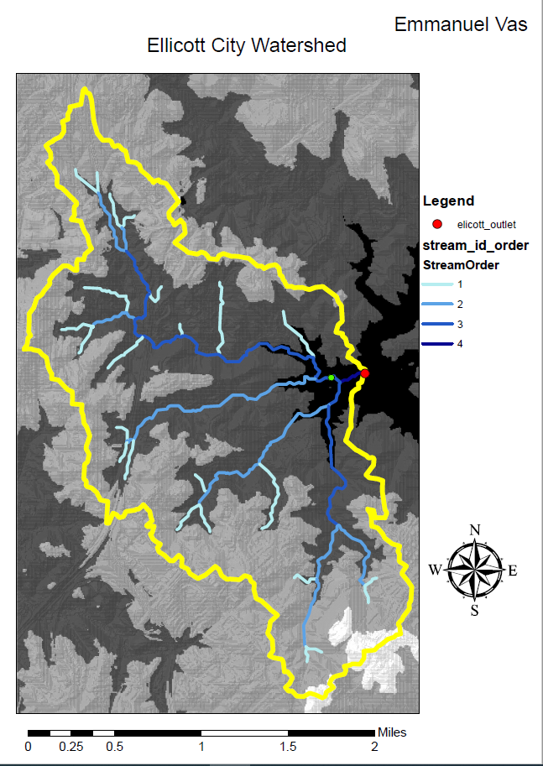

The above image shows every stream in the Ellicott City watershed. The one below shows the catchments for each stream. A catchment is an area of land where all water flows to a single stream. So, each stream has one and only one catchment, and each catchment has one and only one stream associated with it. However, one might find it hard to decipher this just by looking at the attribute tables in ArcMap.

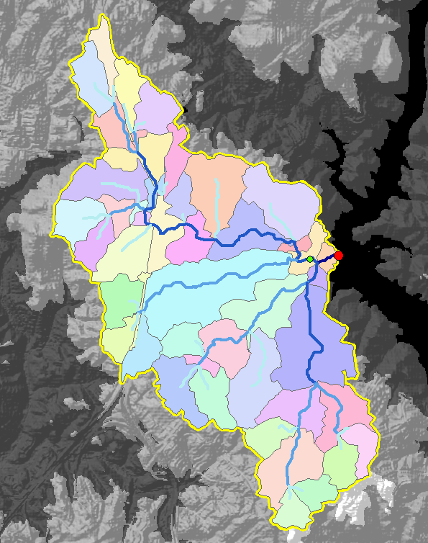This image shows each catchment for each stream in Ellicott City.

Here are the steps I took to derive the watershed and catchments in arcmap:

1. Added elevation tiles in arcmap.
2. Merge into single raster dataset.
3. Use Mosaic to ‘New Raster’ TOOL.
4. Use Spacial Analyst ‘Fill’ TOOL.
5. Use ‘Flow Direction’ TOOL with the filled dem as input.
6. Flow accumulation raster: For each point on the grid, how many cells drain to that point?
7. New shapefile -> outlet
8. Use ‘Watershed’ tool. Input FDir and outlet.
9. Convert watershed raster to polygon.
10. Use raster calculator to create a new layer which identifies points with flow accumulation > 1000.
11. Use ‘Stream Link’ TOOL. FDir and Greater1000 are the inputs.
12. *From this we can derive catchments/small watersheds of the different streams.*
13. Each stream has its own catchment.
14. Stream order: 1st-4th order streams.
15. Use ‘Stream Order’ TOOL. Inputs: stream link, flow direction.
16. Use ‘Raster to Polyline’ TOOL with strlink as input.
17. Use ‘Raster to Polyline’ TOOL with stream order as input.
18. Use ‘Spatial Join’ TOOL. Inputs: catchments, streams.

The data for this project was downloaded from USDA and USGS. Although useful in ArcMap, it lacks organization, and relational properties. So, I plan to design a relational database using ERDPlus, and implement it in Microsoft Access. We can then populate the tables by exporting data out of ArcMap. Once the database is functional, we can view the tables in ArcMap.

*Streams and Catchments tables in ArcMap:*

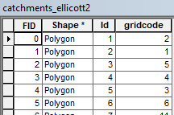 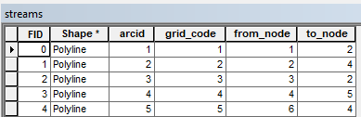

*ERD for Streams and Catchments:*

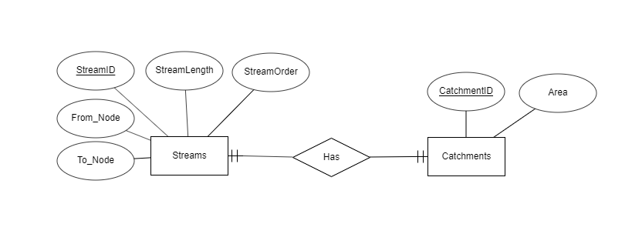

*Relational Schema:*

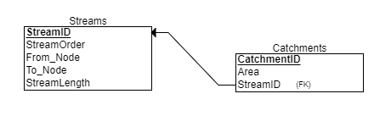

I downloaded the landcover and soils data for Howard County from the USDA Data Gateway. Here are the steps I took to derive CN values:

1. TOOLS: Clip the Soils layer to the watershed boundary.
2. Convert the Landcover layer to vector format before clipping. Use the Raster to Polygon TOOL, and then clip the landcover to the watershed boundary.
3. Union the clipped soils and landcover to get a single vector layer that contains all the geometry and attribute data from both layers.

**Group A Soils:**

High infiltration (low runoff).  Sand, loamy sand, or sandy loam.  Infiltration rate > 0.3 inch/hr when wet.

**Group B Soils:**

Moderate infiltration (moderate runoff).   Silt loam or loam.  Infiltration rate 0.15 to 0.3 inch/hr when wet.

**Group C Soils:**

Low infiltration (moderate to high runoff).   Sandy clay loam.  Infiltration rate 0.05 to 0.15 inch/hr when wet.

**Group D Soils:**

Very low infiltration (high runoff).   Clay loam, silty clay loam, sandy clay, silty clay, or clay.  Infiltration rate 0 to 0.05 inch/hr when wet.  
  
The aim is to now use the Select by Attribute tool combined with the field calculator to assign CN values to every polygon in the watershed.

1. Add a field to the attribute table of landcover_clip_union called "CN"
2. Select by attribute using the following expression : SELECT * FROM landcover_clip_union WHERE (Land_Cover = 'Cultivated Crops' OR Land_Cover = 'Hay/Pasture' OR Land_Cover = 'Herbaceuous') AND HydroSG = 'A'
3. Estimate a Curve Number from the table below:
4. Use the Field Calculator to add the CN value to the Selected Records.
5. Repeat the procedure until all polygons have a curve number.

**Table of Runoff Curve Numbers (SCS, 1986)**

|  |  |  |  |  |
| --- | --- | --- | --- | --- |
| **Description of Land Use** | **Hydrologic Soil Group** | | | |
|  | **A** | **B** | **C** | **D** |
| **Paved parking lots, roofs, driveways** | 98 | 98 | 98 | 98 |
| **Streets and Roads:** | | | | |
| Paved with curbs and storm sewers | 98 | 98 | 98 | 98 |
| Gravel | 76 | 85 | 89 | 91 |
| Dirt | 72 | 82 | 87 | 89 |
| **Cultivated (Agricultural Crop) Land*:** | | | | |
| Without conservation treatment (no terraces) | 72 | 81 | 88 | 91 |
| With conservation treatment (terraces, contours) | 62 | 71 | 78 | 81 |
| **Pasture or Range Land:** | | | | |
| Poor (<50% ground cover or heavily grazed) | 68 | 79 | 86 | 89 |
| Good (50-75% ground cover; not heavily grazed) | 39 | 61 | 74 | 80 |
| **Meadow (grass, no grazing, mowed for hay)** | 30 | 58 | 71 | 78 |
| **Brush (good, >75% ground cover)** | 30 | 48 | 65 | 73 |
| **Woods and Forests:** | | | | |
| Poor (small trees/brush destroyed by over-grazing or burn.) | 45 | 66 | 77 | 83 |
| Fair (grazing but not burned; some brush) | 36 | 60 | 73 | 79 |
| Good (no grazing; brush covers ground) | 30 | 55 | 70 | 77 |
| **Open Spaces (lawns, parks, golf courses, cemeteries, etc.):** | | | | |
| Fair (grass covers 50-75% of area) | 49 | 69 | 79 | 84 |
| Good (grass covers >75% of area) | 39 | 61 | 74 | 80 |
| **Commercial and Business Districts (85% impervious)** | 89 | 92 | 94 | 95 |
| **Industrial Districts (72% impervious)** | 81 | 88 | 91 | 93 |
| **Residential Areas:** | | | | |
| 1/8 Acre lots, about 65% impervious | 77 | 85 | 90 | 92 |
| 1/4 Acre lots, about 38% impervious | 61 | 75 | 83 | 87 |
| 1/2 Acre lots, about 25% impervious | 54 | 70 | 80 | 85 |
| 1 Acre lots, about 20% impervious | 51 | 68 | 79 | 84 |

1. Add a field called "Acres" that is a floating point type.
2. Right click the Acres column and calculate geometry, using acres as the units.
3. Add another new field called "Percent_Area" and calculate the percent area of each CN.
4. Get the sum of the acres column and copy it to the clipboard. Then use the field calculator to divide Acres by the Sum you copied.
5. Add another new field called "compositeCN"
6. Use the field calculator to multiply the CN column by percent_area.
7. Use the Statistics function by right clicking the compositeCN column. The SUM value is your composite curve # for the watershed or CN.

Composite curve # for the watershed or CN: 65.607225

Depth of Direct Runoff (Pe) for a 100-year, 24-hour storm event

Given a precipitation of: P = 7.5 inches

Potential Maximum Retention:

**S = 5.24**

 Initial Abstractions = 1.05

Depth of Direct Runoff = 41.6/11.69 = 3.56

***Soils, by hydrologic soil group:***

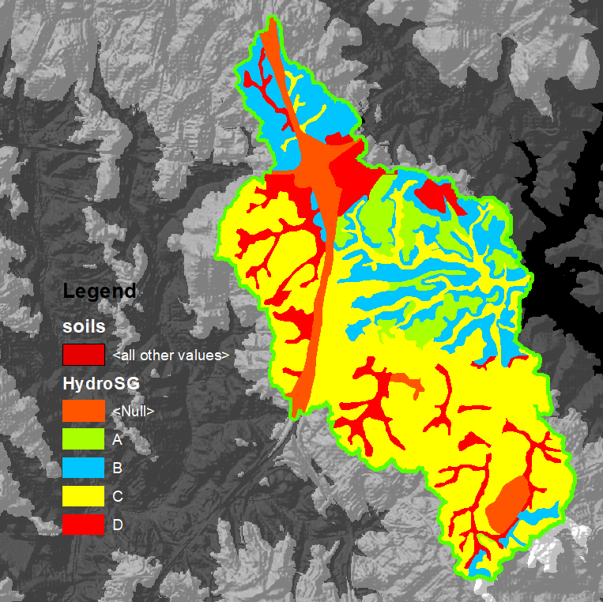

***Elicott City Landcover:***

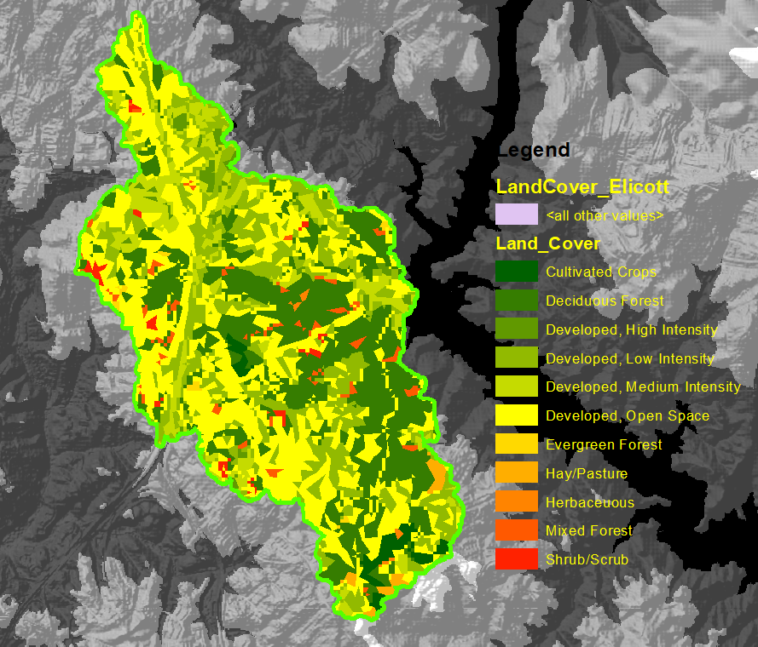

***Landcover_Soils_Union:***

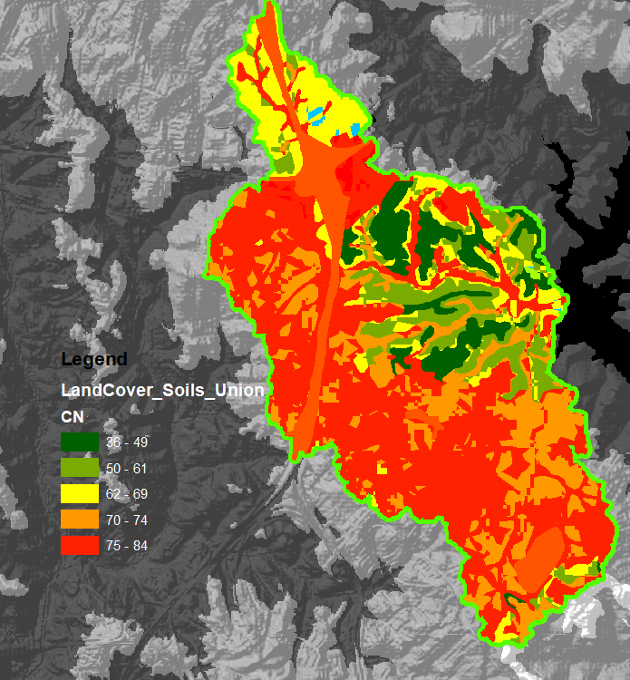

1. Use ‘Spatial Join’ TOOL. Inputs: catchments, streams.

Use the ‘Spatial Join’ TOOL, with the inputs: catchments, landcover_soils_union. This will give us the catchment that every Landcover_soils_union polygon lies in.

This is important for the relational database design, because all of the entities (tables) should be connected.

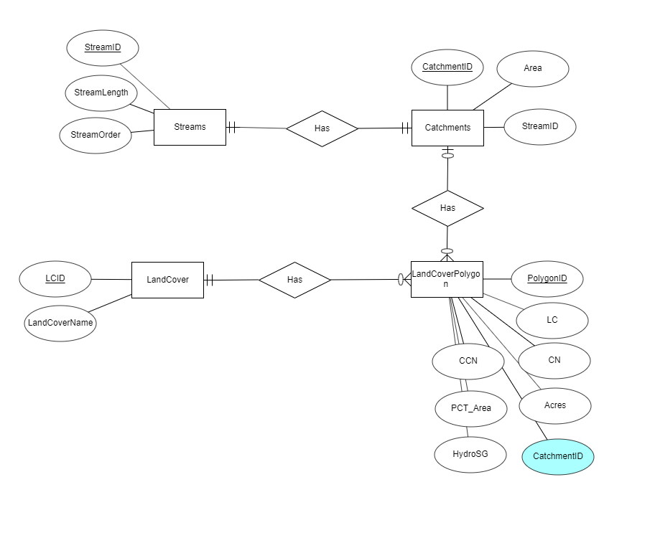

Without the relationship between catchments and polygons, this will not be a relational database. This entity relationship diagram was built using the ERDPlus software. Convert the ER diagram into a relational schema.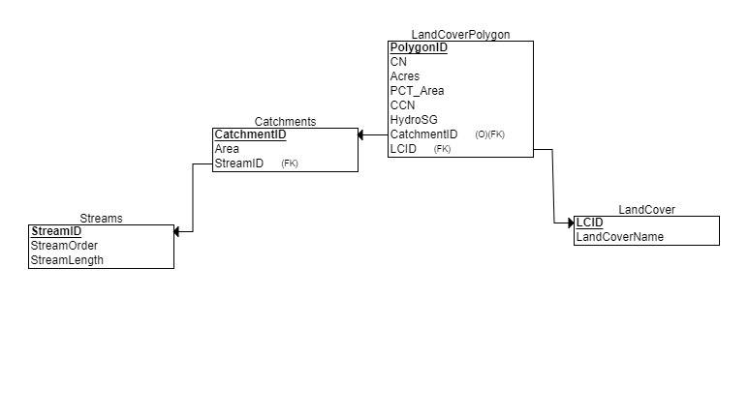

Generate the SQL code from the relational schema.

CREATE TABLE Streams

(

StreamID INT NOT NULL,

StreamOrder INT,

StreamLength INT,

PRIMARY KEY (StreamID)

);

CREATE TABLE Catchments

(

CatchmentID INT NOT NULL,

Area INT,

StreamID,

PRIMARY KEY (CatchmentID),

FOREIGN KEY (StreamID) REFERENCES Streams(StreamID)

);

CREATE TABLE LandCover

(

LCID INT NOT NULL,

LandCoverName VARCHAR(30) NOT NULL,

PRIMARY KEY (LCID)

);

CREATE TABLE LandCoverPolygon

(

PolygonID INT NOT NULL,

LCID INT,

HydroSG CHAR,

CN INT,

Acres INT,

PCT_Area INT,

CCN INT,

CatchmentID INT,

PRIMARY KEY (PolygonID),

FOREIGN KEY (CatchmentID) REFERENCES Catchments(CatchmentID),

FOREIGN KEY (LCID) REFERENCES LandCover(LCID)

);

Run this code in MySQL, and the tables will be created. Now we have to populate them by exporting data from ArcMap to MySQL.

Export data from the attribute tables which are needed into text documents, and convert them into CSV files in Microsoft Excel. Make sure that the columns are in the same order in MySQL and in the CSV.

Use MySQL to analyze data using joins. For example:

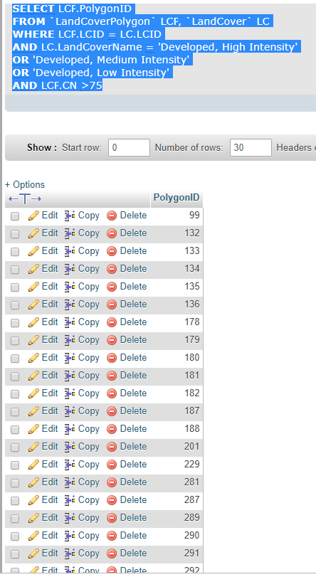

The results can be exported into a select statement, which can be pasted into ArcMap again, to select by attributes. This was used to locate developed areas with high CN values. This was the result in ArcMap:

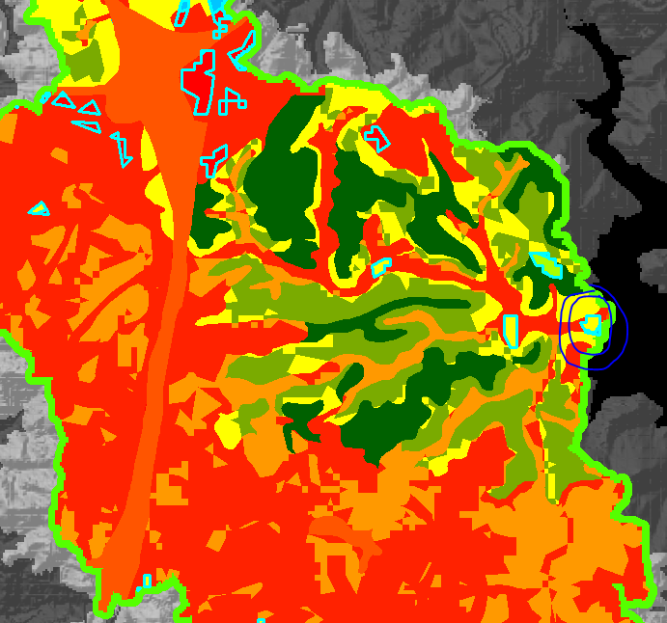

# Ellicott City Watershed Master Plan

Howard County will move forward with a flood mitigation plan that calls for tearing down four buildings and digging an underground tunnel to capture cascading stormwater during a downpour. The plan calls for the Phoenix Emporium, Bean Hollow, Discoveries and Great Panes Art Glass Studio to be demolished at the lower end of Main Street and for the county to build a 15-foot-wide, 1,600-foot-long "north tunnel" running underground from Lot F to the Patapsco River on the north side of Main Street. The tunnel will be designed to capture overflow from the Hudson branch and reduce flood depths in the event of a storm.

Let us examine if the circled location picture above matches the locations of the buildings that are to be demolished.

The new ‘buildings’ layer was created from a select by location to the ‘EllicottCity_Boundary’ layer and exported as a feature class. The dissolve was then run due to the buildings feature class being over 300 records with no attributes to use to separate them.

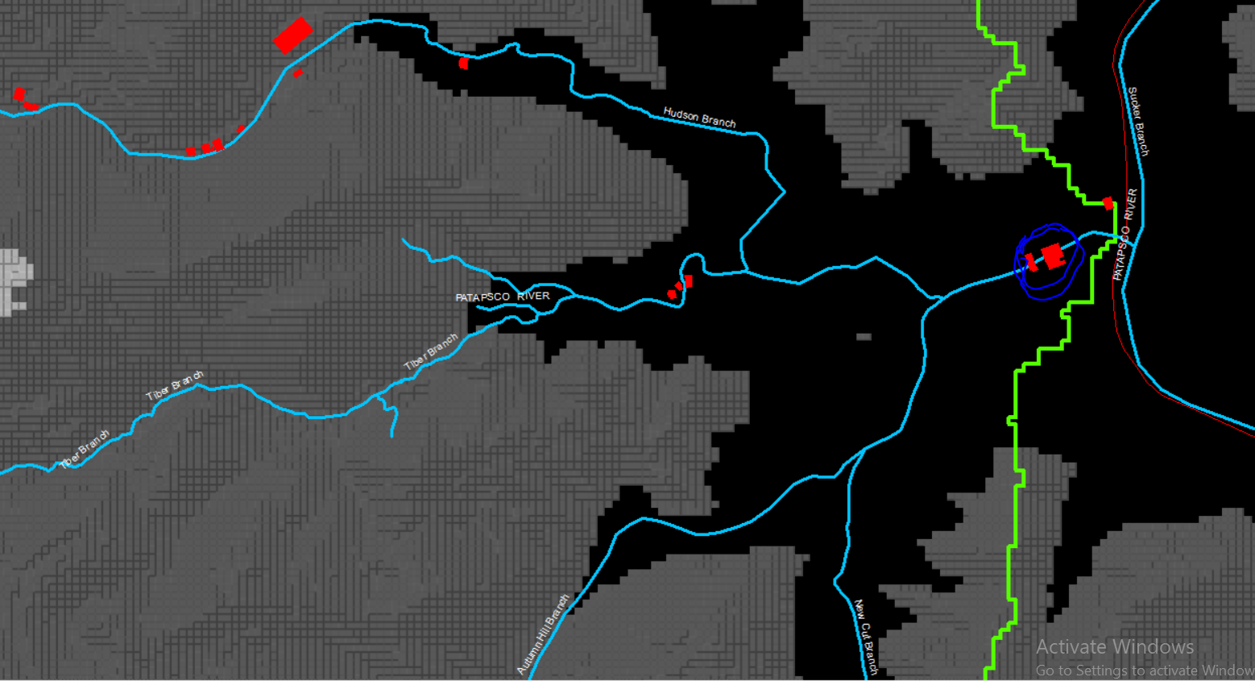

The red polygons represent the buildings that have an impact on flooding in Ellicott City. The circled buildings match the developed areas with high CN values, and the coordinates of the buildings that are to be demolished, according to the Ellicott City Watershed Master Plan.

# 100 Year Flood Mapping

A one-hundred-year flood is a flood event that has a 1 in 100 chance of being equaled or exceeded in any given year. The 100-year flood is also referred to as the 1% flood, since its annual exceedance probability is 1%.

The Digital Flood Insurance Rate Map (DFIRM) Database depicts flood risk information and supporting data used to develop the risk data. The primary risk classifications used are the 1-percent-annual-chance flood event, the 0.2-percent-annual- chance flood event, and areas of minimal flood risk.

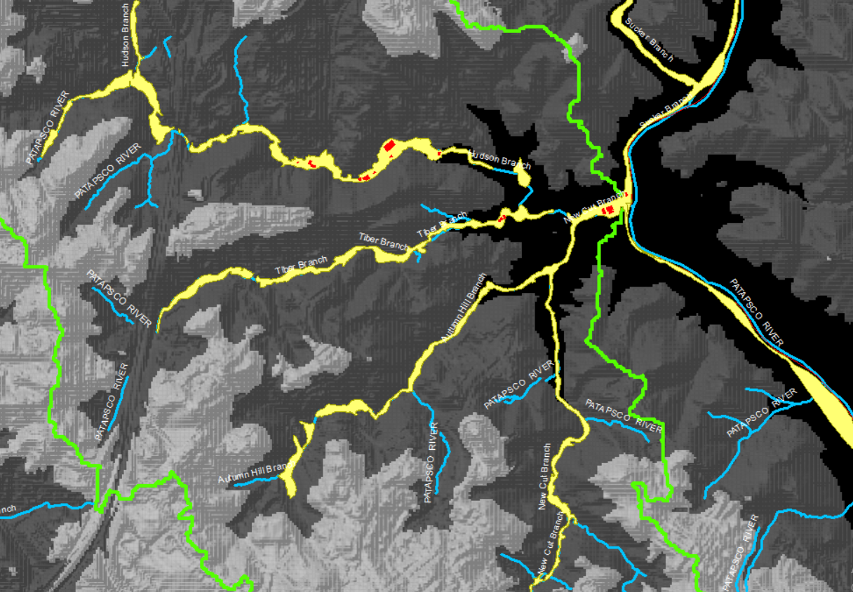

The areas in yellow are the 100 year floodplains in Ellicott city. The area between where the four streams (Hudson, Tiber, New Cut, Autumn Hill) meet and Patapsco river is our area of interest.

# Updates/Improvements to the Database

We can join the catchments and buildings layer, to identify which catchment each building belongs to, and more importantly, which stream the catchment belongs to. This way, we can identify which streams have buildings with impervious surfaces that are in the vicinity.

The following changes were made to the ER Diagram:

1. Create a new entity ‘Buildings’, with attributes BuildingID and CatchmentID.
2. Each catchment can have 0 or more buildings, and each building can belong to 1 and only one catchment.
3. Connect the two tables with a one to many relationship. Define the cardinality constraints.
4. Add ‘StreamName’ as an optional attribute to the ‘Streams’ entity.

Here is the updated ERD and Relational Schema:

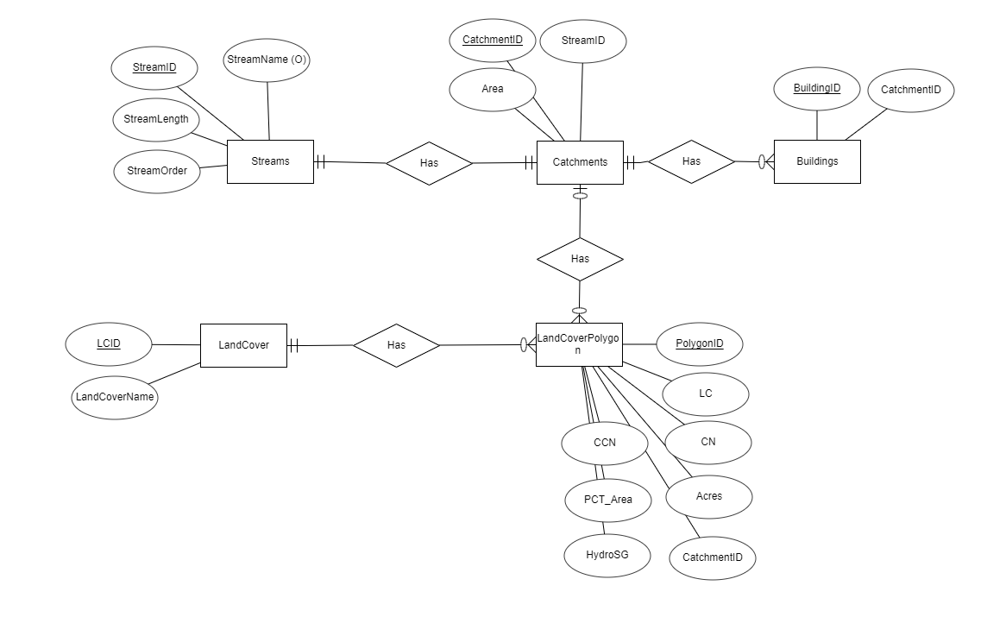

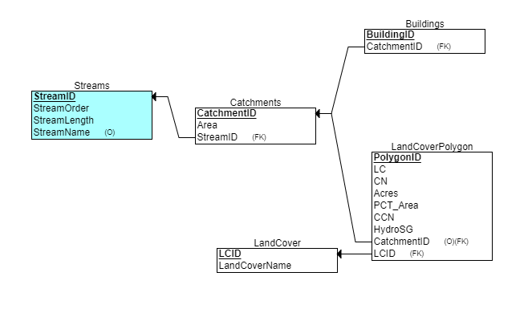

# Bibliography

(2019, 12 20). Retrieved from arcgis.com: https://www.arcgis.com/home/item.html?id=adbca65f20e74208a82241524f22f290

ERIN B. LOGAN. (2019, 12 20). *Baltimore Sun*. Retrieved from https://www.baltimoresun.com/maryland/howard/ph-ho-cf-flood-update-20190418-story.html

*USDA Data Gateway*. (2019, 12 20). Retrieved from https://datagateway.nrcs.usda.gov/