Group - A099
Dataset – DS003

We are using the Histogram, a graphical method to check for normalcy of our dependent variable Prices of housing units in United States of America.
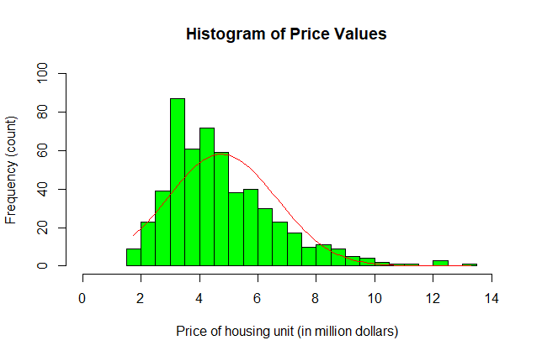

As shown on the above figure, the normal curve overlay does not follow the shape of the underlying data. Therefore, on our analysis, we would use the Spearman’s Rho test, a non-parametric test for correlation (where it does not assume normality).
On the Spearman’s Rho, our chosen variables in our dataset, will be ranked then analysed, to check if there is correlation; to confirm our null hypothesis or not.

