1. INTRODUCTION
1.1 Problem statement and research motivation
1.2 The data set
1.3 Research question
1.4 Null hypothesis and alternative hypothesis
2. BACKGROUND RESEARCH
2.1 Research papers
2.2 Why RQ is of interest (research gap)
3.VISUALIZATION
3.1 Appropriate plot for the RQ output of an R script
The research question is an attempt to determine if there was a correlation between the price of a house and its area. To visualize this, the histogram of the price values and a scatterplot of the two values was created.
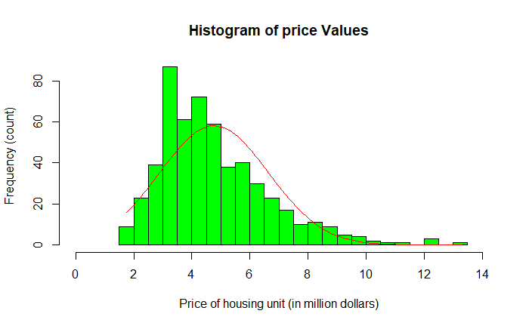
Figure1.1:Histogram of price values

=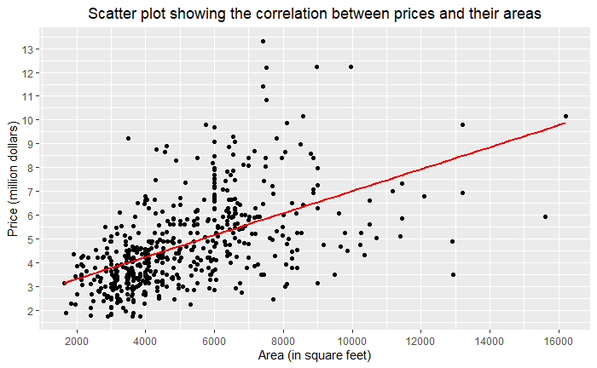
Figure1.2: Scatter plot showing correlation
3.2 Additional info to understand the data (optional)
As seen in Figure 1.1 above, the histogram shows the frequency distribution of the price values available in our dataset. The insight derived from this visualization is that the price values are concentrated within a specific range.
Figure 1.2 depicts a scatterplot showing the relationship between the price of houses and their area in our dataset. The insight from this visualization is that there is a positive correlation between house price and area, as larger house areas tend to correspond to higher prices.

3.3 Useful information for the data understanding
The histogram reveals a skewed distribution, with most house prices ranging from $2M to $6M, peaking at $4M. The scatterplot shows a positive correlation between house price and area, with larger houses costing more. However, the scatterplot and the outliers on it suggest that additional factors influence pricing beyond just area.
4. ANALYSIS
According to the research questions, the null and alternative hypotheses were generated and further analysis were carried out on the data to test and determine the output result. The two hypotheses were:
H₀ – null hypotheses – Is there no correlation between the price and area
H₁- alternative hypotheses – Is there a correlation between the price and area

4.1 Statistical test used to test the hypotheses and output
The probability distribution of the dependent variable is deemed to be non-parametric as seen in figure 1.1. The Characteristic of the non-parametric nature of the distribution would be the skew of the distribution and in this case, it is skewed towards the left. Another is that the data points do not fall within the bell curve. Therefore, the Spearman correlation test was used to conduct the statistical test.
The result of the correlation test produced outputs of which two are what we are interested in; the p-value and the correlation coefficient.
4.2 The null hypothesis rejected /not rejected
- explain the results
The test of our hypothesis is determined by the output derived from the statistical test. When the test was conducted using R code, we got a p-value of less than 0.05 where 0.05 is a default value and a correlation coefficient of 0.6. This means our null hypothesis is rejected and our result is significant. proving that the correlation result is not a fluke on a simple sample of data but will bring about similar output with any other dependent variable data chosen randomly from the housing dataset.
5.EVALUATION – group’s experience at 7COM1079
5.1 What went well
5.2 Points for improvement
5.3 Group’s time management
5.4 Project’s overall judgement
5.5 Comment on GitHub log output
6.CONCLUSIONS
6.1 Results explained.
6.2 Interpretation of the results
6.3 Future work, limitations of your study
7.REFERENCE LIST
Harvard (author, date) format.
8.APPENDICES
8.1 R code used for analysis and visualization.
8.2 GitHub log output.

