AI and Machine Learning / Google Cloud service

**The different type of learning**

1. Supervised Learning – The AI is presented with a set of inputs and there corresponding output, its goal would be to find an algorithm that maps correctly the inputs to some outputs.
2. Unsupervised Learning – The AI will be on its own to try and find some patterns or structure in the inputs, it is commonly used to find patterns in a data set.
3. Reinforcement Learning – The AI will be interacting with a dynamic environment and is giving a goal. Ex: drive a car, play against an opponent, etc. The AI is provided with some feedback and based on the feedback that it received (good or bad), it will try to improve from it.

**Google Cloud AI**

The Cloud of AI computing (the service mentioned are used on the cloud by the companies so that they don’t have to have the infrastructure to process the model(s) they want to train).

* Cloud TPUs – Is a Tensor Processing Unit (custom build chips made for computing deep neural network network task), more powerful training and more accurate models, it is also cost-effective and with faster speed and scale; and
* Cloud GPUs – Is a range of NVIDIA GPUs (Graphics processing unit, has in the term graphics cards), to be used by the company for training their AI. It is also a cost-effective process in which you can scale-up (it is refer as to a migration of the computation of the learning model to a bigger and faster processing server, and this allow the company to keep running the workload the way they always have) or scale-out (which refer to expanding the computation to other/multiple servers rather than a big server. It allow the possibility to move one workload to an other server or even to combine them into a single computing resource, if needed) the workload process.

Tensor-Flow

* The AI Cloud computing of Google has support for Tenser-Flow model which to choose from a variety of models. The support for more custom model is also supported by the cloud service.

The Blockchain

**What is a Blockchain?**

The Blockchain is mostly used as a digital ledger (it is a digital record of transactions made from one party to an other). It consist of **Blocks** that record transactions across many computers, so that any block can not be altered retroactively (event that already happened) without altering the other subsequent blocks. The Blockchain is managed autonomously by a process called peer-to-peer (which is the process of computing a certain workload on multiple computer which allow faster results). The use of a Blockchain as for the transferring of digital goods, remove the possibility of having the problem of double-spending which can be seen as a falsified or duplicated digital goods (counterfeit money), and in which case can lead to an inflation. The blocks are linked together using cryptography (it is a process used to secure information). The blocks all contain a *cryptographic hash* (it is the outcome of a certain message and cannot be the same hash for another message, if provided the same message twice you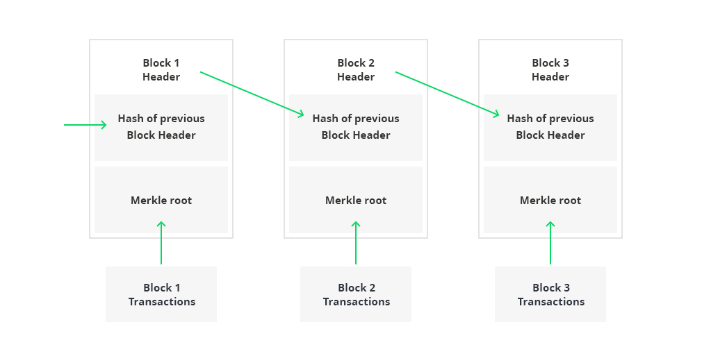 will be getting the same hash) of the previous block, a timestamp, and some transaction data (mostly known as Merkle root).

**The usage of the Blockchain by Rocket-Elevators**

The Blockchain that Rocket Elevators want to use is called a **Smart Contract Blockchain** which is intended to automatically execute, control or document relevant information about a given contract. The objective here is to reduce the need for inter-mediators, arbitration and avoid fraud lost, as well as reduce malicious and accidental exception. That way we avoid the need for a third party to come in place to act as an intermediary between two contracting entities.

**The Blockchain and Google Cloud Service**

Google now allows the hosting of STRATO node (is a rapid deployment Blockchain for businesses called Blockapps), in their clouds. The name of this service is called a BAAS.

**DevOps**