

**Frontrunner Workbook**



**Professional Skills Workshop, February 2022**

**First Impressions Activity 1:**



|  |
| --- |
| **Notes:** |
|  |
|  |
|  |
|  |

**First Impressions Activity 2:**

|  |
| --- |
| Notes: |
|  |
|  |
|  |
|  |

|  |
| --- |
| **My First Impression – Action Points:** |
|  |
|  |
|  |
|  |

**Organising Myself at Work Activity:**

|  |
| --- |
| Reflections: |
|  |
|  |
|  |
|  |

|  |
| --- |
| Reflections: |
|  |
|  |
|  |
|  |

|  |
| --- |
| **Organising myself at work – Action Points:** |
|  |
|  |
|  |
|  |

**Personal and Professional Development Action Plans:**

|  |
| --- |
| What I’d like to achieve in my placement: |
|  |
|  |
|  |
|  |

|  |
| --- |
| Reflections from the group: |
|  |
|  |
|  |
|  |

|  |  |  |  |
| --- | --- | --- | --- |
| **Development Area** | **What do I need?** | **Who can help me?** | **How will I use this?** |
|  |  |  |  |
|  |  |  |  |
|  |  |  |  |
|  |  |  |  |
|  |  |  |  |
|  |  |  |  |

**Growth Mindset:**

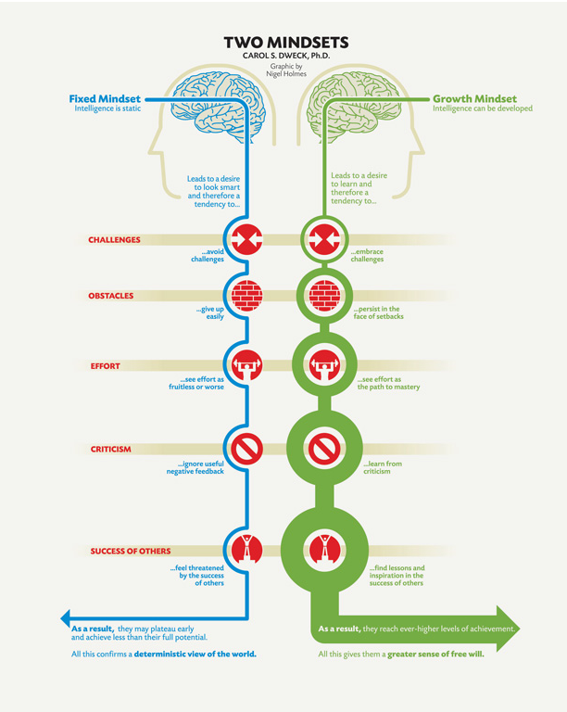

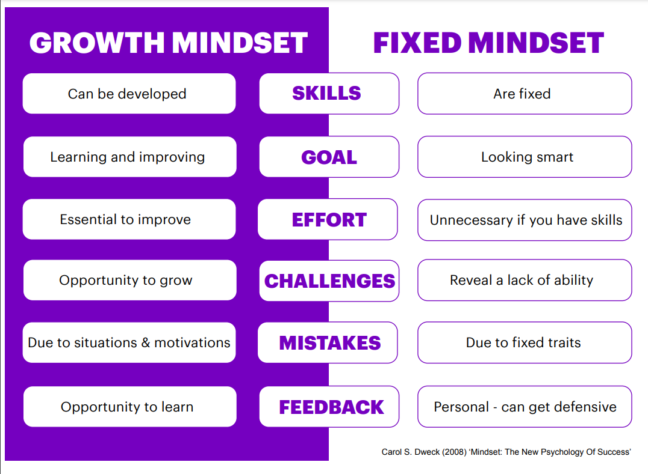

|  |
| --- |
| **Notes:** |
|  |
| **Action Points:** |
|  |
|  |

**Developing Good Working Relationships**

|  |
| --- |
| **Notes:** |
|  |
|  |
|  |
|  |
| **Action Points:** |
|  |
|  |
|  |

**Capturing your Learning:**

|  |
| --- |
| **Notes:** |
|  |
|  |
|  |
| **Action Points:** |
|  |
|  |