# 

# **Computer Architecture and Technology Convergence Assignment**

# **Submitted by**: Emmet McDonagh (G00222864)

# **Submitted to**: Brian McGinley

# 30th April 2021

Contents

Q1: Binary Arithmetic: 1

Q1.1 1

Q1.2 1

Q1.3 2

Q1.4 2

Q 1.5 3

Q2: Linux Assignment 3

Q 2.1 3

Q2.2 5

Q 2.3 14

Q2.3.1: 14

Q2.3.2: 15

Q2.4 15

References 17

# Q1: Binary Arithmetic:

## Q1.1

## Add 11011 to 1011

sum

Carry values

|  |  |  |  |  |  |  |
| --- | --- | --- | --- | --- | --- | --- |
|  | **1** | **1** | **0** | **1** | **1** |  |
|  |  | **1** | **1** | **0** | **1** | **1** |
| **+** |  |  | **1** | **0** | **1** | **1** |
|  | **1** | **0** | **0** | **1** | **1** | **0** |

## 11011 + 1011 = 100110

## Q1.2

Convert -31 to an 8-bit two complement number

1. Convert the magnitude, 31 to binary.

31/2= 15(1); 15/2= 7(1); 7/2= 3(1); 3/2= 1(1); ½ = 0 (1)

1 1 1 1 1 2

1. Pad to 8 bits: 0 0 0 1 1 1 1 1
2. Negate the numbers by inverting the bits and adding 1.

**Carry value**

sum

|  |  |  |  |  |  |  |  |  |
| --- | --- | --- | --- | --- | --- | --- | --- | --- |
|  |  |  |  |  |  |  | **0** |  |
|  | **1** | **1** | **1** | **0** | **0** | **0** | **0** | **0** |
| **+** |  |  |  |  |  |  |  | **1** |
|  | **1** | **1** | **1** | **0** | **0** | **0** | **0** | **1** |

Therefore -3110 is 1 1 1 0 0 0 0 1

Convert -59 to an 8-bit two complement number

1. Convert the magnitude, 59 to binary.

59/2=29(1); 29/2=14(1); 7(0); 7/2=3(1); 3/2=1(1); ½=0(1)

1 1 1 0 1 1 2

1. Pad to 8 bits: 0 0 1 1 1 0 1 1
2. Negate the numbers by inverting the bits and adding 1.

sum

**Carry value**

|  |  |  |  |  |  |  |  |  |
| --- | --- | --- | --- | --- | --- | --- | --- | --- |
|  |  |  |  |  |  |  | **0** |  |
|  | **1** | **1** | **0** | **0** | **0** | **1** | **0** | **0** |
| **+** |  |  |  |  |  |  |  | **1** |
|  | **1** | **1** | **0** | **0** | **0** | **1** | **0** | **1** |

Therefore -5910 is 1 1 0 0 0 1 0 1

## Q1.3

Decimal equivalent of the binary number 11101001

|  |
| --- |
| 1 x 27 = 1 x 128= 128  1 x 26 = 1 x 64 = 64  1 x 2**5** = 1 x 32 = 32  0 x 2**4** = 0 x 16 = 0  1 x 2**3** = 1 x 8 = 8  0 x 2**2** = 1 x 4 = 0  0 x 2**1** = 1 x 2 = 0  1 x 2**0** = 1 x 1 = 1  = 23310 |

## Q1.4

|  |  |  |  |  |
| --- | --- | --- | --- | --- |
| Truth Table | | | | |
|  | X | Y | D | B-Out |
| 0 | 0 | 0 | 0 |
| 0 | 1 | 1 | 1 |
| 1 | 0 | 1 | 0 |
| 1 | 1 | 0 | 0 |

D = X⊕Y

## Q 1.5

Draw a logical diagram corresponding to the following Boolean expression (AB + C)D.

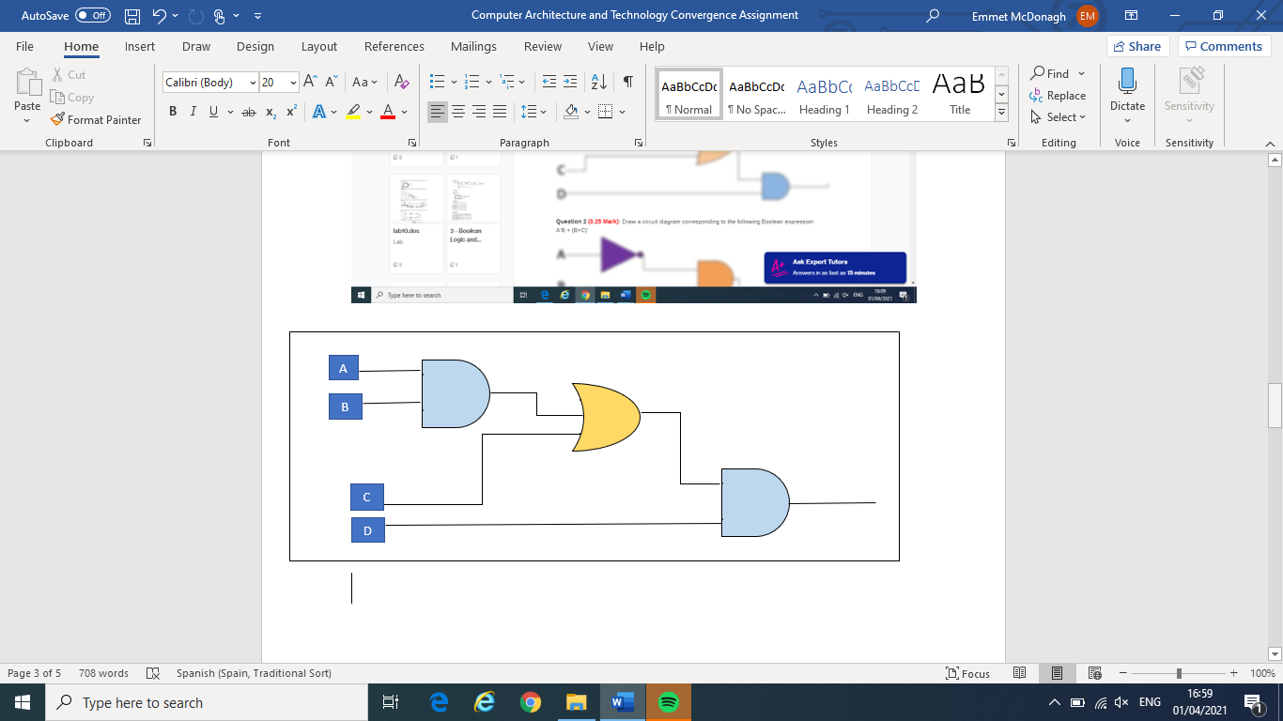

# Q2: Linux Assignment

## Q 2.1

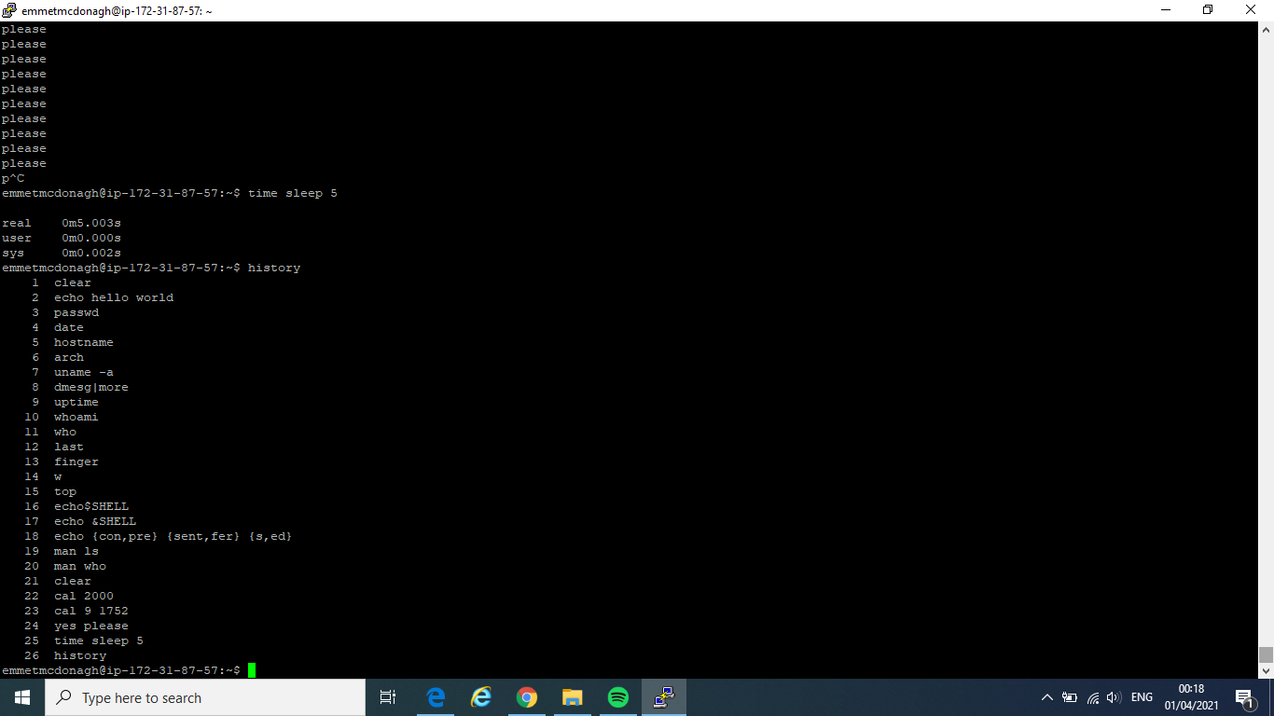

* Command: echo hello world.

Output: types “hello world” on terminal screen.

* Command: passwd.

Used to change the password of a user account.

* Command: date.

Displays the system date and time on Linux.

* Command: hostname.

Used to view a computer’s hostname and domain name (DNS) (**Domain Name Service**), and to display or set a computer’s hostname or domain name.

* Command: arch.

It is used to print machine hardware name.

* Command: uname**:**

Prints basic information about a computer’s software and hardware.

* Command: dmesg:

it is used to retrieve its data by reading the kernel ring buffer.

* Command: uptime

It gives you the time for which the system has been running.

* Command: whoami.

Prints the username of the current user. In other words, it displays the name of the currently logged-in user.

* Command: who

Prints a list of who is logged in. It can also show the current run level, time of the last system boot, and more.

* **Command last**

Displays a list of last logged in users.

* Command: finger.

User information lookup command used in Linux to check the information of any currently logged in users from the terminal.

Command: w.

Displays summary information related to users that are currently logged in, what each user is currently doing, and what load all the activity is imposing on the computer itself.

* Command: top.

It displays the Linux tasks.

* Command: Echo $SHELL.

It is used to view current shell that is being used.

* Command: echo {con,pre}{sent,fer}{s,ed}

It gives us the combination of all possible words

* Command: man

It gives us manual page of ls command. Basically, ls command is used to give list of directory contents.

* Command: man who

It gives us manual page of who command. Basically, who command is used to show who is logged on.

* Command: clear

It is used to clear terminal.

* Command: Cal 2000

Displays current month calendar on the terminal.

* Command: cal 9 1752

It gives us calendar of Sept. 1752

* Command: yes please

Outputs the same string, STRING, in a constant stream.

* Command: time sleep 5

Used to delay for a fixed amount of time during the execution of any script.

* Command: history

It shows the user history of all commands which were typed in terminal.

## Q2.2

Command: date

Thu Apr 22 16:31:43 UTC 2021

Used to change the password of a user account.

Command: hostname

ip-172-31-87-57

Used to view a computer’s hostname and domain name.

Command: arch

x86_64

It is used to print machine hardware name.

Command: uname -a

Linux ip-172-31-87-57 5.4.0-1038-aws #40-Ubuntu SMP Fri Feb 5 23:50:40 UTC 2021 x86_64 x86_64 x86_64 GNU/Linux

Prints basic information about a computer’s software and hardware.

Command: uptime

16:48:44 up 38 days, 19:25, 4 users, load average: 0.00, 0.00, 0.00

It gives you the time for which the system has been running.

Command: whoami

emmetmcdonagh

Prints the username of the current user. In other words, it displays the name of the currently logged-in user.

Command: who

derekhiggins pts/0 2021-04-22 14:21 (193.178.96.210)

marinanikonchuk pts/1 2021-04-22 15:53 (45.139.74.30)

emmetmcdonagh pts/3 2021-04-22 16:16 (194.125.25.189)

janaholikova pts/7 2021-04-21 11:13 (37.228.249.69)

Prints a list of who is logged in. It can also show the current run level, time of the last system boot, and more.

Command: finger

Login Name Tty Idle Login Time Office Office Phone

derekhiggins pts/0 1:35 Apr 22 14:21 (193.178.96.210)

emmetmcdonagh pts/3 Apr 22 16:16 (194.125.25.189)

janaholikova pts/7 Apr 21 11:13 (37.228.249.69)

marinanikonchuk pts/1 53 Apr 22 15:53 (45.139.74.30)

User information lookup command used in Linux to check the information of any currently logged in users from the terminal.

Command: w

17:02:27 up 38 days, 19:39, 4 users, load average: 0.00, 0.00, 0.00

USER TTY FROM LOGIN@ IDLE JCPU PCPU WHAT

derekhig pts/0 193.178.96.210 14:21 1:38m 0.04s 0.00s pager

marinani pts/1 45.139.74.30 15:53 56:51 0.03s 0.00s nano table.sh

emmetmcd pts/3 194.125.25.189 16:16 1.00s 0.08s 0.00s w

janaholi pts/7 37.228.249.69 Wed11 11.00s 0.20s 0.13s vi scriptsample.sh

Displays summary information related to users that are currently logged in, what each user is currently doing, and what load all the activity is imposing on the computer itself.

Command: top

top - 17:04:54 up 38 days, 19:41, 4 users, load average: 0.00, 0.00, 0.00

Tasks: 127 total, 1 running, 126 sleeping, 0 stopped, 0 zombie

%Cpu(s): 0.0 us, 6.2 sy, 0.0 ni, 93.8 id, 0.0 wa, 0.0 hi, 0.0 si, 0.0 st

MiB Mem : 978.6 total, 74.2 free, 255.3 used, 649.1 buff/cache

MiB Swap: 0.0 total, 0.0 free, 0.0 used. 544.0 avail Mem

PID USER PR NI VIRT RES SHR S %CPU %MEM TIME+ COMMAND

1 root 20 0 170944 11352 6692 S 0.0 1.1 4:11.14 systemd

2 root 20 0 0 0 0 S 0.0 0.0 0:00.11 kthreadd

3 root 0 -20 0 0 0 I 0.0 0.0 0:00.00 rcu_gp

4 root 0 -20 0 0 0 I 0.0 0.0 0:00.00 rcu_par_gp

6 root 0 -20 0 0 0 I 0.0 0.0 0:00.00 kworker/0:0H-kblockd

9 root 0 -20 0 0 0 I 0.0 0.0 0:00.00 mm_percpu_wq

10 root 20 0 0 0 0 S 0.0 0.0 1:51.80 ksoftirqd/0

11 root 20 0 0 0 0 I 0.0 0.0 1:49.25 rcu_sched

12 root rt 0 0 0 0 S 0.0 0.0 0:17.18 migration/0

13 root 20 0 0 0 0 S 0.0 0.0 0:00.00 cpuhp/0

14 root 20 0 0 0 0 S 0.0 0.0 0:00.00 kdevtmpfs

15 root 0 -20 0 0 0 I 0.0 0.0 0:00.00 netns

16 root 20 0 0 0 0 S 0.0 0.0 0:00.00 rcu_tasks_kthre

17 root 20 0 0 0 0 S 0.0 0.0 0:00.00 kauditd

18 root 20 0 0 0 0 S 0.0 0.0 0:00.00 xenbus

19 root 20 0 0 0 0 S 0.0 0.0 0:00.01 xenwatch

20 root 20 0 0 0 0 S 0.0 0.0 0:01.00 khungtaskd

21 root 20 0 0 0 0 S 0.0 0.0 0:00.00 oom_reaper

22 root 0 -20 0 0 0 I 0.0 0.0 0:00.00 writeback

23 root 20 0 0 0 0 S 0.0 0.0 0:00.15 kcompactd0

24 root 25 5 0 0 0 S 0.0 0.0 0:00.00 ksmd

25 root 39 19 0 0 0 S 0.0 0.0 0:07.59 khugepaged

71 root 0 -20 0 0 0 I 0.0 0.0 0:00.00 kintegrityd

72 root 0 -20 0 0 0 I 0.0 0.0 0:00.00 kblockd

73 root 0 -20 0 0 0 I 0.0 0.0 0:00.00 blkcg_punt_bio

74 root 0 -20 0 0 0 I 0.0 0.0 0:00.00 tpm_dev_wq

75 root 0 -20 0 0 0 I 0.0 0.0 0:00.00 ata_sff

76 root 0 -20 0 0 0 I 0.0 0.0 0:00.00 md

77 root 0 -20 0 0 0 I 0.0 0.0 0:00.00 edac-poller

78 root 0 -20 0 0 0 I 0.0 0.0 0:00.00 devfreq_wq

79 root rt 0 0 0 0 S 0.0 0.0 0:00.00 watchdogd

82 root 20 0 0 0 0 S 0.0 0.0 0:11.89 kswapd0

83 root 20 0 0 0 0 S 0.0 0.0 0:00.00 ecryptfs-kthrea

85 root 0 -20 0 0 0 I 0.0 0.0 0:00.00 kthrotld

86 root 0 -20 0 0 0 I 0.0 0.0 0:00.00 nvme-wq

87 root 0 -20 0 0 0 I 0.0 0.0 0:00.00 nvme-reset-wq

88 root 0 -20 0 0 0 I 0.0 0.0 0:00.00 nvme-delete-wq

89 root 20 0 0 0 0 S 0.0 0.0 0:00.00 scsi_eh_0

90 root 0 -20 0 0 0 I 0.0 0.0 0:00.00 scsi_tmf_0

91 root 20 0 0 0 0 S 0.0 0.0 0:00.00 scsi_eh_1

92 root 0 -20 0 0 0 I 0.0 0.0 0:00.00 scsi_tmf_1

94 root 0 -20 0 0 0 I 0.0 0.0 0:45.99 kworker/0:1H-kblockd

95 root 0 -20 0 0 0 I 0.0 0.0 0:00.00 ipv6_addrconf

104 root 0 -20 0 0 0 I 0.0 0.0 0:00.00 kstrp

107 root 0 -20 0 0 0 I 0.0 0.0 0:00.00 kworker/u31:0

120 root 20 0 0 0 0 S 0.0 0.0 0:17.67 jbd2/xvda1-8

121 root 0 -20 0 0 0 I 0.0 0.0 0:00.00 ext4-rsv-conver

159 root 19 -1 185332 66132 64316 S 0.0 6.6 25:08.46 systemd-journal

192 root 20 0 18964 4372 2920 S 0.0 0.4 0:34.14 systemd-udevd

204 root 0 -20 0 0 0 I 0.0 0.0 0:00.00 cryptd

267 root 0 -20 0 0 0 I 0.0 0.0 0:00.00 kaluad

268 root 0 -20 0 0 0 I 0.0 0.0 0:00.00 kmpath_rdacd

269 root 0 -20 0 0 0 I 0.0 0.0 0:00.00 kmpathd

270 root 0 -20 0 0 0 I 0.0 0.0 0:00.00 kmpath_handlerd

271 root rt 0 280200 17992 8200 S 0.0 1.8 3:55.29 multipathd

279 root 0 -20 0 0 0 S 0.0 0.0 0:00.04 loop0

282 root 0 -20 0 0 0 S 0.0 0.0 0:00.01 loop1

284 root 0 -20 0 0 0 S 0.0 0.0 0:00.00 loop2

303 systemd+ 20 0 90424 4928 4056 S 0.0 0.5 0:04.04 systemd-timesyn

377 systemd+ 20 0 26924 5392 4424 S 0.0 0.5 0:05.60 systemd-network

380 systemd+ 20 0 24092 9624 5464 S 0.0 1.0 0:05.79 systemd-resolve

443 root 20 0 241668 6324 4576 S 0.0 0.6 7:22.08 accounts-daemon

444 root 20 0 2540 856 788 S 0.0 0.1 0:00.00 acpid

451 root 20 0 8536 2988 2712 S 0.0 0.3 0:04.63 cron

452 message+ 20 0 7852 4728 3580 S 0.0 0.5 0:16.08 dbus-daemon

463 root 20 0 29264 12108 4476 S 0.0 1.2 0:00.07 networkd-dispat

465 syslog 20 0 224500 4872 3284 S 0.0 0.5 4:10.89 rsyslogd

471 root 20 0 17460 7112 5444 S 0.0 0.7 0:11.83 systemd-logind

475 daemon 20 0 3792 2224 2052 S 0.0 0.2 0:00.04 atd

588 root 20 0 7352 2132 2008 S 0.0 0.2 0:00.00 agetty

626 root 20 0 5828 1788 1676 S 0.0 0.2 0:00.02 agetty

627 root 20 0 242048 6772 5128 S 0.0 0.7 0:02.75 polkitd

645 root 20 0 108088 13100 5448 S 0.0 1.3 0:00.06 unattended-upgr

1074 root 20 0 645572 10024 0 S 0.0 1.0 1:31.14 amazon-ssm-agen

1100 root 20 0 734388 16752 0 S 0.0 1.7 1:13.35 ssm-agent-worke

50766 root 0 -20 0 0 0 I 0.0 0.0 0:00.00 xfsalloc

50767 root 0 -20 0 0 0 I 0.0 0.0 0:00.00 xfs_mru_cache

52504 root 20 0 12176 5256 4324 S 0.0 0.5 6:02.33 sshd

91239 root 0 -20 0 0 0 S 0.0 0.0 0:00.00 loop5

328916 root 0 -20 0 0 0 S 0.0 0.0 0:00.16 loop6

594181 root 0 -20 0 0 0 S 0.0 0.0 0:00.00 loop3

836451 angelrua 20 0 18452 8364 6836 S 0.0 0.8 0:01.22 systemd

836457 angelrua 20 0 172156 4780 0 S 0.0 0.5 0:00.00 (sd-pam)

838257 angelrua 20 0 11216 4156 3460 S 0.0 0.4 24:48.99 top

838599 angelrua 20 0 11216 4044 3348 S 0.0 0.4 24:56.93 top

965913 root 0 -20 0 0 0 S 0.0 0.0 0:00.18 loop7

965950 root 20 0 642360 19588 5348 S 0.0 2.0 1:07.19 snapd

1208720 paulobo+ 20 0 18468 8216 6772 S 0.0 0.8 0:00.87 systemd

1208724 paulobo+ 20 0 172156 4792 0 S 0.0 0.5 0:00.00 (sd-pam)

1209392 paulobo+ 20 0 11240 4076 3380 S 0.0 0.4 18:24.10 top

1246933 jamesly+ 20 0 18452 8268 6816 S 0.0 0.8 0:00.84 systemd

1246935 jamesly+ 20 0 172156 4792 0 S 0.0 0.5 0:00.00 (sd-pam)

1247188 jamesly+ 20 0 11236 4008 3316 S 0.0 0.4 17:41.67 top

1989420 root 20 0 13924 8832 7372 S 0.0 0.9 0:00.06 sshd

1989437 janahol+ 20 0 18460 8928 7468 S 0.0 0.9 0:00.14 systemd

1989439 janahol+ 20 0 172156 4800 0 S 0.0 0.5 0:00.00 (sd-pam)

1989514 janahol+ 20 0 14056 5976 4496 S 0.0 0.6 0:00.97 sshd

1989515 janahol+ 20 0 10032 4888 3184 S 0.0 0.5 0:00.07 bash

2079338 root 20 0 13924 8992 7520 S 0.0 0.9 0:00.04 sshd

2079366 derekhi+ 20 0 18452 8944 7500 S 0.0 0.9 0:00.03 systemd

2079368 derekhi+ 20 0 172156 4800 0 S 0.0 0.5 0:00.00 (sd-pam)

2079442 derekhi+ 20 0 14060 6084 4600 S 0.0 0.6 0:00.06 sshd

2079443 derekhi+ 20 0 10032 5180 3440 S 0.0 0.5 0:00.04 bash

2081293 derekhi+ 20 0 8968 4080 2932 S 0.0 0.4 0:00.00 man

2081303 derekhi+ 20 0 7588 2236 1972 S 0.0 0.2 0:00.00 pager

2082054 root 20 0 13920 9032 7576 S 0.0 0.9 0:00.01 sshd

2082071 marinan+ 20 0 18452 9296 7844 S 0.0 0.9 0:00.03 systemd

2082076 marinan+ 20 0 172156 4804 4 S 0.0 0.5 0:00.00 (sd-pam)

2082077 root 20 0 0 0 0 I 0.0 0.0 0:00.00 kworker/0:1-cgroup_destroy

2082152 marinan+ 20 0 14052 5968 4492 S 0.0 0.6 0:00.02 sshd

2082153 marinan+ 20 0 10032 5168 3472 S 0.0 0.5 0:00.03 bash

2082355 janahol+ 20 0 23796 10140 6448 S 0.0 1.0 0:00.15 vi

2082448 root 20 0 0 0 0 I 0.0 0.0 0:00.07 kworker/u30:0-events_unbound

2082527 marinan+ 20 0 8836 3936 3060 S 0.0 0.4 0:00.00 nano

2082786 root 20 0 13924 8984 7524 S 0.0 0.9 0:00.02 sshd

2082802 emmetmc+ 20 0 18456 9528 8072 S 0.0 1.0 0:00.03 systemd

2082803 root 20 0 0 0 0 I 0.0 0.0 0:00.52 kworker/0:2-mm_percpu_wq

2082807 emmetmc+ 20 0 172156 4804 4 S 0.0 0.5 0:00.00 (sd-pam)

2082903 emmetmc+ 20 0 14056 6092 4612 S 0.0 0.6 0:00.09 sshd

2082904 emmetmc+ 20 0 10032 5064 3300 S 0.0 0.5 0:00.08 bash

2082988 root 20 0 450420 23328 20172 S 0.0 2.3 0:00.21 fwupd

2083558 root 20 0 0 0 0 I 0.0 0.0 0:00.02 kworker/u30:2-events_power_efficient

2084406 root 20 0 13204 7916 6816 S 0.0 0.8 0:00.01 sshd

2084407 sshd 20 0 12176 4580 3672 S 0.0 0.5 0:00.00 sshd

2084408 root 20 0 13204 7944 6844 S 0.0 0.8 0:00.00 sshd

2084409 sshd 20 0 12176 4552 3640 S 0.0 0.5 0:00.00 sshd

2084411 emmetmc+ 20 0 10872 3636 3176 R 0.0 0.4 0:00.00 top

It displays the Linux tasks.

Command: history

1 tree

2 echo Command: date >> EmmetMcDonagh.txt

3 date >> EmmetMcDonagh.txt

4 echo Used to change the password of a user account. >> EmmetMcDonagh.txt

5 echo >> EmmetMcDonagh.txt

6 clear

7 tree

8 cd

9 tree

10 cd Assignment

11 echo Command: hostname >> EmmetMcDonagh.txt

12 hostname >> EmmetMcDonagh.txt

13 echo Used to view a computer’s hostname and domain name.>> EmmetMcDonagh.txt

14 echo >> EmmetMcDonagh.txt

15 echo Command: arch >> EmmetMcDonagh.txt

16 chmod +x EmmetMcDonagh.txt

17 ./EmmetMcDonagh.txt

18 clear

19 tree

20 ./EmmetMcDonagh.txt

21 vim EmmetMcDonagh.txt

22 clear

23 tree

24 vim EmmetMcDonagh.txt

25 arch >> EmmetMcDonagh.txt

26 echo It is used to print machine hardware name.>> EmmetMcDonagh.txt

27 echo >> EmmetMcDonagh.txt

28 echo Command: uname -a >> EmmetMcDonagh.txt

29 uname -a >> EmmetMcDonagh.txt

30 echo Prints basic information about a computer’s software and hardware. >> EmmetMcDonagh.txt

31 echo >> EmmetMcDonagh.txt

32 echo Command: uptime >> EmmetMcDonagh.txt

33 uptime >> EmmetMcDonagh.txt

34 echo It gives you the time for which the system has been running. >> EmmetMcDonagh.txt

35 echo >> EmmetMcDonagh.txt

36 echo Command: whoami >> EmmetMcDonagh.txt

37 whoami >> EmmetMcDonagh.txt

38 echo Prints the username of the current user. In other words, it displays the name of the currently logged-in user. >> EmmetMcDonagh.txt

39 echo >> EmmetMcDonagh.txt

40 echo Command: who >> EmmetMcDonagh.txt

41 who >> EmmetMcDonagh.txt

42 echo Prints a list of who is logged in. It can also show the current run level, time of the last system boot, and more. >> EmmetMcDonagh.txt

43 echo >> EmmetMcDonagh.txt

44 echo Command: finger >> EmmetMcDonagh.txt

45 finger >> EmmetMcDonagh.txt

46 echo User information lookup command used in Linux to check the information of any currently logged in users from the terminal. >> EmmetMcDonagh.txt

47 echo >> EmmetMcDonagh.txt

48 echo Command: w >> EmmetMcDonagh.txt

49 w >> EmmetMcDonagh.txt

50 echo Displays summary information related to users that are currently logged in, what each user is currently doing, and what load all the activity is imposing on the computer itself. >> EmmetMcDonagh.txt

51 echo >> EmmetMcDonagh.txt

52 echo Command: top >> EmmetMcDonagh.txt

53 top -b -n 1 >> EmmetMcDonagh.txt

54 echo It displays the Linux tasks. >> EmmetMcDonagh.txt

55 echo >> EmmetMcDonagh.txt

56 echo Command: history >> EmmetMcDonagh.txt

57 history >> EmmetMcDonagh.txt

It shows the user history of all commands which were typed in terminal.

## Q 2.3

### Q2.3.1:

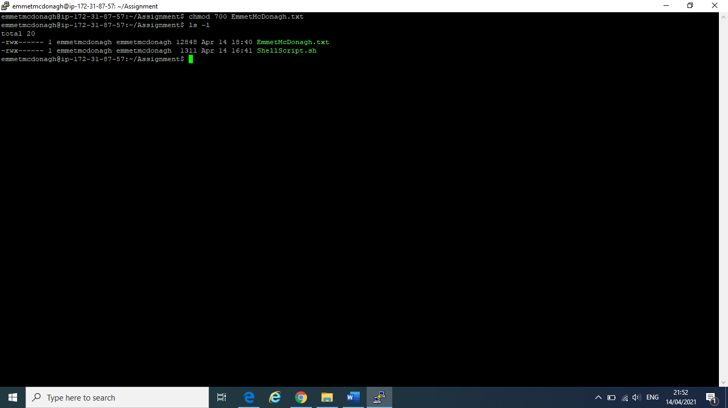

### Q2.3.2:

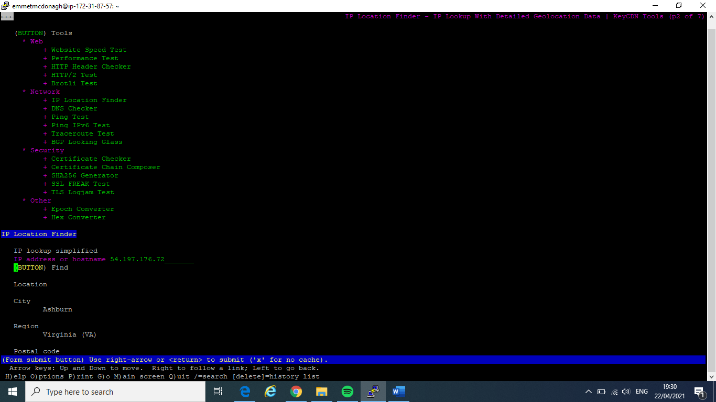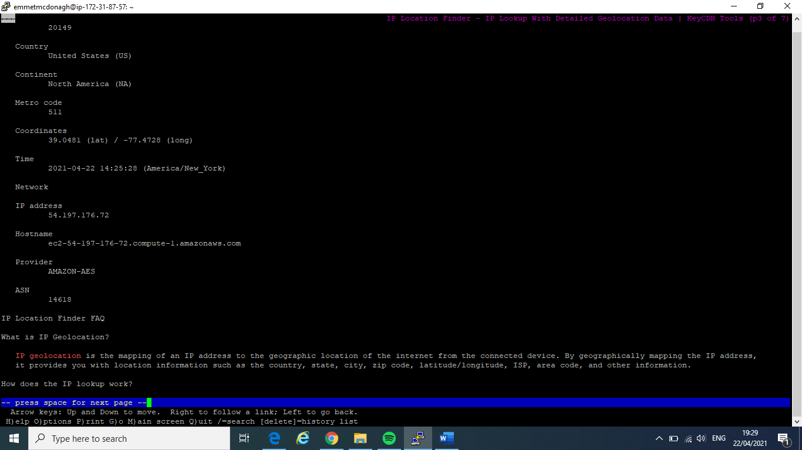

## Q2.4

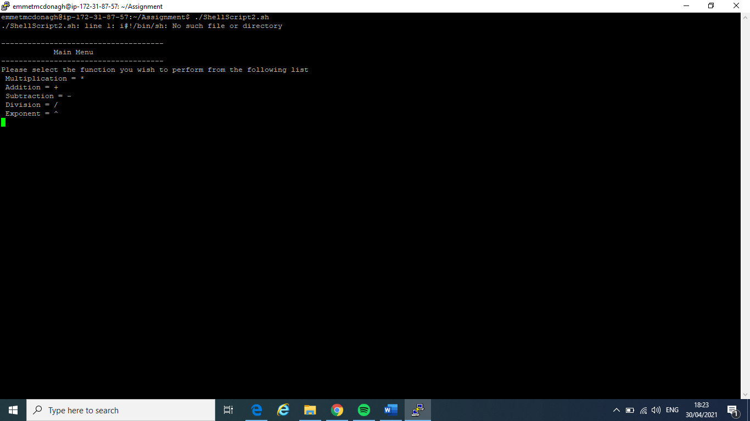

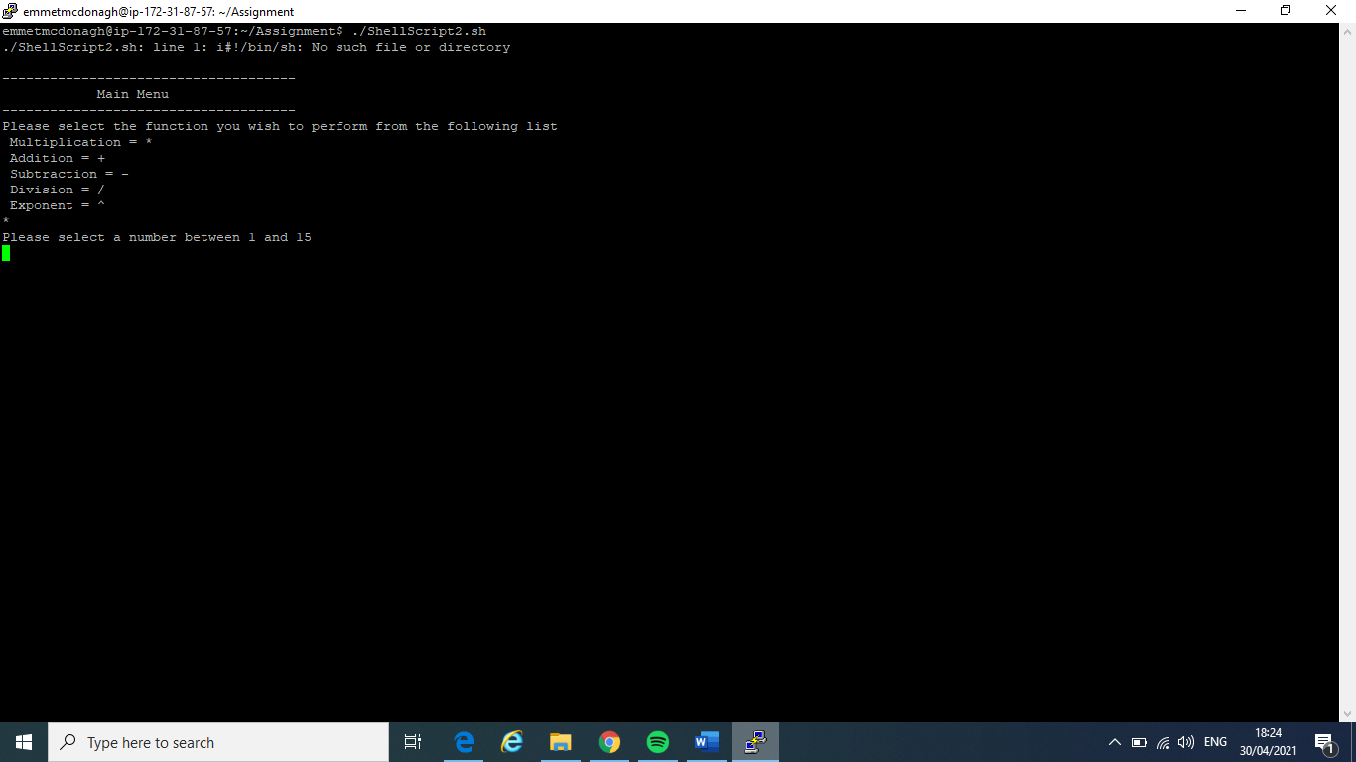

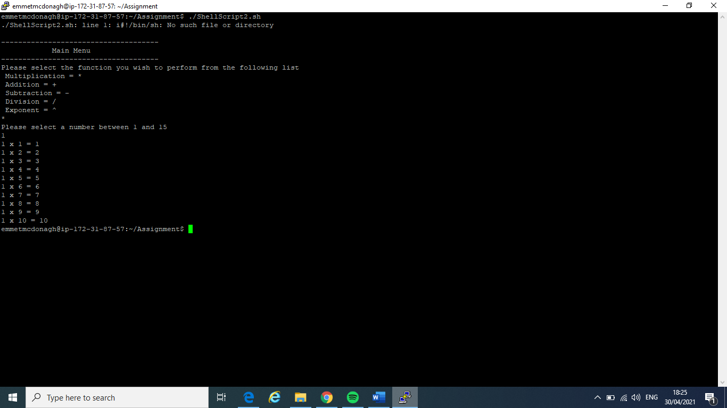

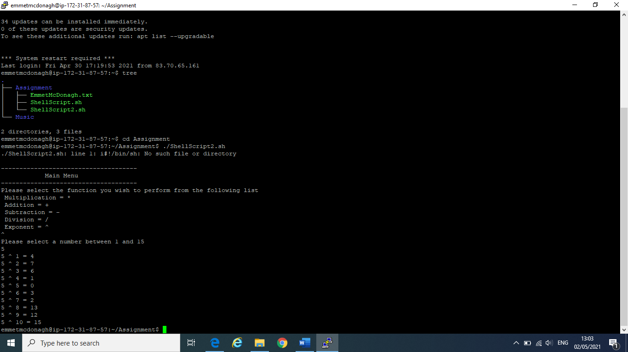

#!/bin/sh

echo " "

echo "-------------------------------------"

echo " Main Menu "

echo "-------------------------------------"

echo "Please select the function you wish to perform from the following list"

echo " Multiplication = *"

echo " Addition = +"

echo " Subtraction = -"

echo " Division = /"

echo " Exponent = ^"

read s

echo "Please select a number between 1 and 15"

read n

i=1

while [ "$i" -le 10 ]

do

if [ "$s" = "*" ]; then

echo "$n x $i = $((n*i))";

elif [ "$s" = "+" ]; then

echo "$n + $i = $((n+i))";

elif [ "$s" = "-" ]; then

echo "$n - $i = $((n-i))";

elif [ "$s" = "/" ]; then

echo "$n / $i = $((n/i))";

elif [ "$s" = "^" ]; then

echo "$n ^ $i = $((n^i))";

fi

i=$((i+1))

done

# References

Academo. (n.d.) *Logic Gate Simulator* [*https://academo.org/demos/logic-gate-simulator/*](https://academo.org/demos/logic-gate-simulator/)

CourseHero. (n.d.) *Shell Script-Shell Script to Print the Multiplication Table.* <https://www.coursehero.com/file/22582832/Shell-Script/>

DistroTube. (2018, December 11). *The Vim Tutorial- Part One-Basic Commands* [Video]. Youtube. <https://www.youtube.com/watch?v=ER5JYFKkYDg>

GMIT, (2021) *Week 4 Decimal Binary Hex Conversion* retrieved from <https://learnonline.gmit.ie/pluginfile.php/268517/mod_resource/content/0/Decimal%20Binary%20Hex%20Conversion.pdf> on 25th April 2021

GMIT, (2021) *Week 4 Real Numbers-Binary Representation* retrieved from

<https://learnonline.gmit.ie/pluginfile.php/307093/mod_resource/content/0/Real%20Numbers%20-%20Binary%20Representation.pdf> on 25th April 2021

GMIT, (2021) *Week 5 Binary Arithmetic* retrieved from <https://learnonline.gmit.ie/pluginfile.php/268509/mod_resource/content/0/Binary%20Arithmetic.pdf> on 25th April 2021

GMIT, (2021) *Week 5 Logic Gates* retrieved from <https://learnonline.gmit.ie/pluginfile.php/268511/mod_resource/content/0/Logic%20Gates.pdf> on 25th April 2021

GMIT, (2021) *Week 6 Circuits* retrieved from

<https://learnonline.gmit.ie/pluginfile.php/268503/mod_resource/content/0/Circuits.pdf> on 25th April 2021

GMIT, (2021) *Week 8 Linux Command Reference/Cheat Sheet* retrieved from

<https://learnonline.gmit.ie/mod/url/view.php?id=166255> on 25th April 2021

GMIT, (2021) *Week 9 Linux Shell Part 2*retrieved from

<https://learnonline.gmit.ie/pluginfile.php/268481/mod_resource/content/0/Linux%20Shell%20Part%202.pdf> on 25th April 2021

GMIT, (2021) *Week 10 Linux File Permissions* retrieved from [*https://learnonline.gmit.ie/course/view.php?id=2712*](https://learnonline.gmit.ie/course/view.php?id=2712) on 25th April 2021

Fireship. (2021, February 10) *Vim in 100 Seconds.* [Video]. Youtube <https://www.youtube.com/watch?v=-txKSRn0qeA>

Harris, S. (2016) *Binary Addition.* Science Direct. <https://www.sciencedirect.com/topics/computer-science/binary-addition>

Unix & Linux. (2017, December 18). *History command inside bash script.* <https://unix.stackexchange.com/questions/5684/history-command-inside-bash-script>

TecMint. (2018, January 29). *How to Save Top Command Output to a File.* [*https://www.tecmint.com/save-top-command-output-to-a-file/*](https://www.tecmint.com/save-top-command-output-to-a-file/)

Irshad, R. (2018, January 15) *Shell script to display the multiplication table of a number* [Video]. Youtube. <https://www.youtube.com/watch?v=ldShX01jByk>

John, G. (2015, October 3) *How to do Binary Addition (The Easy Way)* [Video]. Youtube. <https://www.youtube.com/watch?v=ypqYoFbPfTk>

John, G. (2016, January 28) *The Easy Way to Subtract Binary- Binary Subtraction Made Easy* [Video]. Youtube. <https://www.youtube.com/watch?v=Pr-j2fmcpxc>

John, G. (2010, October 12) *How to convert Binary to Decimal Tutorial (The Easy Way)* [Video]. Youtube. <https://www.youtube.com/watch?v=tfKe8PPI2zs>

Linuxize. (2020, January 29). *Bash Select (Make Menus).* <https://linuxize.com/post/bash-select/>

Mathematics First. (2010, June 20) *Digital Logic- implementing a logic circuit from a Boolean expression.* [Video]. Youtube. <https://www.youtube.com/watch?v=0zSHzQJ6vgo>

Menu driven scripts. (2016, March 29). *Linux Shell Scripting Tutorial- A Beginner’s Handbook* [*https://bash.cyberciti.biz/guide/Menu_driven_scripts*](https://bash.cyberciti.biz/guide/Menu_driven_scripts)

Mike G. (2000, July 27) *Bash Programming- Introduction HOW-TO*. <https://tldp.org/HOWTO/Bash-Prog-Intro-HOWTO.html>

PurpleMath (n.d.). *Number Bases: Introduction & Binary Numbers.* [*https://www.purplemath.com/modules/numbbase.htm*](https://www.purplemath.com/modules/numbbase.htm)

TonyTeachesTech. (2020, September 4). *How to use Putty pscp to Copy Files to/from a Remote Server.[*Video]. Youtube. <https://www.youtube.com/watch?v=w1Tqr7Wk5aU>

Traversy Media. (2018, May 17) *Shell Scripting Crash Course- Beginner Level. [Video]*. Youtube. <https://www.youtube.com/watch?v=v-F3YLd6oMw>