Using Machine Learning to compress images

Using the K-Means Clustering technique to compress an image whilst preserving the image quality.

K-Means Clustering is a technique which takes unlabelled data points and categorises them into k groups. The technique can be used in a variety of circumstances, such as detecting credit card fraud

If we take the simple image in figure 1, we can see the image comprises mainly of yellows, browns and blacks. If we were to colour in the image, we would use a yellow, brown and black pencil. This decision is instinctive, but what specific shade of yellow, brown and black should we choose? How many shades would we need to make the image still look natural? The answers to these questions can be hard to quantify, but we can use a technique called K-Means Clustering to find the optimal shades.
Figure 2 plots a sample of the colour of pixels in figure 1, on a RGB scale. Here, we can see in a more quantitative way how the different colours can be identified as clusters, and thus taking the average of these clusters will provide a good estimate for the best colours of which a single point should be reduced to. To get this point, a K-Means clustering algorithm is employed. The algorithm works by splitting n observations, in this case Width\timesHeight pixels, into k clusters. The algorithm is described by:
- Place k nodes within the data domain
- For each datapoint, calculate the (Euclidean) distance to each node and assign it to the closest node
- Move each of the k datapoints to the position of the minimum distance (centroid) to each n datapoint within the cluster
- Recalculate the distance to each node for each datapoint, reassigning it to different nodes if necessary
- Keep recalculating for x turns or until convergence
Source code for scikitlearns algorithm is found here https://github.com/scikit-learn/scikit-learn/blob/ab93d65/sklearn/cluster/k_means_.py#L704. This algorithm is easy to implement into our code. First we need to reshape the data so all the data is in one dimension using the np.reshape function. Next we take a sample of the data by shuffling the data (shuffle()), and taking the first 1000 points of this shuffled data. This should give us a good sample of the original image while reducing the strain on the algorithm. Next we fit our sample with the KMeans model,
Model = KMeans(n_clusters=n_colours).fit(arr_sample)
The output, model.cluster_centers_, prints the R G B values for the 3 clusters fit to the data. This output is plotted in figure 3.

15.7 KB -> 9.29 KB

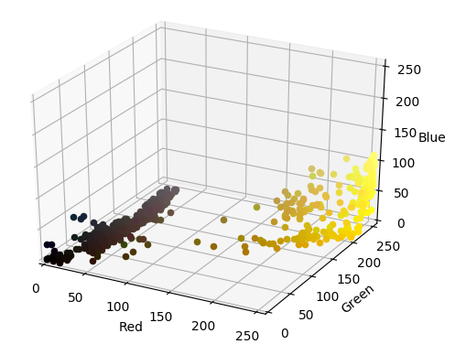
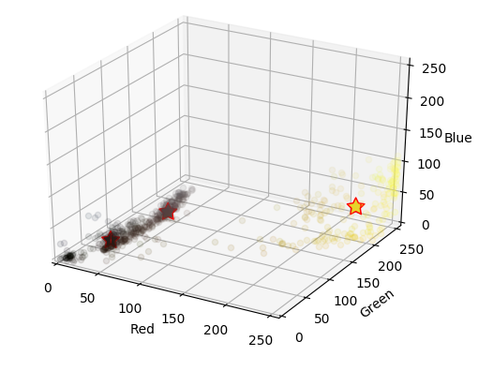


Titanic Survival Predictions using Machine Learning

In this post, I will use a Random Forest algorithm to determine who will survive on the titanic.

- We have many features
- Want to classify if a passenger survives (1) or dies (0)
- Iterate through every data points and calculate gini index
- Gini score 0, 50/50 split in the data. Gini score 1, all data points from class (1) on one side, class (0) on the other side.

- Binary is 0 or 1
- Each tree contributes to the overall forest
- Random forest is a large collection of uncorrelated decision trees
- Input into each tree and find the avg output
- When a new input is entered into the system, it is run down all of the trees. The result may either be an average or weighted average of all of the terminal nodes that are reached, or, in the case of categorical variables, a voting majority.

