INKSPIRE
A Writing Assistant Web Application
Requirements Document Version 1.0

Student: Kantima Pinthong
HTTP 5310 Capstone Project - Fall 2026

1. Introduction

1.1 Project Purpose
Inkspire is a web application for fiction writers who want one place to collect story ideas, organize story information, develop characters and worlds, plan story structure, and write drafts. The application is designed for writers working on short or long stories, including stories that use non-linear timelines, flashbacks, or multiple time periods.
The main goal is to help a writer move from a rough idea to a structured story without having to keep story information in many separate applications. Inkspire will save the writer's work in an online database so the same account and saved writing can be accessed from different devices.

1.2 Target Users
- Writer - the main registered user who creates and manages ideas, stories, planning information, and writing.
- Reviewer - a person who receives a shareable Inkspire link and reads a selected chapter/scene or an entire shared story. The reviewer has read-only access to the shared content.

1.3 Goals
- Provide one organized workspace for story development and writing.
- Reduce the risk of losing drafts by saving writing to an online database.
- Support planning for stories with chapters, scenes, characters, locations, and timelines.
- Allow a writer to check a chapter against their own planned story-structure checklist.
- Provide an optional sharing method so selected writing can be read by another person without giving that person access to the writer's private workspace.

1.4 Features and How it works
The MVP focuses on the Writer workflow: account access, idea management, story management, characters, timeline events, story structure, world information, writing, and story check. Sharing for reviewers is planned as a Should Have feature rather than a core MVP requirement.
The main workflow of Inkspire starts when a writer creates an account and logs in. The writer can first save rough ideas in the Idea Vault. When an idea is ready, the writer can develop it into a story and manage it through My Stories. After opening a story, the writer enters that story's workspace. From there, they can add characters, timeline events, acts, chapters, scenes, locations, research, and other story information. The writer can then use the Writing Editor to write and save their chapters or scenes.
All story-related information is connected to its specific story, so information from different stories remains separate. The writer can use Story Check to review their chapter information and manually track planned story elements.

2. Technical

2.1 Technology Stack
 | Planned technology | Purpose
Front end | React, HTML, CSS, JavaScript | Responsive interface, forms, navigation, interactions, and writing editor UI
Back end | Node.js and Express | Server-side, routing, authentication, and database communication
Database | PostgreSQL | Online persistent storage for user, story, planning, and writing data
API / server communication | REST API | Communication between the React frontend and the Node.js/Express backend
Authentication | User registration and login system | Allow Writers to create accounts and securely access their own data
Cloud Database | Online PostgreSQL database | Store user and story data online so saved work can be accessed from different devices
Deployment | Cloud hosting | Host the web application and online database

2.2 Third-Party Software / APIs
No third-party content API is required for the MVP. External software versions and URLs will be added to this section when final hosting, libraries, or services are selected.

2.3 Security Requirements
- Only an authenticated Writer can access and modify private story-management pages.
- A Writer can only retrieve and modify their own private story data.
- Passwords will be handled by the authentication framework rather than stored as plain text.
- Shared links will expose only the content explicitly selected for sharing.
- Reviewer access will be read-only and will not expose private Writer account or editing controls.

3. Features List

3.1. Main Features
- Account Management
Writers can register for an account, log in, and log out. Each writer can only access and manage their own stories and saved information.
- Idea Vault
Writers can create, view, edit, and delete rough story ideas. When an idea is ready to be developed, the writer can turn it into a story project in My Stories.
- My Stories
Writers can create and manage story projects. Each story has its own workspace where the writer can manage story information and all related content.
- Character Studio
Writers can create and manage characters for a selected story. Character information can include names, personality, background, appearance, goals, and other details.
- Story Timeline
Writers can create and organize events for a selected story. This helps writers plan stories with non-linear timelines, flashbacks, and different time periods.
- Story Builder
Writers can organize a story into Acts, Chapters, and Scenes. They can create, edit, delete, and organize these parts to build the structure of their story.
- Story Structure Checklist
Writers can create a checklist of planned events or story elements for a chapter. They can manually mark each item as complete while writing.
- World Builder
Writers can create and manage locations and other world information related to a selected story.
- Writing Editor and Drafts
Writers can write chapters and scenes using a basic rich text editor and save their writing. Saved drafts are stored in the online database so they can be opened again later.
- Story Check
Writers can review information related to a chapter, such as characters and locations used in the story. They can also review and update the completion status of their Story Structure checklist.
3.2 Supporting Features
- Research & Notes
Writers can save research, notes, and reference links related to a selected story.
- Relationship Map
Writers can create relationships between characters and view them as a visual map.
3.3 Reviewer Feature
- Story Sharing and Reviewer
Writers can create a shareable link for a selected chapter, scene, or an entire story. A reviewer can open the link and read the shared content without access to the writer's private workspace.

4. User Stories
User stories are grouped by role and priority. Must Have stories define the MVP. Should Have stories add useful functionality outside the MVP. Nice to Have stories add polish or advanced functionality.

4.1 Must Have User Stories

1 - A visitor can register for an Inkspire account.
Implementation tasks:
- Create registration page and form
- Validate required fields and account data
- Create user record securely
- Display success or validation message
Estimated time: 6 hours
Messages / states: Success: Account created. Error: Registration information is invalid or the account already exists.

2 - A registered Writer can log in to Inkspire.
Implementation tasks:
- Create login form
- Validate credentials
- Create authenticated session
- Redirect Writer to Dashboard
Estimated time: 5 hours
Messages / states: Error: Invalid email/password. Success: Logged in successfully.

3 - A logged-in Writer can log out of Inkspire.
Implementation tasks:
- Add Logout action
- End authenticated session
- Redirect to public/login page
Estimated time: 2 hours
Messages / states: Status: Logged out successfully.

4 - A logged-in Writer can create a story idea in the Idea Vault.
Implementation tasks:
- Create Add Idea form
- Add title and idea description fields
- Validate required fields
- Save idea to database
Estimated time: 15 hours
Messages / states: Success: Idea saved. Error: Required information is missing.

5 - A logged-in Writer can view story ideas in the Idea Vault.
Implementation tasks:
- Retrieve Writer's ideas
- Display ideas in a list/card view
Estimated time: 5 hours
Messages / states: Status: Ideas displayed; empty state explains that no ideas have been created.

6 - A logged-in Writer can edit a story idea.
Implementation tasks:
- Load selected idea into edit form
- Allow title/description changes
- Validate and update database
- Return to Idea Vault
Estimated time: 5 hours
Messages / states: Success: Idea updated. Error: Invalid or missing information.

7 - A logged-in Writer can delete a story idea.
Implementation tasks:
- Provide Delete action
- Show confirmation status message
- Delete selected idea
- Refresh Idea Vault
Estimated time: 2 hours
Messages / states: Confirmation: Are you sure you want to delete this idea? Success: Idea deleted.

8 - A logged-in Writer can develop an idea into a My Stories project.
Implementation tasks:
- Add Develop into Story action
- Create Story record from selected idea
- Connect story to Writer
- Allow initial story information
Estimated time: 6 hours
Messages / states: Success: Story created. Error: Story could not be created.

9 - A logged-in Writer can create a story.
Implementation tasks:
- Create story form
- Add title, genre, synopsis, and overall plot/story information
- Validate required title
- Save story
Estimated time: 6 hours
Messages / states: Success: Story created. Error: Required story title is missing.

10 - A logged-in Writer can view their stories.
Implementation tasks:
- Retrieve Writer's stories
- Display story cards/list
- Open selected story workspace
Estimated time: 3 hours
Messages / states: Status: Stories displayed; empty state if none exist.

11 - A logged-in Writer can edit story information.
Implementation tasks:
- Load story information into form
- Allow changes to title, genre, synopsis, and plot information
- Validate and save changes
Estimated time: 5 hours
Messages / states: Success: Story information updated. Error: Invalid/missing required data.

12 - A logged-in Writer can delete a story.
Implementation tasks:
- Provide Delete action
- Show confirmation
- Delete story and associated owned data according to relationship rules
- Return to My Stories
Estimated time: 2 hours
Messages / states: Confirmation before deletion. Success: Story deleted.

13 - A logged-in Writer can create a character using Character Studio.
Implementation tasks:
- Create character form
- Add name, personality, background, appearance, goals, and other details
- Validate required name
- Save character
Estimated time: 6 hours
Messages / states: Success: Character created. Error: Character name is required.

14 - A logged-in Writer can view, edit, and delete characters.
Implementation tasks:
- Display characters for selected story
- Provide Read view
- Provide Edit form and Update action
- Provide Delete confirmation and Delete action
Estimated time: 6 hours
Messages / states: Success and error messages are shown for update/delete operations.

15 - A logged-in Writer can create and organize Story Timeline events.
Implementation tasks:
- Create timeline event form
- Add event title, date/time or story-time value, description, and ordering information
- Validate required fields
- Display events in chronological/story order
Estimated time: 7 hours
Messages / states: Success: Event saved. Error: Required timeline information is missing.

16 - A logged-in Writer can edit and delete Story Timeline events.
Implementation tasks:
- Load event into edit form
- Update event data and ordering
- Confirm deletion
- Delete selected event
Estimated time: 2 hours
Messages / states: Success: Event updated/deleted. Error: Invalid event data.

17 - A logged-in Writer can create Chapters and Scenes using Story Builder.
Implementation tasks:
- Create Act, Chapter, and Scene controls
- Store parent-child relationships
- Display hierarchy/tree
- Validate required names
Estimated time: 8 hours
Messages / states: Success: Structure item created. Error: Required title/name is missing.

18 - A logged-in Writer can edit and delete Chapters and Scenes.
Implementation tasks:
- Edit selected structure item
- Update title/order/description as applicable
- Confirm deletion
- Delete or safely handle child items
Estimated time: 7 hours
Messages / states: Success: Item updated/deleted. Status: Confirmation shown before destructive action.

19 - A logged-in Writer can create a Story Structure checklist for a chapter.
Implementation tasks:
- Open chapter checklist
- Add checklist item text
- Save checklist item to chapter
- Display checklist in planned order
Estimated time: 6 hours
Messages / states: Success: Checklist item added. Error: Checklist item cannot be blank.

20 - A logged-in Writer can view and manually mark Story Structure checklist items as complete.
Implementation tasks:
- Display chapter checklist
- Provide completion control
- Save completion state
- Allow completed item to be unchecked
Estimated time: 4 hours
Messages / states: Status: Item marked complete/incomplete.
- 21 - A logged-in Writer can create, edit, view, and delete locations and basic world information.
Implementation tasks:
- Create location/world form
- Store name, type, description, environment, culture, and other information
- Provide Read/Edit/Delete controls
- Confirm destructive actions
Estimated time: 8 hours
Messages / states: Success/error/confirmation messages are shown for CRUD operations.

22 - A logged-in Writer can write and save chapter/scene drafts in the Writing Editor.
Implementation tasks:
- Create editor view
- Load selected chapter/scene
- Provide title/content fields
- Save draft to online database
- Display save status
Estimated time: 12 hours
Messages / states: Status: Saving/Saved. Error: Draft could not be saved.

23 - A logged-in Writer can reopen saved writing from the online database on another device.
Implementation tasks:
- Authenticate Writer
- Retrieve saved drafts from database
- Display available chapters/scenes
- Load selected content into editor
Estimated time: 4 hours
Messages / states: Status: Draft loaded. Error: Saved writing cannot be retrieved.

24 - A logged-in Writer can use Story Check to view characters and locations referenced by a chapter.
Implementation tasks:
- Associate selected chapter with saved story entities
- Display character references
- Display location references
- Provide links to related records
Estimated time: 8 hours
Messages / states: Status: References displayed; empty state if no saved references are available.

25 - A logged-in Writer can review the Story Structure checklist for a chapter and manage its completion state.
Implementation tasks:
- Load selected chapter checklist
- Display planned elements
- Allow manual completion/uncompletion
- Save checklist state
Estimated time: 5 hours
Messages / states: Status: Checklist state saved.

4.2 Should Have User Stories

1 - A logged-in Writer can create a shareable link for a selected chapter or scene so a Reviewer can read it.
Implementation tasks:
- Add Share action to chapter/scene
- Create unique share token
- Store selected content and sharing status
- Display copyable link
- Allow Writer to disable the link
Estimated time: 10 hours
Messages / states: Success: Share link created. Status: Link disabled when Writer turns sharing off.

2 - A logged-in Writer can create a shareable link for an entire story so a Reviewer can read the shared story.
Implementation tasks:
- Add Share Story action
- Create unique share token
- Define story read order from Acts/Chapters/Scenes
- Store sharing status
- Display copyable link
- Allow Writer to disable the link
Estimated time: 10 hours
Messages / states: Success: Story share link created. Error: Story has no readable content.

3 - A Reviewer can open a valid shared link and read the selected chapter/scene or shared story without accessing the Writer's private workspace.
Implementation tasks:
- Create public shared-content route
- Validate share token and active status
- Display read-only content
- Provide navigation for shared story content where applicable
- Return an unavailable message for invalid/disabled links
Estimated time: 7 hours
Messages / states: Error/status: This shared work is unavailable. Read-only view must not expose Writer editing controls.

4 - A logged-in Writer can use Research Vault & Notes to create, view, edit, and delete research notes or reference links.
Implementation tasks:
- Create research/note form
- Store title, note text, source URL, and optional story association
- Provide Read/Edit/Delete actions
- Validate URLs where entered
Estimated time: 9 hours
Messages / states: Success: Note saved. Error: Invalid reference link or missing required information.

5 - A logged-in Writer can view a visual Relationship Map for characters in a story.
Implementation tasks:
- Retrieve characters and relationship records
- Create relationship data model
- Display character nodes and relationship labels
- Allow Writer to add/edit/delete relationships
Estimated time: 12 hours
Messages / states: Success: Relationship displayed. Error: Relationship cannot be saved.

4.3 Nice to Have User Stories

1 - A logged-in Writer can export selected story information or writing to a downloadable document.
Implementation tasks:
- Add Export action
- Select story/chapter content
- Generate downloadable file
- Provide success/error status
Estimated time: 10 hours
Messages / states: Success: Export generated. Error: Export could not be created.

2 - A logged-in Writer can customize selected workspace display preferences.
Implementation tasks:
- Add simple preference settings
- Store preferences per Writer
- Apply preferences to workspace UI
- Provide reset option
Estimated time: 6 hours
Messages / states: Success: Preferences saved. Status: Default settings restored.

3 - A logged-in Writer can view basic writing/project statistics.
Implementation tasks:
- Calculate word count and chapter/scene counts
- Display simple dashboard statistics
- Keep statistics informational rather than evaluative
Estimated time: 6 hours
Messages / states: Status: Statistics displayed.

5. Data Design

5.1 Database Schema
- Users
Field | Data Type | Required
UserID | INT | NOT NULL (PK)
Username | VARCHAR(50) | NOT NULL, UNIQUE
Email | VARCHAR(255) | NOT NULL, UNIQUE
PasswordHash | VARCHAR(255) | NOT NULL
CreatedAt | TIMESTAMP | NOT NULL

- Story Ideas
Field | Data Type | Required
IdeaID | INT | NOT NULL (PK)
UserID | INT | NOT NULL (FK)
Title | VARCHAR(255) | NOT NULL
Description | TEXT | NOT NULL
CreatedAt | TIMESTAMP | NOT NULL
UpdatedAt | TIMESTAMP | NOT NULL

- Stories
Field | Data Type | Required
StoryID | INT | NOT NULL (PK)
UserID | INT | NOT NULL (FK)
IdeaID | INT | NULL (FK)
Title | VARCHAR(255) | NOT NULL
Genre | VARCHAR(100) | NULL
Synopsis | TEXT | NULL
CreatedAt | TIMESTAMP | NOT NULL
UpdatedAt | TIMESTAMP | NOT NULL

- Characters
Field | Data Type | Required
CharacterID | INT | NOT NULL (PK)
StoryID | INT | NOT NULL (FK)
Name | VARCHAR(255) | NOT NULL
Personality | TEXT | NULL
Background | TEXT | NULL
Appearance | TEXT | NULL
Goals | TEXT | NULL
OtherDetails | TEXT | NULL

- Timeline Events
Field | Data Type | Required
TimelineEventID | INT | NOT NULL (PK)
StoryID | INT | NOT NULL (FK)
EventTitle | VARCHAR(255) | NOT NULL
EventDate | VARCHAR(100) | NULL
Description | TEXT | NULL
SortOrder | INT | NULL

- Acts
Field | Data Type | Required
ActID | INT | NOT NULL (PK)
StoryID | INT | NOT NULL (FK)
Title | VARCHAR(255) | NOT NULL
Body | TEXT | NULL
SortOrder | INT | NOT NULL

- Chapters
Field | Data Type | Required
ChapterID | INT | NOT NULL (PK)
ActID | INT | NOT NULL (FK)
Title | VARCHAR(255) | NOT NULL
Body | TEXT | NULL
SortOrder | INT | NOT NULL

- Scenes
Field | Data Type | Required
SceneID | INT | NOT NULL (PK)
ChapterID | INT | NOT NULL (FK)
Title | VARCHAR(255) | NOT NULL
Body | TEXT | NULL
SortOrder | INT | NOT NULL

- Story Structure Items
Field | Data Type | Required
StructureItemID | INT | NOT NULL (PK)
ChapterID | INT | NOT NULL (FK)
Description | TEXT | NOT NULL
IsCompleted | BOOLEAN | NOT NULL
SortOrder | INT | NULL

- Locations
Field | Data Type | Required
LocationID | INT | NOT NULL (PK)
StoryID | INT | NOT NULL (FK)
Name | VARCHAR(255) | NOT NULL
Description | TEXT | NULL
Culture | TEXT | NULL
Environment | TEXT | NULL
OtherDetails | TEXT | NULL

- Drafts
Field | Data Type | Required
DraftID | INT | NOT NULL (PK)
StoryID | INT | NOT NULL (FK)
ChapterID | INT | NULL (FK)
SceneID | INT | NULL (FK)
Content | TEXT | NOT NULL
UpdatedAt | TIMESTAMP | NOT NULL

- Research Notes
Field | Data Type | Required
ResearchID | INT | NOT NULL (PK)
StoryID | INT | NOT NULL (FK)
Title | VARCHAR(255) | NOT NULL
Content | TEXT | NULL
ReferenceLink | VARCHAR(500) | NULL
CreatedAt | TIMESTAMP | NOT NULL
UpdatedAt | TIMESTAMP | NOT NULL

4.2 Main Relationships
- One User can own many StoryIdeas and Stories.
- One Story can contain many Characters, Timeline Events, Acts, Locations, Research Notes.
- One Act can contain many Chapters; one Chapter can contain many Scenes and StoryStructureItems.
- Drafts belong to the Writer and are associated with the selected Chapter or Scene.
- Share Links belong to a Story and may target a specific Chapter/Scene or the whole Story.

5. Dataflow Diagrams

Create Story Idea
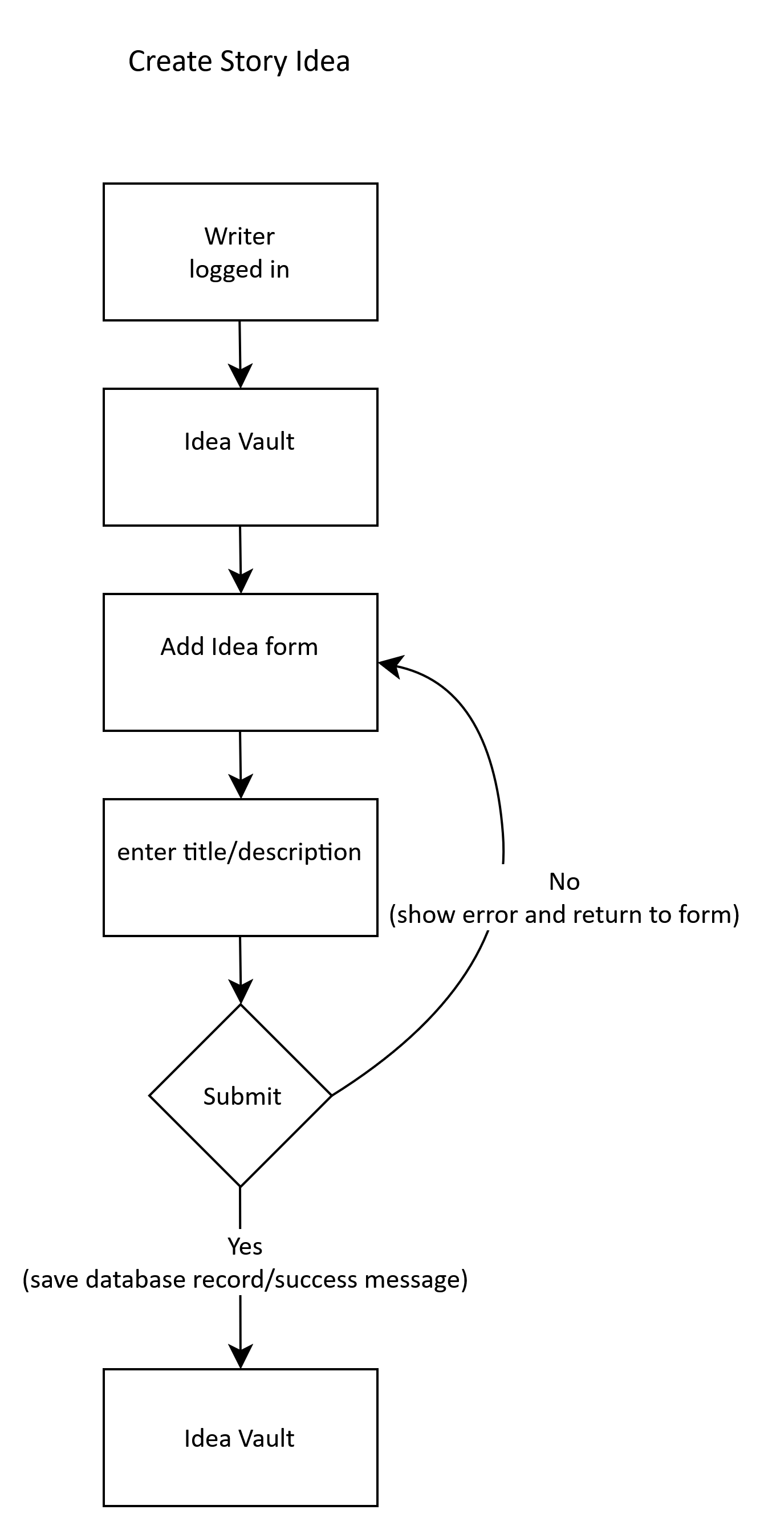

Update Story Idea
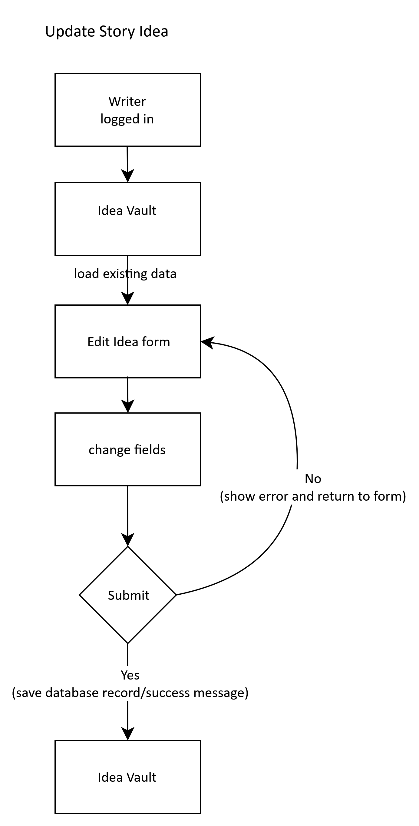

Delete Story Idea
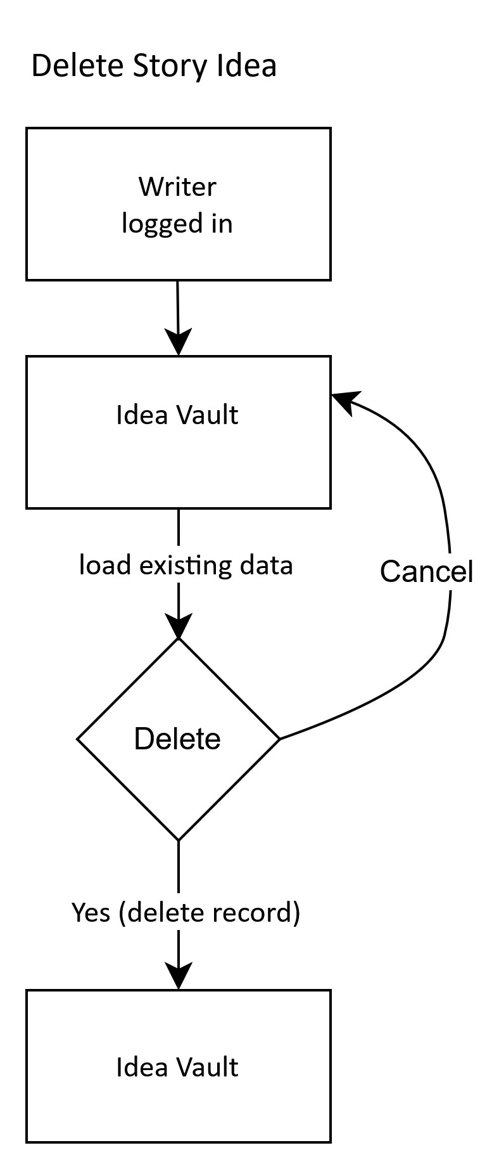

Develop Idea into Story
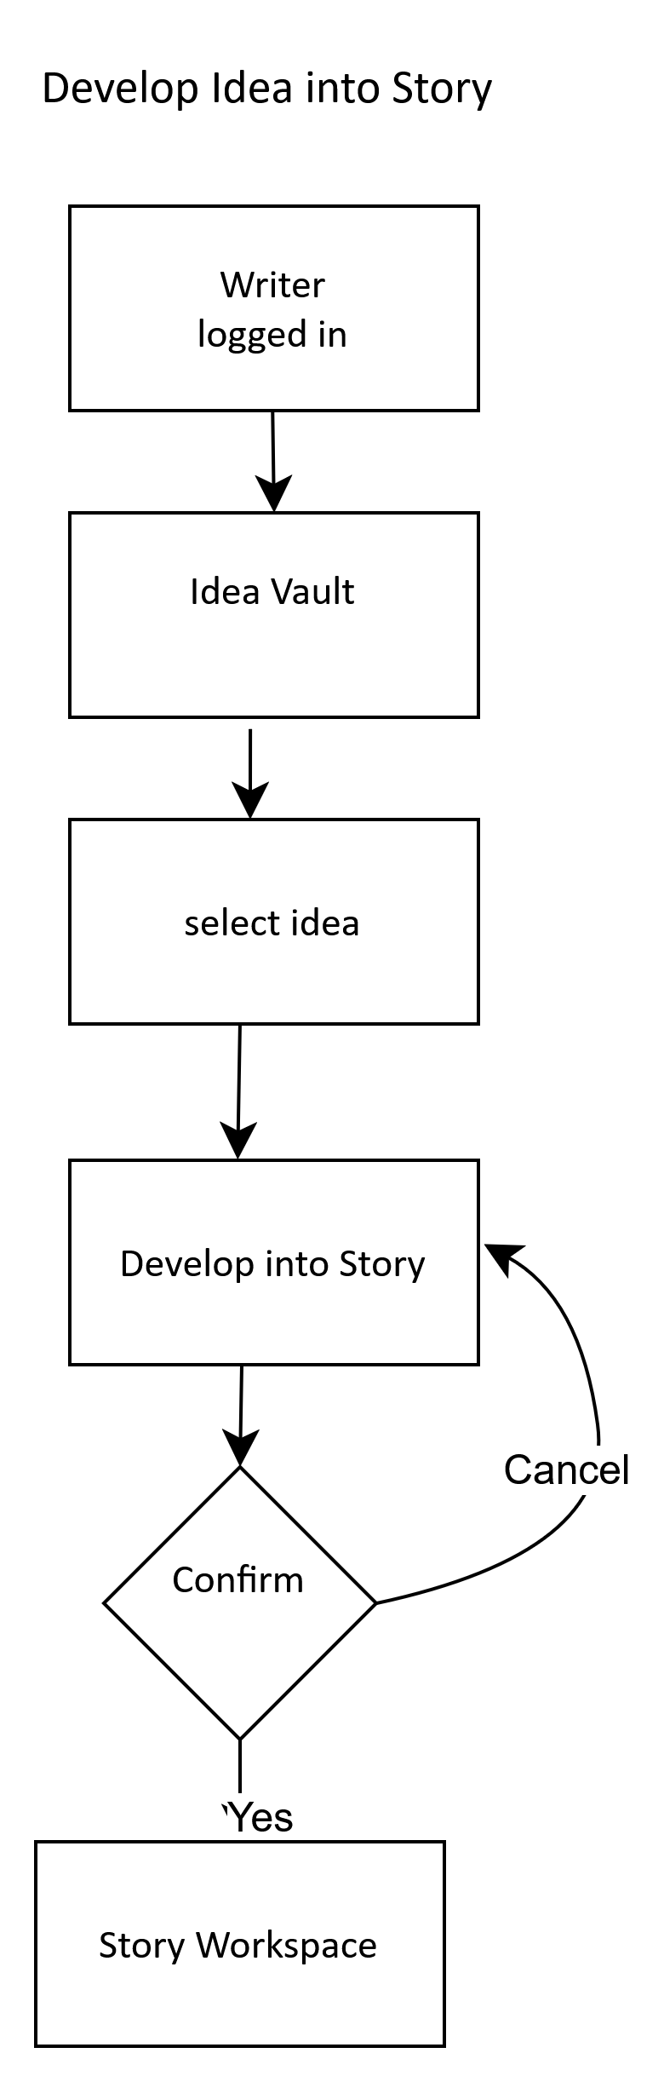

Create Story
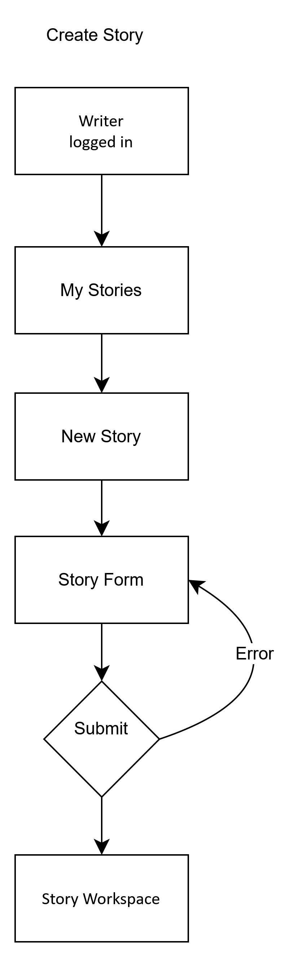

Character CRUD
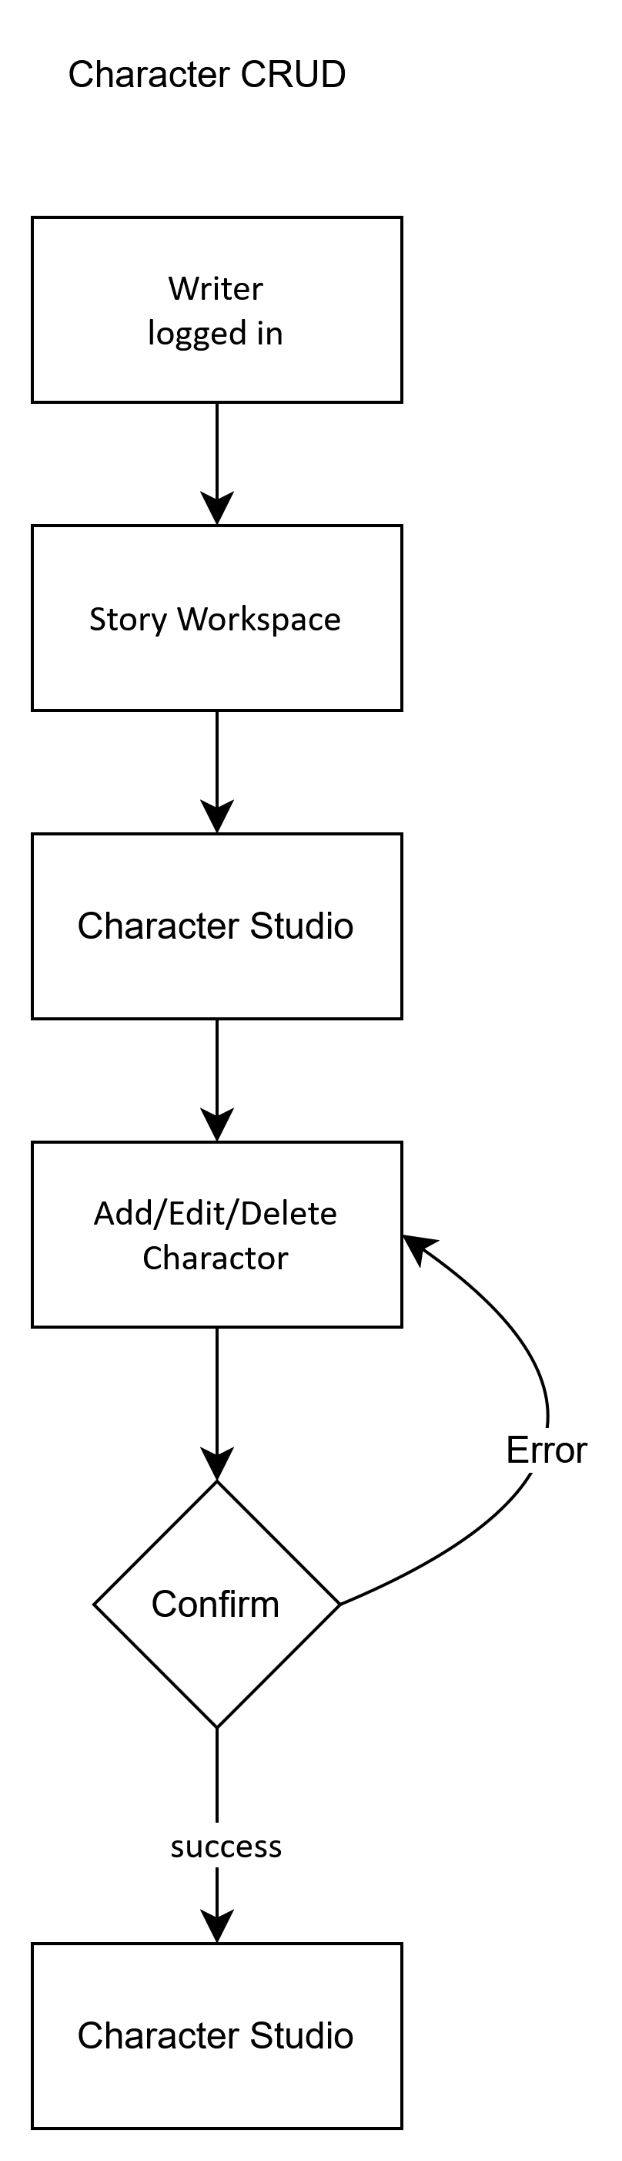

Timeline CRUD
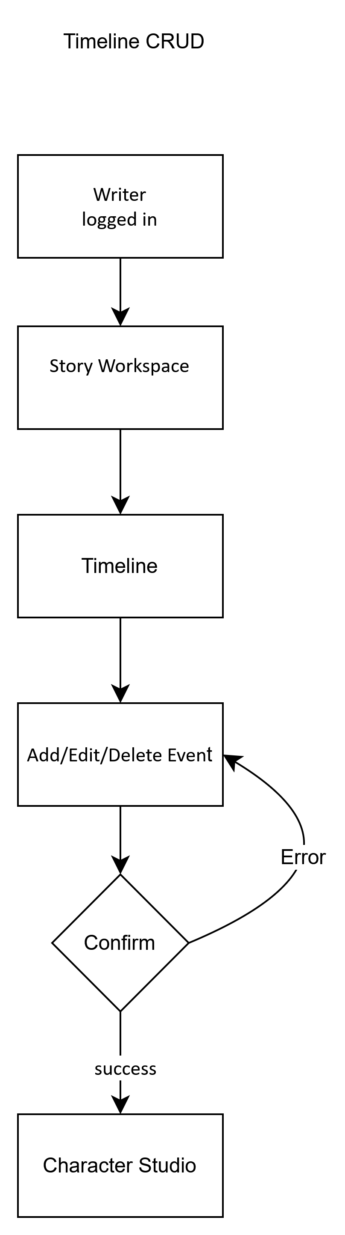

Story Builder
- 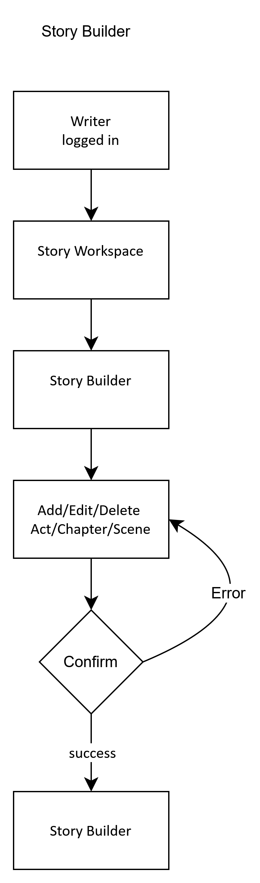

Story Structure Checklist
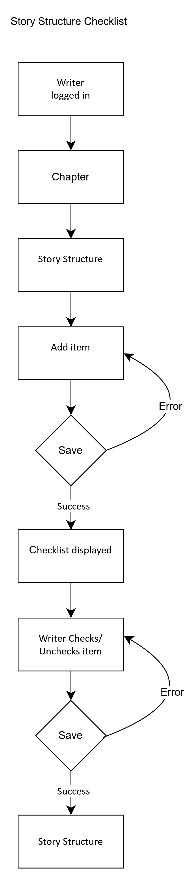

Writing Editor Save
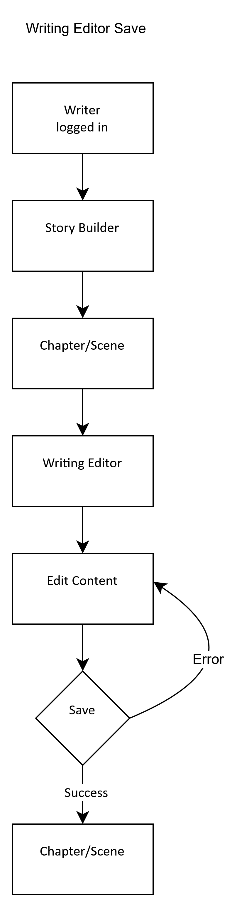

Reopen Saved Writing
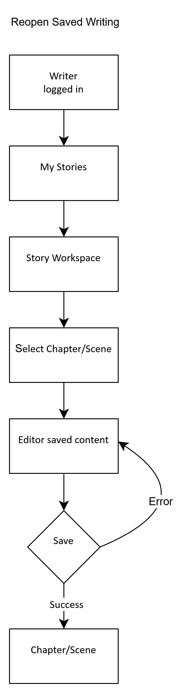

Story Check
- 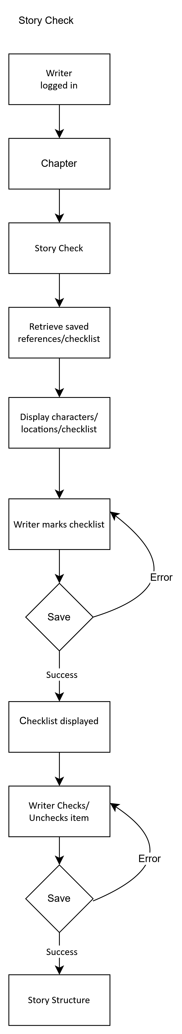

6. Wireframes

Dashboard
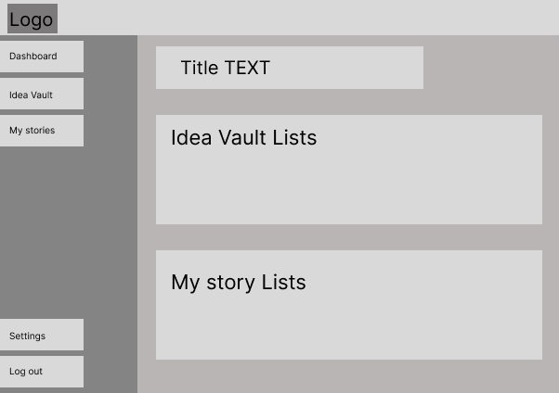

Idea Vault
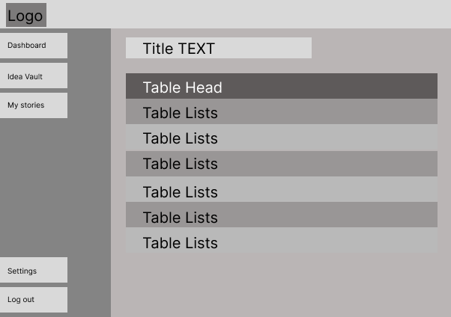

Create Idea
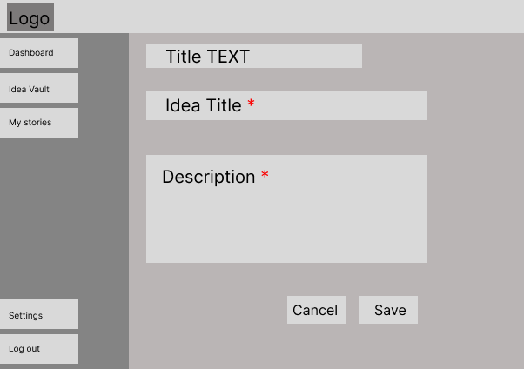

Story Workspace
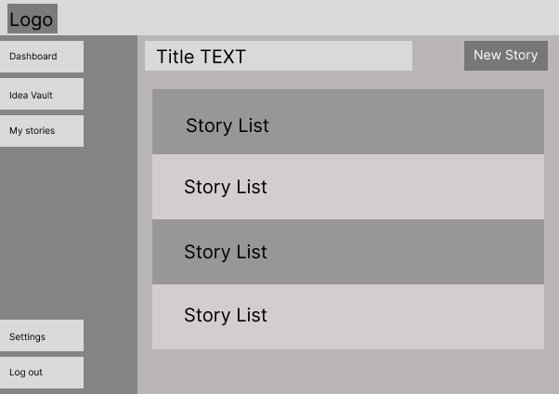

Story Overview
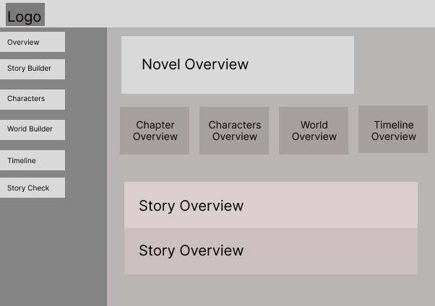

Character Studio
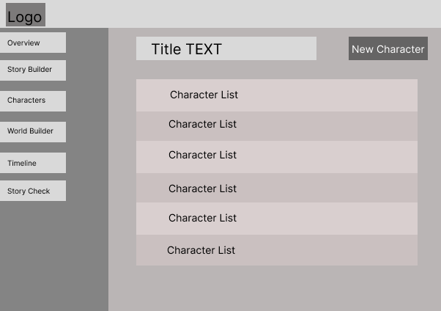

Create Character
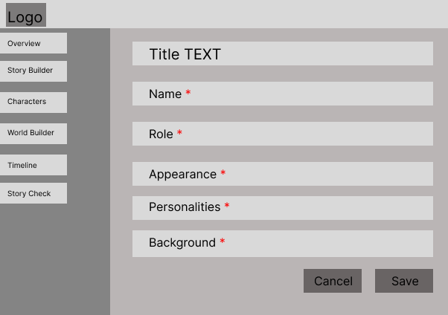

Timeline
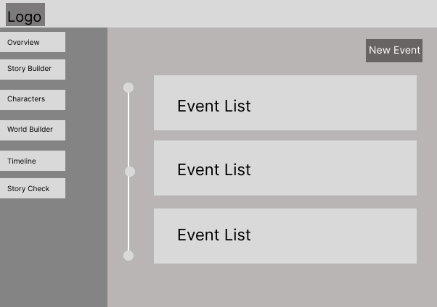

Story Builder
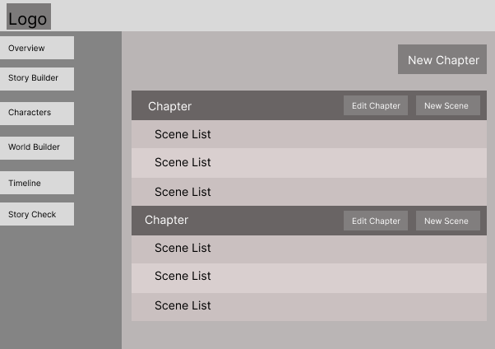

Writing Editor

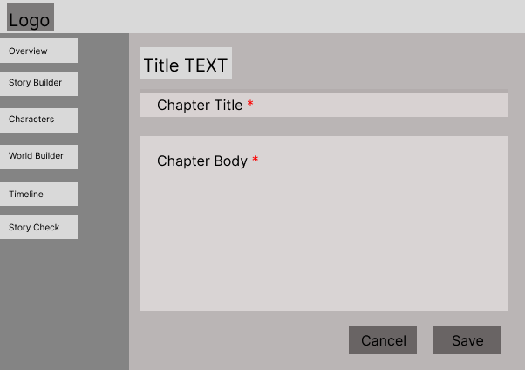

Story Check
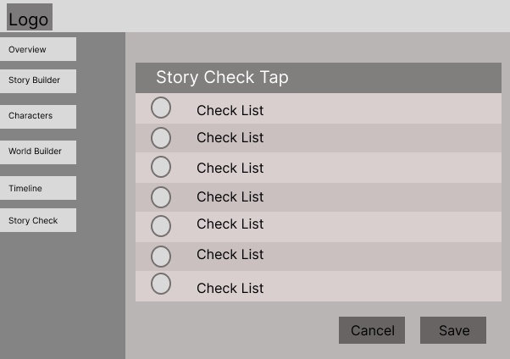

6.1 Required-field convention
Fields marked with * will be required. Required fields will be represented consistently in the final wireframes and forms.

6.2 File-Naming Conventions
- Frontend
- React components: PascalCase
Examples: Navbar.jsx, StoryCard.jsx, CharacterForm.jsx
- React pages: PascalCase
Examples: Dashboard.jsx, IdeaVault.jsx, StoryWorkspace.jsx, WritingEditor.jsx
- CSS files: Match the component or page name
Examples: Navbar.css, StoryCard.css, WritingEditor.css
- JavaScript utility/service files: camelCase
Examples: apiService.js, authService.js, storyService.js
- Backend
- Route files: camelCase
Examples: authRoutes.js, storyRoutes.js, characterRoutes.js
- Controller files: camelCase with Controller
Examples: authController.js, storyController.js, characterController.js
- Model files: camelCase
Examples: userModel.js, storyModel.js, characterModel.js
- Middleware files: camelCase
Examples: authMiddleware.js, errorMiddleware.js
- Service files: camelCase
Examples: storyService.js, shareService.js

6.3 Accessibility Requirements
- Use semantic and appropriate headings.
- All form fields have associated labels.
- Required fields are communicated without relying only on color.
- Keyboard users can access navigation, forms, editor controls, and dialogs.
- Error and success messages are clear and understandable.
- Shared reading pages will be readable on different screen sizes.

6.4 Responsiveness Requirements
- The application will work on desktop, tablet, and mobile screen sizes.
- Navigation will adapt to smaller screens.
- Story Builder and Timeline will remain usable without horizontal overflow where practical.
- Writing Editor will provide a comfortable reading/writing area on desktop and mobile.

6.5 GitHub
Repository link: https://github.com/EmmeyKantima/inkspire

7. Conclusion
Inkspire is planned as a focused writing workspace that combines story planning and writing in one online application. The Must Have requirements define a complete MVP for a Writer, while the Should Have requirements extend the application with sharing/reviewer access, research management, and relationship visualization. The Nice to Have requirements provide additional polish if time permits.
This requirements document will be used as the implementation blueprint. Before coding each feature, the user story, database needs, dataflow, wireframe, validation, messages, accessibility, and responsive behavior should be understood. The document may be revised as the project is reviewed, so version numbers will be updated when requirements change.

