DATA VISUALIZATION TRAINEE EARLY REMOTE INTERNSHIP

WEEK 2

EXPLORATORY DATA ANALYSIS (EDA) PACKAGE

TEAM NO. 09 —MEMBERS AND RESPONSIBILITIES

No. | NAME | ROLE | RESPONSIBILITY
1 | Ehimen Overcomer Felix | Team Lead | Exploratory Data Analysis Report
2 | Felicia Akabaare | Team Member | Key Findings Summary
3 | Kellen Kavosa | Team Member | Key Findings Summary
4 | Lehlohonolo Mafa | Team Member | Exploratory Data Analysis Report
5 | Enuodu Emmanuel | Team Member | Key Findings Summary
6 | Saad Khan | Team Member | Visual Analysis Section
7 | Hassan Irshad | Team Member | Exploratory Data Analysis Report
8 | Nicola Cramer | Team Member | Visual Analysis Section
9 | Ishaq Bamidele | Team Member
10 | David Olaoluwa | Team Member
11 | Akiesiya | Team Member

Exploratory Data Analysis Report

Opportunity Dataset
Week 2: EXPLORATORY DATA ANALYSIS (EDA) REPORT.
Introduction and Dataset Overview:
The purpose of this Exploratory Data Analysis (EDA) is to examine the Opportunity dataset to identify patterns, trends, and insights related to opportunity signups, applications by location, outreach channel performance, and scholarship distribution.
The dataset contains 5,733 records and 33 columns. It includes information about opportunities, such as opportunity names, categories, locations, creation dates, application deadlines, fees, and microscholarship amounts.
The analysis aims to understand how opportunities are distributed, identify important patterns, and highlight areas where further investigation may be beneficial.

- Exploratory Data Analysis Report
created_at | Count of opportunity_id
8/8/2022 | 15
12/2/2022 | 10
3/28/2023 | 274
7/22/2023 | 1052
11/14/2023 | 797
3/9/2024 | 977
7/3/2024 | 542
10/27/2024 | 609
2/19/2025 | 320
6/15/2025 | 227
10/9/2025 | 347
2/2/2026 | 497
5/28/2026 | 59
Grand Total | 5726
- Analysis of Opportunity Sign-Up Trends

Interpretation: Opportunity creation was minimal in 2022, with just 25 opportunities across two dates, then surged in 2023 and reached the highest point in the data on 22 July 2023 with 1,052. Activity stayed strong into early 2024, with 797 on 14 November 2023 and 977 on 9 March 2024, before easing to 542 in July 2024 and 609 in October 2024. Volumes dropped further in 2025, with 320, 227 and 347 across its three dates, followed by a modest rebound to 497 on 2 February 2026. The final date, 28 May 2026, shows only 59, which may reflect a partly recorded period rather than a real collapse. Overall, creation peaked between mid-2023 and early 2024 and has run at a lower level since.
- Analysis of Applications by Location
location | Count of opportunity_id
Work From Home | 2355
Virtual | 1918
Not Specified | 1445
Other (placeholder/test text) | 10
Kolkata | 1
Grand Total | 5729
Interpretation: The geographic analysis reveals that the platform operates on a heavily remote-first architecture. Work From Home leads with 2,355 listings, followed by Virtual with 1,918, and together they account for 4,273 of the 5,729 opportunities. In-person locations represent a statistically insignificant portion of the dataset: Kolkata is the only physical location named, with a single listing. A large group of 1,445 opportunities has no location recorded, so the true share of remote listings could be even higher, or slightly lower, once those are filled in. The 10 records marked as placeholder or test text look like entry errors and are too few to affect the pattern. In short, the platform is built around remote participation, and location is not a limiting factor for most users. This indicates that the platform's primary value proposition for users is offering accessible, borderless engagements.
- Analysis of Outreach Channel Performance
category | Count of opportunity_id
Internship | 1590
Career | 1088
Competition | 734
Course | 632
Event | 622
Engagement | 459
Masterclass | 400
JobSimulation | 198
Xploreu | 2
Unknown | 2
Program | 2
Grand Total | 5729
Interpretation: Internships dominate the platform’s catalogue. With 1,590 listings, Internship is the largest category, followed by Career with 1,088 and Competition with 734. Together these three account for 3,412 of the 5,729 opportunities, which shows a clear focus on career-oriented experiences. Learning and engagement formats form a second tier: Course (632), Event (622), Engagement (459) and Masterclass (400). Job Simulation is a smaller niche with 198 listings, while Program, XploreU and Unknown appear only twice each. In short, the platform is built mainly around helping users gain work experience, with learning content playing a supporting role.This distribution indicates that sponsors and users prioritize practical, career-oriented experiences over passive learning models.
- Analysis of Scholarship Distribution & Summary Statistics
 | Count of opportunity_id
120 | 3722
0 | 810
100 | 190
10 | 143
3000 | 74
1 | 69
1111 | 64
200 | 60
50 | 41
1000 | 24
Grand Total | 5197
Interpretation: By filtering the data to isolate the top ten most frequent microscholarship amounts, we remove the noise of extreme mathematical outliers and reveal a highly standardized financial reward model. The platform does not use dynamic pricing; instead, it relies on fixed-tier incentives. The undeniable baseline is $120, which alone accounts for 3,722 of the opportunities. The second most common tier is $0, representing 810 unpaid opportunities. The heavy concentration of opportunities within these specific, recurring dollar amounts demonstrates that engagements are funded through a rigid, pre-defined tier structure rather than variable budgets.

- Visual Analysis Section:
Figure 1: Opportunities Created by Year
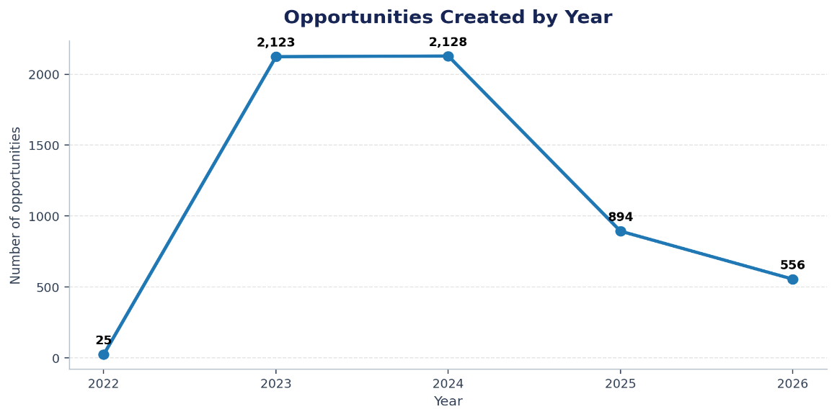
This line chart illustrates the volume of opportunity creation across the dataset's timeline. The sharp peaks in the first quarter of the year (particularly the spike in February 2026) highlight a cyclical release strategy designed to align with academic enrollment periods. The dataset's latest creation date is 28 May 2026; therefore, 2026 is a partial year in this extract and should not be compared directly with complete calendar years. The annual pattern shows changes in listing activity, but it cannot establish whether application demand rose or fell.
Figure 2: Opportunities by Listed Location
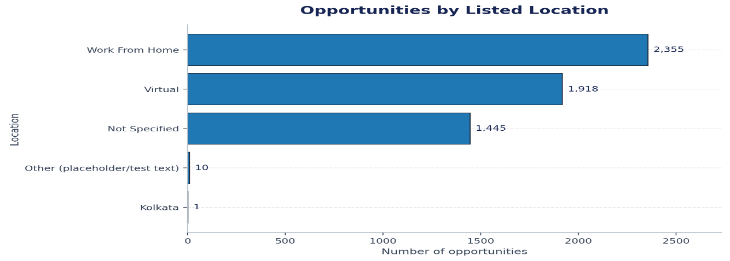
This horizontal bar chart visualizes the platform's remote-first ecosystem. "Work From Home" and "Virtual" classifications completely dominate the distribution, demonstrating that geographic location is almost never a barrier to user participation. The largest location label is Work From Home (460 listings; 40.9%). The location field is dominated by broad labels such as Work From Home, Virtual, and Not Specified rather than named cities or countries. This suggests the field primarily captures delivery mode or a generic location status, rather than a consistently granular geographic location.
Figure 3: Opportunities by Category
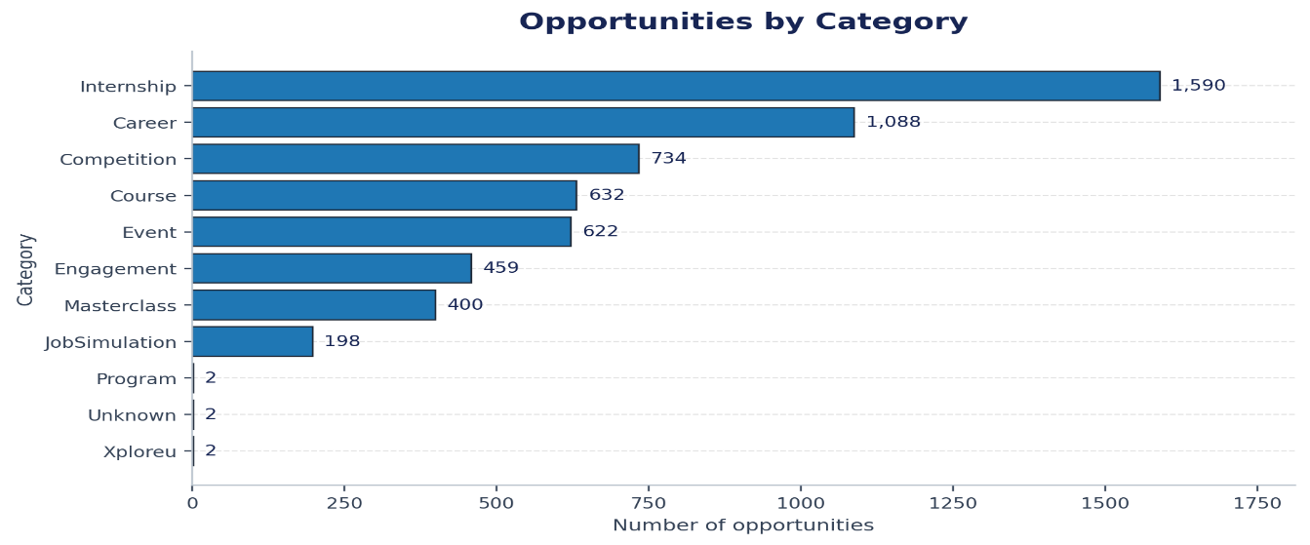
This horizontal bar chart ranks the opportunity categories by total volume. Internships and Career-focused engagements are the clear primary drivers of the platform, significantly outpacing traditional, and passive educational courses. Internship is the largest category with 544 opportunities (48.4% of the analyzed listings). Internships account for nearly half of the retained dataset, so overall patterns are strongly influenced by internship listings. The next largest categories are shown in the table below; smaller categories have much less representation and should be interpreted cautiously.
Figure 4: Most Common Microscholarship Values
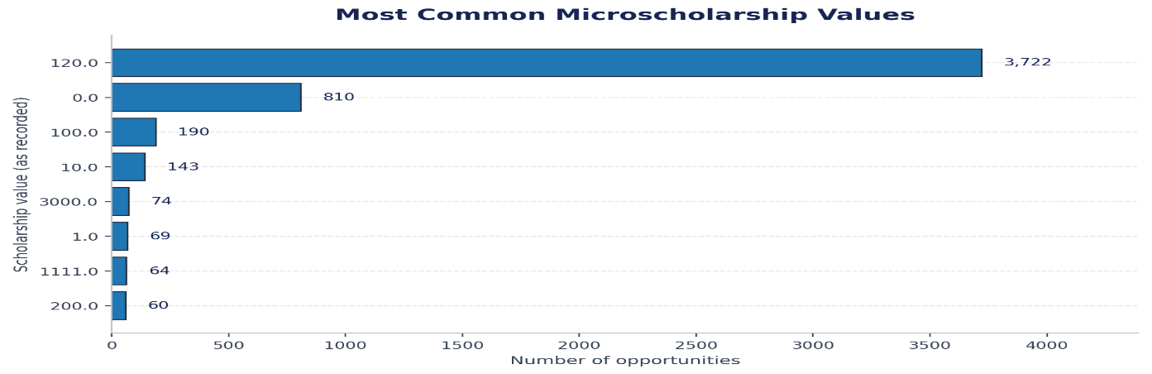
This horizontal bar chart highlights the frequency of specific financial reward amounts across the platform. The massive frequency spike at the $120 mark visually confirms that the platform utilizes a standardized, fixed-tier incentive model rather than dynamic pricing. There are 1,122 numeric microscholarship values and 3 missing/non-numeric values in the non-test subset. The median is 48.00, the mean is 454,741.84, and the maximum is 500,000,000.00. 304 records have a value of zero and 818 have a positive amount.
Because the mean is much higher than the median and the maximum is extremely large, the distribution is strongly right-skewed. The median is a more representative measure of a typical listing than the mean. Very large values should be checked against source records before being treated as valid awards.
- KEY FINDINGS SUMMARY

Purpose and Data Scope
This summary presents the main insights from the exploratory analysis of the Opportunity dataset. The source file contained 5,729 records, of which 4,604 were identified as test records and excluded. The analysis therefore focuses on 1,125 real opportunity records, with no duplicate opportunity IDs reported. The dataset describes listed opportunities; it does not contain individual student sign-ups or applicant-level records.

Key Findings

Opportunity creation varied across years
The highest annual count was recorded in 2023, with 363 opportunities, followed by 2025 with 318. The dataset records 260 opportunities in 2024 and 166 in 2026 up to 28 May. The 2022 count was 16. These figures describe when opportunities were created, not when students signed up. Because 2026 is incomplete, it should not be compared directly with full calendar years. The pattern suggests that opportunity publishing volume changes over time, but the dataset alone does not explain why.

Internships dominate the opportunity catalogue
Internships account for 544 records, or 48.4% of the 1,125 real opportunities—nearly half of the catalogue. The next largest categories are Competition (121), Event (118) and Course (111). Together, these figures show that internships are the clearest concentration in the dataset, while the remaining opportunities are spread across several smaller categories. Program, Xploreu and Unknown each have two records; the report identifies the two Unknown records as Testimonial records rather than real opportunities.

Listed opportunities are predominantly remote
Work From Home is the most common listed location, with 460 opportunities (40.9%), followed by Virtual with 365 (32.4%). Combined, these categories represent 825 opportunities, or 73.3% of the real records. A further 299 records (26.6%) have no specified location, while one record lists Kolkata. This indicates that remote participation is a prominent feature of the catalogue. These figures refer to the opportunity's listed location, not the locations of applicants, and missing location information limits a complete geographic interpretation.

Scholarship values are recorded for most opportunities, but need context
Of the 1,120 real opportunities with a recorded microscholarship value, 816 (72.9%) have a positive scholarship amount and 304 (27.1%) have a value of zero. The most common positive value is 120, appearing 171 times, followed by 100 (99 times) and 10 (86 times). The median recorded microscholarship value is 47.50. Three values were not recorded, and two extremely large values above 100,000 were excluded from the reported distribution. Because the unit or currency of scholarship values is not documented, these figures should be interpreted as recorded values rather than assumed to represent a confirmed currency amount.

Most listed opportunities have no fee
The summary statistics report 847 records with a zero fee, 276 with a positive fee and two missing fee values. The median fee across recorded units is 0.00, consistent with zero-fee opportunities forming the majority. Among paid opportunities, the reported median fee is 27, with the fee chart capped at the 98th percentile (1,500) to keep extreme values from obscuring the main pattern. Since more than one currency label is present, fee amounts should not be added together or directly compared across currencies without conversion.

Sign-ups and outreach-channel performance cannot be measured from this file
Although the broader assignment asks about sign-up trends, applications by location and outreach-channel performance, the available dataset does not include student-level sign-up or application counts, applicant locations, or a clear outreach-channel field with clicks, sign-ups and applications. Opportunity creation dates can be used to analyze publishing activity, but they cannot be treated as sign-up trends. Channel performance and application geography therefore remain unanswered questions rather than negative results.

Recommended Follow-up Analysis
- Add channel attribution fields (campaign, source, medium, referral, or discovery channel) and funnel metrics to evaluate outreach performance.
- Standardize location semantics into separate fields for delivery mode (virtual/remote/in-person) and physical geography (city, region, country).
- Confirm currency and units for fee and microscholarship; inspect extreme values against source records and use robust statistics.
- Review missingness by field with the data owner to distinguish valid optional fields from data-entry or extraction issues.

Conclusion
This Exploratory Data Analysis will provide an overview of the Opportunity dataset and highlight important patterns in opportunity availability, location, outreach, and scholarship distribution.
The findings will support better understanding of the dataset and help identify areas for improvement. All final conclusions and recommendations will be based on the calculated statistics, visualizations, and observed patterns.

